INSTRUCTIONS

for

Downloading & Installing

*Medicare Remit Easy Print* Software

onto a Network

(You plan to share the application with other users on a network)



This software was developed by the Centers for Medicare & Medicaid Services (CMS) for use by Medicare providers/suppliers to view and print a Health Insurance Portability and Accountability Act (HIPAA) compliant Medicare 835. Medicare has no liability and takes no responsibility for any other use of this software.

|  |
| --- |
| PC Requirements |

Recommended speed: 2.0 GHZ or faster

Compatible speed: 1.0 GHZ

Please note: the processing time for importing and accessing the SPR files within the *Medicare Remit Easy Print* application will be dependent upon on the processing capability of the PC and the size of the files being imported viewed.

|  |
| --- |
| Operating System Requirements |

Recommended: Windows XP

Other compatible versions: Windows 2000, Windows Vista, Windows 7

.NET Framework: 2.0 SP2

This application uses Visual Basic.Net, a Microsoft compatible language and, like many applications that require an MS Windows platform, MREP requires a .NET framework. More than likely one or more.NET frameworks were pre-installed on your Windows operating system or Windows Update downloaded a newer version on your PC. You must have .NET framework version 2.0 SP2 on each PC using the MREP Application.

**Note:** .NET frameworks 3.0, 3.5, and 4.0 include the 2.0 SP2 framework so if one of these frameworks is present, .NET 2.0 SP2 does not need to be installed separately. Windows 8 users may need to install or enable the .NET 3.5 framework 3.5 on each PC that uses MREP.

If you do not have the necessary framework installed, you may receive a message stating that this version of the framework is required during the installation process and prompting you to install it.is required during the installation process and prompting you to install it.

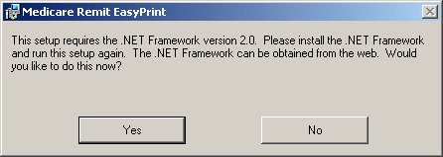

By clicking Yes—and if you have access to the Internet—you are redirected to the Microsoft web site to download the .NET framework 2.0 SP. Download NetFx20SP2_x86.exe for 32-bit systems or NetFx20SP2_64.exe for 64-bit systems. We do not recommend that you download a beta version of the .NET framework if you are presented with this option on the Microsoft web site.

Outside of the application installation process, you may also visit the link to [Microsoft .NET Framework Version 2.0 Service Pack 2](http://www.microsoft.com/en-us/download/details.aspx?id=1639) at the Microsoft website to transport directly to the location on the Microsoft web site to download the 2.0 SP2 .NET framework version.

If you want to learn more about the 2.0 SP2 .NET Framework version and/or determine if you need to install this version, you may visit

.[Net Framework Developer Center](http://msdn.microsoft.com/en-us/netframework/default.aspx) at the Microsoft website.

Please follow the directions within the web site when using this link.

If you do not have access to the Internet and you receive a message to update your .NET framework, you have to obtain a copy of the .NET framework from Microsoft. The Medicare Remit Easy Print application does not work without the appropriate .NET framework installed on each machine accessing the application.

|  |
| --- |
| Download Instructions - ZIP file |

**Step 1.** From the CMS website select **‘*Medicare Remit Easy Print – Version x.x [Zip]’*.** (x.x is the latest version number available on the web site.) Depending on your browser settings, you may encounter a pop-up blocker requiring that you allow the download.

**Step 2.** Click on the zip file. Depending on your browser settings, you may encounter a pop-up blocker requiring that you allow the download. A message similar to the following will appear:

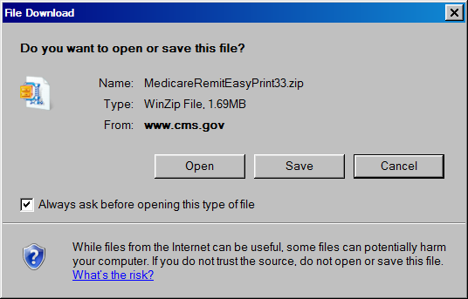

**Step 3.** Click on ‘Open’ and a screen similar to the following will appear.

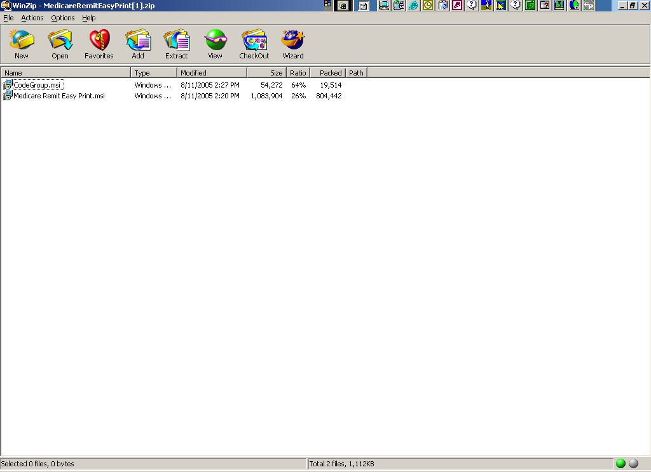

**Step 4.** Highlight the CodeGroup.msi and select ‘Extract’ if you wish to extract the file to the network at that time. A screen similar to the following will appear. (Note: the folders displayed will be dependent upon the folders set up by the user – below is just an example.)

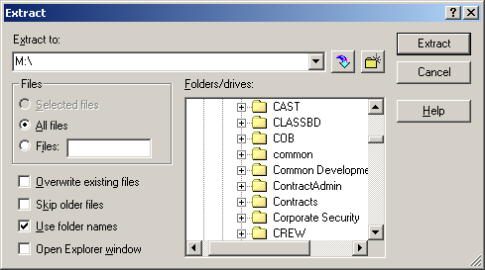

**Step 5.** Select the directory on your network where you wish to store the CodeGroup.msi, and click on the ‘Extract’ button.

**Step 6.** Record the location of the CodeGroup.msi file:

_______________________________________________________

**Step 7.** You will return to the WinZip window. Highlight the MedicareRemitEasyPrint.msi file and select ‘Extract’.

**Step 8.** Select the same location on your network to which you saved the CodeGroup.msi file and click the ‘Extract’ button.

Please note: If you have errors that prevent you from downloading the software, please make screen prints of your errors and contact your Medicare carrier. Screen prints can be made by pressing ‘ALT’ and ‘Print Screen’ buttons on your keyboard at the same time while you have the error message screen displayed, and copying them to a word document.

|  |
| --- |
| Installation Instructions |



Installing Medicare Remit Easy Print on a Network

When you install Medicare Remit Easy Print on a network:

* Install the Medicare Remit Easy Print application on the network by using the MedicareRemitEasyPrint.msi.
* Install the CodeGroup.msi file on every PC accessing the Medicare Remit Easy Print application.
* Important!: When installing on a network drive, insure that the drive letter the network drive is mapped to is the same on ALL PC’s that will be using Easy Print. If not, runtime errors will result.

How to Install Medicare Remit Easy Print on the Network

**Step 1.** Make sure you know the location of the MedicareRemitEasyPrint.msi file (refer to the download instructions where you recorded the location at which the file was saved, **Step 6**).

**Step 2.** Create a directory on the network for the Medicare Remit Easy Print installation, where the application and all the associated files will be stored. This directory must have adequate security for PHI. Record the location:

________________________________________________

**Step 3.** Open Microsoft Windows Explorer and find the MedicareRemitEasyPrint.msi and CodeGroup.msi files.

**Step 4.** Double-click the MedicareRemitEasyPrint.msi file:

Installation icon and filename

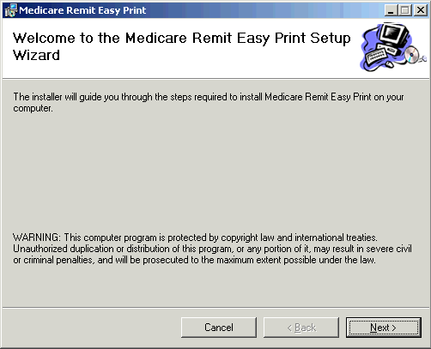The *Medicare Remit Easy Print* Setup Wizard opens:

**Step 5.** Click the ‘Next’ button.

The Select Installation Folder window opens.

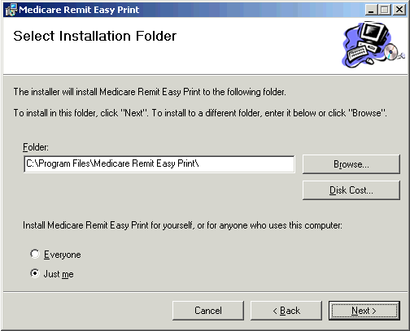

T:\Easy Print Files\

**Step 6.** Browse for the network directory (noted in Installation **Step 2**) where you want the application and all the associated files to be stored.

**Step 7.** Select ‘Everyone’, and click the ‘Next’ button.

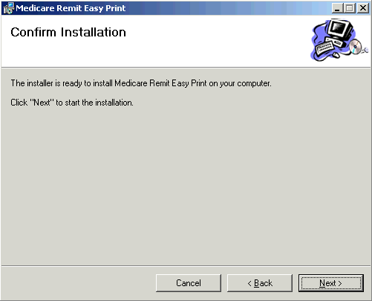The Confirm Installation window opens:

**Step 8.** Click the ‘Next’ button

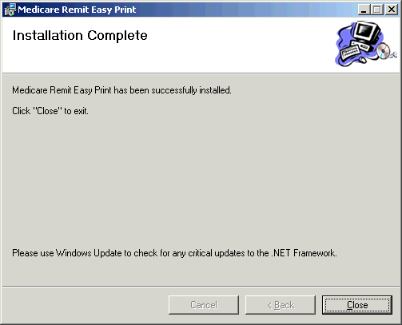When the installation is finished, the Installation Complete window opens:

**Step 9.** Click the Close button.

The Medicare Remit Easy Print shortcut is available in the directory you recorded during Installation **Step 2.** Have each user go to that directory and copy the shortcut to his/her desktop.

**Step 10.** Complete the CodeGroup.msi installation on each PC.

Installing the Medicare Remit Easy Print Code Group on the PC



After you install the Medicare Remit Easy Print application on the network, you must install the CodeGroup.msi on **EVERY** PC that needs to access the application.

### How to Install the Medicare Remit Easy Print Code Group

**Step 1.** Make sure you know the location of the CodeGroup.msi file.

**Step 2.** Open Microsoft Windows Explorer and find the CodeGroup.msi file.

**Step 3.** Double-click the CodeGroup.msi file:

CodeGroup

The installation completes without opening any windows or displaying any messages.

#### How to Know that the Medicare Remit Easy Print Code Group Install Completed Successfully

If the installation DID complete successfully, the PC user can open Medicare Remit Easy Print.

If the installation DID NOT complete successfully, the PC user cannot open Medicare Remit Easy Print and sees this message:

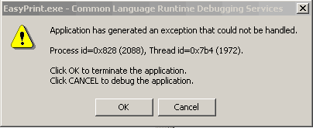

Hint:

If you see this error message on the PC, you need to install the Medicare Remit Easy Print Code Group.

Have the user click OK and install the CodeGroup.msi again.

**The Installation Process is Complete!**

**Thank you for using**

***Medicare Remit Easy Print.***