CMS Identity Management (IDM)

Tier 1 Help Desk User Guide

Version 1.6

Document Number: CMS IDM Help Desk UI User Guide-2024.V1.6 Contract Number: HHSM-500-2017-0006I TO 75FCMC18F0002
Last Reviewed: 07/31/2024

Table of Contents
1 Introduction 1
1.1 What is IDM? 1
1.2 Overview 1
2 Accessing IDM 2
2.1 User Access Considerations 2
2.2 Logging into CMS IDM 2
3 Accessing the IDM Help Desk UI 3
4 Help Desk Functions 5
5 Help Desk Search Options 8
5.1 Search Input Rules and Restrictions 9
5.2 Application Search 10
5.3 Enterprise Search 13
5.4 Role Request Audit 15
6 View User / Role Request Details 19
7 Updating a User’s Email Address 27
8 Updating a User’s LOA / IAL 31
9 Suspending a User 40
10 Unlock Account 43
11 Password Reset 46
11.1 Password Reset via Email 46
11.2 Manual Password Reset 49
12 View / Remove Multi-Factor Authentication (MFA) Devices 53
13 View / Remove Application Roles 57
14 Cancelling a Pending Role Request 61
15 Contacting Tier 2 & Tier 1 Responsibilities 64

Table of Figures
Figure 1: IDM Login Screen 2
Figure 2: SMS Authentication 3
Figure 3: IDM Landing Page 3
Figure 4: Help Desk / Manage Users Tile on IDM Landing Page 4
Figure 5: Help Desk / Manage Users UI Landing Page 4
Figure 6: Initial Search Tabs 5
Figure 7: Enterprise Search Results User ID Hyperlink and User Actions 6
Figure 8: User Options Tabs and User Actions 6
Figure 9: Role Request Audit Search Results User ID Hyperlink and Type Hyperlink 6
Figure 10: Role Request Audit Details Example Screen 7
Figure 11: Application Search Parameters 8
Figure 12: Enterprise Search Parameters 9
Figure 13: Role Request Audit Parameters 9
Figure 14: IDM Landing Page with Help Desk / Manage Users Tile 10
Figure 15: Application Search 11
Figure 16: Application Search Fields 11
Figure 17: Application Search with Application / Role Info 12
Figure 18: Application Search Results Example from Application / Role Info 12
Figure 19: Application Search with Application / Role Info Post Last Search 13
Figure 20: IDM Landing Page with Help Desk / Manage Users Tile 13
Figure 21: Enterprise Search 14
Figure 22: Enterprise Search Optional Fields 14
Figure 23: Enterprise Search with User ID Info 15
Figure 24: Enterprise Search Results Example from User ID 15
Figure 25: Enterprise Search with User ID Info Post Last Search 15
Figure 26: IDM Landing Page with Help Desk / Manage Users Tile 16
Figure 27: Role Request Audit 16
Figure 28: Role Request Audit Fields 17
Figure 29: User Role Request Audit with User ID Info / Date Range 17
Figure 30: Role Request Audit Search Results Example from User ID / Date Range 17
Figure 31: Role Request Audit with User ID Info / Date Range Post Last Search 18
Figure 32: User Search Example Enterprise Search Result 19
Figure 33: User ID Selection Enterprise Search 19
Figure 34: User Details Page 20
Figure 35: User Details Page User Information 21
Figure 36: User Details Page Personal Contact Information 22
Figure 37: User Details Page Business Contact Information 23
Figure 38: Role Audit Search Results 23
Figure 39: User ID Selection Role Audit Search Results 24
Figure 40: Request Audit Details Page ‘Remove’ Request Type Example 25
Figure 41: Request Audit Details Page ‘Add’ Request Type Example 26
Figure 42: Valid Enterprise Search 27
Figure 43: Enterprise Search go to User Details / Update E-Mail Address 28
Figure 44: User Details Select Update E-Mail Address User Action 29
Figure 45: Enter New Email Information Update E-Mail Address Popup 29
Figure 46: Enter New Email Information Update E-Mail Address Popup Submit / Cancel 30
Figure 47: User Details Successful User Email Information Update 30
Figure 48: Enterprise Search Results Successful User Email Information Update 30
Figure 49: Valid Enterprise Search 31
Figure 50: Enterprise Search go to User Details / Update User’s LOA/IAL 31
Figure 51: User Details Select Update User’s LOA/IAL User Action 32
Figure 52: Acknowledging that the user’s identify has been verified 32
Figure 53: LOA/IAL Puerto Rico Address Formatting Tips Pop-Up Modal 33
Figure 54: LOA/IAL Puerto Rico Address Formatting Tips Link 34
Figure 55: LOA/IAL Update Cancel/Submit 34
Figure 56: Enterprise Search Results Successful User LOA/IAL Update 35
Figure 57: First LOA/IAL Update Failure Error Message 36
Figure 58: Initial Proofing Status with 3 Attempts 37
Figure 59: Duplicate Submitted Information Error Message 38
Figure 60: Final LOA/IAL Update Failure Error Message 39
Figure 61: Valid Enterprise Search 40
Figure 62: Enterprise Search go to User Details / Suspend Account 40
Figure 63: User Details Select ‘Suspend Account’ User Action 41
Figure 64: Checkbox and Justification Suspend Account Popup 41
Figure 65: Suspend Account Popup Submit / Cancel 42
Figure 66: User Details Successful User Suspension 42
Figure 67: Search Results Successful User Suspension 42
Figure 68: Valid Enterprise Search Status LOCKED_OUT 43
Figure 69: Enterprise Search go to User Details / Unlock Account 43
Figure 70: User Profile Select Unlock Account 44
Figure 71: User Details Unlock Account Popup Justification Field 44
Figure 72: Unlock Account Popup Cancel / Submit 45
Figure 73: User Details Successful User Account Unlock 45
Figure 74: Search Results Successful User Account Unlock 45
Figure 75: Enterprise Search go to User Details / Reset Password 46
Figure 76: User Profile Select Password Reset 46
Figure 77: Radio Button Options and Justification Reset Password Popup 47
Figure 78: Reset Password Popup Cancel / Submit 47
Figure 79: System Generated Password Reset Email 48
Figure 80: Password Reset UI - SQA Prompt 48
Figure 81: Password Reset UI - New Password 49
Figure 82: Enterprise Search go to User Details / Reset Password 49
Figure 83: User Profile Select Password Reset 50
Figure 84: Radio Button Options and Justification Reset Password Popup 50
Figure 85: Reset Password Popup Temporary Password 51
Figure 86: Login Reset Password UI 52
Figure 87: Enterprise Search go to User Details 53
Figure 88: User Details Select MFA 53
Figure 89: User Details MFA – ‘Remove Factor’ and ‘Update E-Mail Address’ Actions 54
Figure 90: User Details MFA – ‘Add to Cart’ and ‘Process Requests’ Actions 54
Figure 91: User Details MFA – ‘Remove from Cart’ Action 55
Figure 92: User Details MFA – Remove MFA Device(s) Popup Justification 55
Figure 93: User Details MFA – Remove MFA Device(s) Popup Cancel / Remove MFA Device(s) 56
Figure 94: User Details Successful MFA Device Removal 56
Figure 95: Enterprise Search go to User Details 57
Figure 96: User Details Select Applications 57
Figure 97: User Details Applications – ‘Remove Now’ and ‘Add to Remove Cart’ Actions 58
Figure 98: User Details Applications – ‘Remove from Cart’ and ‘Remove Now’ Actions 58
Figure 99: User Details Applications – Remove Role/Attribute Popup Reason and Justification 59
Figure 100: User Details Applications – Remove Role/Attribute Popup Cancel/Remove Selected 59
Figure 101: User Details Successful Role/Attribute Removal 60
Figure 102: Enterprise Search go to User Details 61
Figure 103: User Details Select Pending Requests 61
Figure 104: User Details Pending Requests – ‘Cancel Pending Role Request’ Action 61
Figure 105: User Details Pending Requests – Cancel Pending Role Request Popup Justification 62
Figure 106: User Details Pending Requests – Cancel Pending Request Popup Cancel/Remove 62
Figure 107: User Details Successful Pending Role Request Cancellation 63
List of Tables
Table 1: Record of Change 66
Table 2: Acronyms 67
Table 3: Glossary 68
Table 4: Referenced Documents 69

Introduction
The Centers for Medicare & Medicaid Services (CMS) is a vital federal agency dedicated to safeguarding healthcare coverage for over 100 million Americans. CMS plays a pivotal role in the nation's healthcare landscape by overseeing and administering critical programs such as Medicare, Medicaid, and the Children's Health Insurance Program (CHIP) across all 50 states.
CMS serves as a cornerstone in ensuring access to quality healthcare for vulnerable populations and seniors. With its mission firmly rooted in fostering improved and seamlessly coordinated care, CMS collaborates closely with healthcare communities and organizations nationwide. This collaborative effort is geared towards enhancing the overall quality and accessibility of healthcare services, ultimately aiming to improve the well-being of millions of Americans.

What is IDM?

The Identity Management System (IDM) is an essential component of CMS's efforts to ensure secure and efficient access to their applications. IDM serves as an identity management and services system that provides authorized users with access to various CMS applications. The primary purpose of IDM is to enable business partners and authorized personnel to create and manage a single User ID, which can be used to access one or more CMS applications.

This is a guide to assist Help Desk users in their support of system users. Help Desk users are tasked with submitting, reviewing, and approving requests for access, as well as changes in access, using the IDM User Interface (UI).

Overview

The structure of the Helpdesk UI is designed for Helpdesk agents to provide support for users and application administrators in managing access to CMS applications. This structure consists of two tiers:

Tier 1 Help Desk: Each CMS application is required to maintain its own Tier 1 Help Desk. The Tier 1 Help Desk is responsible for assisting application end users with access-related requests and issues. This includes tasks such as general account management and handling changes in access permissions. The specific capabilities and functions of Tier 1 Help Desks can vary based on the application's needs and policies.

Tier 2 Help Desk: The IDM team maintains a Tier 2 Help Desk, which serves as a more advanced level of support. Tier 2 Help Desk comes into play when Tier 1 Help Desks encounter issues or requests that exceed their capabilities or require centralized coordination and expertise. The Tier 2 Help Desk is responsible for handling more complex access issues, troubleshooting problems that cannot be resolved at the Tier 1 level, and ensuring a higher level of coordination across various CMS applications.

Accessing IDM

User Access Considerations
The IDM system users include new users and users uploaded from other applications. IDM users fall into three functional categories:
- Help Desk Users – Provide Tier 1 application Help Desk support to application Approvers and End Users.
- Approver Users – Review and approve application role requests that are submitted by end users. Complete Annual Role Certifications.
- Application End Users – Users of CMS applications.

Logging into CMS IDM
The IDM Help Desk UI is accessed by logging into CMS IDM and is used for all Help Desk functions.

Note: Instructions on how to register for a CMS IDM account and then requesting a role can be found in the “CMS IDM User Guide”. This document is located on the IDM Guides and Documentation page.

To Login to CMS IDM follow these steps:
Step 1: Navigate to CMS IDM. The CMS IDM login page is displayed below. Enter your User ID and Password into the appropriate fields and agree to the Terms & Conditions by selecting the checkbox (left arrow in Figure below). Then, select ‘Sign In’ (right arrow in Figure Below).
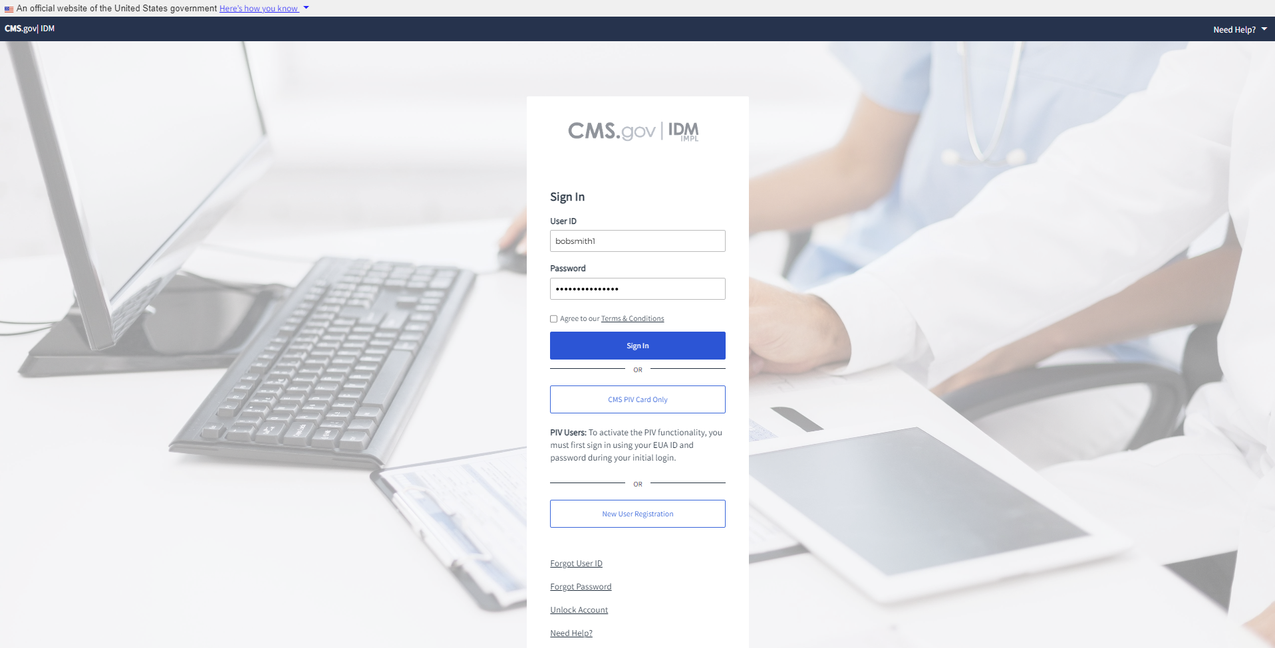
Figure 1: IDM Login Screen
Step 2: Follow the Multi-Factor Authentication (MFA) onscreen instructions to complete MFA. The Figure below shows an example of the SMS Authentication method.
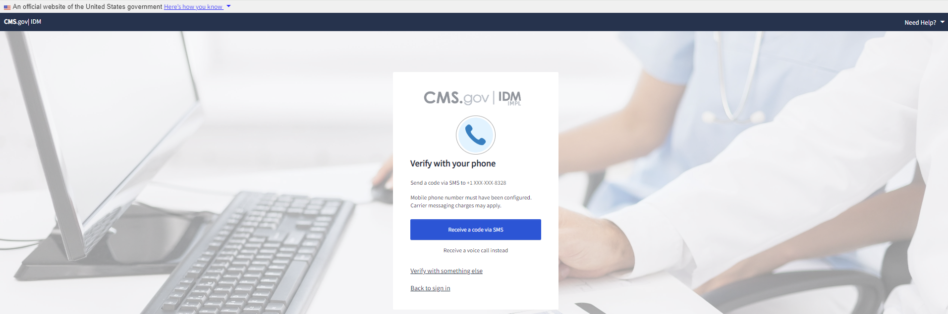
Figure 2: SMS Authentication
Step 3: You will be directed to the IDM landing page.
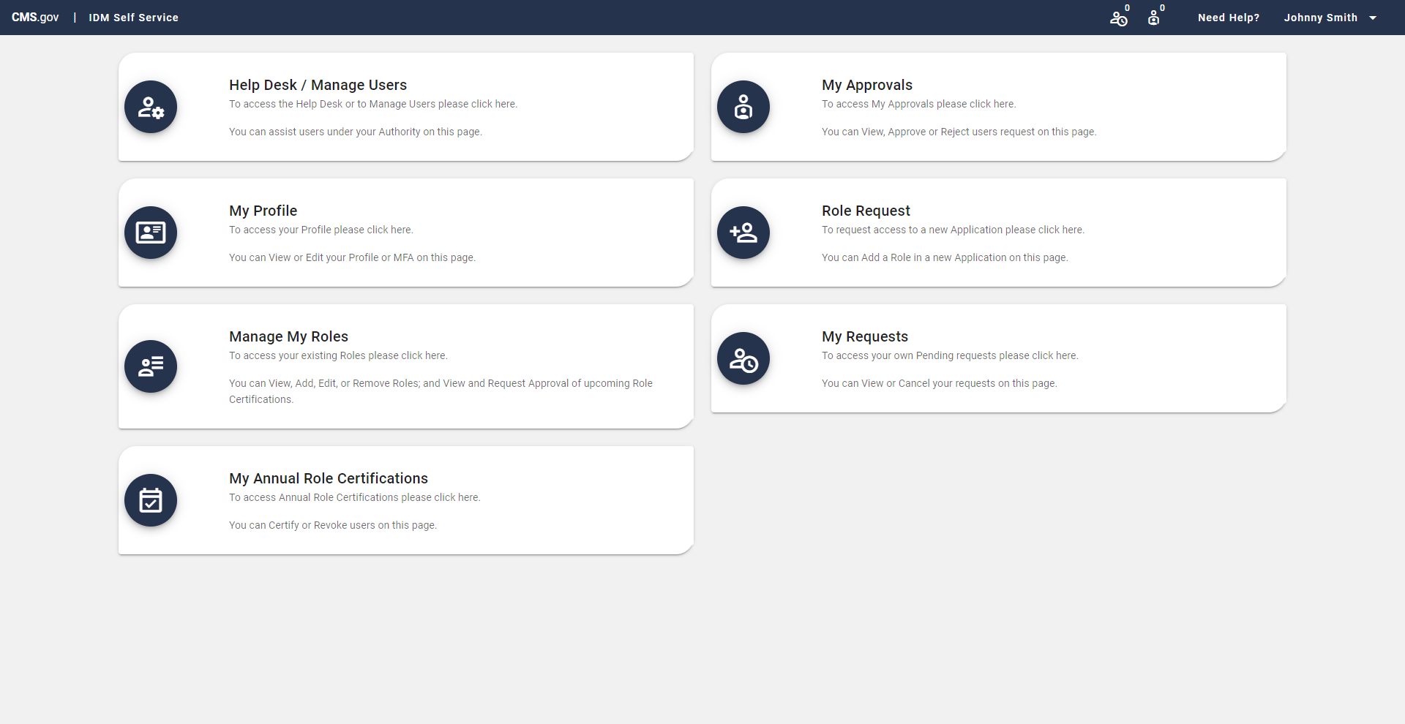
Figure 3: IDM Landing Page

Accessing the IDM Help Desk UI
Step 1: Users who have a Help Desk role within IDM access the Help Desk UI by selecting the ‘Help Desk / Manage Users Tile’ on the IDM landing page.
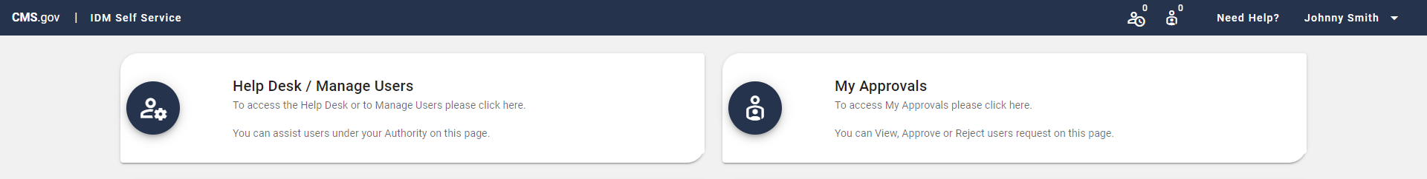
Figure 4: Help Desk / Manage Users Tile on IDM Landing Page
Step 2: Selecting the ‘Help Desk / Manage Users tile’ will direct the user to the Help Desk UI. Application Search is selected by default. The below figure shows what a Tier 1 Help Desk User would see.
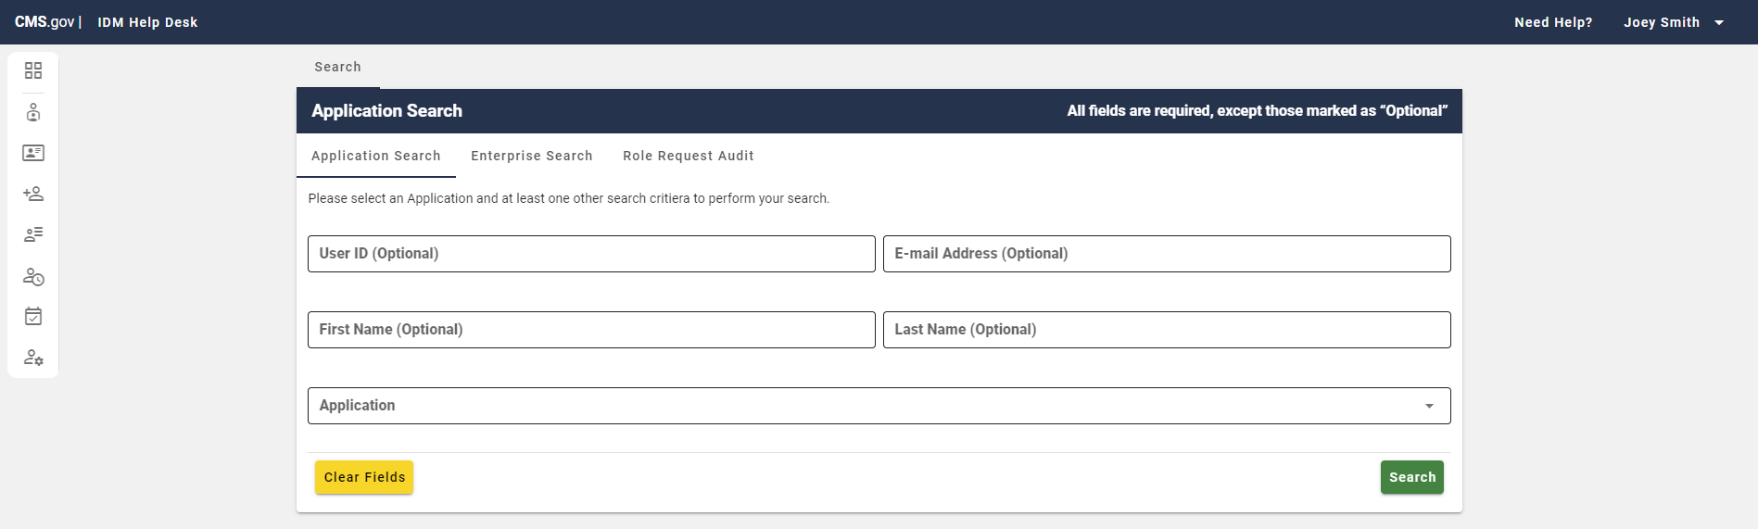
Figure 5: Help Desk / Manage Users UI Landing Page

Help Desk Functions
Applications are responsible for managing their own Tier 1 Help Desk to assist their application end users. Tier 1 Help Desk users can perform the following functions in IDM:
Tier 1 User Tabs

- Initial Search Tabs

  - Application Search
  - Enterprise Search
  - Role Request Audit
Figure 6: Initial Search Tabs

Enterprise Search & Application Search User Options and User Actions
- View User Details Tabs (Appears after clicking the User ID hyperlink in search results)
  - User Profile Tab (View Profile Data)
  - Applications Tab (Remove Role or Attribute)
  - Pending Requests Tab (Cancel a Role Request)
  - MFA Tab (View MFA Devices)

- View User Actions (Located to the right of the tabs listed above). These actions are visible on search results as well for Enterprise Searches. The action name appears upon mouse hover or is detected by a screen reader.

- Reset Password
  - Manual Password Reset (Justification Required)
  - Via Email (Justification Required)

- Update Email
- Unlock a User’s Account
- Suspend a User’s Account (Note: Only Tier 2 Users can Unsuspend)
- Update Level of Assurance/Identity Assurance Level - LOA/IAL (Note: Only available if the application has established a Manual Identity Proofing Process)
In the Figure below, we see the Enterprise Search results where the Tier 1 Help Desk user can either click on the User ID (left arrow) to get the additional user details and tab options or use the actions on the right (right arrow) listed above which are visible in Enterprise Search results.

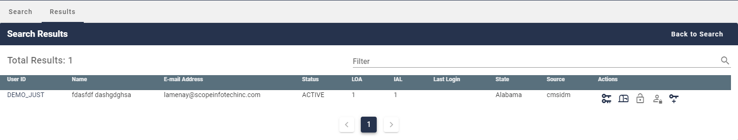 Figure 7: Enterprise Search Results User ID Hyperlink and User Actions

In this next Figure, we see what the Tier 1 Help Desk User sees when they select that User ID Hyperlink. Details Tabs are seen on the left (left arrow) and User Details Actions are seen on the right (right arrow).

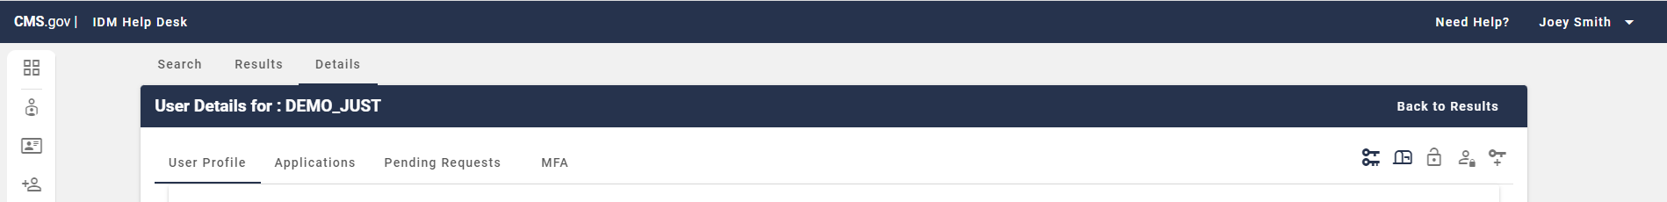
Figure 8: User Options Tabs and User Actions

Role Request Audit User Options
- View Request Audit Details by clicking the ‘User ID’ (Left arrow in Figure below) or ‘Type’ (Right arrow in Figure below). See ‘Request Audit Details’ page in second Figure below.

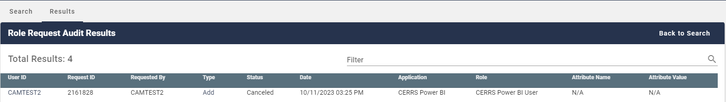
Figure 9: Role Request Audit Search Results User ID Hyperlink and Type Hyperlink

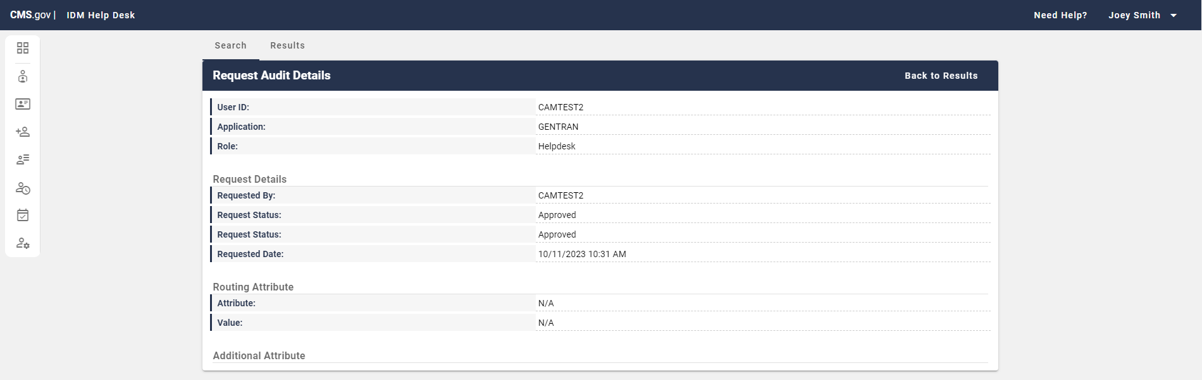
Figure 10: Role Request Audit Details Example Screen

Help Desk Search Options
This section outlines how a Tier 1 Help Desk user can search for specific users, events, and requests in IDM such as:

- Users in an application (Application Search) for which they have a help desk role.
- Users across the entire system (Enterprise Search)
- Requests by users (Role Request Audit) within the last two years.

Note: If the item that you’re looking for is not returned in the original search you should return to the search tab and modify or add to your search criteria.

Tier 1 Help Desk users can search for user accounts using the following search options:

- Application Search – Finds matches for mandatory and optional fields. Must search by Application, plus at least one other field. Application Search fields include:

  - User ID
  - E-mail Address
  - First Name
  - Last Name
  - Application
  - Group (this field appears once the application is selected)
  - Role (this field appears once the application is selected)
Figure 11: Application Search Parameters
- Enterprise Search – Finds matches for optional fields. Must input at a minimum User ID or E-Mail Address and alternatively First Name and Last Name. Enterprise Search fields include:

  - User ID
  - E-Mail Address
  - First Name
  - Last Name
  - Date of Birth
  - Last 4 SSN
  - State
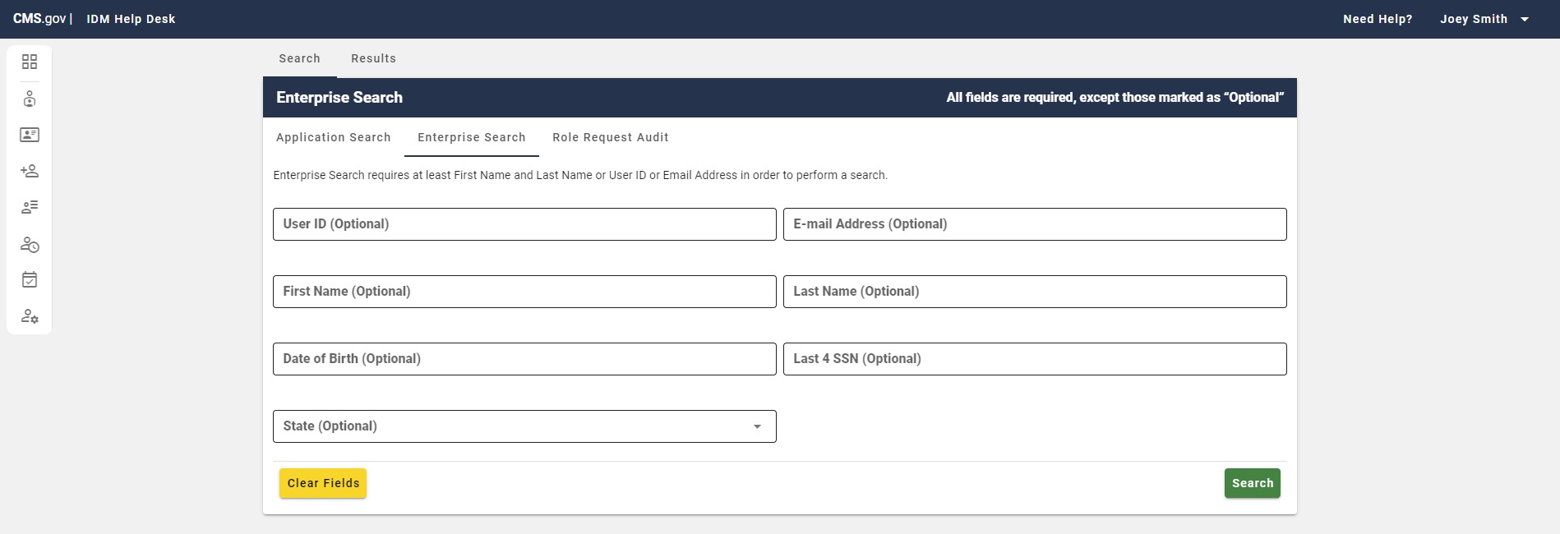
Figure 12: Enterprise Search Parameters

- Role Request Audit – Finds matches for required fields (see below - must input a. or b.)
  - User ID
  - Request ID
  - Desired Requested Date Range (Must be within the last two years)


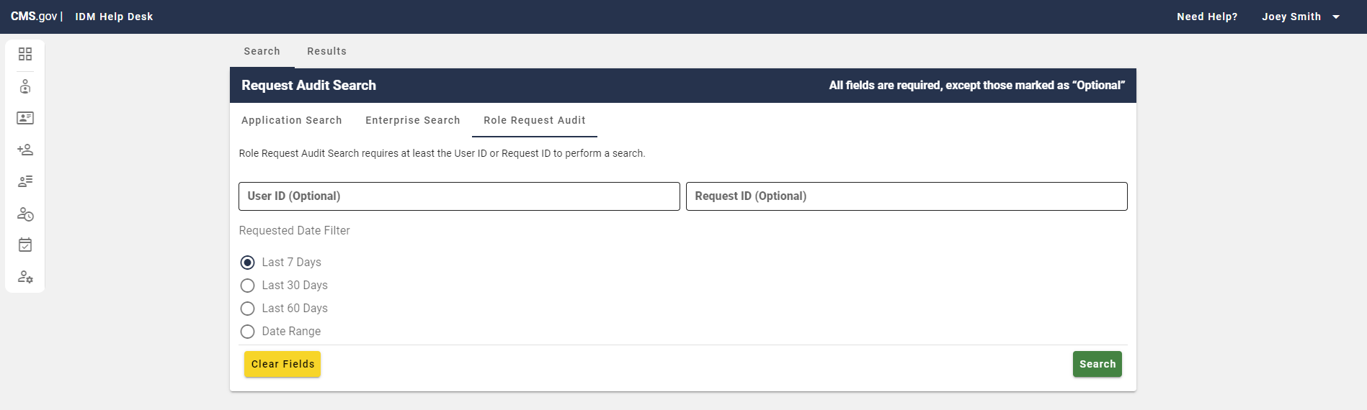
Figure 13: Role Request Audit Parameters

Search Input Rules and Restrictions
The following input rules and restrictions exist when conducting searches within IDM:
When entered for Application Search and Enterprise Search:
- The User ID field must contain at least two characters.
- The E-mail Address field must contain at least four characters.
- First Name and Last Name fields have a minimum of one character.
- User ID and E-mail Address fields can only contain the following special characters: Dash (-), Underscore (-), Apostrophe (‘), At Sign (@), and Period (.).
- First Name and Last Name fields can only contain the following special characters: hyphens (-), spaces (), and apostrophes (‘) as needed.
- For Date of Birth field, the user must be over 18 years of age. (Enterprise Search)
When entered for Role Request Audit:

- The User ID field must be full and valid.
- The Request ID must be full and valid.
- The Date Range must be within the last two years from today.

Application Search
Tier 1 Help Desk users should utilize the Application Search function within the Help Desk UI to search for users that have a role within a specific application. When Tier 1 Help Desk users land on the Help Desk UI, Application Search is the default search method.

To conduct an Application Search the Help Desk user must select the application from the Application dropdown and at least one of the following optional fields: User ID, E-mail Address, First Name, Last Name, or Role. Role appears once the Application field has been selected.

Application Search returns a maximum of 50 users. Once the results are returned they can be sorted by User ID, First and Last Name, E-mail Address, State, Status, LOA attribute, IAL attribute, or Actions.

To search for a user using Application Search complete the following:

Step 1: After login navigate to the Help Desk UI by selecting the ‘Help Desk / Manage Users’ tile.

Figure 14: IDM Landing Page with Help Desk / Manage Users Tile

Step 2: Select the ‘Application Search’ tab.

Figure 15: Application Search

Step 3: Enter at least one of the following optional fields: User ID, E-mail Address, First Name, or Last Name as well as the required Application field. Once the Application field is entered, the optional Role field will also appear for entries.

Note: Once the Application field is entered, an optional Group field may also appear for specific applications.

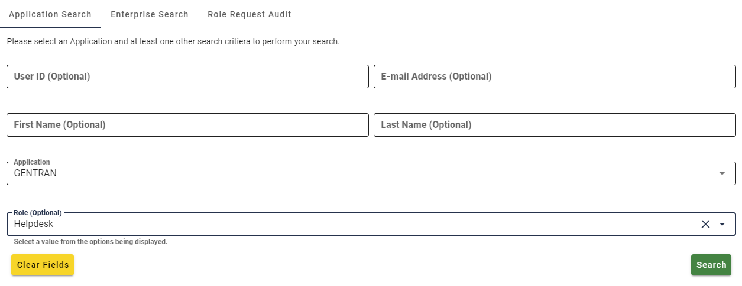
Figure 16: Application Search Fields

Step 4: After you have entered the acceptable amount of information in the appropriate format specified above, select ‘Search’ to attempt the search.

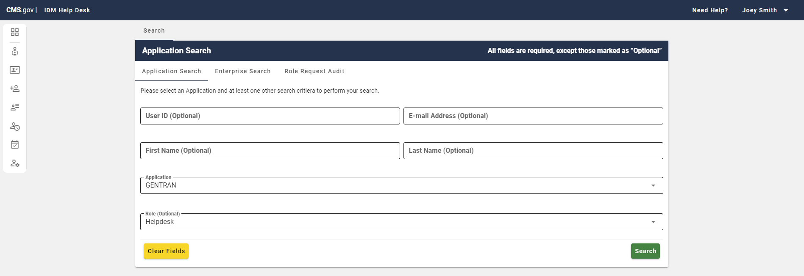
Figure 17: Application Search with Application / Role Info
The search results will appear here unless you receive an error message and must adjust your inputs.

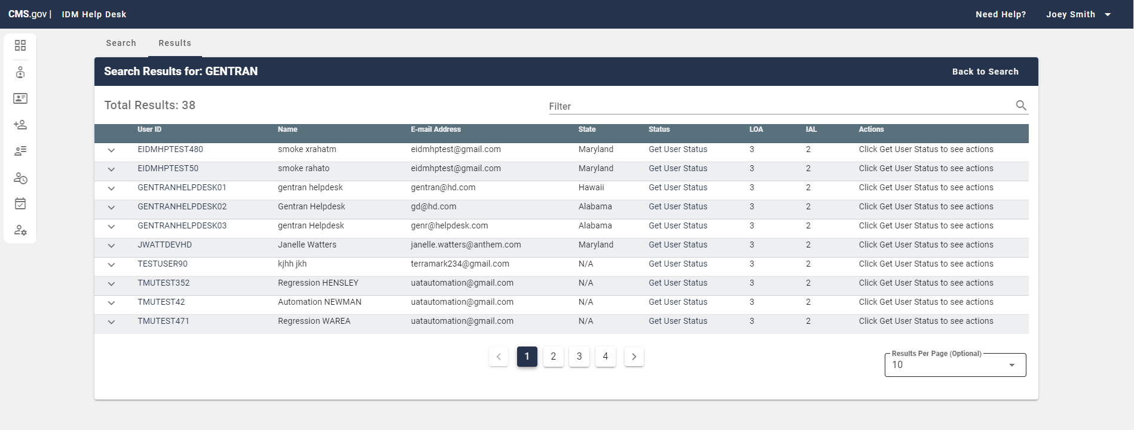
Figure 18: Application Search Results Example from Application / Role Info
Step 5: If your search does not return the desired result you can return to the Search Tab to make the necessary changes. Additionally, you can switch back and forth between the Results Tab and Search Tab without losing your last search results (while within Application Search).

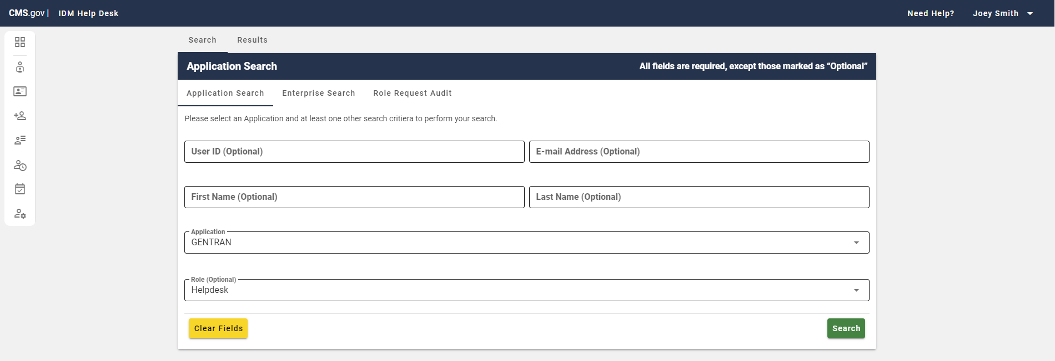
Figure 19: Application Search with Application / Role Info Post Last Search

Enterprise Search
Tier 1 Help Desk users should utilize the Enterprise Search function within the Help Desk UI to search for users across the entire system, regardless of application affiliation. This search is helpful especially when a user does not yet have a role, the user contacts the wrong help desk, or is uncertain with which application they are associated.

To conduct an Enterprise Search the Help Desk user must enter at least one of the following fields: User ID, E-mail Address, First and Last Name. Other optional fields include Date of Birth, Last 4 SSN, and State.

Enterprise Search returns a maximum of 5 users. Results can be sorted by User ID, First and Last Name, E-mail Address, Status, LOA attribute, IAL attribute, Last Login, or State.

To search for a user using an Enterprise Search complete the following these steps:

Step 1: After login navigate to the Help Desk UI by selecting the ‘Help Desk / Manage Users’ tile.
Figure 20: IDM Landing Page with Help Desk / Manage Users Tile

Step 2: Select the ‘Enterprise Search’ tab.

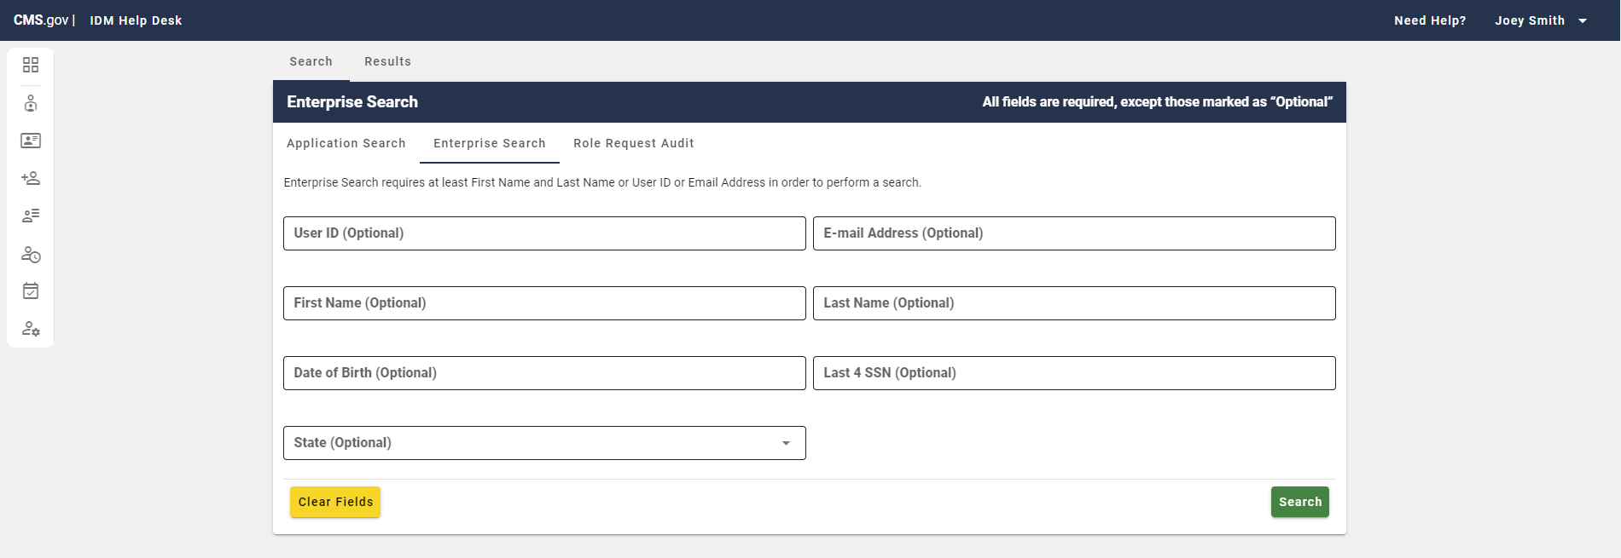
Figure 21: Enterprise Search

Step 3: Enter at least one of the following optional fields: User ID, E-mail Address, First Name, or Last Name. Other optional fields include Date of Birth, Last 4 SSN, and State.

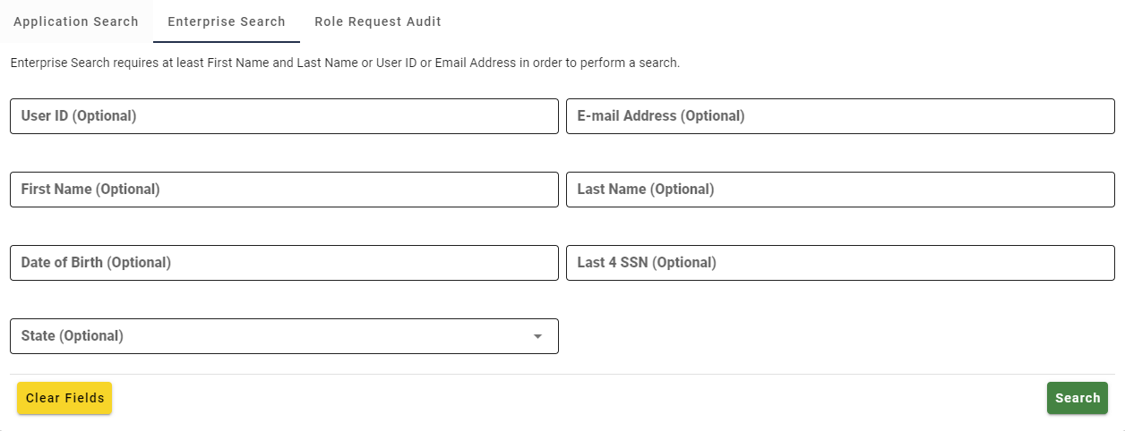
Figure 22: Enterprise Search Optional Fields

Step 4: After you have entered the acceptable amount of information in the appropriate format specified above, select ‘Search’ to attempt the search.

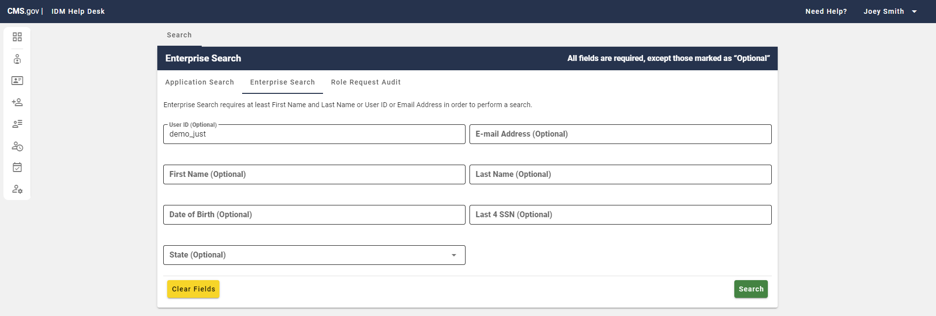
Figure 23: Enterprise Search with User ID Info
The search results will appear here unless you receive an error message and must adjust your inputs.

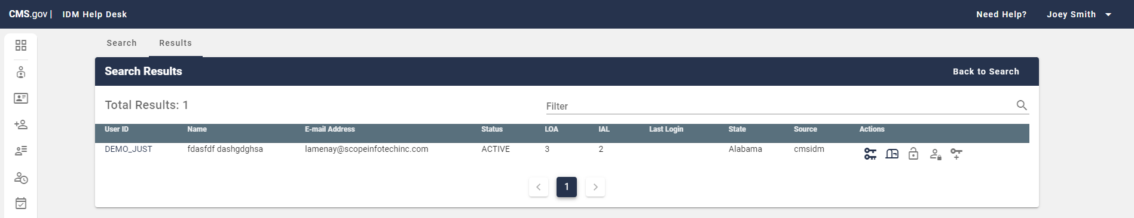
Figure 24: Enterprise Search Results Example from User ID

Step 5: If your search does not return the desired result you can return to the Search Tab to make the necessary changes. Additionally, you can switch back and forth between the Results Tab and Search Tab without losing your last search results (while within Enterprise Search).

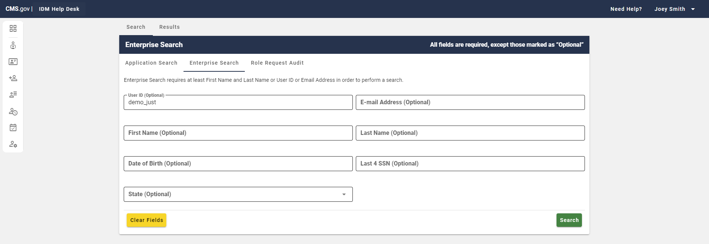
Figure 25: Enterprise Search with User ID Info Post Last Search

Role Request Audit
Tier 1 Help Desk users should utilize the Role Request Audit Search function within the Help Desk UI to search for users who made specific requests within the last two years.

Note: Tier 1 Help Desk users only have access to requests within their applications, while Tier 2 Help Desk users have access to requests within all applications.

To conduct a Role Request Audit the Help Desk user must enter at least a valid User ID or valid Request ID. The Requested Date Filter for the appropriate date range. Requested from date must be within 2 years of today. Start Date and End Date entries appear upon selecting ‘Date Range’ in the format DD/MM/YYYY.

Once the results are request results are returned, they can be sorted by User ID, Request ID, Requested By, Type, Status, Date, Application, Role, Attribute Name, and Attribute Value.

To search for a user using Role Request Audit complete the following:

Step 1: After login navigate to the Help Desk UI by selecting the ‘Help Desk / Manage Users’ tile.

Figure 26: IDM Landing Page with Help Desk / Manage Users Tile

Step 2: Select the ‘Role Request Audit’ tab.

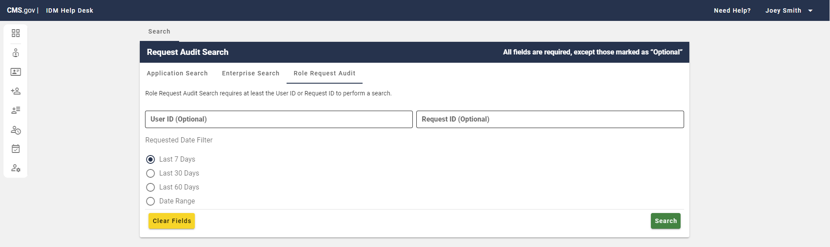
Figure 27: Role Request Audit

Step 3: Enter at least a valid User ID or valid Request ID. Adjust the Requested Date Filter for the appropriate date range. Requested from date must be within 2 years of today. Start Date and End Date entries appear upon selecting ‘Date Range’ in the format DD/MM/YYYY.

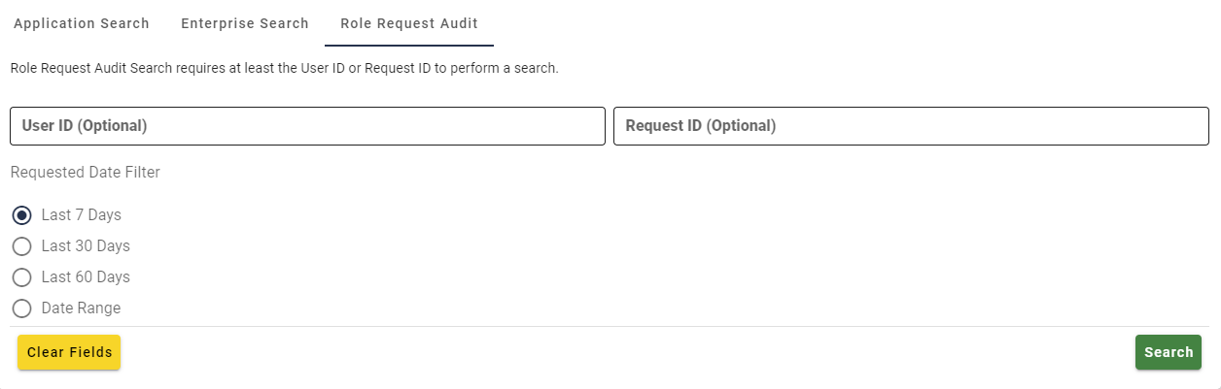
Figure 28: Role Request Audit Fields

Step 4: After you have entered the acceptable amount of information in the appropriate format specified above, select ‘Search’ to attempt the search.

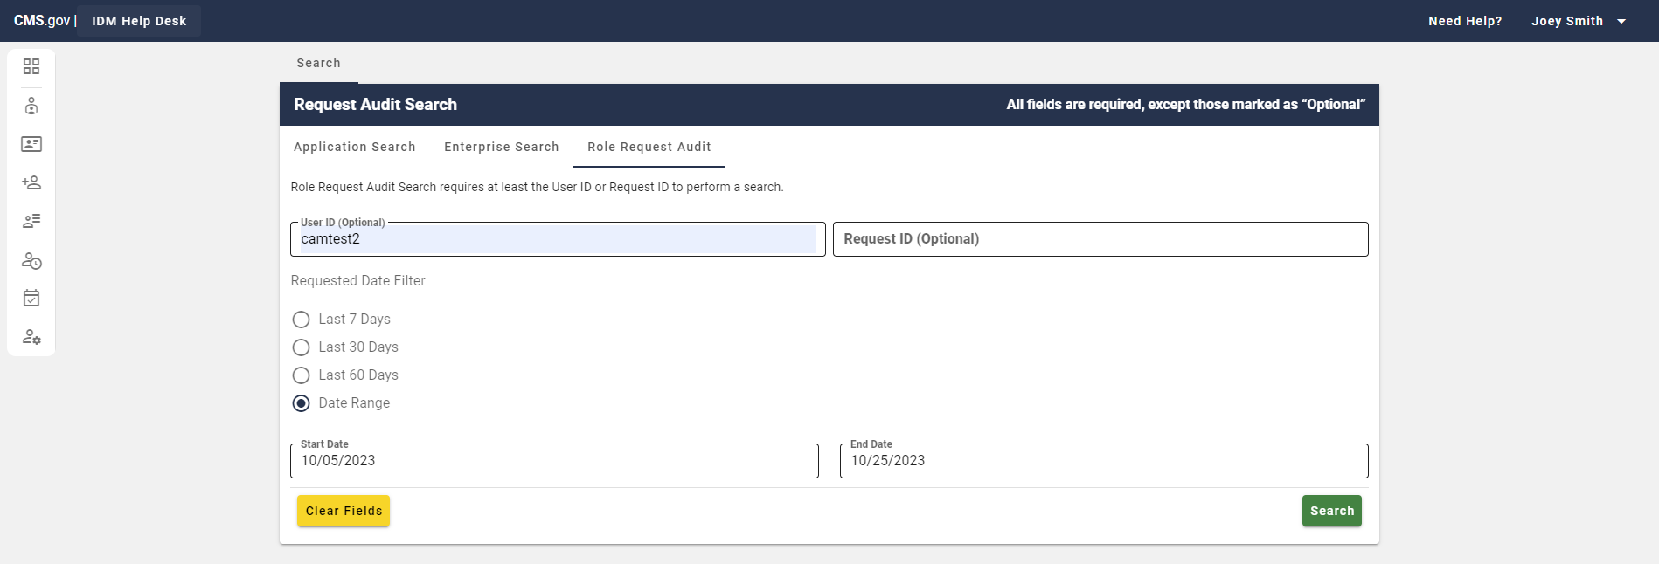
Figure 29: User Role Request Audit with User ID Info / Date Range
The search results will appear here unless you receive an error message and must adjust your inputs.

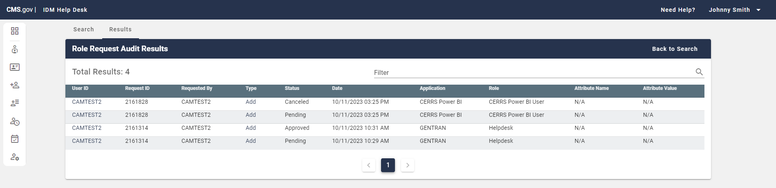
Figure 30: Role Request Audit Search Results Example from User ID / Date Range

Step 5: If your search does not return the desired result you can return to the Search Tab to make the necessary changes. Additionally, you can switch back and forth between the Results Tab and Search Tab without losing your last search results (while within Role Request Audit).

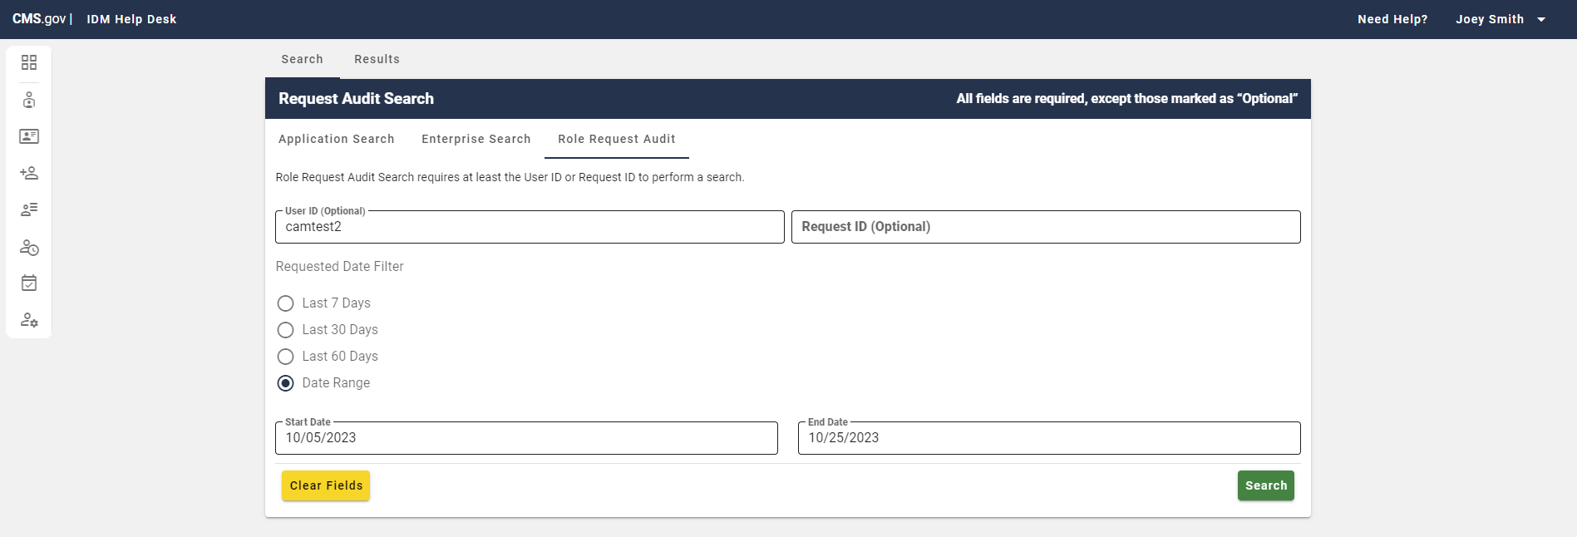
Figure 31: Role Request Audit with User ID Info / Date Range Post Last Search

View User / Role Request Details
This section describes how Help Desk users can view the account information and role request details associated with a user through the IDM Help Desk UI.

View User Details (Application Search and Enterprise Search):

Step 1: Follow the steps in either the Application Search or Enterprise Search sections to complete a valid user search.

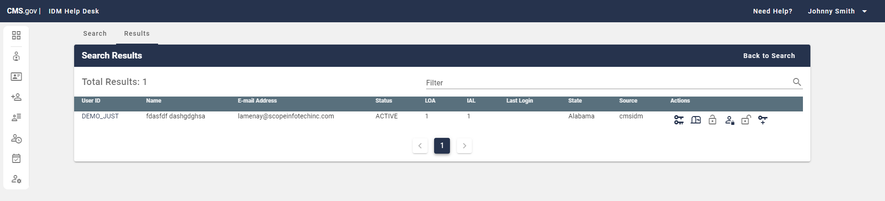
Figure 32: User Search Example Enterprise Search Result

Step 2: To view the user details associated with a specific user, select the hyperlink User ID within the User ID field on the left side.

Figure 33: User ID Selection Enterprise Search

Step 3: You will be directed to the User Details page, where you can view the user’s information.

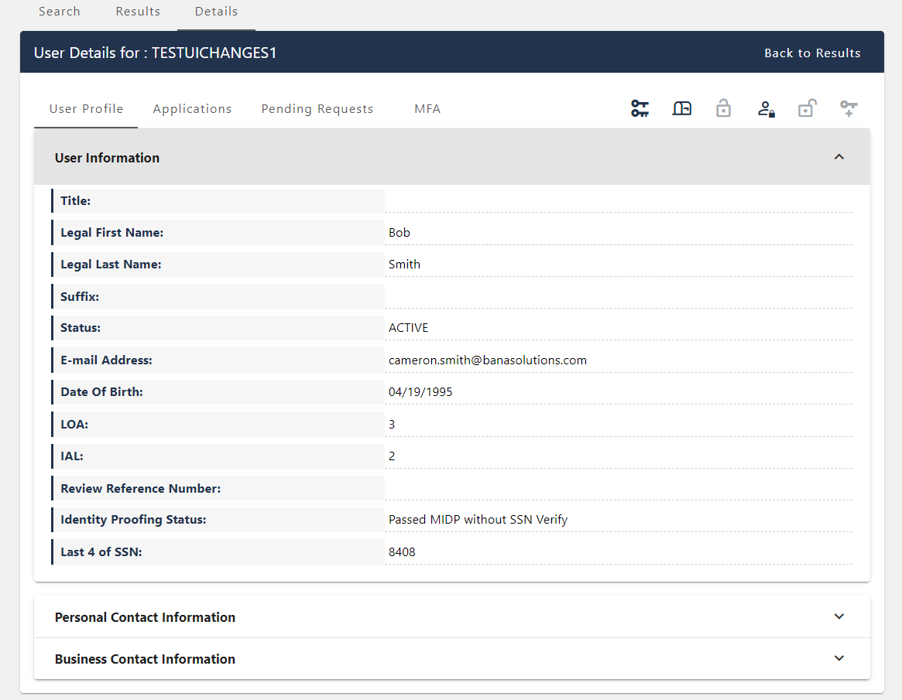
Figure 34: User Details Page

The following user details may be viewed using the Help Desk UI:

Note: The information is divided into three separate horizontal tabs, with ‘User Information’ tab being the default display after selecting a User ID.

- User Information:

  - Title
  - First Name
  - Last Name
  - Suffix
  - Status
  - E-mail Address
  - User ID
  - Date of Birth
  - LOA (Level of Assurance)
  - IAL (Identity Assurance Level)
  - Review Reference Number
  - Identity Proofing Status
  - Last 4 of SSN

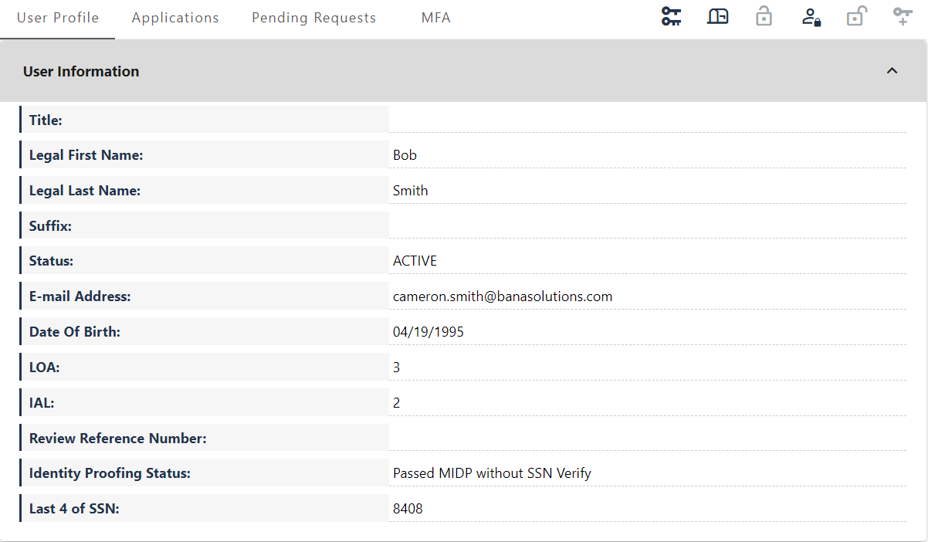
Figure 35: User Details Page User Information

- Personal Contact Information:

  - Home Address Line 1
  - Home Address Line 2
  - City
  - Province/Region/Territory
  - State
  - Zip Code
  - Zip Code Extension
  - Country
  - Country Code
  - Phone Number

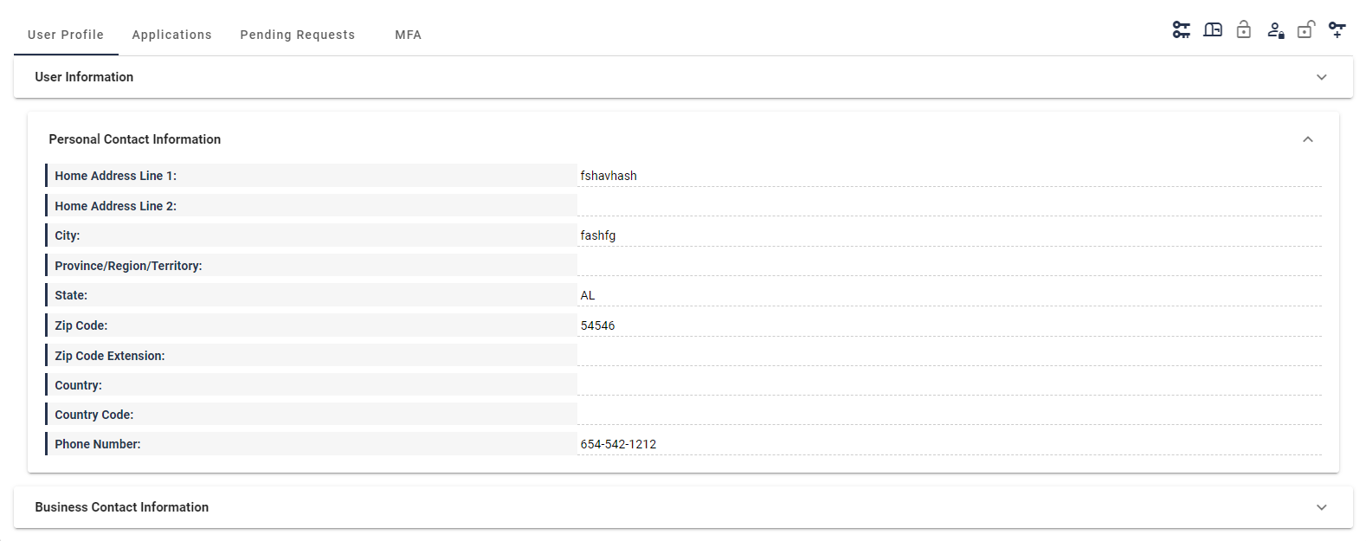
Figure 36: User Details Page Personal Contact Information

- Business Contact Information:

  - Professional Credentials
  - Company Name
  - Company Address Line 1
  - Company Address Line 2
  - Company City
  - Company State
  - Company Zip Code
  - Company Zip Code Extension
  - Company Phone
  - Company Phone Extension
  - Office Phone
  - Office Phone Extension.

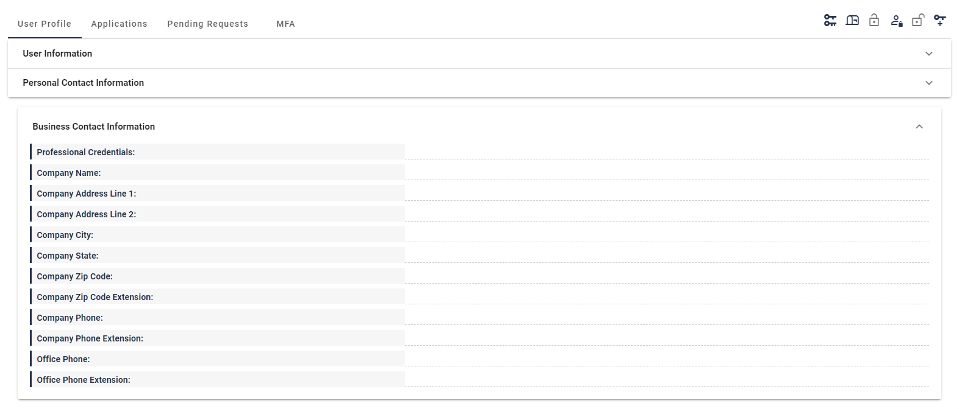
Figure 37: User Details Page Business Contact Information

View Role Request Details:

Step 1: Follow the steps in Role Request Audit to complete a valid search.

Figure 38: Role Audit Search Results

Step 2: To view the request audit details associated with a specific user, select the hyperlink ‘User ID’ within the User ID column on the left side (left arrow in Figure below) or the ‘Type’ within the Type column on the right (right arrow in Figure below).

Note: You will see a note icon next to ‘Remove’ Types that include a reason for removal (right arrow in Figure below).

Figure 39: User ID Selection Role Audit Search Results

Step 3: You will be directed to the Request Audit Details page, where you can view the details of the user’s request. Below are a couple of examples.

Note: For Tier 1 Help Desk Users, no Justification information will be displayed.

- Request Audit Details for ‘Remove’ Request Type:

Top of Details Page

  - User ID
  - Application
  - Role

Request Details

  - Requested By
  - Request ID
  - Request Status
  - Requested Date

Routing Attribute

  - Attribute
  - Value

Reason (If reason exists)

  - Reason for Removal

Note: Justification is only displayed for Tier 2 Help Desk Users

Additional Attribute

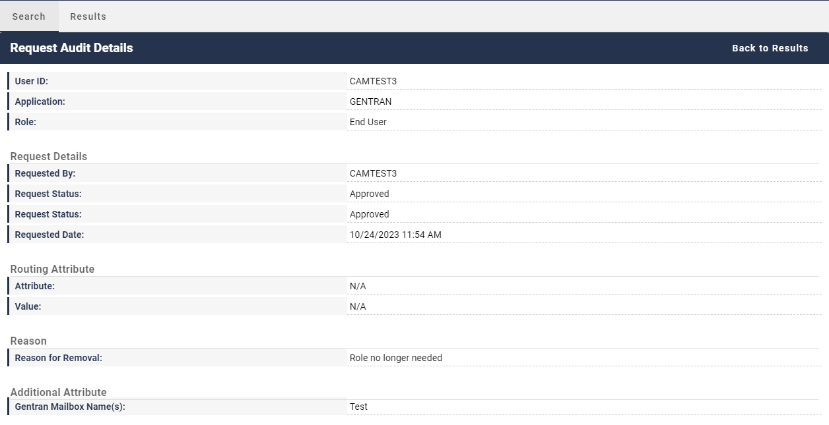
Figure 40: Request Audit Details Page ‘Remove’ Request Type Example

- Request Audit Details for ‘Add’ Request Type:

Top of Details Page

  - User ID
  - Application
  - Role

Request Details

  - Requested By
  - Request ID
  - Request Status
  - Requested Date

Routing Attribute

  - Attribute
  - Value

Additional Attribute

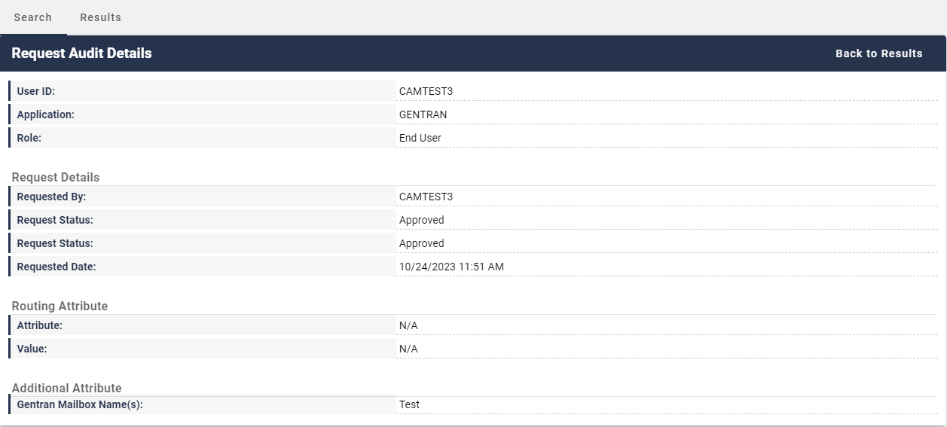
Figure 41: Request Audit Details Page ‘Add’ Request Type Example

Updating a User’s Email Address
This section describes how Help Desk users can update a user’s email address using the IDM Help Desk UI.

Step 1: Follow the steps in either the Application Search or Enterprise Search sections to complete a valid search.

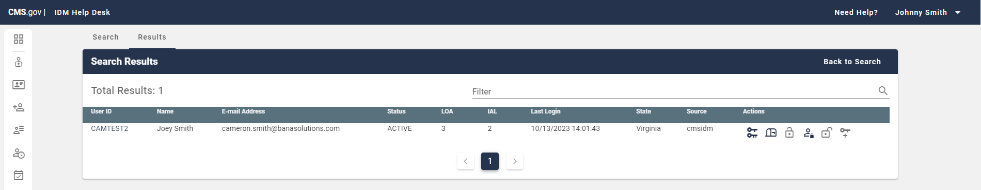
Figure 42: Valid Enterprise Search

Step 2: Select the hyperlink User ID of the user you wish to act upon within the User ID field (Left arrow in Figure below)

Note: In Enterprise search results, you can directly select the Update E-Mail Address User Action (Right arrow in Figure below). If you do this, skip to Step 4.

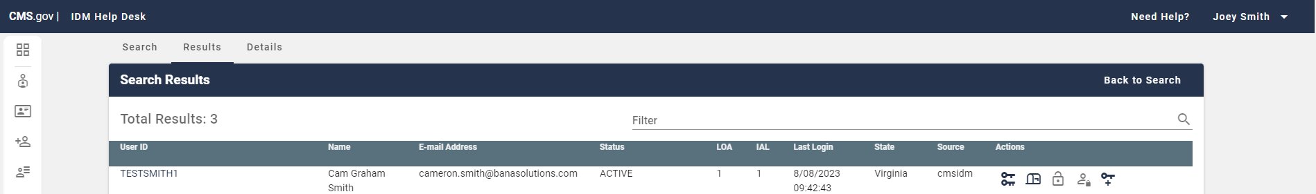
Figure 43: Enterprise Search go to User Details / Update E-Mail Address

Step 3: From the User Details page select, select the mailbox icon from the User Action menu which is located at the top right of the screen. This will allow you to update the user’s email address.

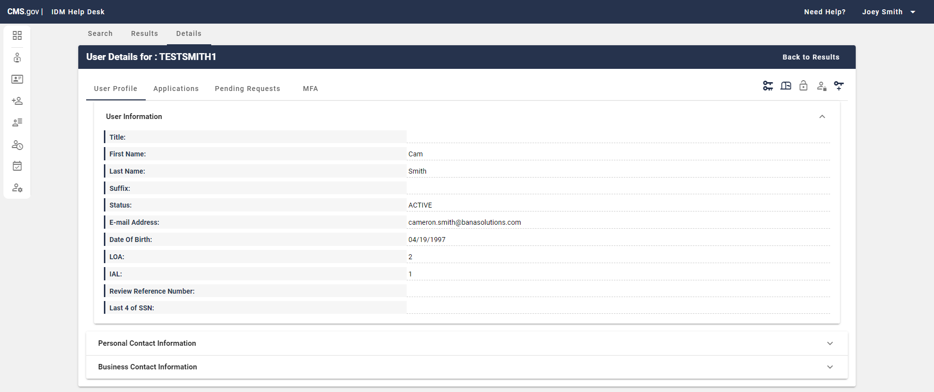
Figure 44: User Details Select Update E-Mail Address User Action

Step 4: Enter the new email address in the ‘E-mail Address’ field and a justification in the ‘Justification’ field for changing the user’s email address.

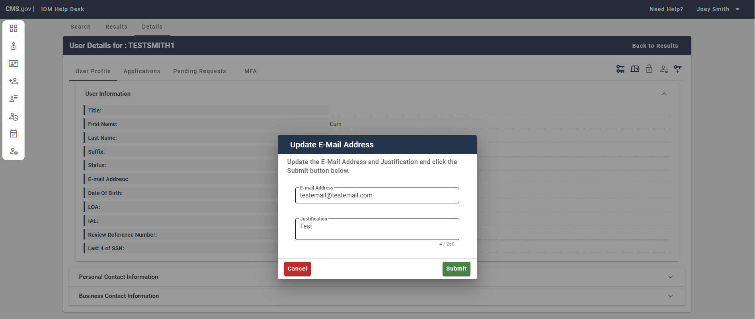
Figure 45: Enter New Email Information Update E-Mail Address Popup

Step 5: To approve the email address change, select ‘Submit’ within the Update Email popup (Right arrow in Figure below). To abandon the change, select ‘Cancel’ (Left arrow in Figure below).

Figure 46: Enter New Email Information Update E-Mail Address Popup Submit / Cancel

Step 6: If the email address change was successful, you will see a successful message appear above ‘User Information’ (First Figure below). If the change was conducted in Enterprise search results, you will see the message there above the results (Second Figure Below).

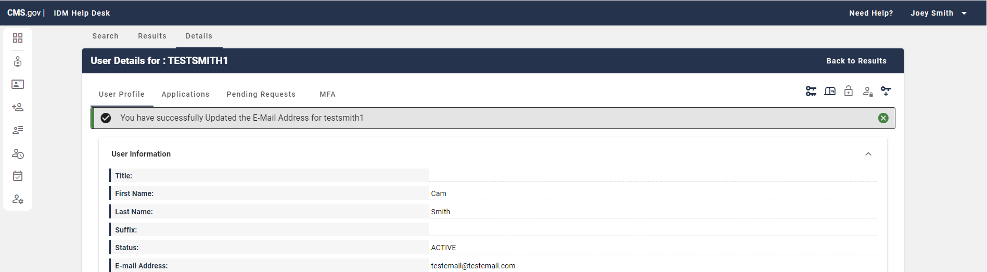
Figure 47: User Details Successful User Email Information Update

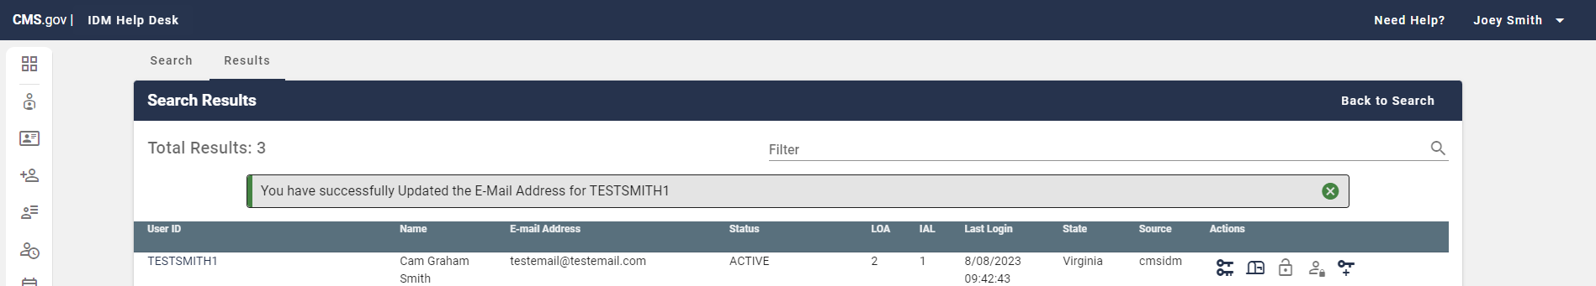
Figure 48: Enterprise Search Results Successful User Email Information Update

Updating a User’s LOA / IAL
This section describes how Help Desk users can update a user’s LOA / IAL (Level of Assurance / Identity Assurance Level) using the IDM Help Desk UI. Help Desk users can raise a user’s LOA and IAL, however they cannot lower the LOA or IAL of a user. Help Desk users can only take the action to raise the LOA or IAL of an active user; if the user’s account is suspended or locked, the Help Desk cannot raise the user’s LOA or IAL. Only applications that have implemented a manual IDP process can step up the IAL of users under their purview.

Step 1: Follow the steps in either the Application Search or Enterprise Search sections to complete a valid search.

Figure 49: Valid Enterprise Search

Step 2: Select the hyperlink User ID of the user you wish to act upon within the User ID field (Left arrow in Figure below)

Note: In Enterprise search results, you can directly select the “Update User’s LOA/IAL” User Action (Right arrow in Figure below). If you do this, skip to Step 4.

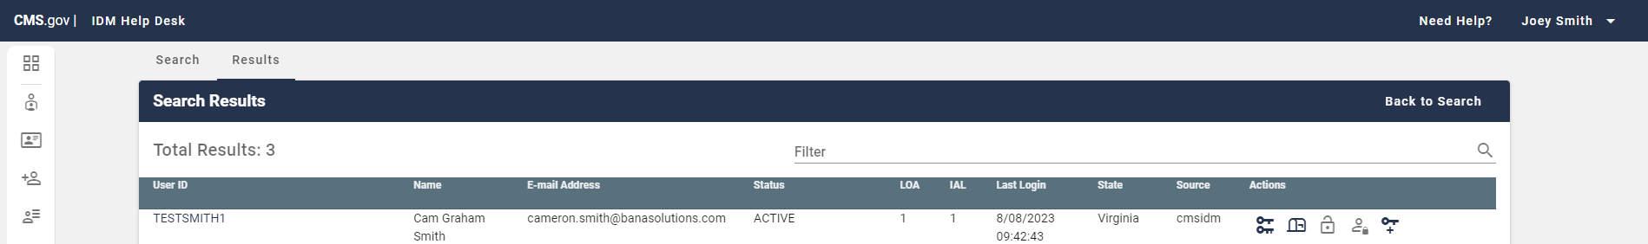
Figure 50: Enterprise Search go to User Details / Update User’s LOA/IAL

Step 3: From the User Details page select ‘Update Users LOA/IAL’.

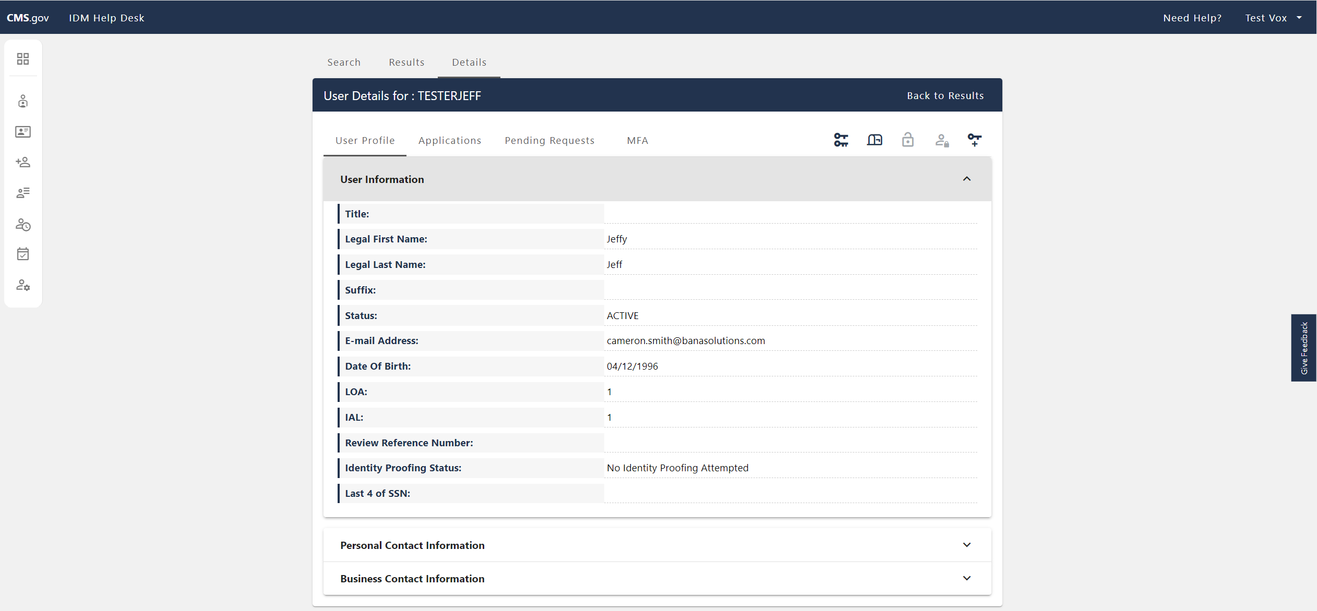
Figure 51: User Details Select Update User’s LOA/IAL User Action

Step 4: Within the Update User’s LOA/IAL page, read the disclaimer message and check the checkbox to acknowledge that you have manually verified the user’s identity.

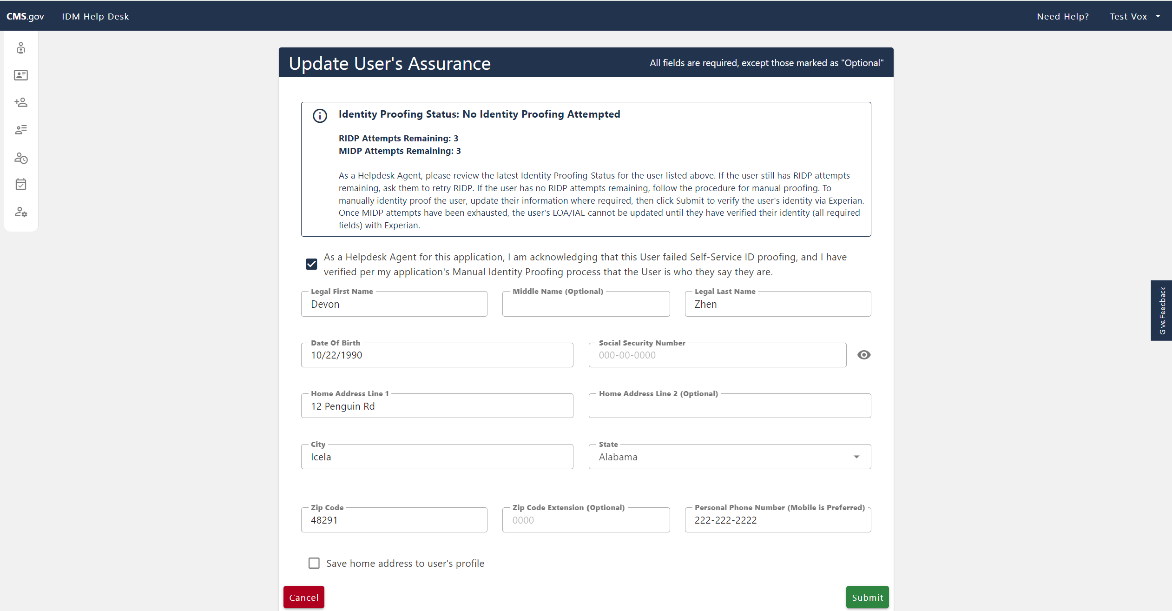
Figure 52: Acknowledging that the user’s identify has been verified

Step 5: Update the user’s information where required.

Required fields include:

- Legal First Name
- Legal Last Name
- Date of Birth
- Social Security Number
- Home Address Line 1
- City
- State
- Personal Phone Number

When choosing a state, if Commonwealth of Puerto Rico is chosen, a pop-up modal will appear, showing the address formatting tips (First Figure below). To access the information again, a clickable blue text below the dropdown will appear which can be opened (Second Figure below).

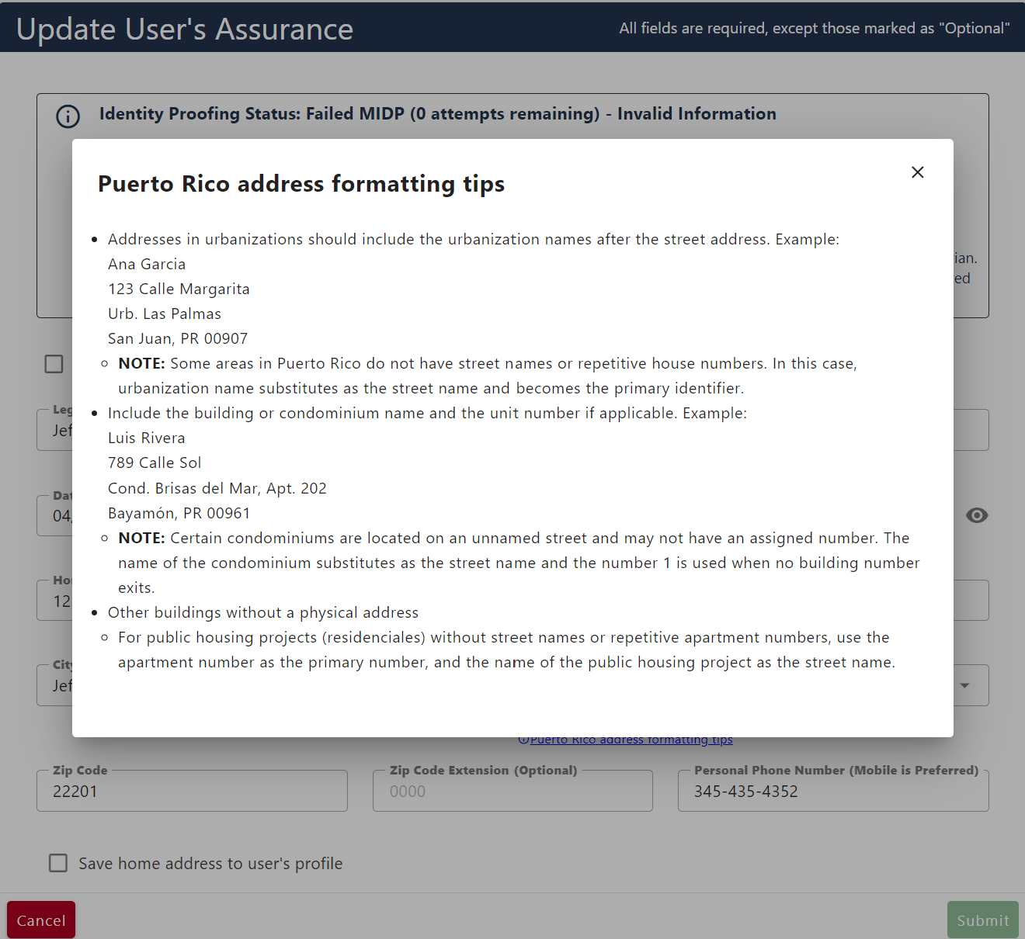
Figure 53: LOA/IAL Puerto Rico Address Formatting Tips Pop-Up Modal
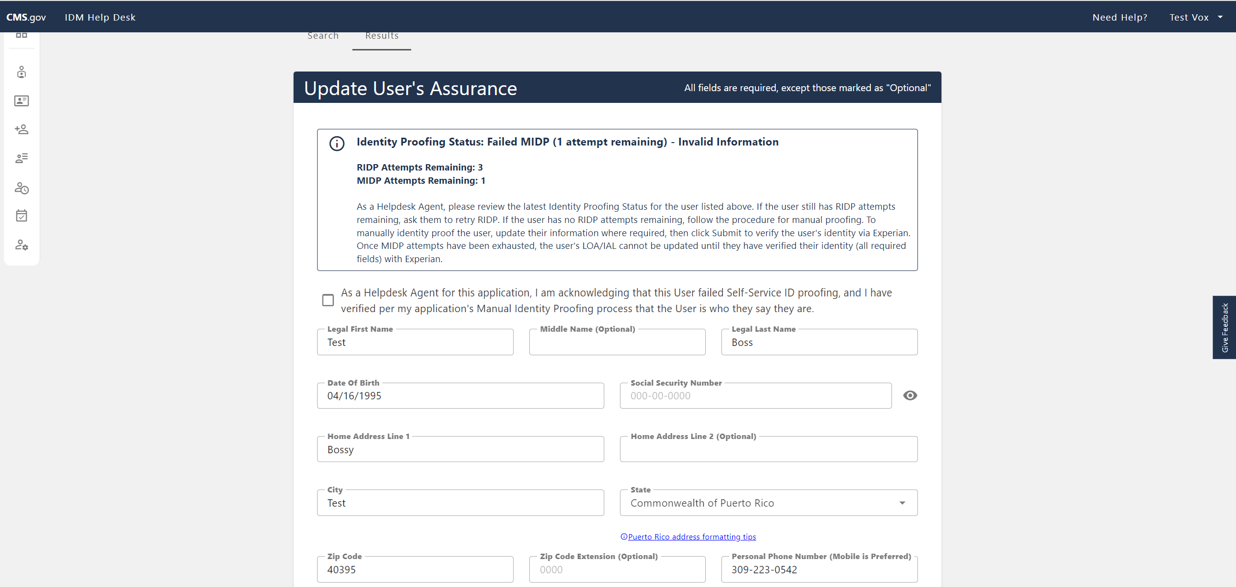
Figure 54: LOA/IAL Puerto Rico Address Formatting Tips Link

Step 6: To conduct the LOA/IAL update, select ‘Submit’ (Right arrow in Figure below) within the Update User’s LOA/IAL page. To abandon the change, select ‘Cancel’ (Left arrow in Figure below). If the result was successful, proceed to Step 7, if not, proceed to Step 8.

Figure 55: LOA/IAL Update Cancel/Submit

Step 7: If the LOA/IAL update was successful, you will see a successful message appear.

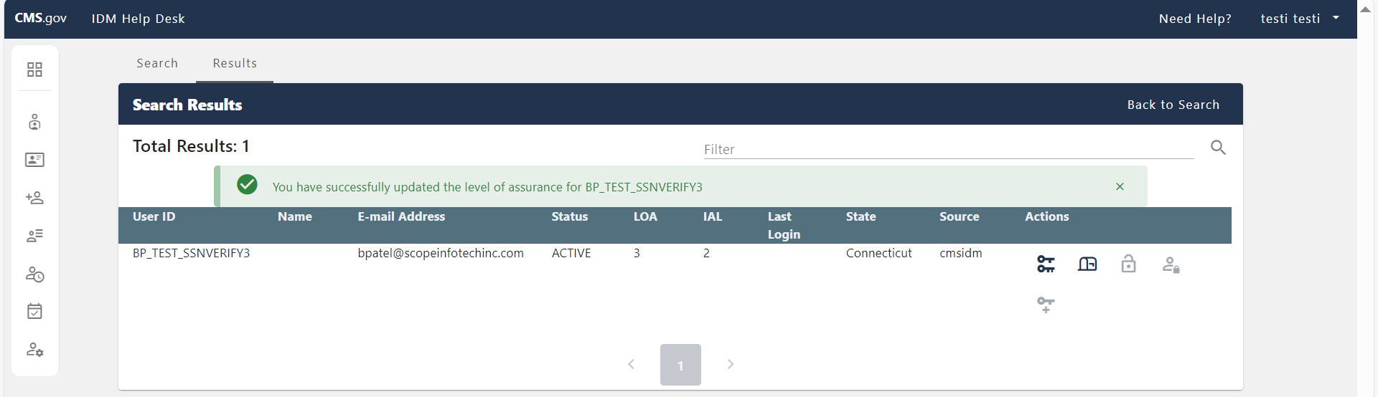
Figure 56: Enterprise Search Results Successful User LOA/IAL Update

Step 8: If the LOA/IAL update was unsuccessful, an updated error message (Top arrow in Figure below) and info box (Bottom arrow in Figure below) will appear above ‘User Information’ based on the current proofing status. The count for attempts in the error message will have decreased by one, as well as the count for 'MIDP Attempts Remaining' in the info box.

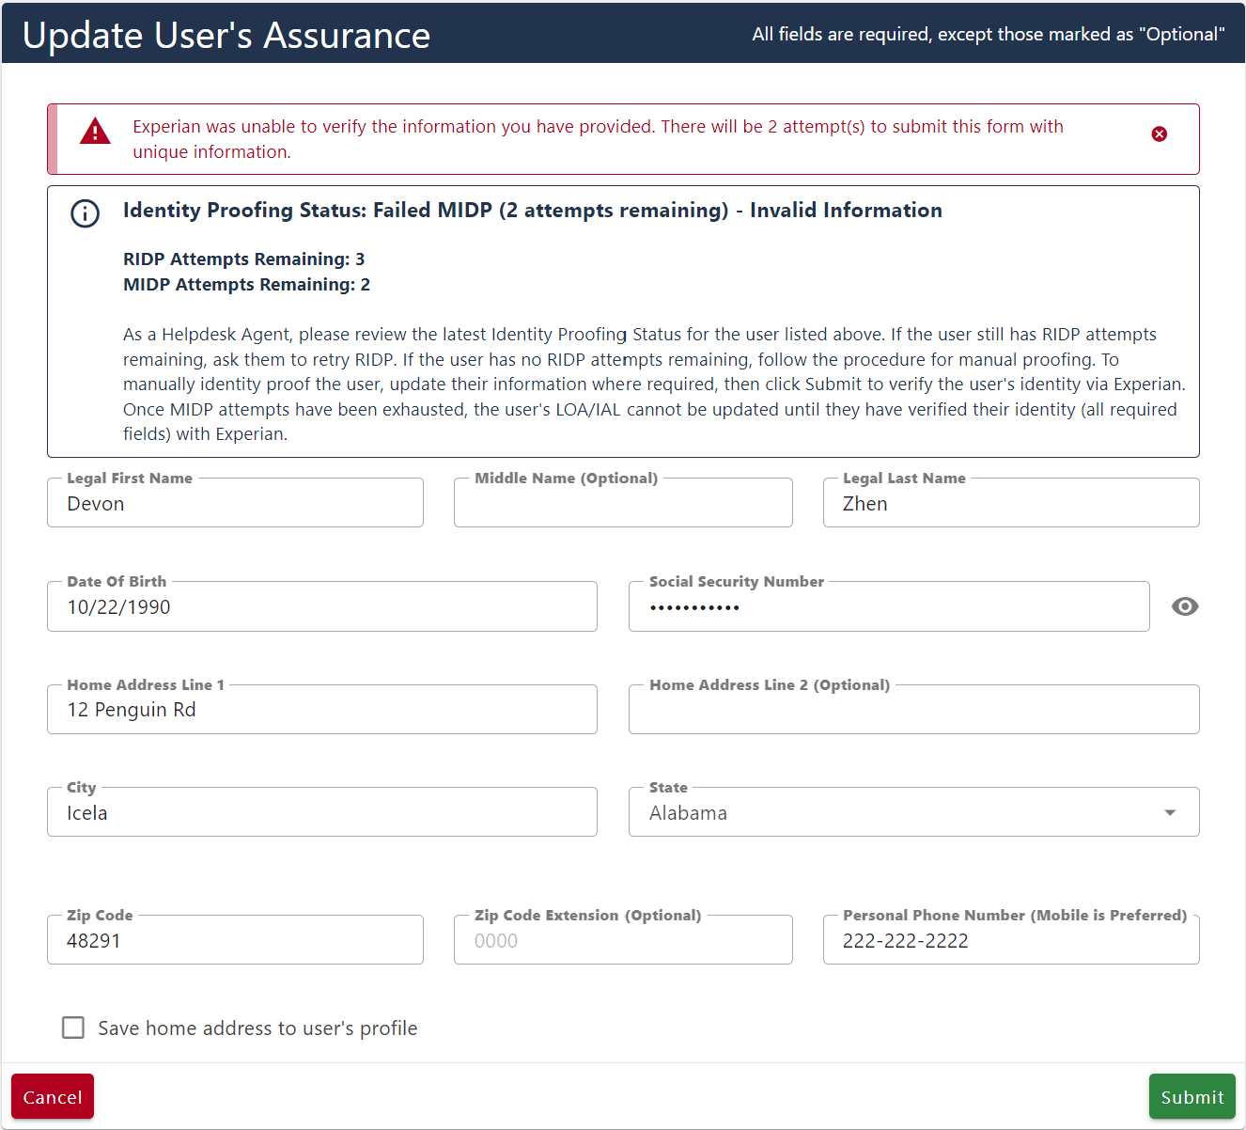
Figure 57: First LOA/IAL Update Failure Error Message

There are three total attempts allowed to update a user’s LOA/IAL. The count returned under ‘MIDP Attempts Remaining’ in the info box seen below will decrease following a failed attempt, as well as in subsequent error messages that appear above this info box upon the failure (First Figure below). The same information is not allowed to be entered twice (Second Figure Below).

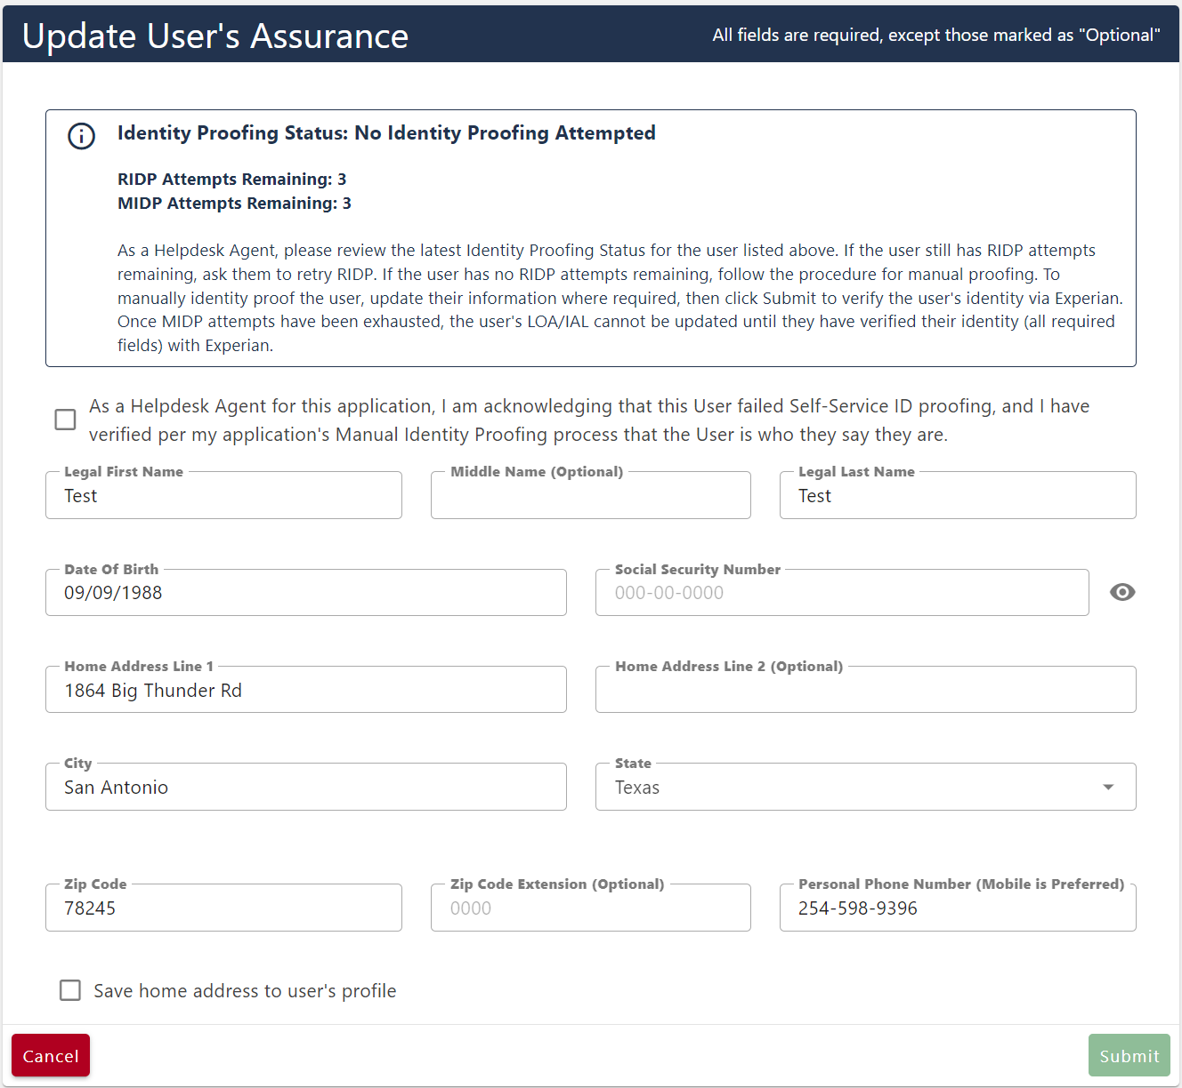
Figure 58: Initial Proofing Status with 3 Attempts

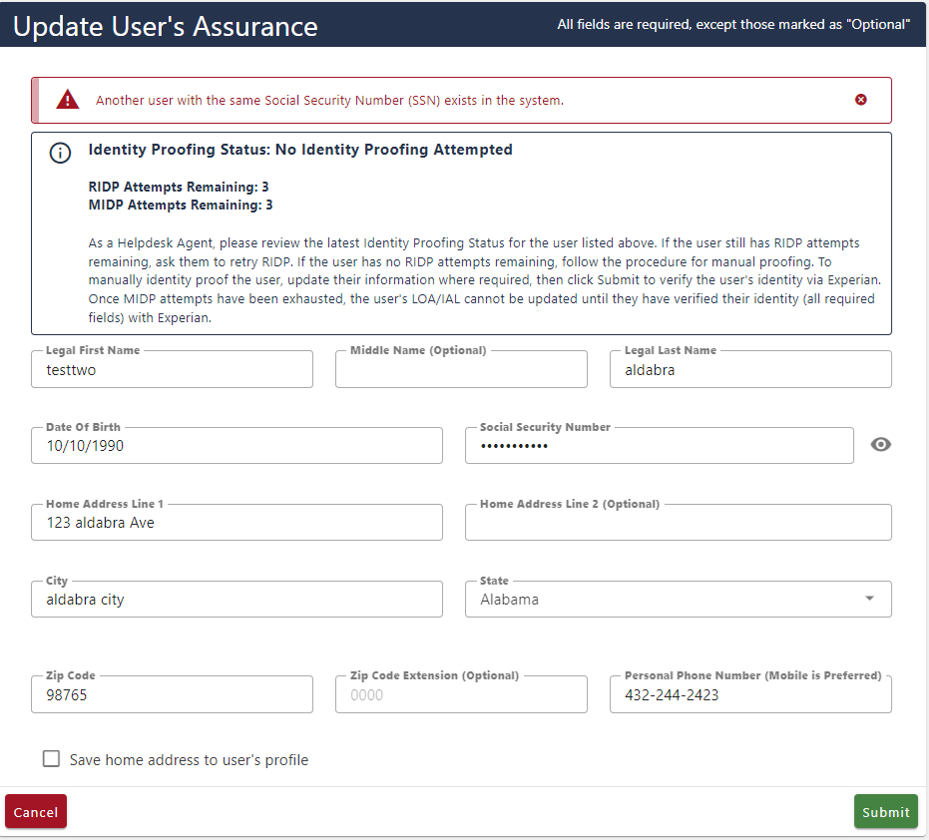
Figure 59: Duplicate Submitted Information Error Message

If the provided information does not pass after three attempts, the error message will provide a link for the user to file a dispute with Experian (First arrow in Figure below). This link should be utilized in the case that there is a discrepancy with the information that Experian has on file. The submit button will become disabled (Second arrow in Figure below).

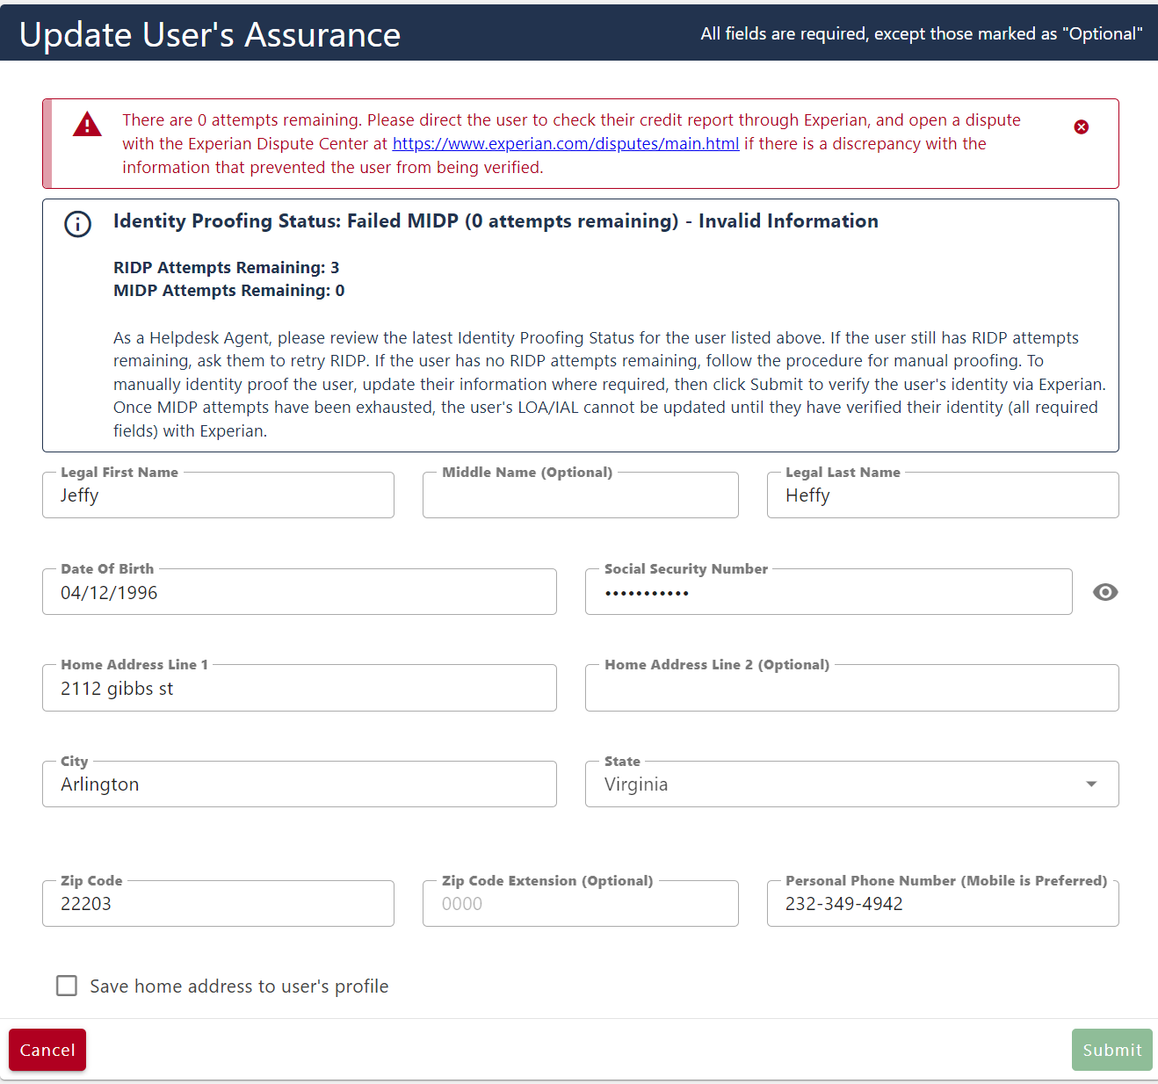
Figure 60: Final LOA/IAL Update Failure Error Message

Suspending a User
This section describes how Tier 1 Help Desk users can suspend a user using the IDM Help Desk UI. Tier 1 Help Desk Users can only suspend a user who has roles in their application. End users in IDM are suspended when they violate the system’s user agreement. Examples of user agreement violations include users sharing their account with another individual, using screen scraping software, and cases where the user’s identity has been stolen and their account may be accessed fraudulently. In such cases, the users’ approver, or the business owner of the application will request that the user’s account be suspended. A Tier 1 helpdesk user can also detect violations and suspend users without the business owner’s request. A user can only be unsuspended by a Tier 2 Help Desk User when the reason for suspension has been addressed and the application’s business owner has provided confirmation to the IDM Tier 2 Help Desk that the user should be unsuspended.

Step 1: Follow the steps in either the Application Search or Enterprise Search sections to complete a valid search.

Note: In search results, you may have to select the ‘Get User Status’ hyperlink under the ‘Status’ column to see the user’s status.

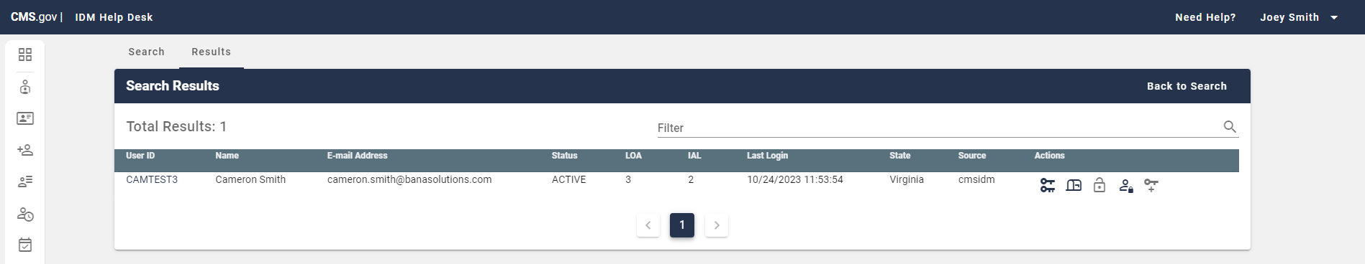
Figure 61: Valid Enterprise Search

Step 2: Select the hyperlink User ID of the user you wish to act upon within the User ID field (Left arrow in Figure below)

Note: In Enterprise search results, you can directly select the “Suspend Account” User Action (Right arrow in Figure below). If you do this, skip to Step 4.

Figure 62: Enterprise Search go to User Details / Suspend Account

Step 3: From the User Details page select ‘Suspend Account’.

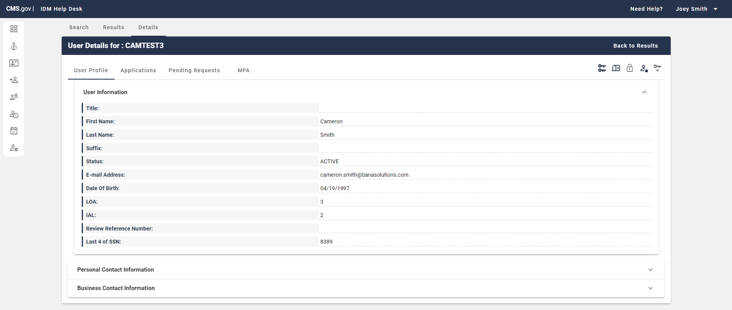
Figure 63: User Details Select ‘Suspend Account’ User Action

Step 4: From the Suspend User page, select the checkbox (Top arrow in Figure below) confirming you would like to suspend the user and enter a justification for suspending the user in the ‘Justification’ field (Bottom arrow in Figure Below).

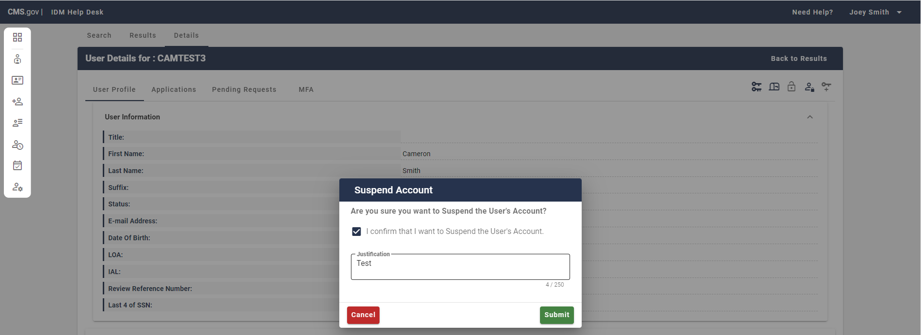
Figure 64: Checkbox and Justification Suspend Account Popup

Step 6: To conduct the user’s suspension, select ‘Submit’ (Right arrow in Figure below) within the Suspend Account popup. To abandon the request to suspend the user’s account select ‘Cancel’ (Left arrow in the Figure Below).

Figure 65: Suspend Account Popup Submit / Cancel

Step 7: If the suspension was successful, you will see a successful message appear above ‘User Information’ (First Figure below). If the change was conducted in Enterprise search results, you will see the message there above the results (Second Figure Below).

Note: In search results, you may have to select the ‘Get User Status’ hyperlink under the ‘Status’ column the user’s status.

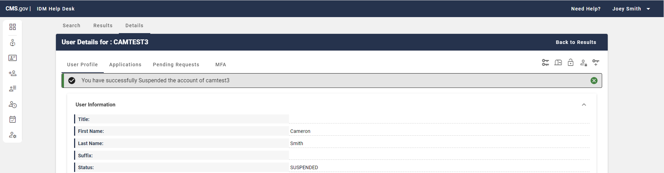
Figure 66: User Details Successful User Suspension

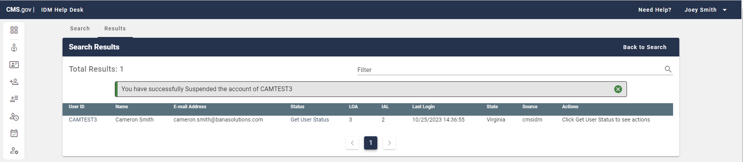
Figure 67: Search Results Successful User Suspension

Unlock Account
A user’s account can be locked due to inactivity, three failed password attempts by the user during login, or five failed attempts at MFA authentication. MFA authentication max attempts failure results in a one-hour lockout.

This section describes how Help Desk users can unlock the account of a user whose account has been locked using the IDM Help Desk UI.

An account lock can occur due to three failed password attempts by the user during login or five failed attempts at MFA authentication. MFA authentication max attempts failure results in a one-hour lockout.

Step 1: Follow the steps in either the Application Search or Enterprise Search sections to complete a valid search. Within a successful search result, you will see the user’s status is “LOCKED_OUT”.

Note: In search results, you may have to select the ‘Get User Status’ hyperlink under the ‘Status’ column to see the user’s status.

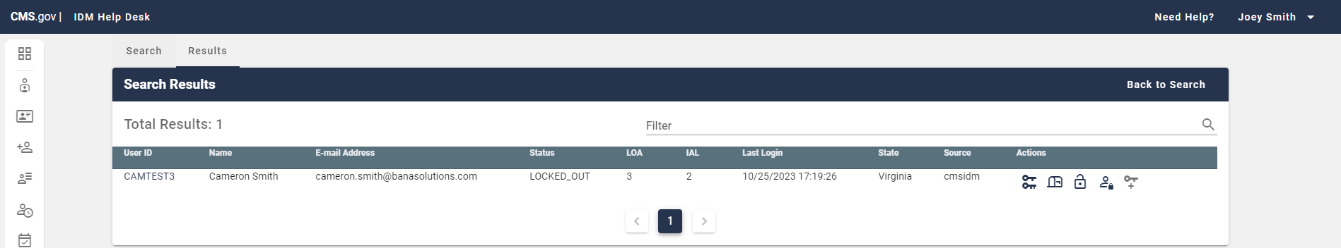
Figure 68: Valid Enterprise Search Status LOCKED_OUT

Step 2: Select the hyperlink User ID of the user you wish to act upon within the User ID field (Left arrow in Figure below)

Note: In Enterprise search results, you can directly select the “Unlock Account” User Action (Right arrow in Figure below). If you do this, skip to Step 4.

Figure 69: Enterprise Search go to User Details / Unlock Account

Step 3: From the User Details page select ‘Unlock Account’.

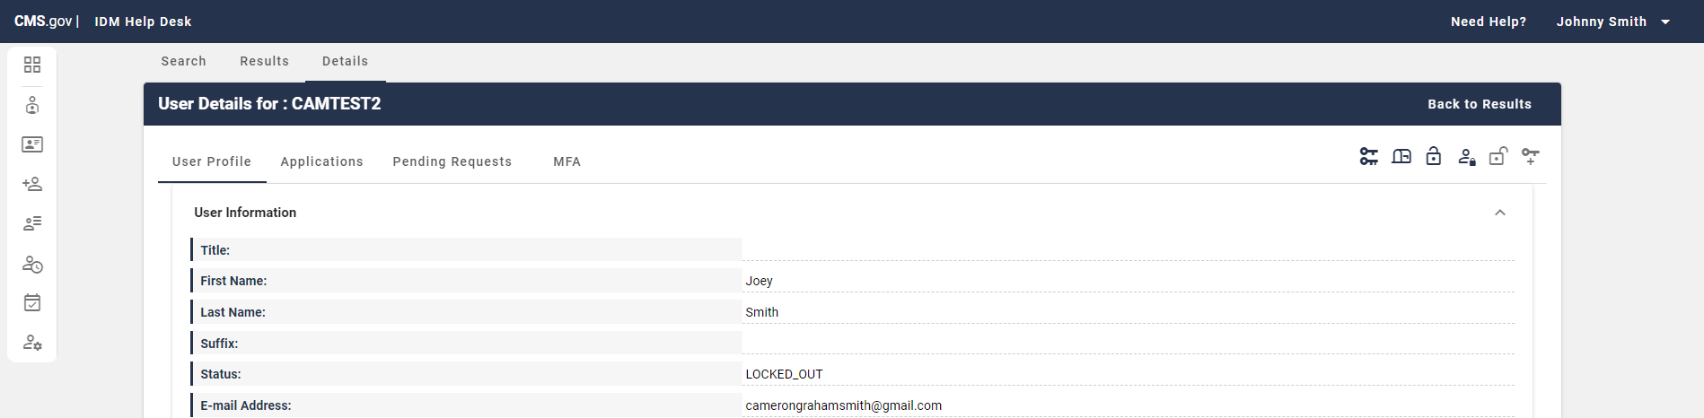
Figure 70: User Profile Select Unlock Account

Step 4: From the Unlock Account popup enter a justification for unlocking the account in the ‘Justification’ field.

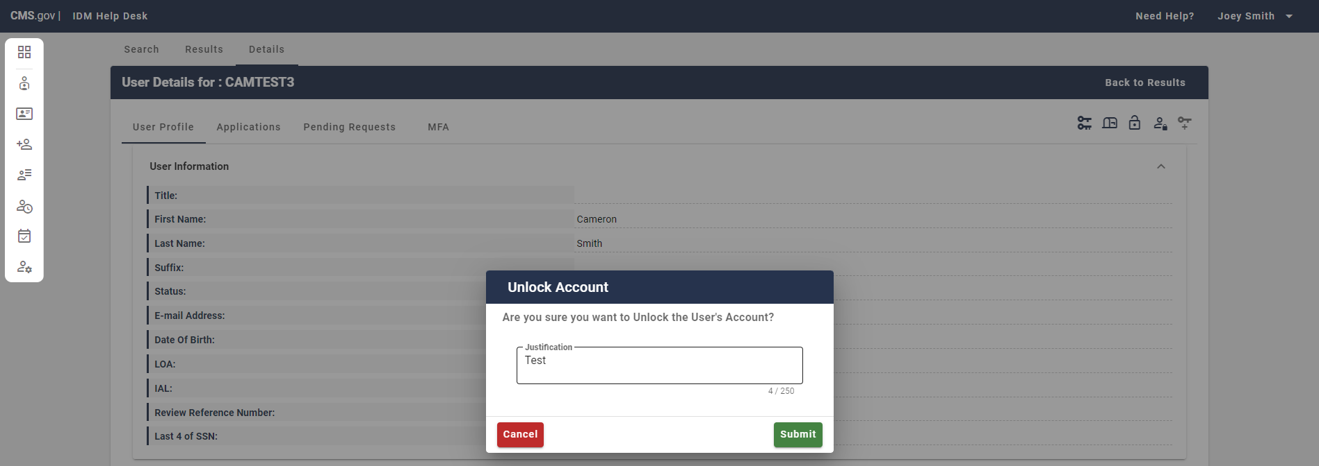
Figure 71: User Details Unlock Account Popup Justification Field

Step 5: To approve the unlocking of the user’s account, select ‘Submit’ within the Unlock Account popup (Right arrow in figure below). To abandon the request to suspend the user’s account select ‘Cancel’ (Left arrow in Figure below).

Figure 72: Unlock Account Popup Cancel / Submit
Step 6: If the account unlock was successful, you will see a successful message appear above ‘User Information’ (First Figure below). If the change was conducted in Enterprise search results, you will see the message there above the results (Second Figure Below). The user’s status should now show as ‘Active’ in search results and on the User Details page.

Note: In search results, you may have to select the ‘Get User Status’ hyperlink under the ‘Status’ column to see the user’s status.

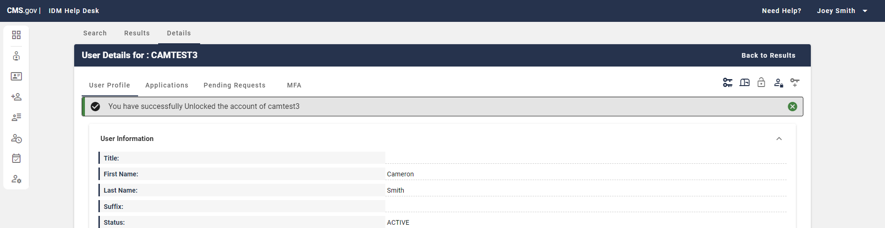
Figure 73: User Details Successful User Account Unlock

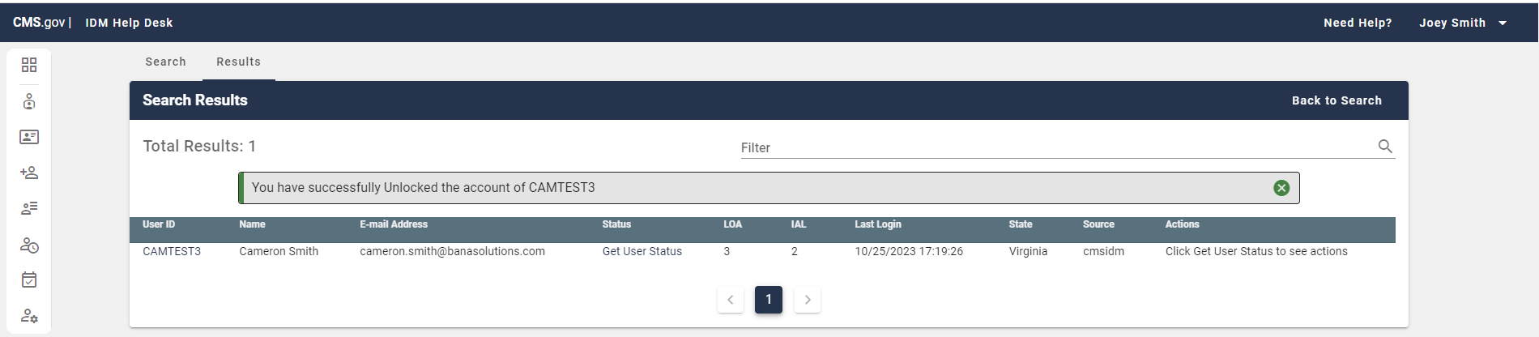
Figure 74: Search Results Successful User Account Unlock

Password Reset
This section provides information related to resetting a user’s password using the IDM Help Desk UI. In IDM, Tier 1 Help Desk users can assist users with a password reset in two ways:

- Via Email: A link is emailed to users which allows them to reset their password.
- Manually: The Help Desk user will generate and share a temporary password with the user over the phone. The user will use the temporary password to login to the system, and upon login, will be required to reset their password.

Password Reset via Email
Step 1: Follow the steps in either the Application Search or Enterprise Search sections to complete a valid search.

Step 2: Select the hyperlink User ID of the user you wish to act upon within the User ID field (Left arrow in Figure below)

Note: In Enterprise search results, you can directly select the “Reset Password” User Action (Right arrow in Figure below). If you do this, skip to Step 4.

Figure 75: Enterprise Search go to User Details / Reset Password

Step 3: From the User Details page select ‘Reset Password’.

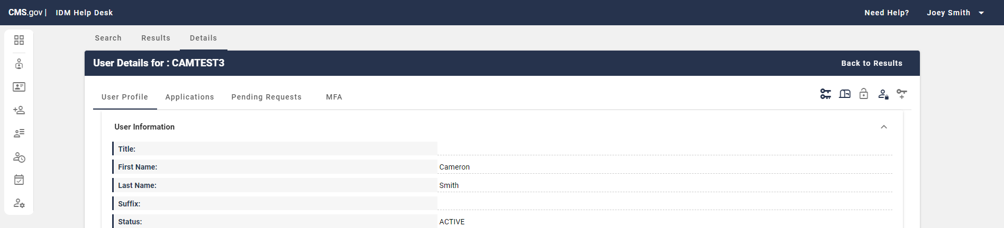
Figure 76: User Profile Select Password Reset

Step 4: Using the radio buttons, select ‘E-mail a Password Reset Link to the User’ (Top arrow in Figure below) and enter a justification in the ‘Justification’ field (Bottom arrow in Figure below).

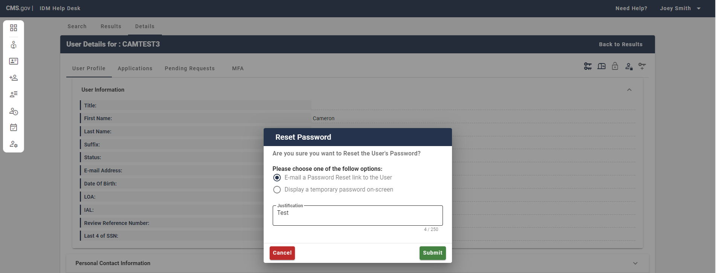
Figure 77: Radio Button Options and Justification Reset Password Popup

Step 5: To E-Mail a password reset link to the user, select ‘Submit’ within the Reset Password popup (Right arrow in figure below). To abandon the request to E-Mail a password reset link to the user, select ‘Cancel’ (Left arrow in Figure below).

Figure 78: Reset Password Popup Cancel / Submit

Step 6: The user will receive a system generated email with a link to reset their password. Ther should then select the ‘Reset Password’ link.

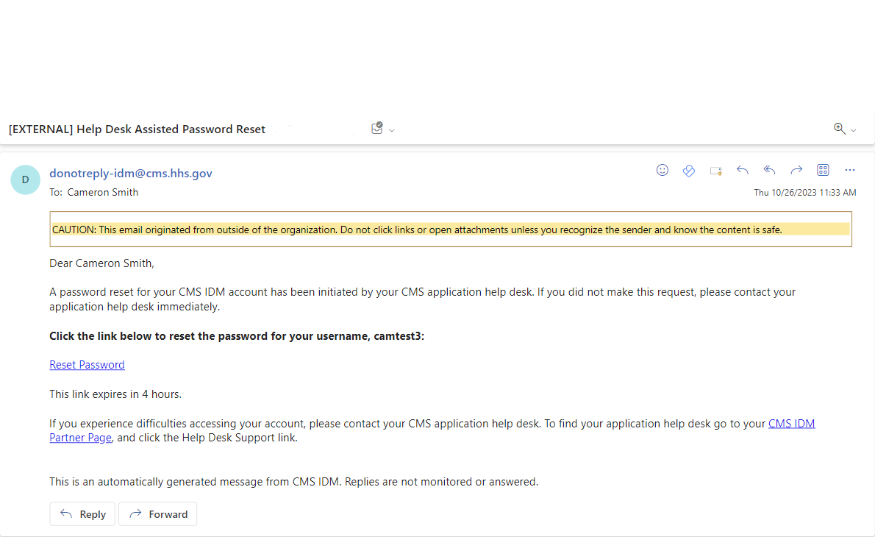
Figure 79: System Generated Password Reset Email

Step 7: The user must enter their Security question answer (Top arrow in Figure below), then select ‘Reset Password’ (Bottom arrow in Figure Below).


Figure 80: Password Reset UI - SQA Prompt

Step 8: The user will then be prompted to enter a new password in the ‘New Password’ field (Top arrow in Figure Below) and confirm the new password in the ‘Confirm Password’ field (Bottom arrow in Figure Below). Once the new password has been created and confirmed in the provided fields select ‘Reset Password’.

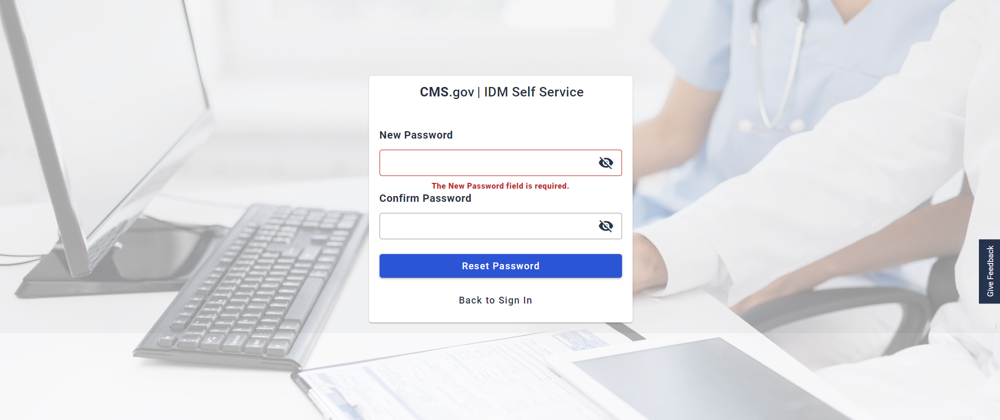
Figure 81: Password Reset UI - New Password
Step 9: The user will see a success popup that they have successfully changed their password and can select ‘Back to Sign in’ to sign in once again with the new password.


Figure 79: Password Reset UI – Back to Sign In

Manual Password Reset

The Help Desk user is responsible for authenticating the user over the phone prior to generating a temporary password.

Step 1: Follow the steps in either the Application Search or Enterprise Search sections to complete a valid search.

Step 2: Select the hyperlink User ID of the user you wish to act upon within the User ID field (Left arrow in Figure below)

Note: In Enterprise search results, you can directly select the “Reset Password” User Action (Right arrow in Figure below). If you do this, skip to Step 4.

Figure 82: Enterprise Search go to User Details / Reset Password

Step 3: From the User Details page select ‘Reset Password’.
Figure 83: User Profile Select Password Reset

Step 4: Using the radio buttons, select ‘Display a temporary password on-screen’ (Top arrow in Figure below) and enter a justification in the ‘Justification’ field (Bottom arrow in Figure below).
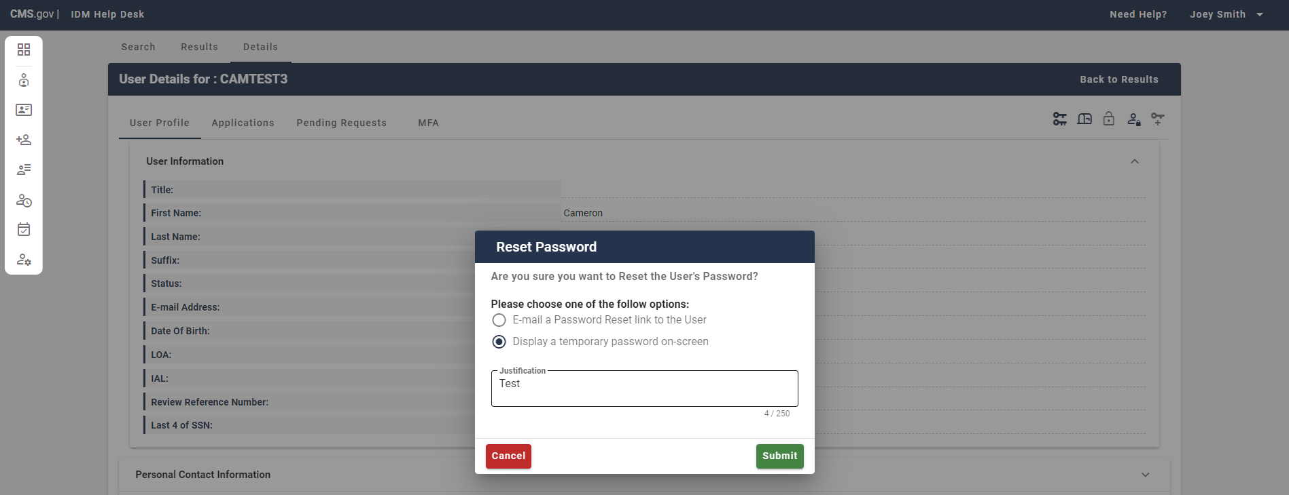
Figure 84: Radio Button Options and Justification Reset Password Popup

Step 5: The Help Desk user is responsible for authenticating the user over the phone prior to generating a temporary password. To display a temporary password on-screen, select ‘Submit’ within the Reset Password popup (Right arrow in figure below). To abandon the request to display a temporary password on-screen, select ‘Cancel’ (Left arrow in Figure below).

Figure 83: Reset Password Popup Cancel / Submit

Step 6: A system generated password displays to the Help Desk user. They can communicate this temporary password to the user after authenticating them over the phone.

Note: As soon as the Help Desk user closes the popup with the temporary password on it, the password is unrecoverable, and the process would need to be repeated. Suggest to Help Desk users to keep this popup intact until they have successfully logged in and changed their password in IDM.

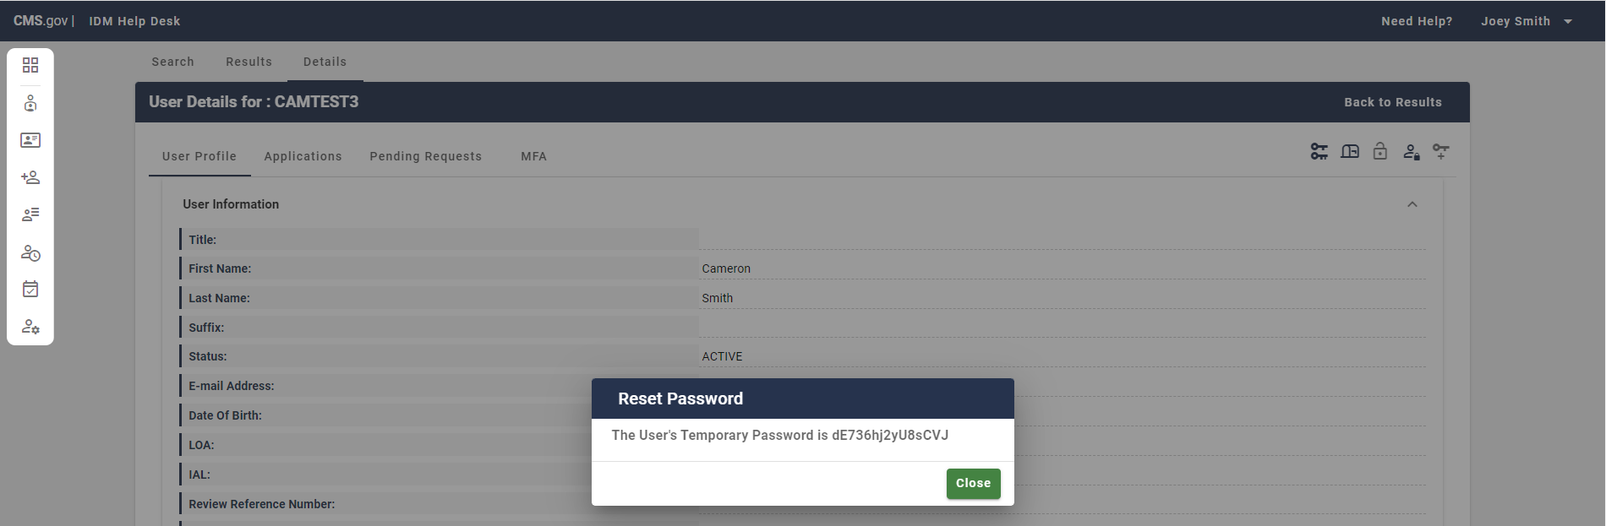
Figure 85: Reset Password Popup Temporary Password

Step 7: Upon their next login with the temporary password, the user will be required to change their password. They should enter the new password in the ‘New password’ field (First arrow in Figure below), and the new password again in the and ‘Re-enter password’ field (Second arrow in Figure below). Once done correctly the user will be logged in with their new password.

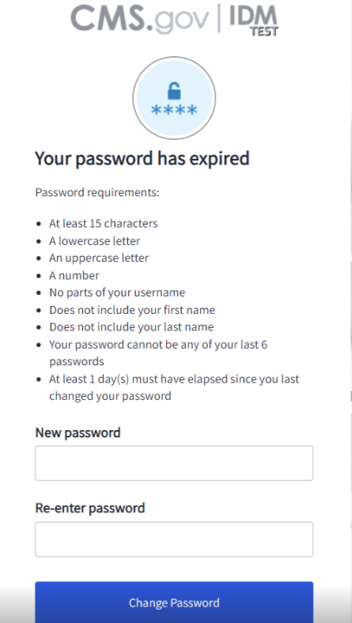
Figure 86: Login Reset Password UI

View / Remove Multi-Factor Authentication (MFA) Devices
This section describes how Help Desk users can view the MFA devices associated with a user’s account. In IDM Email is the default MFA device for all users required to login using MFA. End users can add other MFA factors to their account at any time through ‘My Profile’.

Step 1: Follow the steps in either the Application Search or Enterprise Search sections to complete a valid search.

Step 2: Select the hyperlink User ID of the user you wish to act upon within the User ID field.

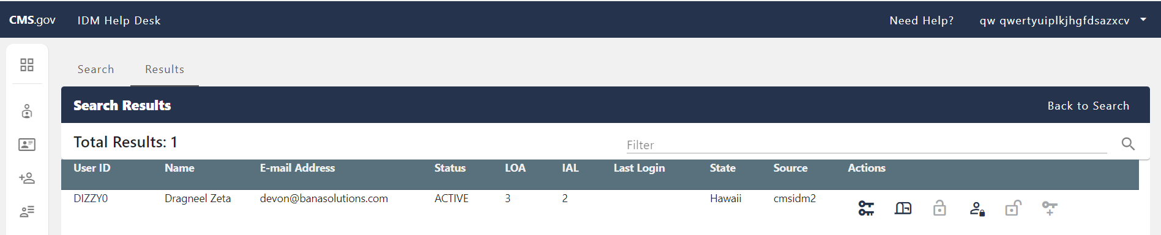
Figure 87: Enterprise Search go to User Details

Step 3: From the User Details page select ‘MFA’.

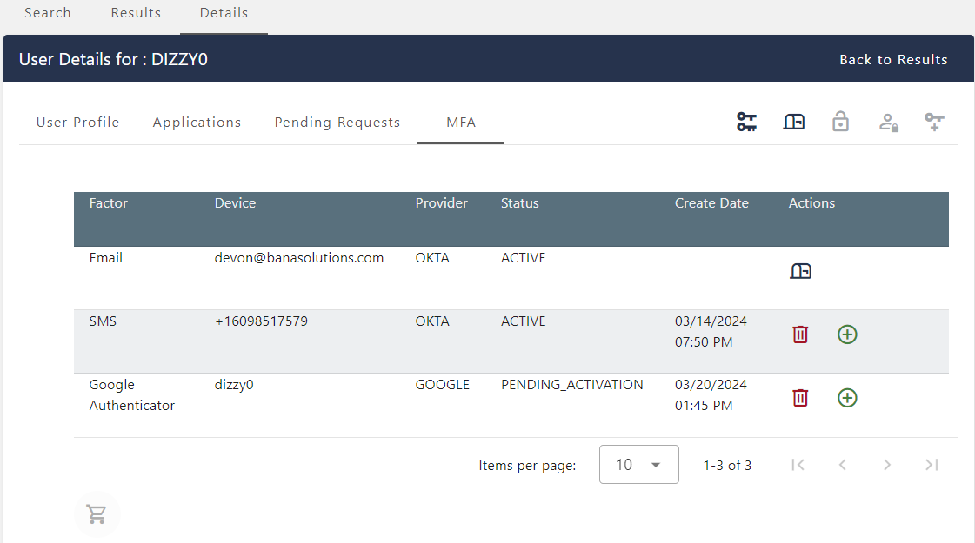
Figure 88: User Details Select MFA
Step 4: The Tier 1 Help Desk user can view and remove one or multiple MFA Factors by selecting the trash icon in the Action column (Bottom Arrow in Figure Below).
Please note that Tier 1 Help Desk users cannot remove email as an MFA device. Help Desk users can update the user’s e-mail address. To update the user’s e-mail address, the Help Desk user will select the mailbox icon in the Action column (Top Arrow in Figure Below). The Help Desk user must provide a justification when updating a user’s email address.

Figure 89: User Details MFA – ‘Remove Factor’ and ‘Update E-Mail Address’ Actions

Additionally, the Tier 1 Help Desk user can use the ‘Add to Cart’ action (Right Arrow in Figure Below) to add MFA factors for removal and the ‘Remove’ action (Available once items added to cart - Left arrow in Figure below) to remove items in the cart.

Figure 90: User Details MFA – ‘Add to Cart’ and ‘Process Requests’ Actions

Once added to the cart, Items can be removed from the cart using the ‘Remove from Cart’ action.

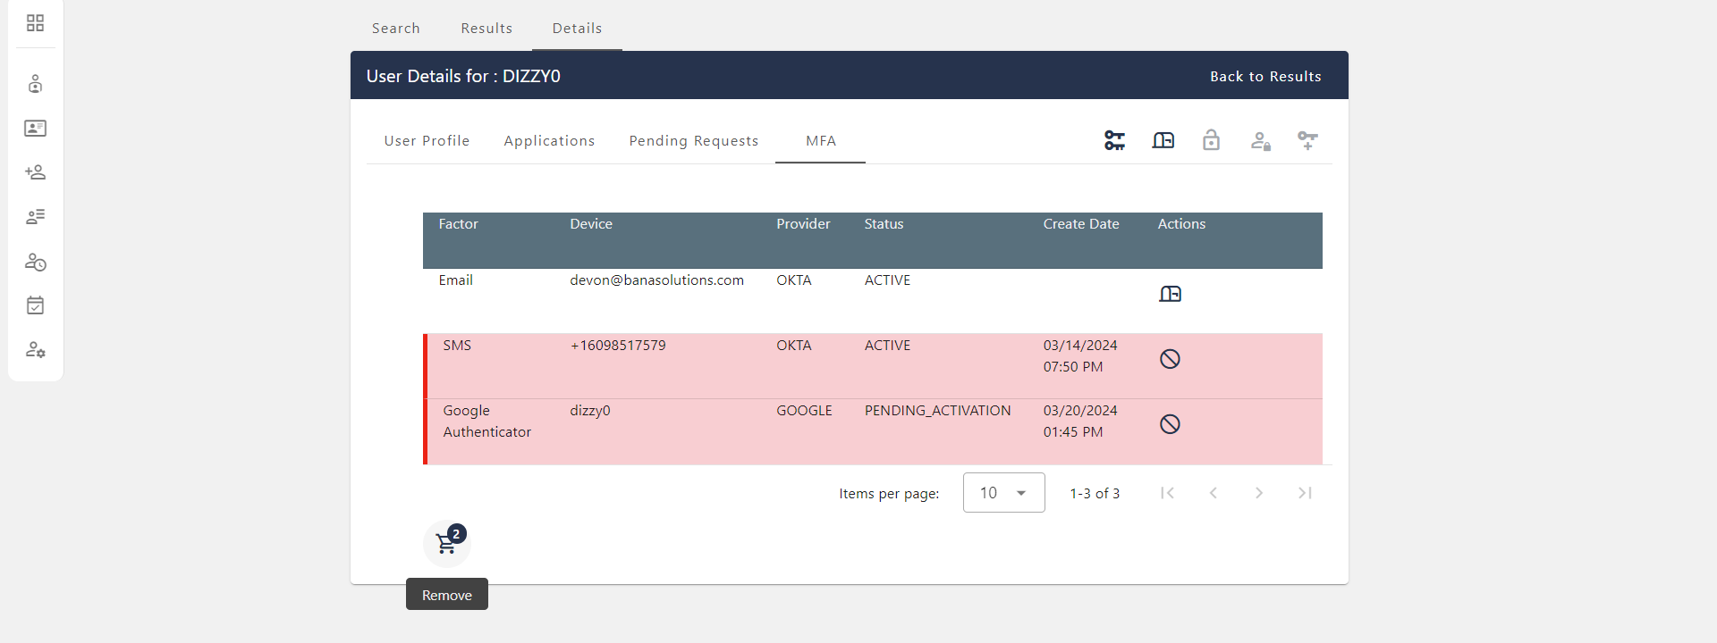
Figure 91: User Details MFA – ‘Remove from Cart’ Action

Step 5: In all removals for MFA Factors, a justification must be provided in the ‘Remove MFA Device(s)’ popup.

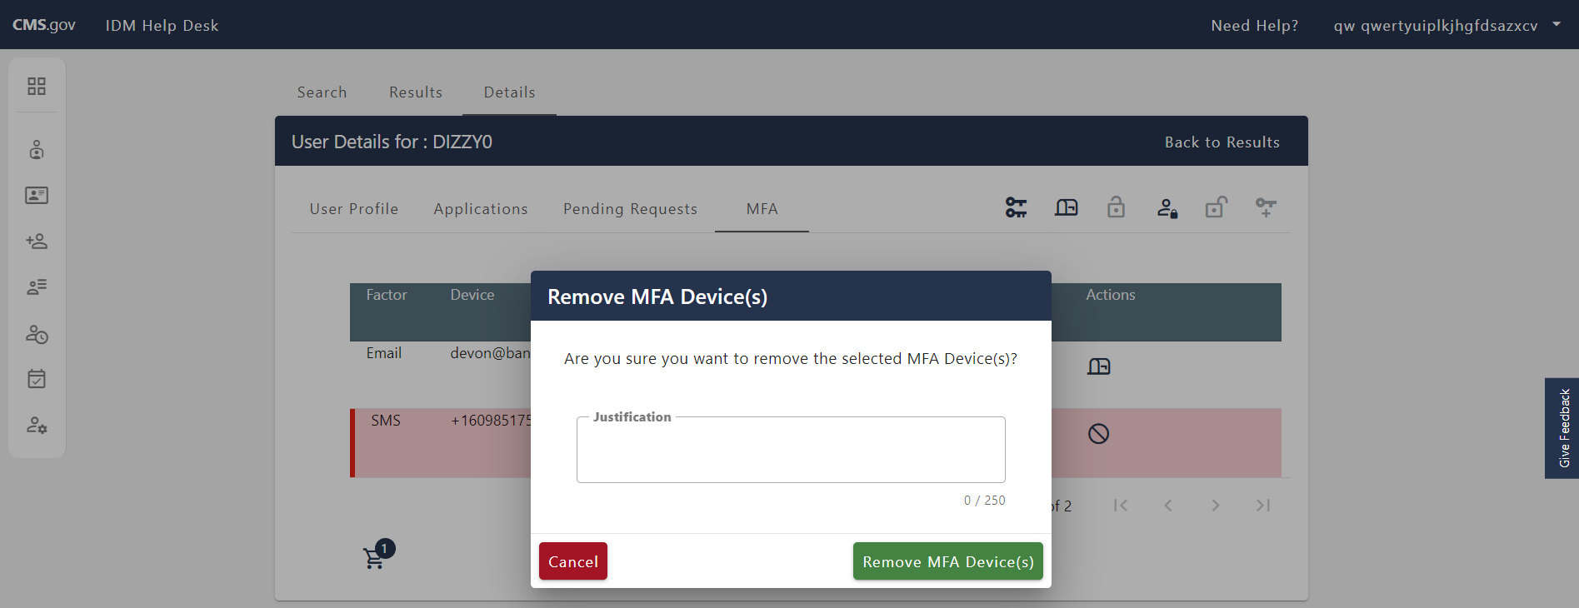
Figure 92: User Details MFA – Remove MFA Device(s) Popup Justification

Step 6: To remove the selected MFA Factors from the user’s account after entering a justification, select ‘Remove MFA Device(s)’ within the Remove MFA Device(s) popup (Right arrow in figure below). To abandon the request to remove these MFA Factors from the user’s account, select ‘Cancel’ (Left arrow in Figure below).

Note: This popup may be labeled as ‘Remove MFA Device’ when removing just one MFA factor from the user’s account.

Figure 93: User Details MFA – Remove MFA Device(s) Popup Cancel / Remove MFA Device(s)

Step 7: If the MFA Factor Removal on the user’s account was successful, you will see a successful message appear at the top of the MFA page.

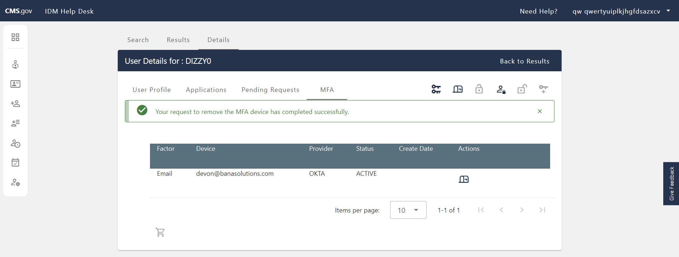
Figure 94: User Details Successful MFA Device Removal

View / Remove Application Roles
This section describes how Tier 1 Help Desk users can remove roles and attributes for a user’s profile in IDM within their applications.

Note: Only Tier 1 Help Desk users with the ‘Remove Role’ capability can remove a role or attribute and will see the action icons for removal.

Step 1: Follow the steps in either the Application Search or Enterprise Search sections to complete a valid search.

Step 2: Select the hyperlink User ID of the user you wish to act upon within the User ID field.

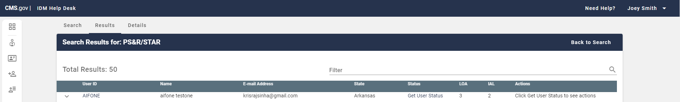
Figure 95: Enterprise Search go to User Details

Step 3: From the User Details page select ‘Applications’.

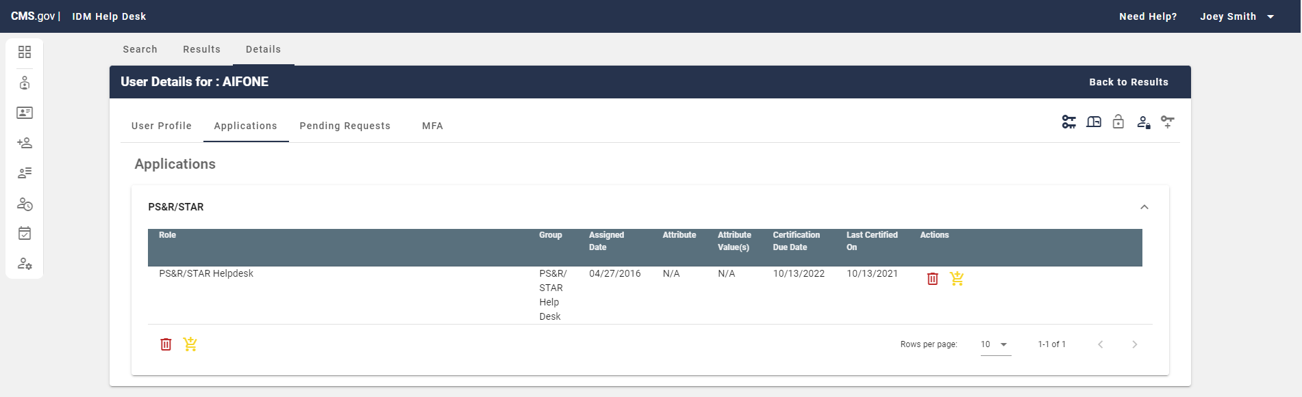
Figure 96: User Details Select Applications

Step 4: Tier 1 Help Desk with ‘Remove Role’ capability can remove roles and attributes within their applications by using the actions ‘Remove Now’ (Left arrow in Figure below) and ‘Add to Remove Cart’ (Right arrow in Figure below).

Figure 97: User Details Applications – ‘Remove Now’ and ‘Add to Remove Cart’ Actions

Once an item is added to the cart, it can be removed with the ‘Remove from Cart’ (Left arrow in Figure below) action and an additional ‘Remove Now’ action will appear in the top right of the Applications page (Right arrow in Figure below).

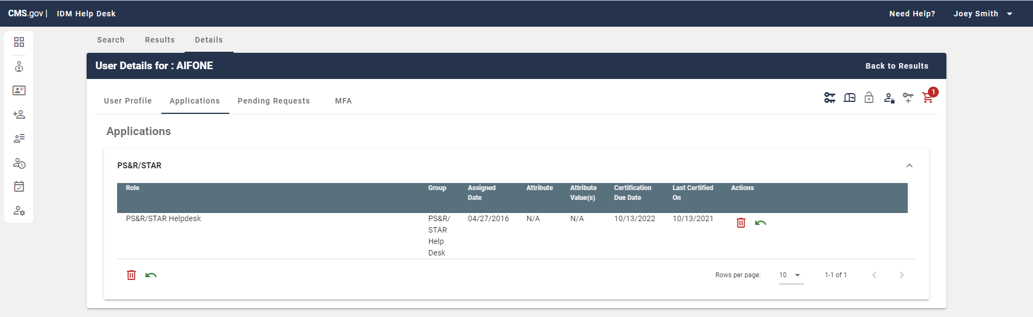
Figure 98: User Details Applications – ‘Remove from Cart’ and ‘Remove Now’ Actions

Step 5: On the Remove Role/Attribute Popup, select a ‘Reason for Removal’ (Required – Top arrow in Figure below) and a ‘Justification’ (Optional – Bottom arrow in Figure below).

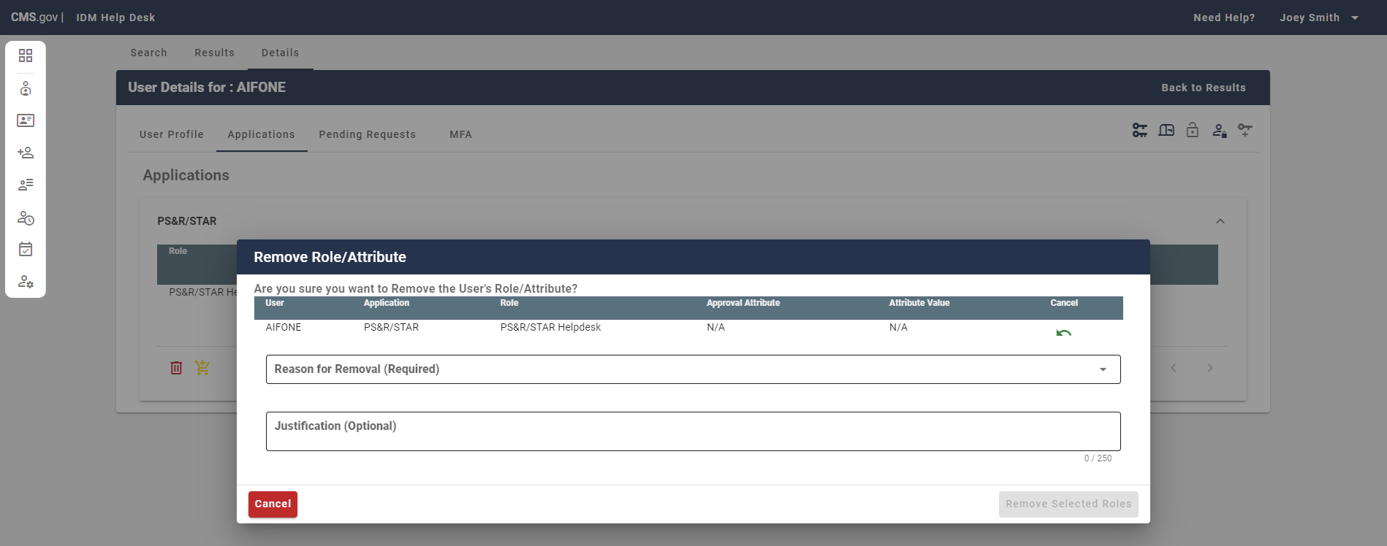
Figure 99: User Details Applications – Remove Role/Attribute Popup Reason and Justification

Step 6: To remove the selected roles/attributes from the user’s account after entering a reason for removal, select ‘Remove Selected Roles’ within the Remove Role/Attribute popup (Right arrow in figure below). To abandon the request to remove these roles/attributes from the user’s account, select ‘Cancel’ (Left arrow in Figure below).

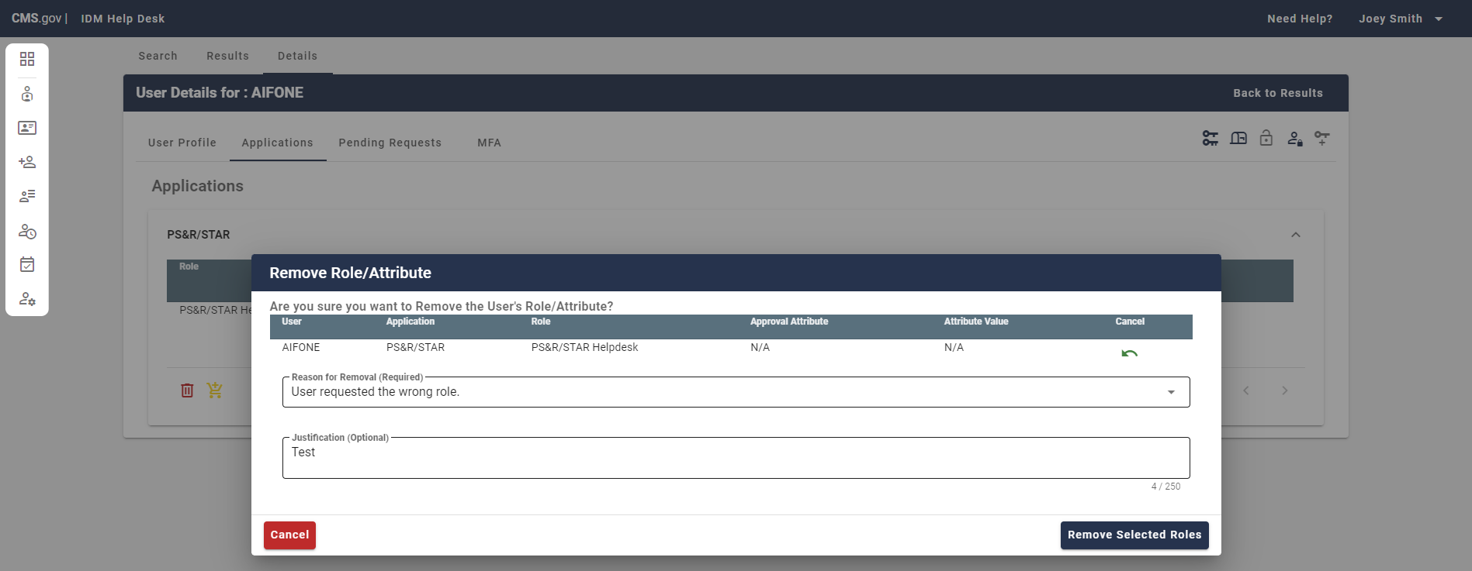
Figure 100: User Details Applications – Remove Role/Attribute Popup Cancel/Remove Selected

Step 7: If the role/attribute removal on the user’s account was successful, you will see a successful message appear at the top of the Applications page.

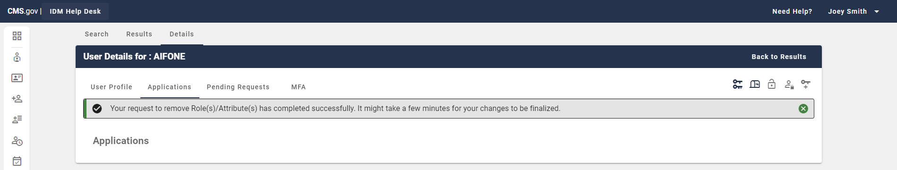
Figure 101: User Details Successful Role/Attribute Removal

Cancelling a Pending Role Request
This section provides information on how to cancel a role/attribute request that is in-flight and has not been approved and added to a user’s profile.

Step 1: Follow the steps in either the Application Search or Enterprise Search sections to complete a valid search.

Step 2: Select the hyperlink User ID of the user you wish to act upon within the User ID field.

Figure 102: Enterprise Search go to User Details

Step 3: From the User Details page select ‘Pending Requests’.

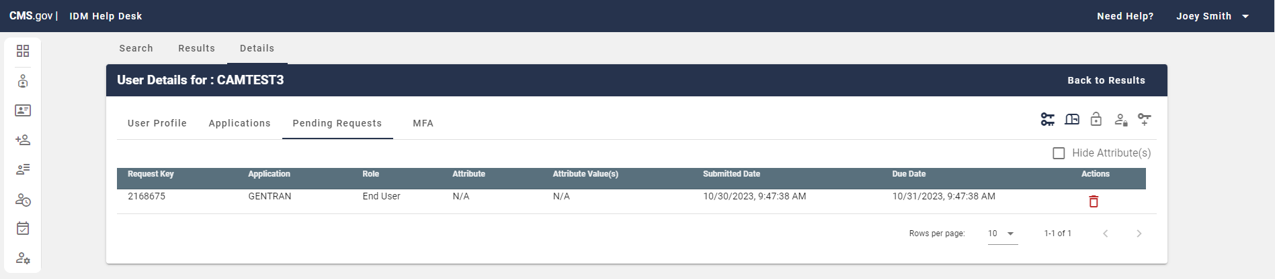
Figure 103: User Details Select Pending Requests

Step 4: Tier 1 Help Desk Users can cancel requests within their applications using the ‘Cancel Pending Role Request’ action.

Figure 104: User Details Pending Requests – ‘Cancel Pending Role Request’ Action

Step 5: On the Cancel Pending Role Request Popup, select a ‘Justification’ (Required).
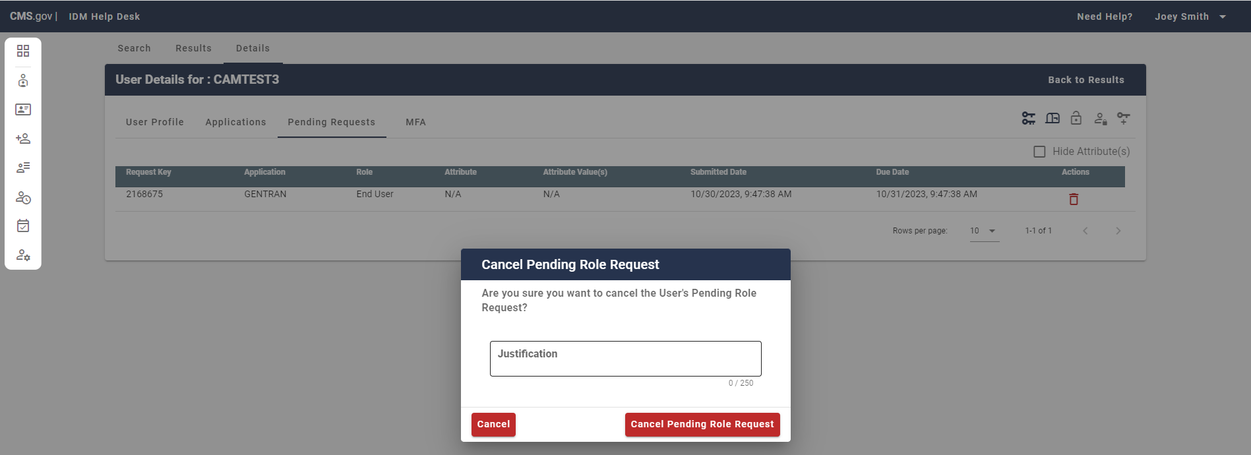
Figure 105: User Details Pending Requests – Cancel Pending Role Request Popup Justification

Step 6: To cancel the user’s role request, after entering a justification in the provided field in the Cancel Pending Role Request popup select ‘Cancel Pending Role Request’ (Right arrow in Figure below). To abandon the request to cancel the pending role request select ‘Cancel’ (Left arrow in Figure below).
Figure 106: User Details Pending Requests – Cancel Pending Request Popup Cancel/Remove

Step 7: If the cancelation of the user’s request was successful, you will see a successful message appear at the top of the Pending Requests page.
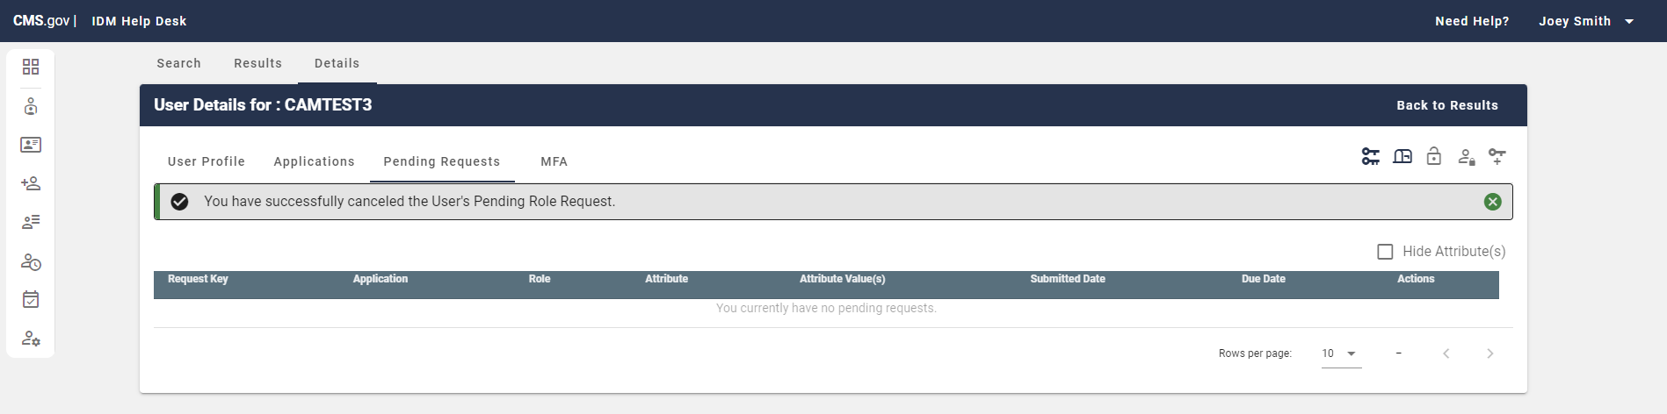
Figure 107: User Details Successful Pending Role Request Cancellation

Contacting Tier 2 & Tier 1 Responsibilities

Contact information for the IDM Tier 2 Help Desk should NEVER be shared with end users. This document is not for public consumption and is only designated for use by the following parties:
- Application CMS Business Owners/Business Owner Representatives
- Application Development Organizations (ADO)
- Application Tier 1 Help Desk staff

The IDM Tier 2 Help Desk supports technical issues regarding IDM systems for Application Help Desks. If an end user is experiencing a technical issue with an IDM system that cannot be resolved at the Application Help Desk level, the Application Help Desk can escalate the issue to IDM Tier 2.

Tier 1 Help Desks can reach out to IDM Tier 2 in one of the following ways:

E-mail: IDMSupport@cms.hhs.gov
Phone: 888-441-0414
Hours of Operation: 7am - 7:30pm
Phone Support Hours of Operation: 7am - 7:30pm
Workflows: User -> App Help Desk -> Tier 2 Help Desk

Instructions for Users:

When contacting the IDM Help Desk, it's helpful to include the following:

• Name of the Application
• Your User ID
• E-mail address associated with the User ID
• Short description of the issue
• URL you are trying to access
• Screenshot of the error (whenever possible)

It is important to verify the user is who they say they are. The application help desk needs to ask the following questions before you proceed with helping the user:

• User ID
• First/Last name
• E-mail address associated with the account
• Last 4 of the users’ SSN
• DOB

Please do not give the users hints on what the answers are.

List of tasks that IDM Tier 1 performs:

• Helps End Users with gaining access/signing into the application
• Reset passwords
• Unlock/lock accounts
• Update e-mail addresses
• Suspend accounts
• Approve/Reject role requests (varies by helpdesk)
• Remove roles
• Cancel pending requests
• MFA issues
• Manual ID Proofing (depending on the application)

For the Tier 1 Help Desks:

Before Tier 1 Help Desks reach out to IDM Tier 2 Support, please have as many of the following troubleshooting steps completed/answered.

• Application Name:
• Brief Description of the issue:
• User ID:
• First/Last Name:
• E-mail address associated with the user’s account:
• Steps taken by the user to receive the error:
• IDM environment incident occurred in:
• URL the user is trying to access:
• Screenshot of the error (whenever possible) including the URL:
• Approximate date and time when the error/issue occurred:
• Whether the error/issue occurs consistently or intermittently:
• Whether the issue is impacting a single user or group of users:
• Browser version/type that the user has attempted to use:
• Troubleshooting steps taken by the Application’s Tier 1 Help Desk:

Appendix A: Record of Change

Version Number | Date | Author/Owner | Description of Change | Approval(s)
0.1 | 10/30/19 | Matthew Teeters, CMS | Initial Draft Version
1.0 | 11/13/2023 | Cameron Smith, Omni / Bana | Sections 1-15 Updated, renamed to ‘Tier 1 Help Desk User Guide’ and version reset to 1.0
1.1 | 03/19/2024 | Brandon Poff, Omni/Bana | Section 8 Updated with SSN Verify details, version updated to 1.1
1.2 | 04/15/2024 | Cameron Smith, Omni Bana | Section 2.2, Step 7 in section 11.2, section 11.1 and Section 12 updated for OIE Upgrade
1.3 | 07/11/2024 | Devon Zhen, Omni Bana | Section 6, Step 3 User Details info and image update  Section 8, Step 5,8 updated Information and images
1.4 | 07/24/2024 | Cameron Smith, Omni Bana | Section 8 screenshot updates and wording changes based on info box updates
1.5 | 07/29/2024 | Cameron Smith, Omni Bana | Updated Puerto Rico Tips Image Section 8
1.6 | 07/31/2024 | Cameron Smith, Omni Bana | Updated Images in Section 8 and some texts to be more explanatory
Table 1: Record of Change

Appendix B: Acronyms

Acronym | Literal Translation
ADO | Application Development Organizations
CMS | Centers for Medicare & Medicaid Services
DHHS | Department of Health and Human Services
DIMES | Division of Identity Management Enterprise Systems
EIDM | Enterprise Identity Management
ESSG | Enterprise Systems Solutions Group
FISMA | Federal Information Security Management Act
GTL | Government Task Leader
IAL | Identity Assurance Level
ICD | Interface Control Document
IDLM | Identity Lifecycle Management
IMPL | Implementation Environment
IT | Information Technology
LOA | Level of Assurance
MFA | Multi-Factor Authentication
NIST | National Institute of Standards and Technology
OIT | Office of Information Technology
PPACA | Patient Protection and Affordable Care Act
PROD | Production Environment
RIDP | Remote Identity Proofing
UI | User Interface
XLC | Expedited Life Cycle
Table 2: Acronyms

Appendix C: Glossary

Term | Acronym | Definition
Centers for Medicare & Medicaid Services | CMS | Centers for Medicare & Medicaid Services (CMS) is a Federal agency within the United States Department of Health and Human Services that administers the Medicare program and works in partnership with state governments to administer Medicaid, the State Children’s Health Insurance Program, and health insurance portability standards.
Table 3: Glossary

Appendix D: Reference Documents

Document Name | Document Number | Issuance Date
Table 4: Referenced Documents

