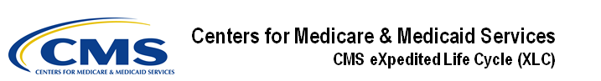
Identity Management (IDM)

User Guide
Version 1.02
10/18/2021
Document Number: IDM User Guide Version 1.02
Contract Number: HHSM-500-2017-00015I TO HHSM-500-T0001

Note: Working copy versions delivered to the client for review will be published as a major version. The client has agreed to review these documents as follows: as-is, ongoing, “work-in-progress” drafts and working copy versions.

Table of Contents
1. Introduction 1
1.1 Identity Management (IDM) System Overview 1
1.2 User Guide Purpose 1
1.3 Where to Get Help 1
2. Prepare to Access the IDM System 3
2.1 Verify the Web Browser is Supported 3
2.2 Verify and Adjust the Screen Resolution if Necessary 3
2.3 Review Account Creation Instructions 3
3. Overview of the IDM System 4
4. How to Create a New User Account 5
5. How to Sign In 7
5.1 How to Sign In (All Users) 7
5.2 How to Sign In with a PIV Card (CMS EUA Users Only) 8
5.3 The IDM Self Service Dashboard at a Glance 9
6. How to Request a Role 10
6.1 How to Request a Role for a New Application 10
6.1.1 What to do When Users Can’t Verify Their Identity with Online Proofing 13
6.1.2 What to do When Users Can’t Verify Their Identity with Phone Proofing 14
6.2 How to Request a Role in an Existing Application 14
6.3 How to Add Attributes to an Existing Role 15
7. How to View and Cancel Role Requests 17
7.1 How to View Role Requests 17
7.2 How to Cancel a Role Request 18
8. How to Remove Roles and Role Attributes 19
8.1 How to Remove a Role 19
8.2 How to Remove Attributes From a Role 20
9. IDM User Account Self-Service Features 21
9.1 How to Change an Expired Password 22
9.2 How to Reset a Forgotten Password 23
9.3 Recover a forgotten User ID 25
9.4 How to Unlock a User Account 26
10. How to Manage MFA and Recovery Devices 28
10.1 How to View MFA and Recovery Devices 29
10.2 How to Add an Email, IVR, or SMS MFA/Recovery Device 30
10.3 How to Activate a Pending Email, IVR, or SMS MFA/Recovery Device 30
10.4 How to Add a Google Authenticator Mobile App MFA Device 31
10.5 How to Add an Okta Verify MFA Device 32
10.6 How to Add a YubiKey MFA Device 33
10.7 How to Edit MFA Device Settings 33
10.8 How to Remove an MFA Device 34
11. How Manage User Account Profile Information 35
11.1 How to Open and Close the My Profile Function 35
11.2 How to View User Profile Information 35
11.3 How to View and Modify Personal Contact Information 36
11.4 How to View and Modify Business Contact Information 37
11.5 How to Change the User Account Password 37
11.6 How to Change the User Security Question and Answer 38
12. How to Approve Role Requests 39
12.1 How to Open and Close the My Approvals Function 39
12.2 How to View a List of Pending Approval Requests 40
12.2.1 How to View Details for a Specific Pending Approval Request 40
12.3 How to Approve or Reject a Single Request 41
12.4 How to Approve or Reject Multiple Requests on a Single Page 41
12.5 How to Simultaneously Approve and Reject Multiple Requests 42
12.6 How to Export a List of Pending Approvals to an Excel Spreadsheet 43
13. How to View IDM Reports 45
13.1 Description of the IDM Reports Function 45
13.2 How to Access the IDM Reports 45
13.3 How to Print a Report 47
13.4 How to Export a Report to an Excel Spreadsheet 47
14. How to Perform Annual Role Certification 48
14.1 Annual Role Certification for Manually Approved Roles 48
14.1.1 How to Open and Close the My Annual Role Certifications Function 48
14.1.2 How to View a List of Pending Certifications 49
14.1.3 How to Perform a Global Search 50
14.1.4 How to Perform an Advanced Search 51
14.1.5 How to View User/Role Details and Certify/Revoke a Single User’s Role 52
14.1.6 How to Bulk Certify or Revoke Multiple User Roles 54
14.1.7 How to use the Cart to Certify and Revoke Multiple User Roles 55
14.2 Annual Role Certification for Validated Roles 57
14.2.1 System Notifications Sent for Users who Fail Pre-check Validation 57
15. Instructions for Help Desks 58
15.1 Description of the Help Desk/Manage Users Functions 58
15.2 How to Access the Help Desk Functions 58
15.3 How to Choose the Appropriate Search 58
15.4 How to Perform an Application Search 59
15.5 How to Perform an Enterprise Search 60
15.6 How to View a User’s Profile 61
15.7 How to View a Summary of a User’s Applications 62
15.8 How to Remove a Single Role 63
15.9 How to Remove Multiple Roles 65
15.10 How to Cancel Pending Requests 68
15.11 How to View a User’s MFA Devices 69
15.12 How to Update a User’s Email Address 70
15.13 How to Reset a User’s Password (Email Reset Method) 71
15.14 How to Reset a User’s Password (Temporary Password Method) 72
15.15 How to Unlock a User’s Account 73
15.16 How to Suspend a User’s Account 73
15.17 How to Update a User’s Level of Assurance (LOA) 74
15.18 How to Unsuspend a User’s Account 75
15.19 How to Create User Audit Reports 76
15.20 How to Create Role Request Audit Reports 78
15.21 How to Manage YubiKey MFA Devices for Use with IDM 79
15.21.1 How to Generate the YubiKey Seed File 80
15.21.2 How to Manage YubiKey MFA Devices in Okta 83
15.21.3 How to Revoke a YubiKey MFA Device in Okta 84
Appendix A: Password Policy 85
Appendix B: IDM Report Categories 86
Appendix C: Requesting Configurable Help Desk Privileges 87
Appendix D: User Audit Report Type Summary 88
Appendix E: Acronyms 89
Appendix F: Approvals 90

List of Figures
Figure 1: Location of the Help Center Menu and Link 1
Figure 2: IDM System Sign In Window 5
Figure 3: Self Service Dashboard Layout 9
Figure 4: The Role Request Window 11
Figure 5: Role Request - RIDP Terms and Conditions 11
Figure 6: Role Request - Attribute Selection 12
Figure 7: RIDP Online Proofing Error Message. 13
Figure 8: Experian Phone Verification Confirmation 13
Figure 9: Phone Proofing RIDP Error Message 14
Figure 10: Manage My Roles Window - User's Existing Roles 14
Figure 11: Add Role Window 15
Figure 12: Application Roles Window - Role Details View 16
Figure 13: My Requests - Role Requests Pending Approval 17
Figure 14: Request Details Window 18
Figure 15: Manage My Roles Window 19
Figure 16: Edit Role Details Window 20
Figure 17: IDM Sign In Window with Self-Service Links 21
Figure 18: IDM Self-Service Change Expired Password Window 23
Figure 19: IDM Self-Service Reset Password Request 24
Figure 20: IDM Self-Service Reset Password Set New Password 25
Figure 21: IDM Self-Service Forgot User ID Window 26
Figure 22: IDM Self-Service Unlock Account Window 27
Figure 23: Manage MFA and Recovery Devices Window 30
Figure 24: My Profile - My Information 36
Figure 25: My Profile - Personal Contact Information 36
Figure 26: My Profile - Business Contact Information 37
Figure 27: My Profile - Change Password Form 38
Figure 28: My Profile - Change Security Question Form 38
Figure 29: My Approvals Window 40
Figure 30: My Reports Window 45
Figure 31: My Reports Window with Sample Report (Full Screen View) 46
Figure 32: Location of the My Reports Export Options Button 47
Figure 33: My Annual Role Certifications Window 49
Figure 34: My Annual Role Certification Advanced Search Window 51
Figure 35: My Annual Role Certification User Details 53
Figure 36: Certifications to Process Window 55
Figure 37: Certify and Revoke Multiple User Roles using the Cart Feature 56
Figure 38: Application and Enterprise Search Capabilities Matrix 59
Figure 39: Help Desk Application Search Form 59
Figure 40: Help Desk Application Search Results 60
Figure 41: Help Desk Enterprise Search Form 61
Figure 42: Help Desk Enterprise Search Results 61
Figure 43: User Details User Profile Tab 62
Figure 44: Enterprise Search Results - Applications Tab 63
Figure 45: Application Search Results - Applications Tab 63
Figure 46: Application Search Results 64
Figure 47: User Details Applications Tab 65
Figure 48: List of User’s Roles / Attributes 67
Figure 49: User Details Pending Requests Tab 69
Figure 50: User Details MFA Device Summary 70
Figure 51: Help Desk User Audit Search Form 76
Figure 52: User Audit Report - User Profile Events 77
Figure 53: User Audit Report - User Authentication Events 77
Figure 54: User Audit Report - User Access Events 77
Figure 55: Help Desk Role Request Audit Search Form 78
Figure 56: Role Request Audit Report 79
Figure 57: YubiKey Personalization Tool Startup Window 81
Figure 58: YubiKey Personalization Tool - Device Present 81
Figure 59: YubiKey Personalization Tool - Settings Tab 82
Figure 60: YubiKey Personalization Tool - Yubico OTP Tab 82
Figure 61: Okta YubiKey Administration Window 83

List of Tables
Table 1: Self Service Dashboard Layout 9
Table 2: MFA and Recovery Device Summary 28
Table 3: YubiKey Device Status List 84
Table 4: Summary of Current IDM Reports 86
Table 5: Help Desk Privileges 87
Table 6: IDM Help Desk User Audit Report Type 88
Table 7: Acronyms 89
Table 8: Approvals 90

Introduction
The Centers for Medicare & Medicaid Services (CMS) is a federal agency that ensures health care coverage for more than 100 million Americans. CMS administers Medicare and Medicaid and provides funds and guidance for all of the 50 states in the nation, for their Medicaid programs, and Children’s Health Insurance Program (CHIP). CMS works together with the CMS community and organizations in delivering improved and better coordinated care.

Identity Management (IDM) System Overview
CMS created the IDM System to provide Business Partners with a means to request and obtain a single User ID which they can use to access one or more CMS applications. The IDM System uses a cloud-based distributed architecture that supports the needs of both legacy and new applications while providing an improved user experience on desktop and laptop computers as well as tablet and smartphone mobile devices.

User Guide Purpose
This user guide provides step-by-step instructions for performing the most common tasks using the IDM System. The tasks a user can perform varies depending on their role and includes, but is not limited to, creating an account, logging in to the IDM System, requesting a role, identity proofing, managing role requests, performing account management functions, and generating reports.

Where to Get Help
Users can quickly find answers to common questions in the Help Center using the Need Help? menu and the Need Help? link. The Need Help? menu is located at the top right corner of the IDM Self Service user interface and the Need Help? link is located at the bottom center of the IDM Self Service Sign In window.
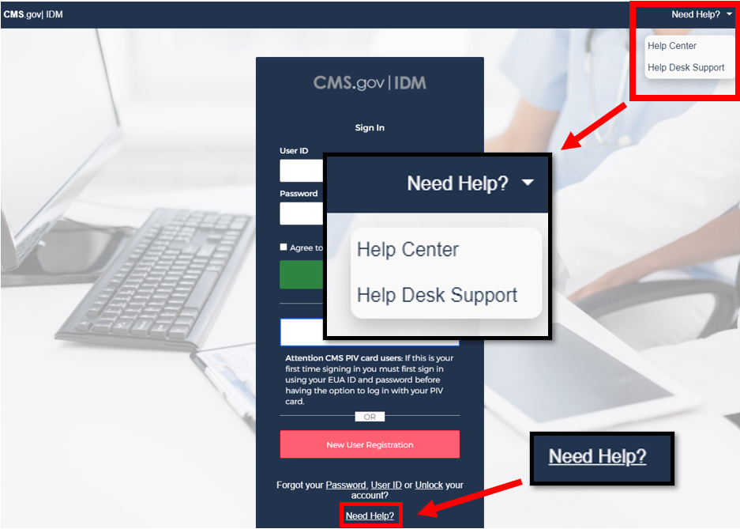
Figure 1: Location of the Help Center Menu and Link

The Help Center provides answers to the following topics:
- How do I find my Application Help Desk contact information?
- How do I sign in?
- How do I unlock my account?
- How do I change my password?
- How do I add Multi-Factor Authentication (MFA)?
- How do I use the IDM system?
- How to perform Annual Role Certification?
Users that require support beyond what is offered in the Help Center will be referred to the corresponding topic within this user guide.
Application (Tier 1) Help Desk contact information can also be obtained from the CMS Tier 1 Help Desk Support website.

Note: When the IDM System experiences a planned or unplanned outage, application login services continue to function normally, however new user registration, role request and account management services will not be available. If an outage exists, the system will display a message that informs users about the outage and where they can obtain additional information.

Prepare to Access the IDM System
Users who access the IDM System using a desktop or laptop computer may need to perform software updates or configure web browser settings and privacy settings. Users who access the IDM user interface (UI) with a mobile computing device such as a smartphone or tablet generally have less control over updates and privacy settings. The procedures discussed in this section may not apply to mobile device users.

Verify the Web Browser is Supported
The IDM UI was tested for compatibility with current versions of the following modern web browsers:
- Microsoft Edge
- Google Chrome
- Mozilla Firefox
- Safari
All of the web browsers listed above are configured by default to receive regular security updates and patches. Even in cases where the user’s organization manages operating system and application software updates, users who access the IDM System UI with one of these web browsers should not encounter compatibility issues.

Verify and Adjust the Screen Resolution if Necessary
The IDM System UI is best viewed on a display resolution of 1366 x 768. Many modern desktop, laptop, and mobile computing devices have default display settings that exceed the IDM System minimum. If adjustments are necessary, use the display settings adjustment procedure that is appropriate for your device.

Review Account Creation Instructions
All users should receive account creation instructions from their organization or their CMS contact prior to creating an account on the IDM System. Not every CMS application requires the same information, so it is important for the user to review any instructions that were provided by their organization or CMS contact before starting the account creation process.

Overview of the IDM System
The following terms are introduced in this section:
- Role - A name given to a set of permissions in an application, e.g., Representative, Submitter, or Authorizer. A role defines what the user is allowed to do by virtue of having been assigned or granted that role. Each application defines the access privileges and permissions assigned to each role. For example, “Submitter” could identify a role that has permission to upload documents to an application.
- Role Attribute - A characteristic of a role that represents a functional limitation or additional information that modifies the scope of that role’s access privileges. For example, a submitter with the role attribute of Maryland might only be permitted to upload documents to a specific folder relevant to the State of Maryland.

The IDM System provides the means for users to be approved for access to many other CMS systems and applications. IDM governs access to CMS systems by managing identity proofing, the creation of User IDs and passwords, and setting up multi-factor authentication (MFA). It also enables users to manage roles within CMS applications. IDM generally supports three types of users along with their most common features or functions:
Application End Users:
- Create an account, sign in to IDM, request a role, modify, or remove a role, perform identity proofing, sign in to an application, manage their profile, and perform self-service functions such as recover a forgotten User ID, reset a forgotten password, reset an expired password, and unlock account.
Application Approvers:
- In addition to End User functions, they approve or reject role requests. Some application approvers may also be granted the capability to reset passwords and unlock accounts for users under their management.
Application (Tier 1) Help Desk Users:
- In addition to End User functions, they search and view accounts and user account details, reset passwords, unlock accounts, suspend a user’s account, and update a user’s email address. Some Application (Tier 1) Help Desk users may also be granted the capability to approve and reject requests for application approver roles; and to update a user’s Level of Assurance (LOA).
IDM (Tier 2) Help Desk Users:
- In addition to the functions performed by all other types of users, they can also create user audit reports, role audit reports, and unsuspend a user’s account.

How to Create a New User Account
The following terms are introduced in this section:
- Security Question and Answer (SQA) - The security question is a question to which the user provides a unique answer. They both become part of the user’s account and are used to authenticate the user when they access IDM’s self-service functions.
- User Account - A user account generally refers to the User ID and all profile information that is associated to it. The user account does not refer to roles within the account.
Users create a new user account using the New User Registration button  located on the Sign In window.
- Navigate to https://home.idm.cms.gov/. The Sign In window appears.
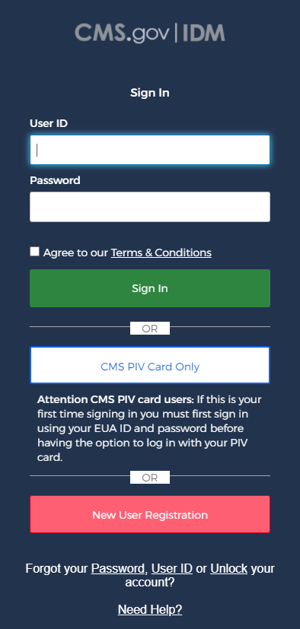
Figure 2: IDM System Sign In Window
- Click the New User Registration button. The User Registration window appears.
- Enter the First Name and Last Name. Middle Name and Suffix are optional.
- Enter the Date of Birth.
- Enter the E-mail Address and the Confirm E-mail Address. The Email Address and the Confirm E-mail Address must match. Please ensure that the email address is valid because the IDM System uses email to communicate with users for many reasons including sign-in, security, and self-service.
- Click the View Terms & Conditions button. Read the IDM System terms and conditions then click the Close Terms & Conditions button.
- Click the checkbox to acknowledge agreement with the terms and conditions, then click the Next button. The User Contact Information window appears.
- If the home address is outside the 50 U.S. states or the U.S. territories, select the Foreign Address radio button.
- Enter the Home Address, City, State, Zip Code and Phone Number.
- Click the Next button. The User Account Credentials window appears.
- Enter the desired User ID, Password and Confirm Password. The Password and Confirm Password must match.
- Select a Security Question from the list.
- Type the security question answer into the Answer dialog box.
- Click the Submit button to submit the account registration request. The system will display a message that indicates the account was successfully created.
- Click the Return button. The screen refreshes and the IDM System Sign In window appears.

Note: CMS policy requires that the combination of each user’s first name, last name, and email address be unique in the IDM System. If an error occurs for this combination it may mean that the combination of information entered is already in use. Users should try entering the information again or call their Application Help Desk for assistance.

How to Sign In
The following terms are introduced in this section:
- Multi-factor Authentication (MFA) - MFA is an additional layer of security that functions as a “second” password. It is transmitted as a numeric code to the user’s email or phone and is good for one sign-in only. Some roles in IDM require MFA while others may not. See Section 10 How to Manage MFA and Recovery Devices for more information about MFA.

Note: CMS Enterprise User Administration (EUA) account holders may use their Personal Identity Verification (PIV) card. See the procedure in Section 5.2 How to Sign In with a PIV Card (CMS EUA Users Only) to sign in to the IDM System.

Note: New users who are required to log in with MFA will be required to set up an MFA device the first time they sign in to the IDM System. All users are encouraged to add additional MFA devices using the procedures described in Section 10 How to Manage MFA and Recovery Devices.

Note: The Session Expiring window appears if a user is logged in to IDM but has been inactive for 28 minutes. If the user clicks the Continue Session button, their session will be extended for another 30 minutes. If the user clicks the Logout button, they will be immediately logged out. If the user does nothing, they will automatically be logged out of the IDM System after 30 minutes of inactivity.

How to Sign In (All Users)
Use the following procedure to sign in.
- Navigate to https://home.idm.cms.gov The Sign In window appears as illustrated by Figure 2: IDM System Sign In Window.
- Enter the User ID and Password.
- Read the Terms & Conditions, click the checkbox to acknowledge agreement, and then click the Sign In button. The Verification Code Request window appears.
- Click the Send me the Code button. The screen refreshes and the Code Request window appears.
- Enter the Verification Code.
- (Optional) Click the checkbox to select the option “Do not challenge me on this device for the next 30 minutes”. If the checkbox is selected, users will bypass the MFA verification if they sign out and sign back into the system again within 30 minutes of their initial sign-in.
- Click the Verify button. The IDM Self Service Dashboard appears. Go to Section 5.3 The IDM Self Service Dashboard at a Glance for a brief description of the IDM Self Service Dashboard.

Note: Users whose accounts were migrated from the legacy Enterprise Identity Management (EIDM) System or whose accounts were uploaded with a new application should update the answer to their security question using the procedures in Section 11.6 How to Change the User Security Question and Answer.

Note: It is recommended that all users add additional MFA and/or Recovery devices using the procedures in Section 10 How to Manage MFA and Recovery Devices.

How to Sign In with a PIV Card (CMS EUA Users Only)
The following terms are introduced in this section:
- Personal Identity Verification (PIV) - A PIV credential is a US Federal government credential that is used to access Federal government controlled facilities and information systems as assigned.
Before using the PIV button on the IDM Sign In page, EUA users must first sign in one time with their four character EUA ID and their password using the procedure in Section 5.1 How to Sign In (All Users).
After a successful sign-in with an EUA ID and password, the CMS PIV Card Only button will be available to enable subsequent sign-ins using the procedure below:
- Click the checkbox to acknowledge agreement with the terms and conditions.
- Click the CMS PIV Card Only button. 
- Follow the prompts. The IDM Self Service Dashboard appears after the user is authenticated.

The IDM Self Service Dashboard at a Glance
The IDM Self Service Dashboard provides access to functions that allow users to manage their user profile, request new applications, and manage roles for applications to which they have been granted access.
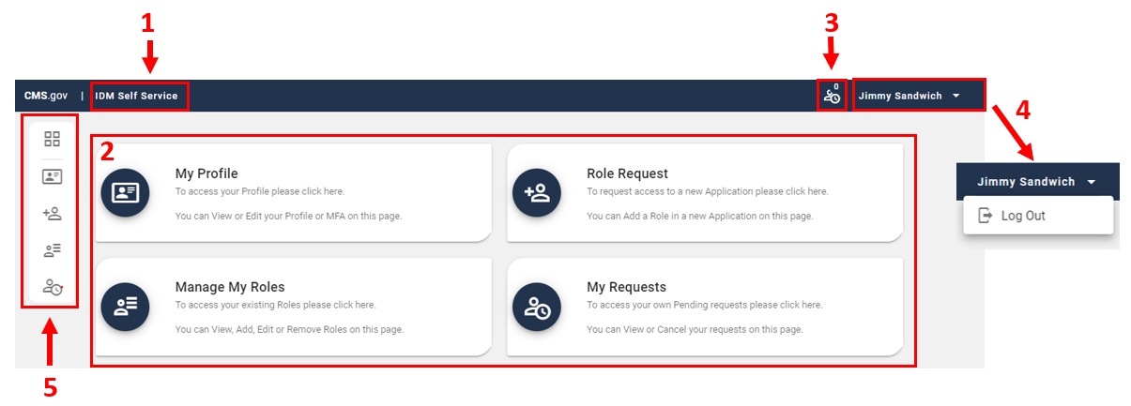
Figure 3: Self Service Dashboard Layout
Table 1: Self Service Dashboard Layout
Reference | Name | Description
1 | IDM Self Service Home Button | This button returns the user to the IDM Self Service Dashboard.
2 | IDM Self-Service Function Buttons | These buttons provide user access to the functions that are accessed through the IDM Self Service Dashboard.
3 | My Requests Counter | This counter displays the number of pending requests that the user has submitted. It also provides 1-click access to a list of those requests.
4 | Dropdown Menu | This menu displays user’s identity and provides access to the Log Out function when clicked.
5 | Self Service Taskbar | This taskbar appears whenever a user accesses one of the Self Service functions. It enables the user to move between the various Self Service functions.

How to Request a Role
The following terms are introduced in this section:
- Remote Identity Proofing (RIDP) - Describes the process that is used to confirm a person’s identity. Most users will be required to complete RIDP as part of the process of being approved for a role. RIDP is also called Identity Verification. Users may have three opportunities to verify their identity. Verification occurs in the following order:
  - Online Proofing - An identity verification procedure that uses Experian’s computer-based Identity Verification service.
  - Phone Proofing - An identity proofing procedure that uses Experian’s telephone-based Identity Verification service. Phone proofing is only available if the user is unable to verify their identity using online proofing.
  - Manual Proofing - An identity proofing procedure that is performed by an Application (Tier 1) Help Desk in accordance with their policies. Manual proofing is not offered by every application and is only available if the user is unable to first verify their identity through online proofing and phone proofing.

Note: Users with foreign addresses will not be eligible for online proofing or phone proofing.

How to Request a Role for a New Application
Note: The Transformed Medicaid Statistical Information System (T-MSIS) application will be used in this section as an example of the typical procedure for requesting roles and for adding role attributes. The procedure for other applications may vary slightly.

Users request a role for a new application using the Role Request button that is located on the Self Service Dashboard.
- Click the Role Request button. 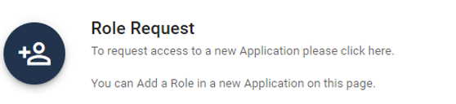 The Role Request window appears.
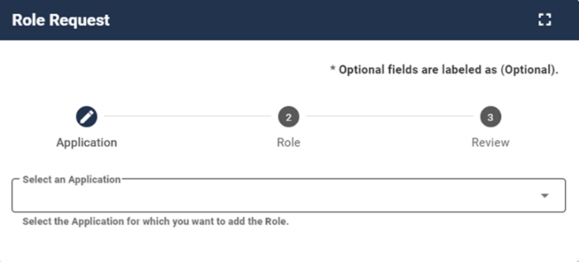
Figure 4: The Role Request Window
- Select an application. The Select a Role menu appears after an application is selected.
- Select a role. The RIDP window appears after a role is selected.
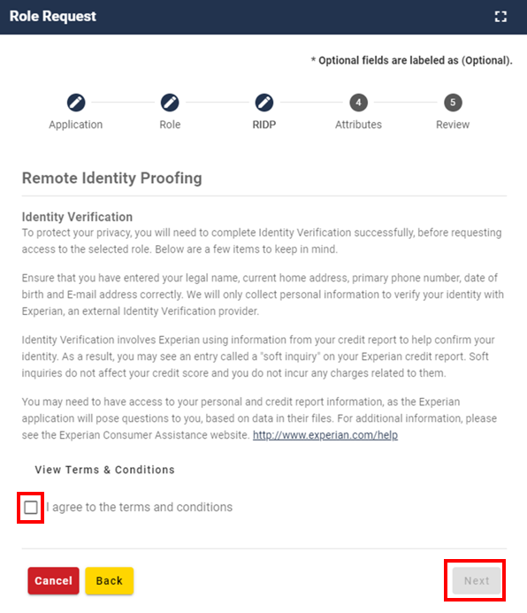
Figure 5: Role Request - RIDP Terms and Conditions
- Review the RIDP terms and conditions, check the “I agree to the terms and conditions” selection box, then click the Next button. The Identity Verification form appears.
- Complete the Identity Verification form and click the Next button. The RIDP proofing questions appear.
- Answer the proofing questions and click the Verify button. The Attribute menu appears.
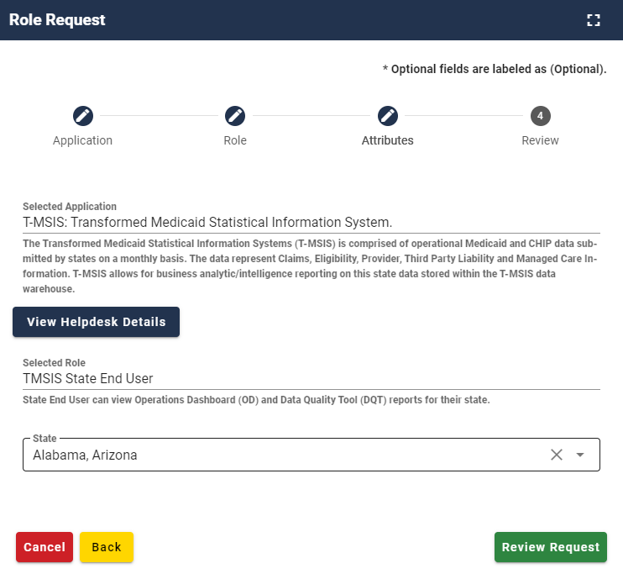
Figure 6: Role Request - Attribute Selection
- Select the required attributes.
- Review the role request information and click the Review Request button. The Reason for Request dialog box appears.
- Enter a justification and click the Submit Role Request button. The Role Request window displays a Request ID and a message which states that the request was successfully submitted to an approver for action.
- The My Requests indicator  on the Self Service Dashboard increments to display the user’s current number of pending requests.
- Click the Back to Home button. The user returns to the Self Service Dashboard.

What to do When Users Can’t Verify Their Identity with Online Proofing
If the RIDP Online Proofing process is unsuccessful, then the system will display an error message as illustrated by Figure 7: RIDP Online Proofing Error Message.
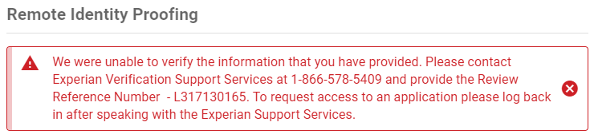
Figure 7: RIDP Online Proofing Error Message.
- Write down the Experian support contact information and the Review Reference Number.
- Click the Cancel button. The Cancel Role Request Process window appears.
- Click the Confirm button.
- Contact Experian using the contact information provided in the error message and perform Phone Proofing.
- If Phone Proofing was successful, sign in to the IDM System and initiate the role request procedure again. When the user reselects the desired role, IDM will be aware of the success or failure of Online and Phone Proofing. The Role Request window displays a message which asks if Experian has been contacted.
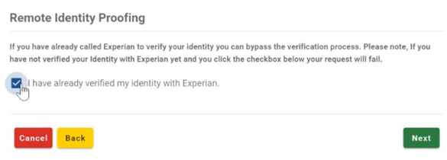
Figure 8: Experian Phone Verification Confirmation
- Click the “I have already verified my identity with Experian” checkbox if Experian has been contacted.
- Click the Next button. The Identity Information Verification form is displayed.
- Verify that the information in the form exactly matches the information that was used to successfully verify the user’s identity by phone.
- Click the Next button, then click the OK button. The Attribute menu appears and the user resumes the Role Request procedure.

What to do When Users Can’t Verify Their Identity with Phone Proofing
If the Phone Proofing RIDP process is unsuccessful, then the system will display an error message as illustrated by Figure 9: Phone Proofing RIDP Error Message.
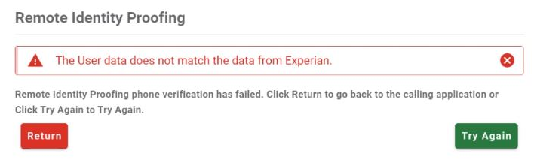
Figure 9: Phone Proofing RIDP Error Message
- Click the Try Again button. The Identity Information Verification form is displayed.
- Verify that the identity information which was proofed on the phone matches the data in the form, then click the Next button.
- If the error message is displayed again, click the Return button, then cancel the Role Request procedure.
- Contact the Application Help Desk and inquire about the Manual Proofing process. Application Help Desk contact information is located on the CMS Tier 1 Help Desk Support website.

How to Request a Role in an Existing Application
Users request a role in an existing application using the Manage My Roles button that is located on the Self Service Dashboard.
- Click the Manage My Roles button.  The Manage My Roles window appears and displays the user’s existing roles.
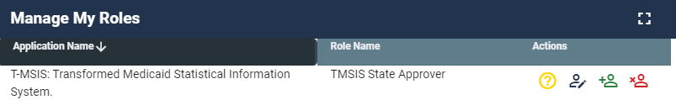
Figure 10: Manage My Roles Window - User's Existing Roles
- Click the Add Role button.  The Add Role window appears. The Selected Application is automatically populated, and the user will not be able to change it.
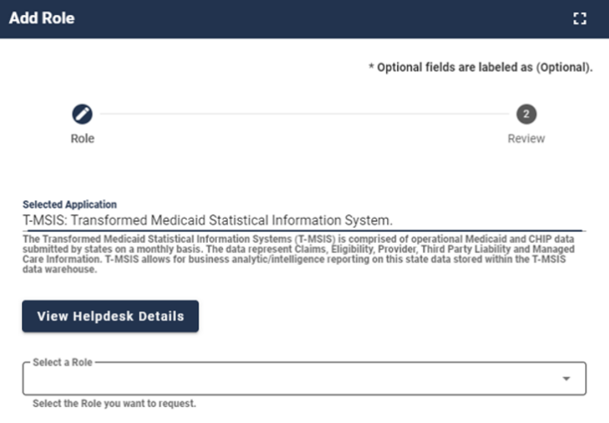
Figure 11: Add Role Window
- Select a Role. The Attribute menu appears.
- Select the required attributes.
- Review the role request information and click the Review Request button. The Reason for Request dialog box appears.
- Enter a justification and click the Submit Role Request button. The Role Request window displays Request ID information and a message which states that the request was successfully submitted to an approver for action.
- The My Requests indicator  on the Self Service Dashboard increments to display the user’s current number of pending requests.

How to Add Attributes to an Existing Role
Users add attributes to an existing role using the Manage My Roles button that is located on the Self Service Dashboard.
- Click the Manage My Roles button. The Manage My Roles window appears and displays the user’s existing roles as illustrated by Figure 10: Manage My Roles Window - User's Existing Roles.
- Click the View Details button.  The Application Roles window appears and displays the role details for the selected role.
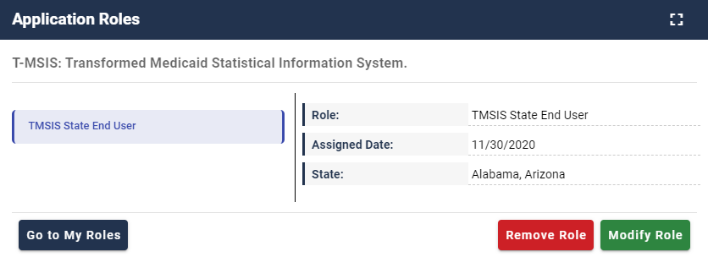
Figure 12: Application Roles Window - Role Details View
- Click the Modify Role button. The Edit Role Details window appears. This window contains fields that are similar to those used during the initial role request, but it only permits the user to modify role attributes.
- Add one or more role attributes.
- Enter a justification statement and click the Submit button. The Edit Role Details window displays Request ID information and a message that informs the user that the request was successfully submitted.
- Click the Go to My Roles button. The Manage My Roles window appears and the My Requests indicator  on the Self Service Dashboard increments to display the user’s current number of pending requests.

How to View and Cancel Role Requests
Users view and cancel role requests that are pending approval action using the My Requests button located on the Self Service Dashboard. Users can also view their role requests by clicking the My Requests indicator located at the top right corner of the Self Service Dashboard.

Note: The Transformed Medicaid Statistical Information System (T-MSIS) application will be used in this section as an example of the typical procedure for viewing and cancelling role requests. The procedure for other applications may vary slightly.

How to View Role Requests
- Click the My Requests button. 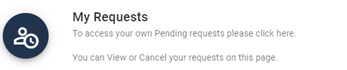 The My Requests window appears and displays the user’s pending role requests.
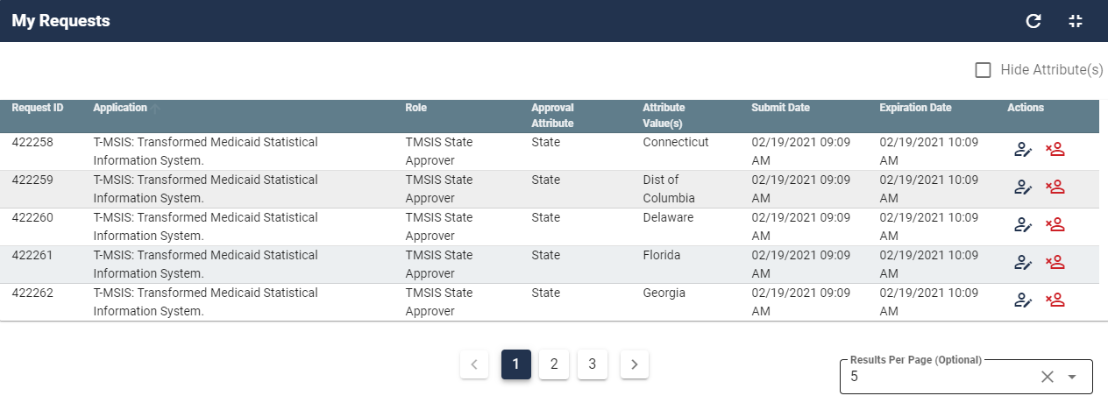
Figure 13: My Requests - Role Requests Pending Approval
- Click the View Details button. The Request Details window appears and displays details of the desired pending request.
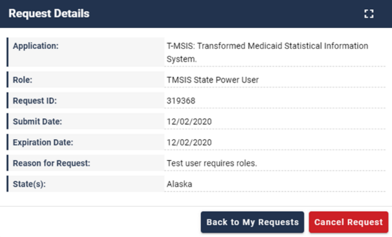
Figure 14: Request Details Window
- Click the Back to My Requests button. The user is returned to the My Requests window.

How to Cancel a Role Request
- Click the My Requests button 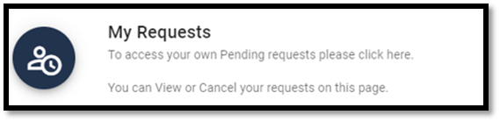 located on the Self Service Dashboard. The My Requests window appears and displays the user’s current pending requests as illustrated by Figure 13: My Requests - Role Requests Pending Approval.
- Click the Cancel Request button  for the role request that will be cancelled. The Cancel Role Requests decision window appears.
- Click the Cancel Role Request button. The My Requests window appears and displays a message that informs the user that the pending request was successfully cancelled.
- The My Requests indicator on the Self Service Dashboard decreases by one for each pending request that is cancelled.

How to Remove Roles and Role Attributes
Users remove roles and role attributes using the Manage My Roles button that is located on the Self Service Dashboard.
Note: The Transformed Medicaid Statistical Information System (T-MSIS) application will be used in this section as an example of the typical procedure for removing roles and role attributes. The procedure for other applications may vary slightly.

Note: The IDM System will display a warning message if the role removal or attribute removal operation could affect the last approver of an organization that still has users associated with that role or attribute. Such users could be left in an “orphaned” state without an approver of record for future role requests.

How to Remove a Role
- Click the Manage My Roles button.  The Manage My Roles window appears and displays the user’s existing roles.
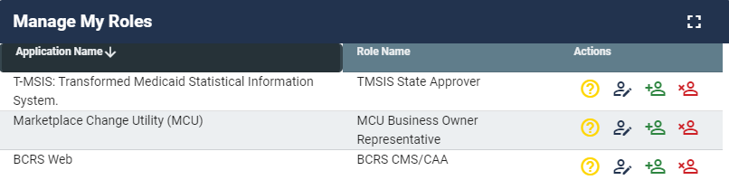
Figure 15: Manage My Roles Window
- Click the Remove Role button.  The Remove Role decision window appears.
- Click the Remove Role button. The Manage My Roles window displays Request ID information and a message that informs the user that the request was successfully submitted.
- Click the Go to My Roles button. The Manage My Roles window appears and displays the user’s current roles.

How to Remove Attributes From a Role
Users remove role attributes using the Manage My Roles button that is located on the Self Service Dashboard.
- Click the Manage My Roles button. The Manage My Roles window appears and displays the user’s existing roles as illustrated by Figure 15: Manage My Roles Window.
- Click the View Details button. The Application Roles window appears and displays the role details for the selected role.
- Click the Modify Role button. The Edit Role Details window appears.
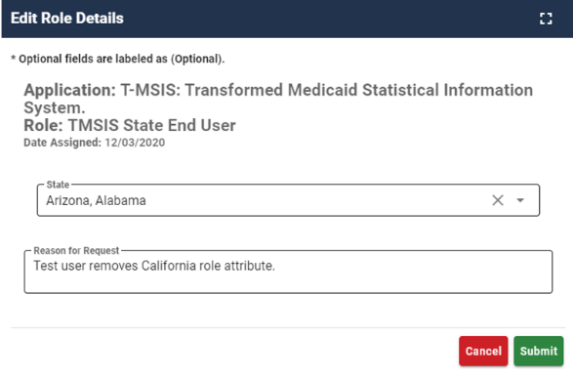
Figure 16: Edit Role Details Window
- Remove the desired role attributes.
- Type a justification statement and click the Submit button. The Edit Role Details window displays Request ID information and a message that informs the user that the request was successfully submitted.
- Click the Go to My Roles button. The Manage My Roles window appears and displays the user’s current roles.

IDM User Account Self-Service Features
The following terms are introduced in this section:
- Recovery - A process that allows a user to reset their own password or unlock their own account without the assistance of a helpdesk.
- Recovery Device - An email, short message service (SMS), or interactive voice response (IVR) MFA device that is used to authenticate a user during the recovery process.

The Change an Expired Password feature as well as the Self-Service features which are available as links at the bottom of the IDM Sign In window can be performed without the assistance of Help Desk personnel. The Self-Service features available as links include:
- Reset a forgotten password.
- Recover a forgotten User ID.
- Unlock an account after being locked out for too many failed login attempts.
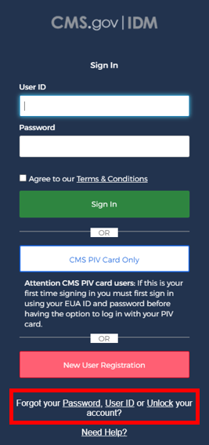
Figure 17: IDM Sign In Window with Self-Service Links

Note: Email is automatically set up as the default recovery device for all users that are required to log in with MFA. The procedures described in this section use the Email recovery device when describing the procedures to use the Self-Service account functions. Users are encouraged to add additional factors using the procedures described in Section 10 How to Manage MFA and Recovery Devices.

Users must meet the following conditions to use the self-service procedures to reset their forgotten password or unlock their account as described in this section of the user guide:
- The user must remember the security question answer that they established when they created their account.
- The user must have an Email, IVR, or SMS recovery device registered and active in their user profile.
Users who do not meet these conditions will not be able to use these self-service procedures and must contact their respective Application Help Desk to obtain assistance. Application Help Desk contact information is located on the CMS Tier 1 Help Desk Support website.

How to Change an Expired Password
When a user’s password expires, the IDM System Sign In window displays a message that informs the user that their password has expired, as shown in Figure 18: IDM Self-Service Change Expired Password Window. The user is required to create a new password using the procedure described in this section before they can sign in to the IDM System.
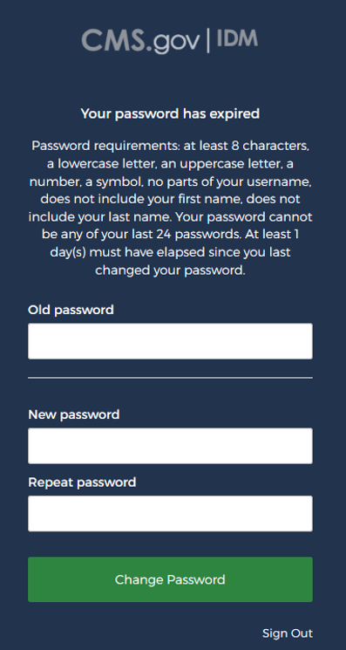
Figure 18: IDM Self-Service Change Expired Password Window
- Enter the Old Password.
- Enter the New Password and the Repeat Password.
- Click the Change Password button.
The User can now log in using the new password.

How to Reset a Forgotten Password
Users who forget their passwords can reset their own password using the Password link that is located at the bottom of the IDM Sign In window as illustrated in Figure 17: IDM Sign In Window with Self-Service Links.
- Click the Password link. The Reset Password window appears.

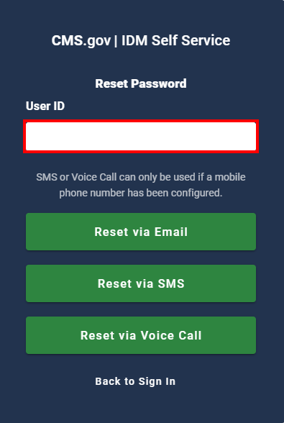
Figure 19: IDM Self-Service Reset Password Request
- Enter the User ID.
- Click the Reset via Email button. The screen refreshes and the system displays a message that informs the user that an email which contains password reset instructions has been sent.
- Click the Back to Sign In button. The IDM System sends an email to the email address listed in the user’s profile. The email informs the user that a password reset request has been made, and it contains a Reset Password hyperlink that the user must use to complete the password reset procedure.
- Click the Reset Password hyperlink contained within the “Forgot Password” email. The Reset Your Password window appears and prompts the user to respond to a security question.
- Enter the security question answer, and then click the Reset Password button. The screen refreshes and the user is prompted to enter a new password.
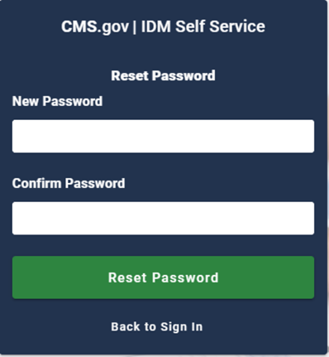
Figure 20: IDM Self-Service Reset Password Set New Password
- Enter the New Password and the Confirm Password. The New Password and the Confirm Password must match.
- Click the Reset Password button. The screen refreshes and displays a message which states that the password was successfully changed.
- Click the Back to Sign In button. The user returns to the IDM Sign In window.

Recover a forgotten User ID
Users who forget their User ID can recover it using the User ID link that is located at the bottom of the IDM Sign In window as illustrated in Figure 17: IDM Sign In Window with Self-Service Links.
- Click the User ID link. The Forgot User ID window appears.
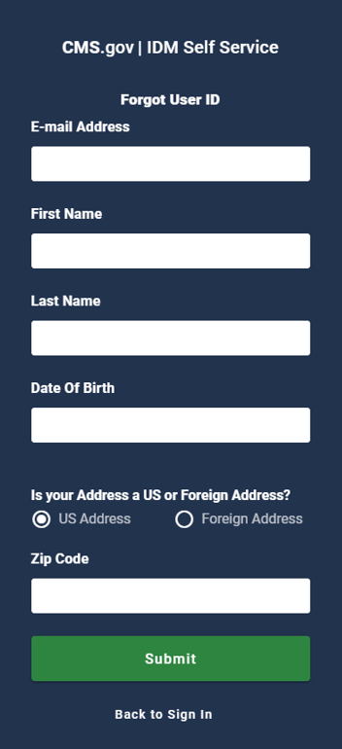
Figure 21: IDM Self-Service Forgot User ID Window
- Enter the E-mail Address, First Name, Last Name, and Date of Birth.
- Keep the default “US Address” setting if the address is a US address. If the address is foreign, click the “Foreign Address” radio button control.
- Enter the Zip Code and click the Submit button. The Forgot User ID window displays a message that informs the user that an email with the requested information has been sent.
- The IDM System sends an email to the email address listed in the user’s profile. This email contains the user’s User ID.
- Click the Back to Sign In button. The user returns to the IDM Sign In window.

How to Unlock a User Account
Users whose accounts are locked for exceeding the maximum number of failed sign-in attempts are automatically redirected to the self-service Unlock Account window illustrated in Figure 22: IDM Self-Service Unlock Account Window. Alternatively, the user may select the Unlock link that is located at the bottom of the IDM Sign In window as illustrated in Figure 17: IDM Sign In Window with Self-Service Links.
When a user is locked out of their account for excessive failed sign-in attempts, the IDM System also sends an email that explains why the account was locked and steps the user should take to unlock the account.
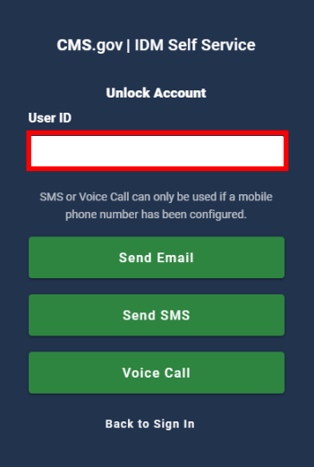
Figure 22: IDM Self-Service Unlock Account Window
- Enter the User ID.
- Click the Send Email button. The Unlock Request Sent window appears.
- Click the Back to Sign In button.
- The IDM System sends an Account Unlock Request email to the email address listed in the user’s profile. This email informs the user of the account unlock request and it contains an Unlock Account hyperlink that the user must use to complete the Unlock Account procedure.
- Click the Unlock Account hyperlink contained within the “Account Unlock” email. The Answer Unlock Account Challenge window appears.
- Enter the security question answer, and then click the Unlock Account button. The screen refreshes and displays a message which states that the account was successfully unlocked.
- Click the Back to Sign In button. The IDM System Sign In window appears and the user’s account is now unlocked.

How to Manage MFA and Recovery Devices
The following terms are used in this section:
- Recovery - A process that allows a user to reset their own password or unlock their own account without the assistance of a helpdesk.
- Recovery Device - An email, short message service (SMS), or interactive voice response (IVR) MFA device that is used to authenticate a user during the recovery process.

A user may have multiple active MFA devices registered to their account if they desire. An email is sent to the user’s email address of record anytime changes occur to an MFA device that is associated with the user’s account.

Note: Adding an MFA device will not add MFA to a user’s sign-in if it is not already required for their role or application.

Table 2: MFA and Recovery Device Summary lists the MFA and Recovery devices that are supported by the IDM System.

Table 2: MFA and Recovery Device Summary
MFA Device | Device Type | Actions | Modifiable Setting | Edit Settings
Email | MFA & Recovery | Add, Activate, Modify, or Remove. | Email Address | User can activate a device that is in pending status.
Text Message (SMS) | MFA & Recovery | Add, Activate, or Remove. | Mobile Phone Number | User can activate a device that is in pending status.
Interactive Voice Response (IVR) | MFA & Recovery | Add, Activate, or Remove. | Phone Number | User can activate a device that is in pending status.
Google Authenticator | MFA Only | Add or Remove. | N/A | Edit is not applicable.
Okta Verify | MFA Only | Add or Remove. | N/A | Edit is not applicable.
YubiKey | MFA Only | Add or Remove. | N/A | Edit is not applicable.

MFA and Recovery device information is part of the user’s account profile. Users view, add, and remove MFA and Recovery devices using the IDM Self Service Dashboard My Profile button and the Manage MFA and Recovery Devices window.

How to View MFA and Recovery Devices
- Click the My Profile button. 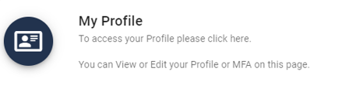 The My Profile window appears.
- Click the Manage MFA and Recovery Devices button.  The Manage MFA and Recovery Devices window opens and displays a summary of the MFA devices that are registered to the user’s profile.
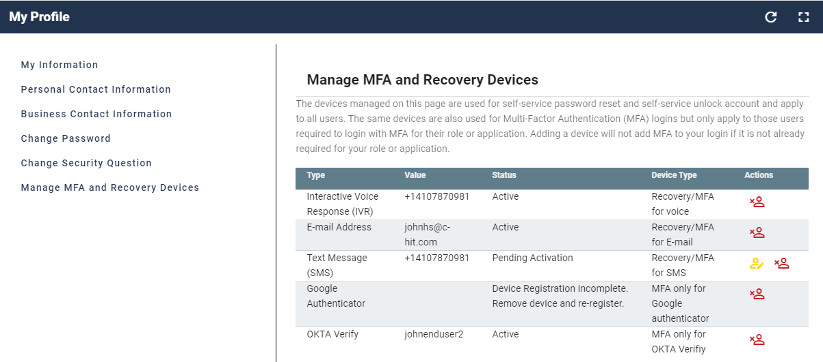
Figure 23: Manage MFA and Recovery Devices Window

How to Add an Email, IVR, or SMS MFA/Recovery Device
Users add an Email, IVR, or SMS MFA / Recovery device using the Manage MFA and Recovery Devices window and the following procedure.
- Access the Manage MFA and Recovery Devices window using the procedure in Section 10.1 How to View MFA and Recovery Devices. The Manage MFA and Recovery Devices window opens as illustrated by Figure 23: Manage MFA and Recovery Devices Window.
- Use the Add another device menu to select the E-mail Address option, Interactive Voice Response (IVR) option, or Text Message (SMS) option. The device configuration window appears.
- Enter the E-mail address for an Email MFA/Recovery device or enter the Phone Number, then enter the Extension if applicable for an IVR MFA/Recovery device.
- Click the Verify MFA button. The MFA confirmation window appears.
- The IDM System sends an email to the email address that is currently associated with the user’s profile places if the Email option was selected. Alternately, if the IVR or SMS option was selected, it places an automated voice call or sends a text message to the phone number that was provided when the device was configured. The email, automated voice call, or text message communicates a one-time verification code to the user.
- Enter the one-time verification code and click the Confirm MFA button. The system displays a message which states that the MFA device was successfully added.
- Click the OK button.

How to Activate a Pending Email, IVR, or SMS MFA/Recovery Device
An Email, IVR, or SMS MFA/Recovery device is placed in “pending” status when a user does not complete the add device procedure. Users activate a pending MFA/Recovery device using the following procedure.
- Access the Manage MFA and Recovery Devices window using the procedure in Section 10.1 How to View MFA and Recovery Devices. The Manage MFA and Recovery Devices window opens as illustrated by Figure 23: Manage MFA and Recovery Devices Window.
- Click the Activate Factor button.  The Activate Factor window appears and displays a message which indicates that an MFA code has been sent.
- The IDM System sends a one-time verification code to the MFA device that is being activated.
- Enter the one-time verification code and click the Confirm MFA button. The system displays a message which states that the MFA device was successfully added.
- Click the OK button.

How to Add a Google Authenticator Mobile App MFA Device
Users add a Google Authenticator mobile app MFA device using the Manage MFA and Recovery Devices window and the following procedure.
- Access the Manage MFA and Recovery Devices window using the procedure in Section 10.1 How to View MFA and Recovery Devices. The Manage MFA and Recovery Devices window opens as illustrated by Figure 23: Manage MFA and Recovery Devices Window.
- Use the Add another device menu to select the Google Authenticator option. The Google Authenticator registration window opens.
- Click the Next button and follow the on-screen prompts for installing a Google Authenticator MFA device.
- Download and install the Google Authenticator mobile app onto the mobile device. Obtain the app from the appropriate app store.
- Click the Register Device button on the IDM Google Authenticator setup window. The window displays a QR code.
- Start the Google Authenticator app on the mobile device and click the Get Started button. The Account Setup screen appears.
- Click the Scan a QR code button on the Google Authenticator app, and then scan the QR code using the Google Authenticator mobile app. The Google Authenticator app generates a one-time verification code.
- Enter the one-time verification code into the IDM Confirm MFA Code dialog box and click the Confirm MFA button. A message is displayed which indicates the MFA device was successfully added.
- Click the OK button.

How to Add an Okta Verify MFA Device
Users add an Okta Verify mobile app MFA device using the Manage MFA and Recovery Devices window and the following procedure.
- Access the Manage MFA and Recovery Devices window using the procedure in Section 10.1 How to View MFA and Recovery Devices. The Manage MFA and Recovery Devices window opens as illustrated by Figure 23: Manage MFA and Recovery Devices Window.
- Use the Add another device menu to select the Okta Verify option. The Okta registration window opens.
- Click the Next button and follow the on-screen prompts for installing an Okta Verify MFA device.
- Download and install the Okta Verify app onto the mobile device. Obtain the app from the appropriate app store.
- Click the Register Device button on the IDM Okta Verify setup window. The window displays a QR code.
- Start the Okta Verify app on the mobile device. The Welcome to Okta Verify screen appears.
- Click the Add Account button on the Okta Verify mobile app, then choose the Organization account type.
- Scan the QR Code using the Okta Verify mobile app.
- A message is displayed which indicates the MFA device was successfully added. Click the OK button.

How to Add a YubiKey MFA Device
The YubiKey MFA device consists of a hardware-based MFA device that plugs into a Universal Serial Bus (USB) port on the user’s desktop or laptop computer.

Note: YubiKey MFA device use is restricted to users who cannot use other supported MFA devices. Each Application Team/Owner of an application that uses YubiKey MFA devices to authenticate users is responsible for purchasing, preparing, managing, and distributing the YubiKey MFA devices to their application users.

Users add a YubiKey MFA device using the Manage MFA and Recovery Devices window and the following procedure.
- Access the Manage MFA and Recovery Devices window using the procedure in Section 10.1 How to View MFA and Recovery Devices. The Manage MFA and Recovery Devices window opens as illustrated by Figure 23: Manage MFA and Recovery Devices Window.
- Use the Add another device menu to select the YubiKey option. The YubiKey registration window opens.
- Click the YubiKey Passcode field.
- Insert the YubiKey device into a USB port and press the button on the YubiKey. A passcode is generated and automatically entered into the YubiKey Passcode field.
- Click the Confirm YubiKey button. A message is displayed which indicates the MFA device was successfully added. Click the OK button.

How to Edit MFA Device Settings
Only Email MFA device settings can be modified. IVR, SMS, Google Authenticator, Okta, and YubiKey MFA device settings must be removed and then re-added if the settings need to be modified.

Note: The Email MFA device uses the same email address that stored in the user’s IDM profile.

Users modify their Email MFA device settings using the My Profile - Personal Contact Information window and the following procedure.
- Click the My Profile button as described in Section 11.1 How to Open and Close the My Profile Function. The My Information window appears.
- Click the Personal Contact Information button.  The Personal Contact Information window appears.
- Click the Edit button.  The Personal Contact Information becomes modifiable.
- Enter the new Email Address and click the Submit button. A message is displayed which indicates the user’s contact information was updated successfully.

Note: The updated Email MFA device may not appear in the Manage MFA and Recovery Devices window until the user logs out and signs in again.

How to Remove an MFA Device
Users may remove MFA devices using the Manage MFA and Recovery Devices window and the following procedure.

Note: If a user removes an active YubiKey MFA device from their account, they must contact their Application Helpdesk before they attempt to re-activate it. The user’s Application Helpdesk must update the YubiKey device with a new seed file and update those changes in IDM’s authentication database before the user can re-activate that device.

- Access the Manage MFA and Recovery Devices window using the procedure in Section 10.1 How to View MFA and Recovery Devices. The Manage MFA and Recovery Devices window opens as illustrated by Figure 23: Manage MFA and Recovery Devices Window.
- Click the Remove Factor button  for the MFA device that requires removal. The Remove MFA Device decision window appears.
- Click the Remove MFA Device button.

How Manage User Account Profile Information
Users view and edit their user account profile information using the IDM Self Service My Profile Function. This function enables users to view and/or modify various attributes of their user profile to include:
- View a summary of their user profile.
- Modify their personal contact information.
- Modify their business contact information.
- Change their password.
- Change their security question.
- Manage their MFA and recovery devices.
An email is sent to the user’s email address of record whenever the user makes a change to their profile information.

How to Open and Close the My Profile Function
Open the My Profile Function:
- Click the My Profile button  located on the Self Service Dashboard. The My Profile window appears.
Close the My Profile Function:
- Choose one of the following actions to close the My Profile function.
- Click the IDM Self Service button  located at the top left corner of the Self Service Dashboard.
- Select another function from the Self Service taskbar.
- Select the Log Out option from the dropdown menu and log out of the system.

How to View User Profile Information
Users view a read-only summary of their user profile information using the My Profile - My Information window and the following procedure.
- Click the My Profile button as described in Section 11.1 How to Open and Close the My Profile Function. The My Information window appears.

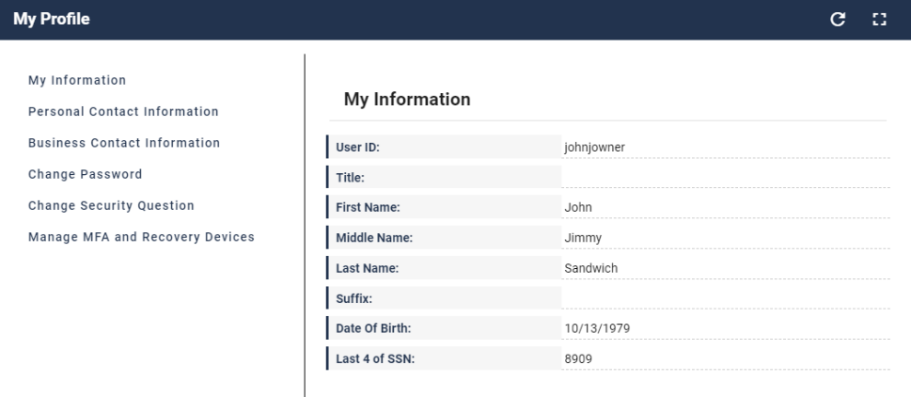
Figure 24: My Profile - My Information

How to View and Modify Personal Contact Information
Users view and modify their personal contact information using the My Profile - Personal Contact Information window and the following procedure.
View Personal Contact Information
- Click the My Profile button as described in Section 11.1 How to Open and Close the My Profile Function. The My Information window appears.
- Click the Personal Contact Information button. The Personal Contact Information window appears.
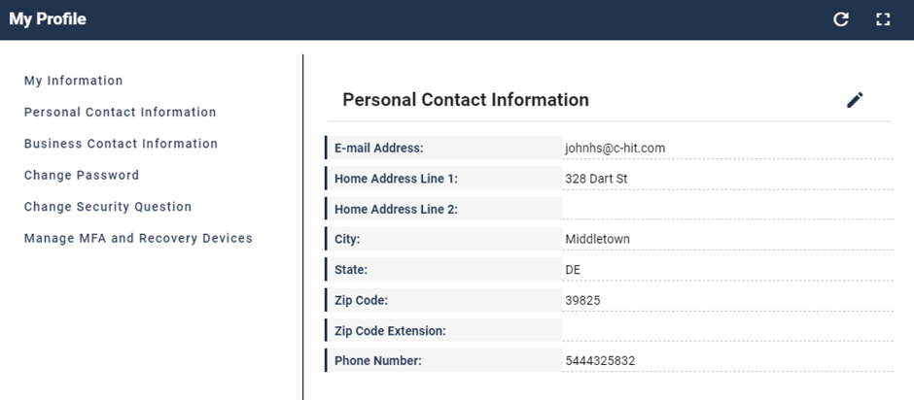
Figure 25: My Profile - Personal Contact Information
Modify Personal Contact Information
- With the Personal Contact Information window open, click the Edit button. The Personal Contact Information becomes modifiable.
- Make the desired changes then click the Submit button. The screen refreshes and the Personal Contact Information window displays the updated information.

How to View and Modify Business Contact Information
Users view and modify their business contact information using the My Profile - Business Contact Information window and the following procedure.
View Business Contact Information
- Click the My Profile button as described in Section 11.1 How to Open and Close the My Profile Function. The My Information window appears.
- Click the Business Contact Information button.  The Business Contact Information window appears.
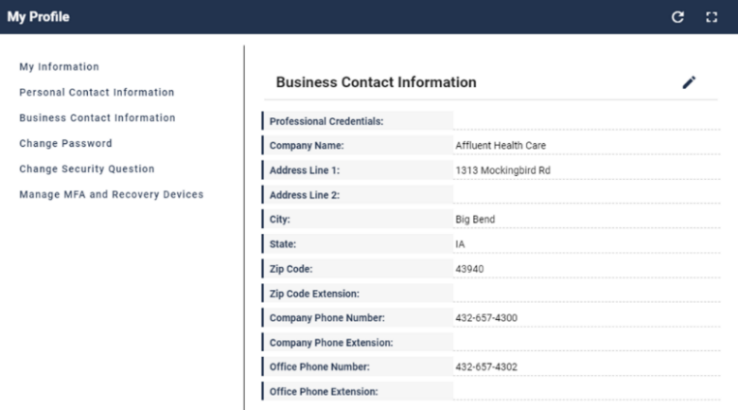
Figure 26: My Profile - Business Contact Information
Edit the User’s Business Contact Information
- With the Business Contact Information window open, click the Edit button. The Business Contact Information becomes modifiable.
- Make the desired changes then click the Submit button. The screen refreshes and the Business Contact Information window displays the updated information.

How to Change the User Account Password
Users change their account password using the My Profile - Change Password window and the following procedure.
- Click the My Profile button as described in Section 11.1 How to Open and Close the My Profile Function. The My Information window appears.
- Click the Change Password button. The Change Password window appears.
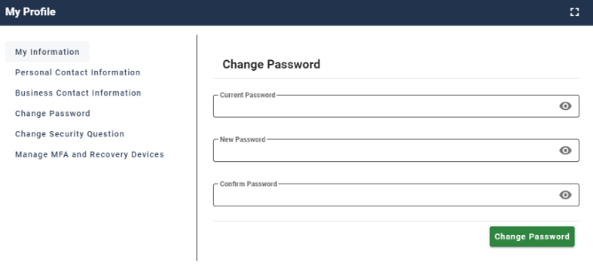
Figure 27: My Profile - Change Password Form
- Enter the Current Password.
- Enter the New Password and the Confirm Password.
- Click the Change Password button.

How to Change the User Security Question and Answer
Users change their security question and answer information using the My Profile - Change Security Question window.
- Click the My Profile button as described in Section 11.1 How to Open and Close the My Profile Function. The My Information window appears.
- Click the Change Security Question button. The Change Security Question window appears.
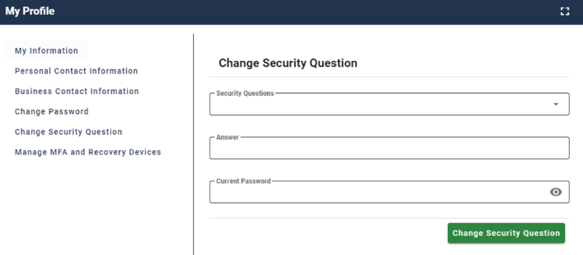
Figure 28: My Profile - Change Security Question Form
- Select a Security Question from the list.
- Enter the security question answer into the Answer field.
- Enter the Current Password.
- Click the Change Security Question button.

How to Approve Role Requests
The following terms are introduced in this section:
- Role Approval - The process used by the Business Owners, their representatives, Authorizers, Help Desks, or other Approvers to grant an application role to a user who is requesting the role.
Users who possess Approver capabilities or Help Desk/Manage User capabilities for an application have the ability to approve or reject role requests from other users who have been placed under their authority. These users are granted access to the My Approvals function and may perform the following tasks:
- View a list of all requests pending approval.
- View the details of a specific request pending approval.
- Approve or reject individual requests pending approval.
- Simultaneously approve and/or reject multiple requests pending approval.
- Export a list of requests pending approval.
The system sends an email to the requesting user’s email address on record which indicates the action that was taken on the request. It also indicates where the user can obtain assistance if they have questions.

How to Open and Close the My Approvals Function
Open the My Approvals Function:
- Click the My Approvals button  located on the Self Service Dashboard. The My Approvals window opens.
Close the My Approvals Function:
- Choose one of the following actions to close the My Approvals function.
- Click the IDM Self Service button located at the top left corner of the Self Service Dashboard.
- Select another function from the Self Service taskbar.
- Select the Log Out option from the dropdown menu and log out of the system.

How to View a List of Pending Approval Requests
Users view a list of all requests that are pending approval using the My Approvals window and the following procedure.
- Click the My Approvals button as described in Section 12.1 How to Open and Close the My Approvals Function. The My Approvals window appears.
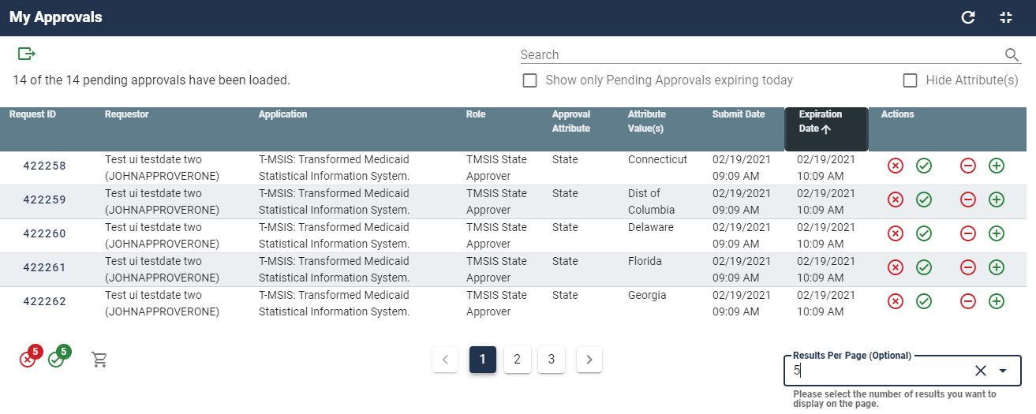
Figure 29: My Approvals Window
The My Approvals window displays a list that contains all requests that have been submitted by other users for the approver to review and approve or reject. An approver has 60 days to approve or reject a request. After 60 days, the request will expire.

How to View Details for a Specific Pending Approval Request
- While viewing records in the My Approvals window, click the Request ID 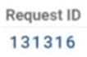 for the desired record that is displayed in the My Approvals window. The Pending Approval Details window appears.
- Click the Go to My Approvals button to close the Pending Approval Details window. The Approver returns to the My Approvals window.

How to Approve or Reject a Single Request
Approvers approve or reject individual pending requests using the Approve Request Now and Reject Request Now buttons on the My Approvals window and the following procedure.
- Click the My Approvals button as described in Section 12.1 How to Open and Close the My Approvals Function. The My Approvals window appears as illustrated by Figure 29: My Approvals Window.

- Click the appropriate button to approve or reject the desired request.
- Approve the Request: Click the Approve Request Now button  on the My Approvals window for the individual record that will be approved. The Approve Request decision window appears.
- Reject the Request: Click the Reject Request Now button  on the My Approvals window for the individual record that will be rejected. The Reject Request decision window appears.
- Enter a brief justification.
- Click the Submit button. The IDM System displays a message which indicates the operation completed successfully. The My Approvals indicator decrements by one.
- Click the Go to My Approvals button. The Approver returns to the My Approvals window.

How to Approve or Reject Multiple Requests on a Single Page
Approvers approve or reject multiple pending requests that are displayed on a single page of requests using the Approve All on Current Page Now and Reject All on Current Page Now buttons on the My Approvals window and the following procedure.
- Click the My Approvals button as described in Section 12.1 How to Open and Close the My Approvals Function. The My Approvals window appears as illustrated by Figure 29: My Approvals Window.
- (Optional) Use the Pagination control 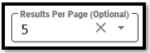 to change the number of requests that are displayed on a page in the My Approvals window.
- Click the appropriate button to approve or reject all requests on the current page:
- Approve the Request: Click the Approve All on Current Page Now button. . The Pending Approvals to Process window opens and all requests on the page are listed with an action to APPROVE.
- Reject the Request: Click the Reject All on Current Page Now button.  The Pending Approvals to Process window opens and all requests on the page are listed with an action to REJECT.
- (Optional) Click the Request Details button  to view details about a specific request. Click the Request Details button again to close the details window for that request.
- (Optional) Click the Remove Request control  to remove a specific request from the Approve or Reject list.
- Enter a brief justification. The same justification will be applied to each request.
- Click the Submit button. All records that appear on the Pending Approvals to Process list will be processed as Approvals or Rejections.
- The IDM System displays a message that indicates the operation completed successfully and the My Approvals indicator is decremented by the number of requests that were processed.
- Click the Go to My Approvals button. The Approver returns to My Approvals window.

How to Simultaneously Approve and Reject Multiple Requests
Approvers simultaneously approve and reject multiple requests using the Bulk Process as an Approval, Bulk Process as a Rejection, and Cart buttons on the My Approvals window and the following procedure.
- Click the My Approvals button as described in Section 12.1 How to Open and Close the My Approvals Function. The My Approvals window appears as illustrated by Figure 29: My Approvals Window.
- (Optional) Use the Pagination control to change the number of requests that are displayed on each page in the My Approvals window.
- Click the appropriate button to approve or reject each individual request that is displayed on the page:
- Approve the Request: Click the Bulk Process as an Approval button.  The request is added to the Pending Approvals to Process queue with an action to APPROVE. The Cart counter increments for each record added to the queue.
- Reject the Request: Click the Bulk Process as a Rejection button.  The request is added to the Pending Approvals to Process queue with an action to REJECT. The Cart counter increments for each record added to the queue.
Click the Cart button.  The Pending Approvals to Process window appears.
- (Optional) Click the Remove Request button to remove a specific request from the bulk Approval/Rejection action.
- Enter a justification for the Rejections and a justification for the Approvals. The same rejection or approval justification will be applied to each rejected or approved request respectively.
- Click the Submit button. All records that appear on the Pending Approvals to Process list will be processed as Approvals or Rejections.
- The IDM System displays a message which indicates the operation completed successfully and the My Approvals indicator is decremented by the number of requests that were processed.
- Click the Go to My Approvals button. The Approver returns to the My Approvals window.

How to Export a List of Pending Approvals to an Excel Spreadsheet
Approvers can export a list of requests that are pending approval using the Export button located on the My Approvals window and the following procedure.
- Click the My Approvals button as described in Section 12.1 How to Open and Close the My Approvals Function. The My Approvals window appears as illustrated by Figure 29: My Approvals Window.
- (Optional) Use the Pagination control to adjust the number of requests that are displayed on each page.
- (Optional) Use the Search box  to perform a search across all columns to obtain a list of records that contain a desired alphanumeric search term.
- (Optional) Click the Expiring Today filter to display only those requests that will expire on the current day.
- (Optional) Click the Hide Attributes filter to hide or view the columns of information that pertain to role attributes.
- (Optional) Click the My Approvals Column Headings  to perform an alphanumeric sort of the information in the respective columns. The sort order will alternate between normal and reverse order each time the user clicks.
- Click the Export button and select the output format. The Save As window opens.
- Click the Save button. The list of pending approvals is downloaded to the user’s computing device as a Microsoft Excel spreadsheet (.xls) file.

How to View IDM Reports

Description of the IDM Reports Function
Users who require access to the IDM Reports must submit a role request for the IDM Reports application using the procedure outlined in Section 6.1 How to Request a Role for a New Application.

Note: Users will receive access to a predetermined number of reports based on the specific role that they request. Appendix B: IDM Report Categories provides a summary of the IDM reports the system produces.

How to Access the IDM Reports
Users that possess report access privileges view the desired reports using the My Reports button which is located on the Self Service Dashboard, and the following procedure.
- Click the My Reports button.  The My Reports window appears.
Figure 30: My Reports Window
- Select a report. The screen refreshes and the report appears.
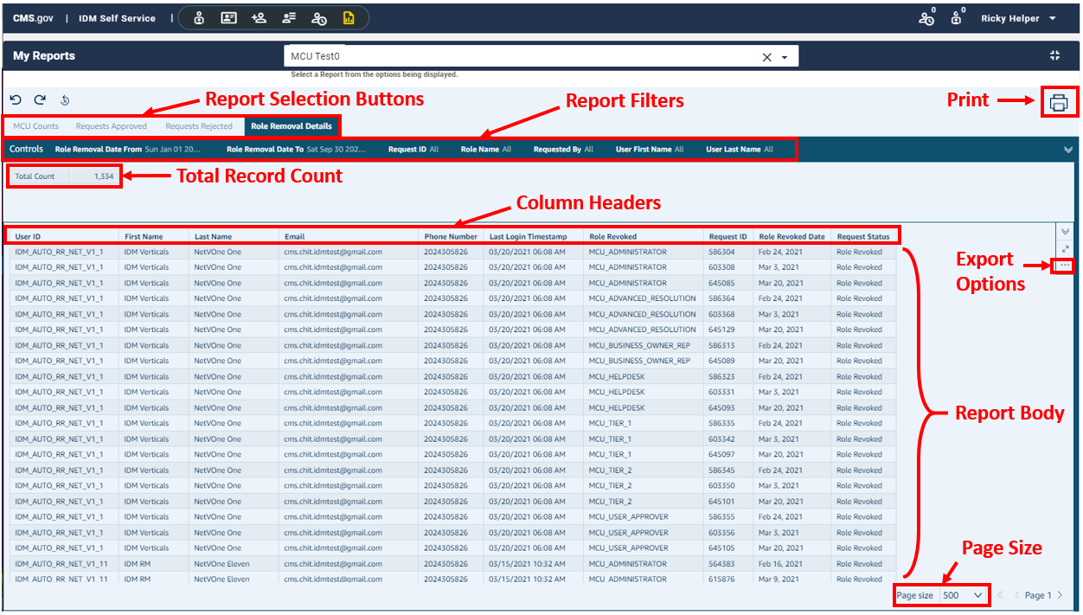
Figure 31: My Reports Window with Sample Report (Full Screen View)
- Click the Report Selection button that corresponds to the desired report if multiple reports are available. For example:

- (Optional) Filter report columns: Click a Report Filter button to filter the report to display specific information. For example: 

- (Optional) Sort report columns: Click a Column Header to change the sort order of the report data based on the order of the selected column. For example:

- (Optional) Change the page size: Click the Page Size button to change the number of records displayed on the screen. For example: 

How to Print a Report
Use the following procedure to print a report.
- Select and view the desired report using the procedure in Section 13.2 How to Access the IDM Reports.
- Click the Print button and choose the Print option. The Prepare for printing window opens.
- (Optional) Change the Paper size and/or the Paper orientation.
- (Optional) Select the Print background color option if the report title cannot be seen against a white background.
- Click the Go to preview button.
- Click the Print button.

How to Export a Report to an Excel Spreadsheet
- Select and view the desired report using the procedure in Section 13.2 How to Access the IDM Reports.
- (Optional) If the Export Options button is not visible, click on any row of the Report Body.
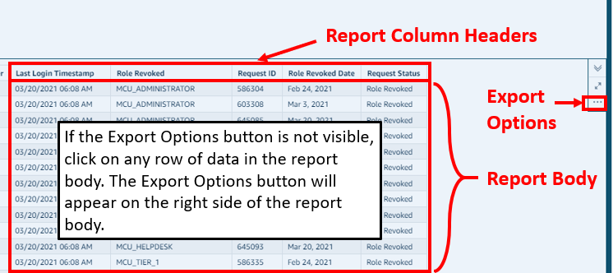
Figure 32: Location of the My Reports Export Options Button
- Click the Export Options button and select the export format.
- The Download Status window appears and displays the progress of the download operation. The Save As window appears after the download is complete.
- Click the Save button.
- Click the Done button on the Download Status window.

How to Perform Annual Role Certification
The following terms are introduced in this section:
- Role - A name given to a set of permissions in an application, e.g., Representative, Submitter, or Authorizer.
- Annual Role Certification - The process for extending the role grant for another year. Annual Role Certification is required every year by CMS security policy and is counted from the date of the previous year’s certification.
- Manually Approved Roles - Roles that are subject to a request and approval process performed by a person. The first or original grant of a manually approved role is valid for one year.
- Validated Roles - Roles that are subject to an automated validation check where user provided data is compared to data maintained in a trusted source by a machine. Validated roles have an annual role certification due date of June 1st each year.

Annual Role Certification for Manually Approved Roles
The IDM System sends email notifications to Approvers who manage users with manually approved roles to remind them of the annual role certification date.
Approvers who manually certify roles may also use the “Pending Annual Role Certification” report to obtain information about all user roles that are pending or due for annual role certification. Approvers must request and be approved for the IDM Reports role before they can access this report. Please refer to Section 13 How to View IDM Reports for information on how to view IDM Reports.

Note: If an approver fails to certify a user’s role, it will be revoked on the certification due date. If a user’s role has been revoked, they will have to use IDM’s Role Request function as described in Section 6 How to Request a Role to request that role again.

How to Open and Close the My Annual Role Certifications Function

Note: The My Annual Role Certifications button is only available for users who have an Approver role and who certify or revoke manually approved roles.

Open the My Annual Role Certifications Function:
- Click the My Annual Role Certifications button 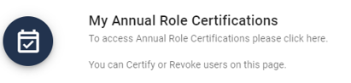 located on the Self Service Dashboard. The My Annual Role Certifications window opens.
Close the My Annual Role Certifications Function:
- Choose one of the following actions to close the My Annual Role Certifications function.
- Click the IDM Self Service button located at the top left corner of the Self Service Dashboard.
- Select another function from the Self Service taskbar.
- Select the Log Out option from the dropdown menu and log out of the system.

How to View a List of Pending Certifications
Users view a list of all role certifications that are pending certification or revocation using the My Annual Role Certifications window and the following procedure.

Note: The My Annual Role Certifications window displays a list of the first 1000 user roles under an Approver’s authority that are pending certification within the next 365 days. A maximum of 1000 roles that are pending certification can be displayed at a time.

- Click the My Annual Role Certifications button as described in Section 14.1 How to Open and Close the My Annual Role Certifications Function. The My Annual Role Certifications window appears.
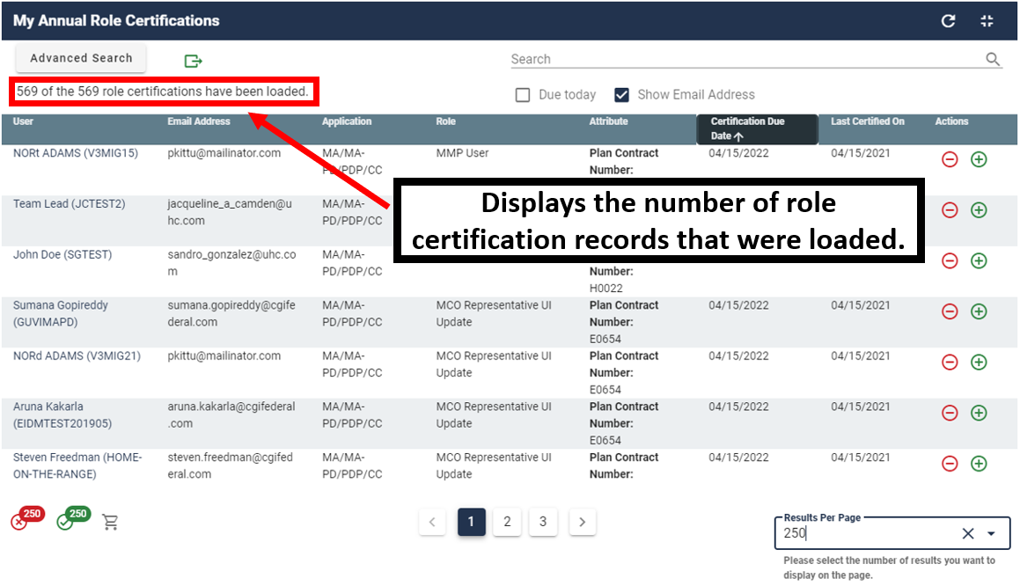
Figure 33: My Annual Role Certifications Window
- (Optional) Use the Pagination control 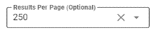 to adjust the number of pending certifications that are displayed on each page.
- (Optional) Use the Page Navigation controls  to move between pages of results. Click the Arrows to move to the previous or next page. Click the Page Numbers to select a specific page of results.
- (Optional) Click the Due Today filter  to display only those users whose certifications expire at the end of the current day.
- (Optional) Click the Show Email Address filter  to hide or view the email address column.
- (Optional) Click any Column Heading 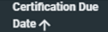 to sort the list based on the contents of that column.

How to Perform a Global Search
Global Search enables Approvers to perform a keyword search across all information (including role attributes if applicable) to narrow the results of the records in their pending role certification queue.

Note: If an Approver has more than 1000 user roles pending role certification, only the first 1000 pending role records can be searched using Global Search.

Note: The Email Address column must be displayed if you want to perform a Global Search based on a user’s email address .

Users perform a global search using the following procedure.
- Click the My Annual Role Certifications button as described in Section 14.1 How to Open and Close the My Annual Role Certifications Function. The My Annual Role Certifications window appears as illustrated by Figure 33: My Annual Role Certifications Window.
- Type a keyword into the Search field. 
- The screen refreshes and the My Annual Role Certifications window only displays records that contain the global search criteria.

How to Perform an Advanced Search
Advanced Search enables Approvers to perform a search using a combination of date range, application, role, and group (if applicable) to narrow the results of the records in their pending role certification queue.
Approvers can use Advanced Search can be used to certify or revoke users at any time during the year.
Users perform an advanced search using the following procedure.
- Click the My Annual Role Certifications button as described in Section 14.1 How to Open and Close the My Annual Role Certifications Function. The My Annual Role Certifications window appears as illustrated by Figure 33: My Annual Role Certifications Window.
- Click the Advanced Search button.  The Advanced Search window appears.
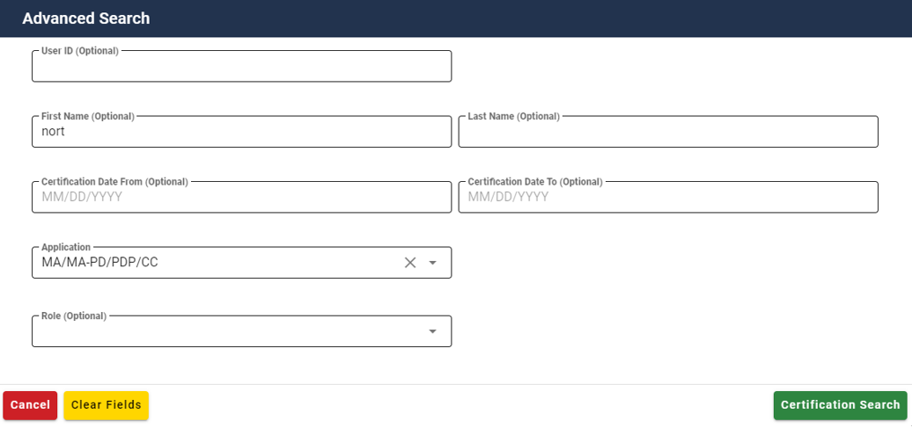
Figure 34: My Annual Role Certification Advanced Search Window
- (Required) Select an Application.
- (Optional) Select a Role and/or Group.
- (Optional) Enter any combination of User ID, First Name, Last Name, Certification Date From or Certification Date To.
- Click the Certification Search button.
- The screen refreshes and the My Annual Role Certifications window only displays those pending certification records that meet the search criteria.
- (Optional) Perform a Global Search by attribute to further narrow the results of an Advanced Search.

How to View User/Role Details and Certify/Revoke a Single User’s Role
Approvers have the ability to view a single user’s profile information and role details, then certify or revoke that user’s role using the following procedure.

Note: The Revoke Role function does not immediately remove a user’s access to IDM and any application(s). Approvers can immediately remove the user’s access via IDM’s role removal function.

- Click the My Annual Role Certifications button as described in Section 14.1 How to Open and Close the My Annual Role Certifications Function. The My Annual Role Certifications window appears as illustrated by Figure 33: My Annual Role Certifications Window.
- Click the User ID of the desired user. 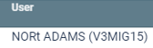 The User Details window appears.
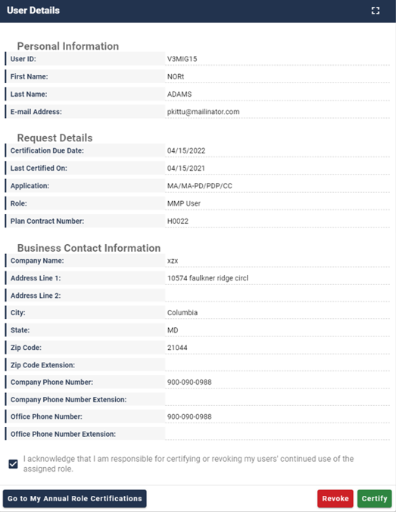
Figure 35: My Annual Role Certification User Details
- Click the Acknowledge box.
- Certify or Revoke the user’s role.
  - Click the Certify button to certify the user’s role.
Or
  - Click the Revoke button to revoke the user’s role.
- The system displays a message that states the transaction was successful.

How to Bulk Certify or Revoke Multiple User Roles
The Bulk Certify/Revoke feature enables Approvers to select all user roles that are displayed on the current page of results then bulk-submit them for certification or revocation. A maximum of 1000 roles that are pending certification can be certified or revoked in a single transaction.

Warning: The more role certifications you try to process in one transaction, the more time it will take for that transaction to complete .

- Click the My Annual Role Certifications button as described in Section 14.1 How to Open and Close the My Annual Role Certifications Function. The My Annual Role Certifications window appears as illustrated by Figure 33: My Annual Role Certifications Window.
- (Optional) Use the Pagination control 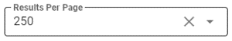 to adjust the number of pending certification records that are displayed on each page.
- Certify or Revoke the user’s role.
- Click the Certify all button  flag all roles displayed on the page for certification.
Or
- Click the Revoke all button  to flag all roles displayed on the page for revocation.
- The Certification(s) to process window appears.
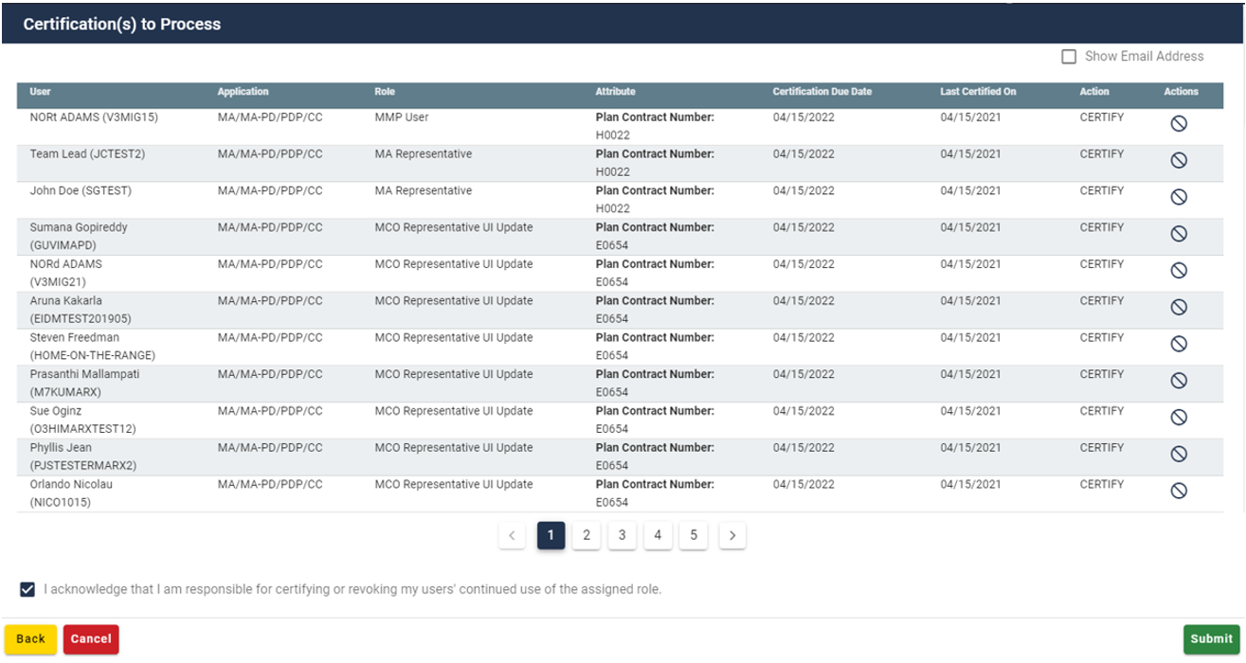
Figure 36: Certifications to Process Window
- (Optional) Click the Remove from Cart button  to reverse the certify or revoke action for a single role.
- Click the Acknowledge box.
- Click the Submit button. All flagged roles are certified or revoked
- The system displays a message that states the transaction was successful.

How to use the Cart to Certify and Revoke Multiple User Roles
The Cart enables Approvers to select multiple user roles then certify and revoke those roles simultaneously in one transaction. A maximum of 1000 roles that are pending certification can be certified or revoked in a single transaction using the Cart.

Warning: The more role certifications you try to process in one transaction, the more time it will take for that transaction to complete .

- Click the My Annual Role Certifications button as described in Section 14.1 How to Open and Close the My Annual Role Certifications Function. The My Annual Role Certifications window appears as illustrated by Figure 33: My Annual Role Certifications Window.
- (Optional) Use the Pagination control to adjust the number of pending certification records that are displayed on each page.
- Certify or Revoke the user’s role.
- Click the Certify button.  The record turns green and is flagged for certification in the Cart. The Cart’s counter increases by one for each flagged record.
Or
- Click the Revoke button.  The record turns red and is flagged for revocation in the Cart. The Cart’s counter increases by one for each flagged record.
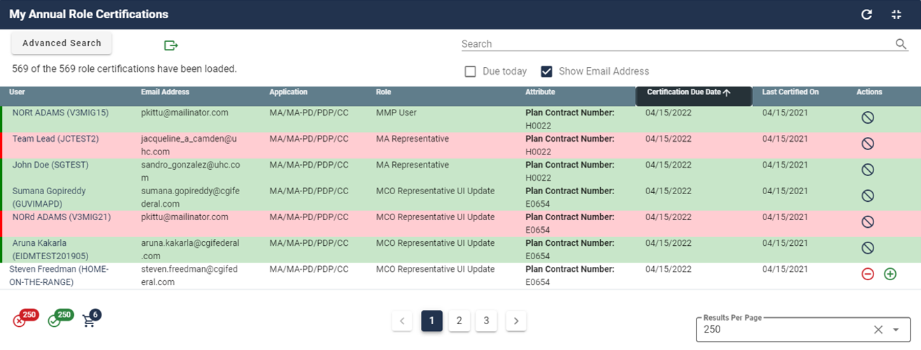
Figure 37: Certify and Revoke Multiple User Roles using the Cart Feature
- (Optional) Click the Remove from Cart button  to reverse the certify or revoke action for a single role. The Cart’s counter decreases by one for each record that is removed.
- Click the Cart button. The Certification(s) to Process window appears as illustrated by Figure 36: Certifications to Process Window.
- Click the Acknowledge box.
- Click the Submit button. The system displays a message that states the action was successful.

Annual Role Certification for Validated Roles
The IDM System performs an Annual Role Certification pre-check validation of user roles based on a comparison of information the user provided during the initial role request and information that is maintained in a trusted source. User roles that pass this pre-check are automatically certified by the system on June 1st and approvers are not required to take any action.

System Notifications Sent for Users who Fail Pre-check Validation
The IDM System sends email notifications to next level application Approvers and Business Owners with information about users who fail the pre-check validation. This email includes the user’s role details and directs the next level application Approvers and Business Owners to take action to correct any discrepancies before the June 1st certification due date for validated roles.
The initial email is sent 90 days before the June 1st certification due date. Subsequent reminder emails are sent at 60 days, 30 days, 7 days, and 1 day before the June 1st certification due date if the discrepancies are not corrected.
Note: If the next level application Approver or Business Owner fails to correct the discrepancies before the June 1st role validation check, the affected users will fail Annual Role Certification and the affected users will have their roles automatically revoked. Any user whose role has been revoked, will have to request that role again by using the IDM’s Role Request function as described in Section 6 How to Request a Role.

Approvers who manually certify roles may also use the “Pending Annual Role Certification” report to obtain information about all user roles that are pending or due for annual role certification. Approvers must request and be approved for the IDM Reports role before they can access this report. Please refer to Section 13 How to View IDM Reports for information on how to view IDM Reports.

Instructions for Help Desks

Description of the Help Desk/Manage Users Functions
The Help Desk/Manage Users button provides access for Application (Tier 1) and IDM (Tier 2) Help Desk staff to the following functions:
- Perform an Application Search (Tier 1 only)
- Perform an Enterprise Search
- Suspend a user’s account
- Remove a user’s roles
- Cancel a user’s pending requests
- Reset a user’s password
- Unlock a user’s account
- Manage a user’s LOA
- Unsuspend a user’s account (Tier 2 only)
- Create User Audit reports and Role Request Audit reports (Tier 2 only)

How to Access the Help Desk Functions
The Help Desk Functions are accessed from the Help Desk UI. Help Desk Users access the Help Desk UI using the Help Desk/Manage Users button located on the IDM Self Service Dashboard.
Open the Help Desk UI:
- Click the Help Desk/Manage Users button. 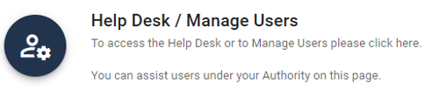 located on the Self Service Dashboard. The Application Search window appears.

How to Choose the Appropriate Search
The matrix illustrated by Figure 38: Application and Enterprise Search Capabilities Matrix provides information to assist Help Desk Users with choosing the appropriate search for the task that needs to be performed.
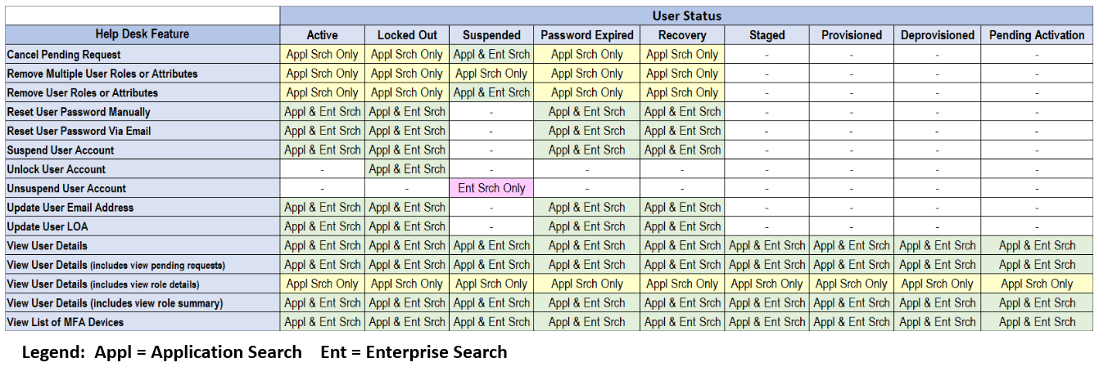
Figure 38: Application and Enterprise Search Capabilities Matrix

How to Perform an Application Search
The Application Search allows users with Tier 1 Help Desk capabilities to search for and assist users in their application.
The Application Search stops returning results after 50 records are returned. Users whose search results exceed this limit must use additional parameters to refine their search.
The procedure that follows provides the steps to perform an Application Search using the Help Desk UI Application Search button.
- Click the Help Desk/Manage Users button. The Application Search form appears.
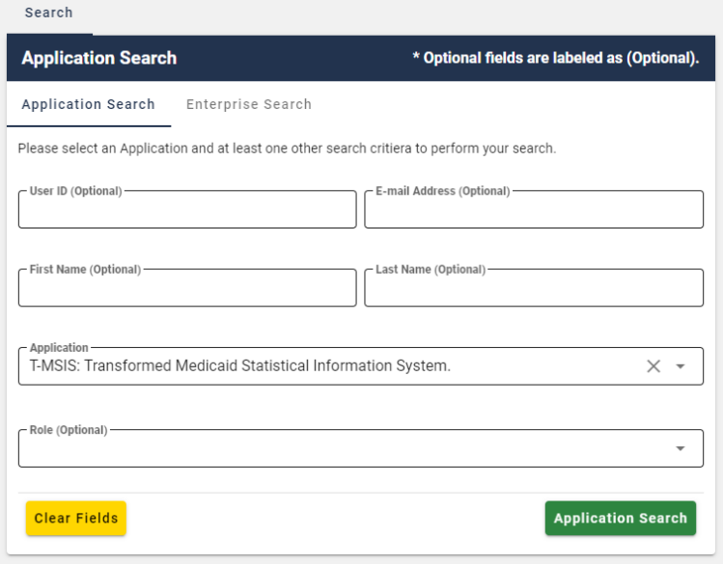
Figure 39: Help Desk Application Search Form
- Select an application from the Application list. The Role list appears.
- (Optional) Select a role from the Role list. Selecting a Role will limit the search to users who possess that role within the application.
- (Optional) Enter any combination of User ID, Email Address, First Name or Last Name. Doing so will limit the number of search results to the combination of those parameters plus the application and role.
- Click the Application Search button. The screen refreshes and the search results appear. If the search does not return results, the system displays a warning message that directs the user to refine their search parameters and submit another search.
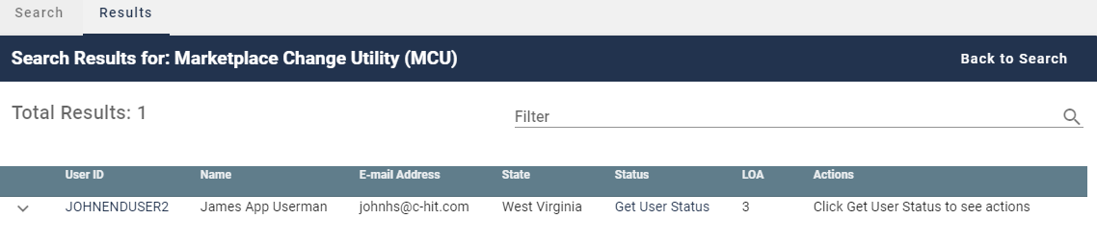
Figure 40: Help Desk Application Search Results
- Perform the desired Help Desk User management functions as described in later sections of this guide.

How to Perform an Enterprise Search
The Enterprise Search allows users with Help Desk capabilities to search for users without limitation to the specific application. It is intended to allow Help Desks to assist users who either do not have a role and therefore cannot be found using Application Search, or who have called a Help Desk for an application other than their own.
All Enterprise Search form fields are considered to be optional parameters; however the Enterprise search form requires that any search contain at least a First Name and Last Name, or a User ID, or an Email Address parameter.
The Enterprise Search will stop returning results after 5 records are returned. Users whose search results exceed this limit will need to refine their search using additional search parameters.
The procedure that follows provides the steps to perform an Enterprise Search using the Help Desk UI Enterprise Search button.
- Click the Help Desk/Manage Users button. The Application Search form appears for Application (Tier 1) Help Desk Users or the Enterprise Search form appears for IDM (Tier 2) Help Desk Users.
- (Application Help Desk Users only) Click the Enterprise Search button.  The Enterprise Search Form appears.
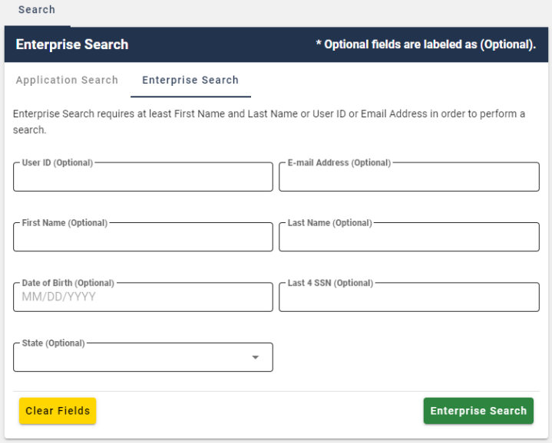
Figure 41: Help Desk Enterprise Search Form
- Enter any combination of User ID or Email Address or First Name and Last Name.
- (Optional) Enter any combination of Date of Birth, or Last 4 SSN. Doing so will limit the number of search results to the combination of those parameters plus the parameters selected in Step 3.
- (Optional) Select a State from the list. Doing so will limit the search to users whose account information matches the state plus the combination parameters selected in previous steps.
- Click the Enterprise Search button. The screen refreshes and the search results appear.
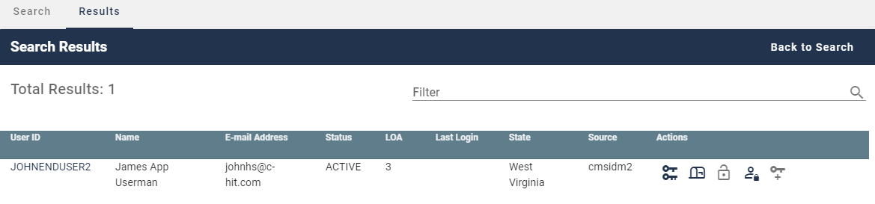
Figure 42: Help Desk Enterprise Search Results
- Perform the desired Help Desk User management functions as described in later sections of this guide.

How to View a User’s Profile
The procedure in this section provides the steps to view a user’s profile. The User Profile view provides “read-only” access.
- Perform an Application Search according to the procedure in Section 15.4 How to Perform an Application Search or an Enterprise Search according to the procedure in Section 15.5 How to Perform an Enterprise Search. The screen refreshes and the search results appear.
- Click the User ID for the desired user. The screen refreshes, the User Details window appears and displays the User Profile information.
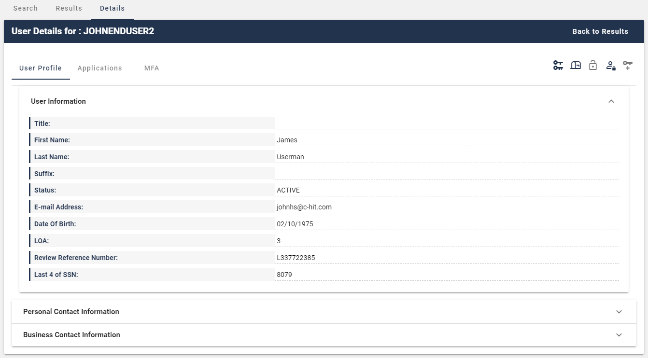
Figure 43: User Details User Profile Tab
- (Optional) Click the Expand Detail button to display or hide the details of the user’s personal contact Information and the user’s business contact information.

How to View a Summary of a User’s Applications
The procedure in this section provides the steps to view a user’s applications.

Note: Role Management controls and functions are only available for Application Search results, additionally, the Help Desk user must possess the capability to access those functions.
- Perform an Application Search according to the procedure in Section 15.4 How to Perform an Application Search or an Enterprise Search according to the procedure in Section 15.5 How to Perform an Enterprise Search. The screen refreshes and the search results appear.
- Click the User ID for the desired user. The screen refreshes, the User Details window appears and displays User Profile information.
- Click the Applications tab. A summary of the user’s Applications is displayed.
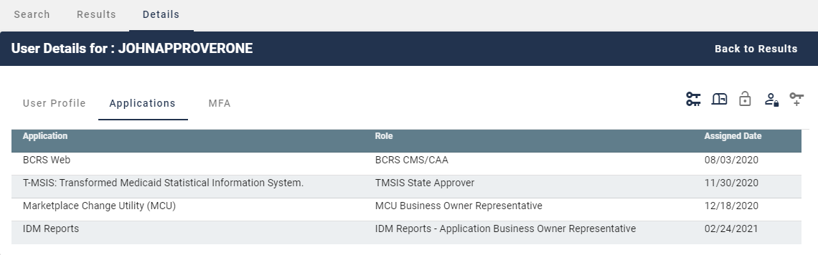
Figure 44: Enterprise Search Results - Applications Tab
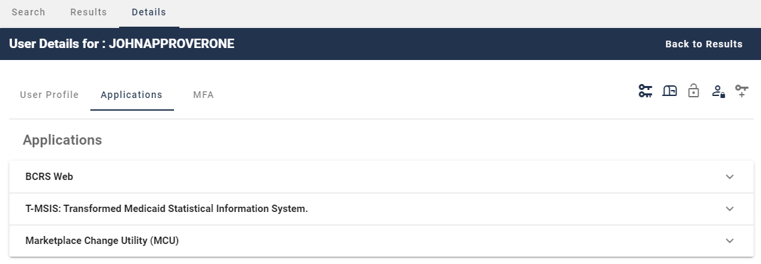
Figure 45: Application Search Results - Applications Tab
- (If applicable) Click the Expand Detail button. A summary of role information for the desired application appears.
- (If applicable) Click the Hide Detail button.  The summary of role information for that application is hidden.

How to Remove a Single Role
Help Desk Users who possess the proper privileges can use either the Application Search Results window or the User Details Applications tab and the Remove Now button to remove a single role from the account of another user.
Note: The IDM System will display a warning message if the role removal or attribute removal operation could affect the last approver of an organization that still has users associated with that role or attribute. Such users could be left in an “orphaned” state without an approver of record for future role requests.

The procedure in this section provides the steps to remove a single role from an individual user’s account using the Help Desk UI Remove Now button.
- Perform an Application Search according to the procedure in Section 15.4 How to Perform an Application Search.

Note: Step 2a provides the sequence of steps that must be followed when using the Application Search Results window, while Step 2b provides the sequence of steps that must be followed when using the User Details Application tab. Both options provide access to the controls that are described in this procedure.

2a) This option uses the Application Search Results window.
- Click the Expand Detail button. A summary of the user’s role/attribute information for the desired application appears and the Remove Now and Add to Cart buttons appear.
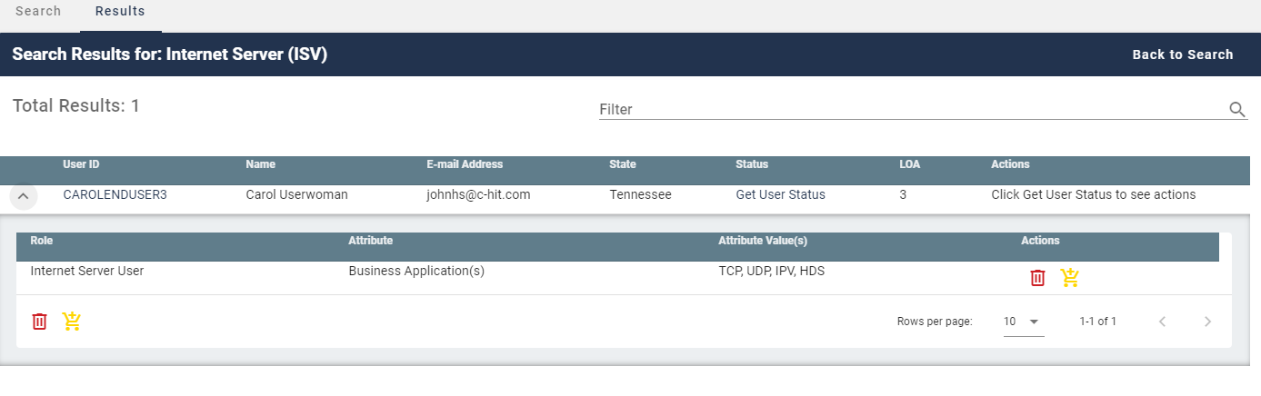
Figure 46: Application Search Results
2b) This option uses the User Details Applications tab.
- Click the User ID for the desired user. The screen refreshes and the User Profile information appears.
- Click the Applications tab. A summary of the user’s applications appears.
- Click the Expand Detail button. A summary of the user’s role/attribute information appears and the Remove Now and Add to Cart buttons appear.
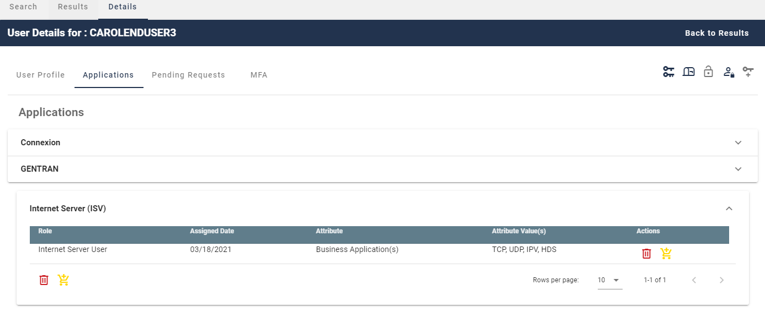
Figure 47: User Details Applications Tab
- Click the Remove Now button  for the role that requires removal. The Remove Role/Attribute window appears.
- Enter a justification and click the Remove Selected Roles button.
- The Help Desk UI displays Request ID information and a message that informs the Help Desk User that the request was successfully submitted.

How to Remove Multiple Roles
A Help Desk User who possesses the proper privileges can use either the Application Search Results window or the User Details Applications tab and the Remove All Now button to remove multiple roles from user accounts in a single operation.

Note: The IDM System will display a warning message if the role removal or attribute removal operation could affect the last approver of an organization that still has users associated with that role or attribute. Such users could be left in an “orphaned” state without an approver of record for future role requests.

The procedure in this section provides the steps to remove multiple roles in a single operation using the Help Desk UI Remove All Now button.
- Perform an Application Search according to the procedure in Section 15.4 How to Perform an Application Search.

Note: Step 2a provides the sequence of steps that must be followed when using the Search Results window, while Step 2b provides the sequence of steps that must be followed when using the User Details Application tab. Both options provide access to the controls that are described in this procedure and illustrated by Figure 48: List of User’s Roles / Attributes.

2a) This option uses the Search Results window.
- Click the Expand Detail button. A list of the user’s role/attribute information for the desired application appears and the Remove Now and Add to Cart buttons appear.

2b) This option uses the User Details Applications tab.
- Click the User ID for the desired user. The screen refreshes and the User Profile information appears.
- Click the Applications tab. A list of the user’s applications appears.
- Click the Expand Detail button. A list of the user’s role/attribute information appears and the Remove Now and Add to Cart buttons appear.
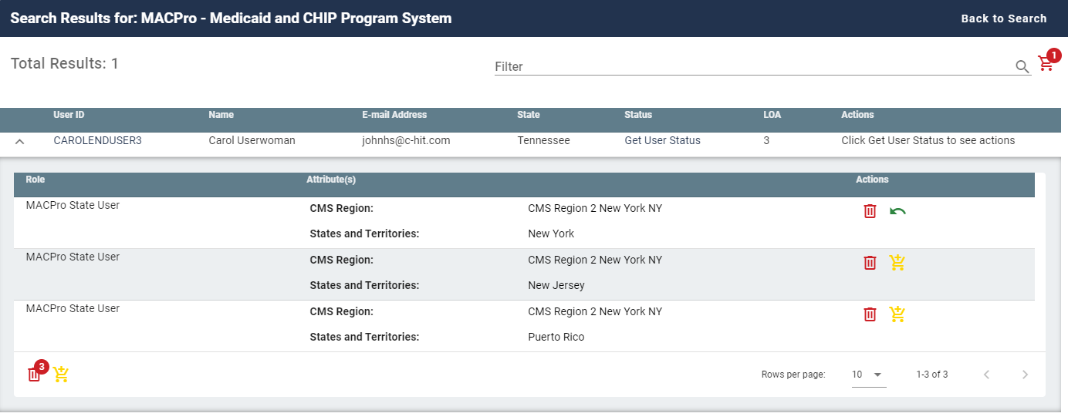
Figure 48: List of User’s Roles / Attributes
- Click the Add to Cart button  for the individual role that requires removal. The Remove From Cart button appears.
- (Optional) Click the Remove from Cart button  for any role that should not be removed.
- The Remove All Now button  appears and increments by “1” for each role that is added to the remove queue. It will also decrease by “1” for each role that is removed from the Cart.
- Click the Remove All Now button. The Remove Role/Attribute window appears.
- (Optional) Review the list and click the Remove from Cart button for any role that should not be removed.
- Enter a justification and click the Remove Selected Roles button. The Help Desk UI displays Request ID information and a message that informs the Help Desk User that the request was successfully submitted.

How to Cancel Pending Requests
A Help Desk User who possesses the proper privileges can cancel pending requests for other users which they manage.
The following procedure provides the steps to cancel pending requests using the Help Desk UI Cancel Pending Role Request button.
- Perform an Application Search according to the procedure in Section 15.4 How to Perform an Application Search.
- Click the User ID for the desired user. The screen refreshes, the User Details window appears and displays User Profile information.
- Click the Pending Requests tab. A list of the user’s pending requests appears.
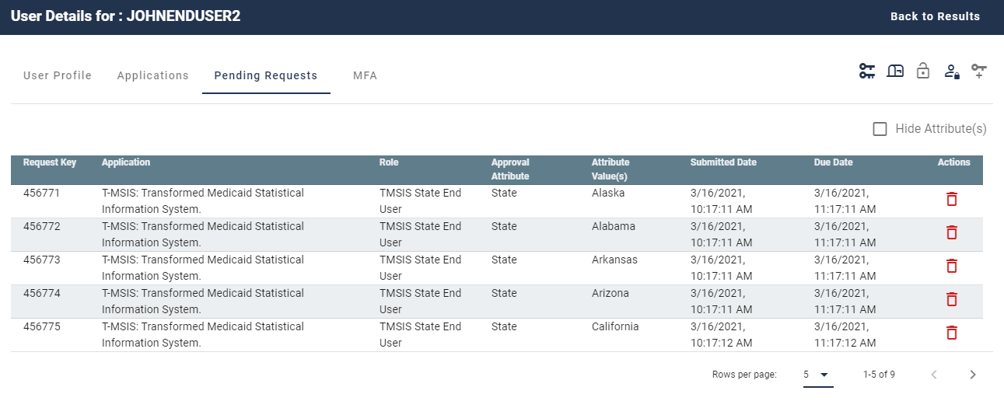
Figure 49: User Details Pending Requests Tab
- Click the Cancel Pending Role Request button  for the role request that requires removal. The Cancel Pending Role Request decision window appears.
- Enter a justification and click the Cancel Pending Role Request button. The Help Desk UI displays Request ID information and a message that informs the Help Desk User that the request was successfully submitted.

How to View a User’s MFA Devices
Help Desk Users use the MFA tab to view a summary of a user’s MFA devices while viewing the User Details of an Application search or an Enterprise search.
This summary consists of the following information:
- Factor - The type of MFA device. The IDM system supports Email, Interactive Voice Response (IVR), Short Message Service (SMS), Okta, and Google Authenticator.
- Device - The identifier assigned to the device. It may be a phone number, User ID, or email address.
- Provider - The service provider of the MFA device.
- Status - The device state. Active devices are ready for use. Devices that are Pending are not ready and must be activated by the user.
- Create Date - The date that the device was activated in the user’s profile, or the date the device entered Pending Activation status.
The following procedure provides the steps to view a summary of a user’s MFA devices using the Help Desk UI MFA tab.
- Perform an Application Search according to the procedure in Section 15.4 How to Perform an Application Search or an Enterprise Search according to the procedure in Section 15.5 How to Perform an Enterprise Search. The Search Results window appears.
- Click the User ID for the desired user.  The User Details window appears and displays the User Profile information.
- Click the MFA tab. The MFA device summary appears.
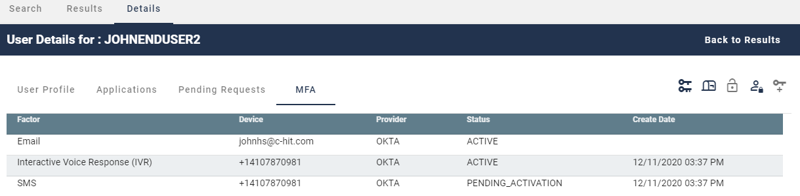
Figure 50: User Details MFA Device Summary

How to Update a User’s Email Address
A Help Desk User who possesses the proper privileges can use the Help Desk UI Update Email Address button to update the email address of another user.
The following procedure provides the steps to update a user’s email address using the Help Desk UI Update Email Address button.

Note: Subsequent to a Help Desk initiated email address change, that user’s email MFA device information will not appear in the Help Desk User’s MFA Device view until that user signs into the system again.

- Perform an Application Search according to the procedure in Section 15.4 How to Perform an Application Search or an Enterprise Search according to the procedure in Section 15.5 How to Perform an Enterprise Search. The Search Results window appears.
- (Application Search Users Only) Click the Get User Status button. The Update E-mail Address button appears under the “Actions” column.
- Click the Update E-Mail Address button  for the desired user. The Update E-Mail Address window appears.
- Enter the new email address.
- Enter a justification and click the Submit button. The system displays a message that indicates the operation completed successfully

How to Reset a User’s Password (Email Reset Method)
When a user is unable to reset their password using the IDM System Self Service Dashboard, that user may request the assistance of a Help Desk User to initiate a password change operation by sending a Password Reset email to the requesting user. The email is sent to the email address that is currently listed in the user’s profile and contains a hyperlink to the IDM System password reset mechanism.
The procedure that follows provides the steps to reset a user’s password using the Help Desk UI Reset Password button and the Email Reset option.

Note: The user will not be able to complete the instructions provided by the hyperlink if they do not remember the security question answer which they established when they created their account.

- Perform an Application Search according to the procedure in Section 15.4 How to Perform an Application Search or an Enterprise Search according to the procedure in Section 15.5 How to Perform an Enterprise Search. The Search Results window appears.
- (Application Search Users Only) Click the Get User Status button. The Reset Password button appears under the “Actions” column.
- Click the Reset Password button  for the desired user. The Reset Password window appears.
- Click the “E-Mail a Password Reset link to the User” option and enter a justification.
- Click the Submit button. The system displays a message which indicates the operation completed successfully.

How to Reset a User’s Password (Temporary Password Method)
When a user is unable to reset their password using the IDM System Self Service Dashboard, that user may request the assistance of a Help Desk User to initiate a password change operation by providing a Temporary Password to the requesting user. This method provides a means for the Help Desk User to provide the temporary password to the user verbally over the phone, via a text message, or other form of communication.
The procedure that follows provides the steps to reset a user’s password using the Help Desk UI Reset Password button and Temporary Password option.
- Perform an Application Search according to the procedure in Section 15.4 How to Perform an Application Search or an Enterprise Search according to the procedure in Section 15.5 How to Perform an Enterprise Search. The Search Results window appears.
- (Application Search Users Only) Click the Get User Status button. The Reset Password button appears under the “Actions” column.
- Click the Reset Password button for the desired user. The Reset Password window appears.
- Click the “Display a temporary password on-screen” option and enter a justification.
- Click the Submit button. The Reset Password window refreshes and displays a temporary password.
- Provide the temporary password to the user.
- Click the Close button. The system displays a message which indicates the operation completed successfully.

How to Unlock a User’s Account
A Help Desk User who possesses the proper privileges can use the Help Desk UI Unlock Account button to unlock a user’s account.

Note: The Unlock Account button will not be selectable unless the user’s account is in a locked state and the Help Desk user possesses account unlock privileges.
The procedure that follows provides the steps to unlock a user’s account using the Unlock Account button.
- Perform an Application Search according to the procedure in Section 15.4 How to Perform an Application Search or an Enterprise Search according to the procedure in Section 15.5 How to Perform an Enterprise Search. The Search Results window appears and indicates the user’s status is “LOCKED_OUT”.
- (Application Search Users Only) Click the Get User Status button. The Unlock Account button appears under the “Actions” column.
- Click the Unlock Account button for the desired user. The Unlock Account window appears.
- Enter a justification and click the Submit button. the system displays a message that indicates the operation completed successfully.

How to Suspend a User’s Account
A Help Desk User who possesses the proper privileges can use the Help Desk UI Suspend Account button to suspend the account of another user.

Note: Once suspended, a user’s account can only be unsuspended by Tier 2 Help Desk personnel.
The procedure that follows provides the steps to suspend a user’s account using the Suspend Account button.
- Perform an Application Search according to the procedure in Section 15.4 How to Perform an Application Search or an Enterprise Search according to the procedure in Section 15.5 How to Perform an Enterprise Search. The Search Results window appears.
- (Application Search Users Only) Click the Get User Status button. The Suspend Account button appears under the “Actions” column.
- Click the Suspend Account button  for the desired user. The Suspend Account window appears.
- Click the “I confirm that I want to Suspend the User’s Account” option.
- Enter a justification and click the Submit button. The system displays a message that indicates the user’s account is suspended.

How to Update a User’s Level of Assurance (LOA)
A Help Desk User who possesses the proper privileges can use the Help Desk UI Update LOA button to change a user’s LOA.

Note: The Update LOA function is optional and configurable by application. The criteria that is used to determine the eligibility of a Help Desk User to obtain access to the Update LOA function depends on the application’s established process. Help Desk Users who require the Update LOA function must follow the process that is outlined in Appendix C: Requesting Configurable Help Desk Privileges.

Note: A user’s LOA cannot be changed if the user’s account is suspended.

The procedure that follows provides the steps to unlock a user’s account using the Update LOA button.
- Perform an Application Search according to the procedure in Section 15.4 How to Perform an Application Search or an Enterprise Search according to the procedure in Section 15.5 How to Perform an Enterprise Search. The Search Results window appears.
- (Application Search Users Only) Click the Get User Status Button. The Update LOA button appears under the “Actions” column.
- Click the Update LOA button  for the desired user. The Update User’s LOA window appears.
- Review the user’s information and manually enter the user’s SSN if the SSN is required and the field is blank.
- Use the LOA menu to select the updated LOA.
- Use the LOA Reason menu to select the reason for the LOA update action.
- Enter a justification and click the Submit button. the system displays a message that indicates the operation completed successfully.

How to Unsuspend a User’s Account
A user whose account was suspended may have their account unsuspended by IDM (Tier 2) Help Desk personnel.

Note: Only an IDM (Tier 2) Help Desk User can unsuspend a user’s account if it has been suspended. Consequently, the Unsuspend Account button will only appear on the Help Desk UI of an IDM (Tier 2) Help Desk Users.
The procedure that follows provides the steps to unsuspend a user’s account using the Help Desk UI Unsuspend Account button.
- Perform an Enterprise Search according to the procedure in Section 15.5 How to Perform an Enterprise Search to find a specific user. The Search Results window appears and shows the user’s Status as “Suspended”.
- Click the Unsuspend Account button  for the suspended user. The Unsuspend Account window appears.
- Enter a justification and click the Submit button. The system displays a message that indicates the user’s account is now unsuspended.

How to Create User Audit Reports
IDM (Tier 2) Help Desk Users have the capability to create User Audit reports using the User Audit button located on the Enterprise Search form.

Note: The capability to create User Audit reports is only available to IDM (Tier 2) Help Desk Users. Consequently audit report creation buttons do not appear on the Enterprise Search form of Application (Tier 1) Help Desk Users.

Tier 2 Help Desk Users can create User Audit reports that are created by User Profile, User Authentication, and User Access event types. Appendix D: User Audit Report Type Summary
summarizes the information that is contained within each User Audit report.
Help Desk users create User Audit Reports using the procedure that follows.
- Click the Help Desk/Manage Users button as described in Section 15.2 How to Access the Help Desk Functions. The Enterprise Search form appears.
- Click the User Audit button.  The User Audit Search form appears.
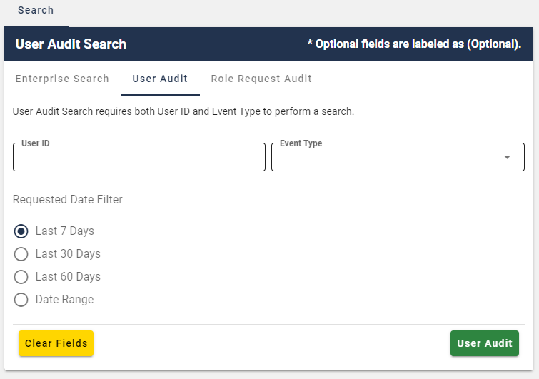
Figure 51: Help Desk User Audit Search Form
- Enter a User ID.
- Select an Event Type from the list.
- Select a Date Range.
- Click the User Audit button. 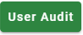 The screen refreshes and the report appears on the Results tab.
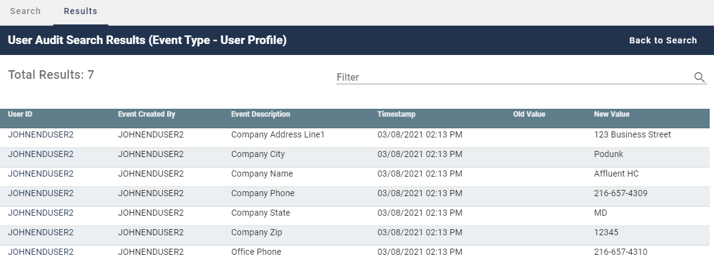
Figure 52: User Audit Report - User Profile Events
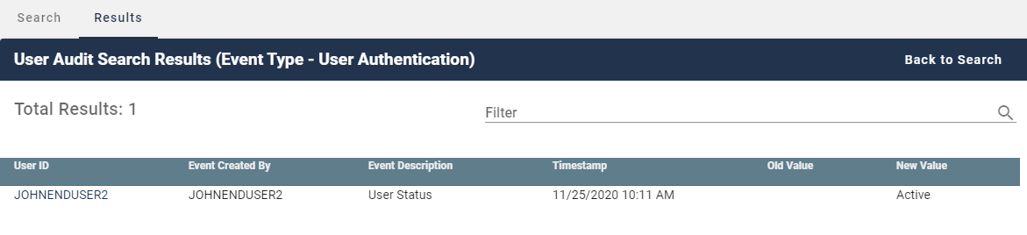
Figure 53: User Audit Report - User Authentication Events
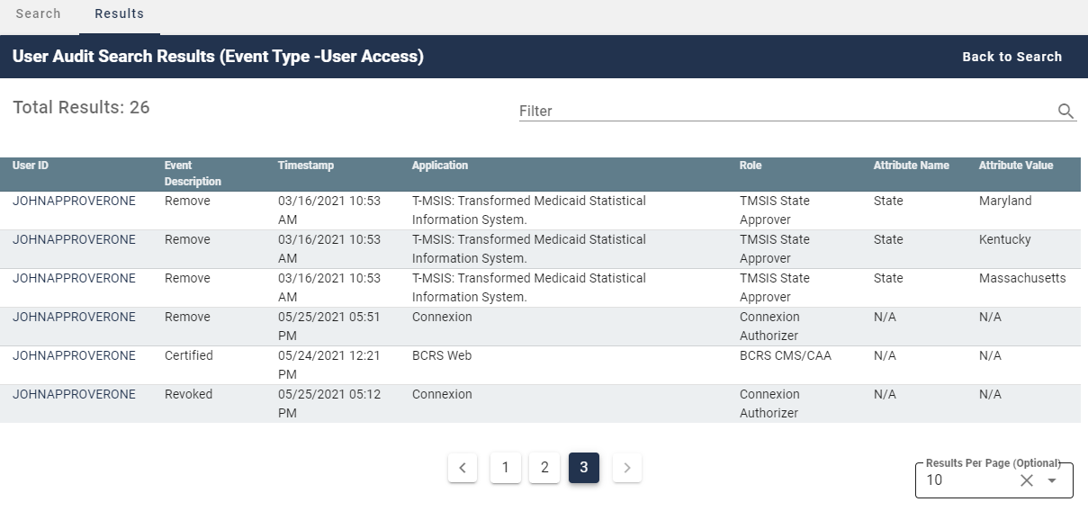
Figure 54: User Audit Report - User Access Events
- (Optional) Click the User ID button for the desired event. The Role Audit Details window appears and displays role details for the selected event.
- Click the Back to Results button.  The search results window appears.

How to Create Role Request Audit Reports
Tier 2 Help Desk Users have the capability to create Role Request Audit reports using the Role Request Audit button located on the Enterprise Search form.

Note: The capability to create Role Request Audit reports is only available to IDM (Tier 2) Help Desk Users. Consequently audit report creation buttons do not appear on the Enterprise Search form of Application (Tier 1) Help Desk Users.

- Click the Help Desk/Manage Users button as described in Section 15.2 How to Access the Help Desk Functions. The Enterprise Search form appears.
- Click the Role Request Audit button. The Role Request Audit Search form appears.
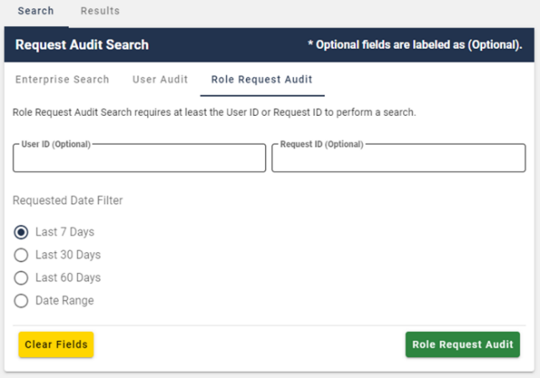
Figure 55: Help Desk Role Request Audit Search Form
- Enter a User ID or enter a Request ID.
- Select a Date Range.
- Click the Role Request Audit button.  The screen refreshes and the report appears on the Results tab.
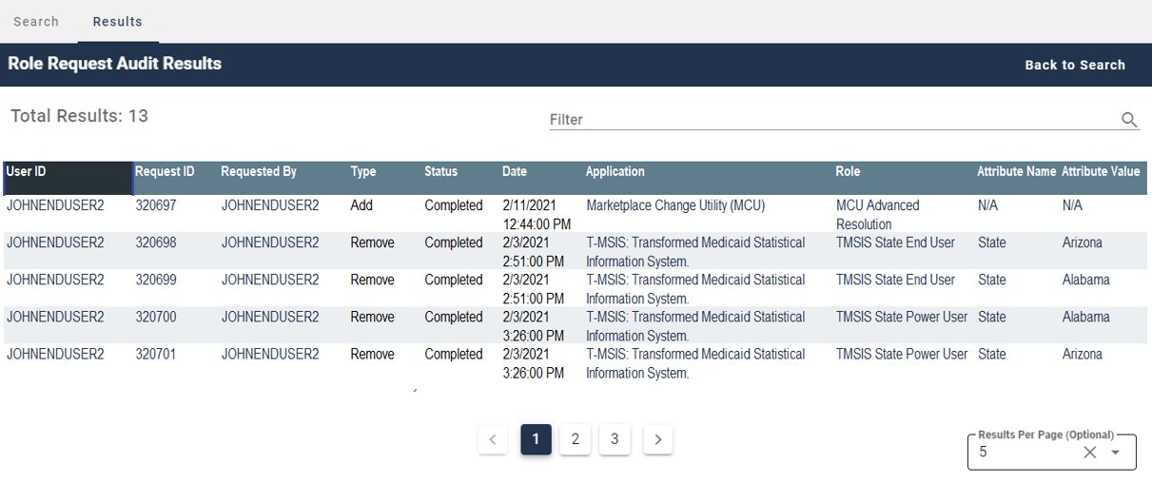
Figure 56: Role Request Audit Report
- (Optional) Click the User ID button for the desired event. The Role Audit Details window appears and displays role details for the selected event.
- Click the Back to Results button. The search results window appears.

How to Manage YubiKey MFA Devices for Use with IDM
Each Application Team/Owner of an Application that uses YubiKey MFA devices to authenticate users is responsible for purchasing, preparing, managing, and distributing the YubiKey MFA devices to the application users.
The procedure in this section provides an overview of the steps that an existing IDM integrated Application Team/Owner follows to enable their Application Users to use a YubiKey MFA device to authenticate to the IDM System.
- The Application Team/Owner creates the YubiKey Seed File using the procedure outlined in Section 15.21.1 How to Generate the YubiKey Seed File
- The Application Team/Owner creates an IDM Service Request (SR) and attaches the YubiKey Seed File.
- The IDM SR Team processes the IDM SR and hands it off to the IDM Okta Team.
- The IDM Okta Team creates an IDM Jira Project Story (component=IDM-SR-Okta) then loads the Seed File. The same Seed File can be used in Okta TEST, IMPL, and PROD environments.
- The IDM Okta Team notifies the Application Team/Owner that the YubiKey Seed File has been loaded and that the YubiKey MFA devices are ready to be used by the Application Users.
- The Application Users add the YubiKey MFA device to their account using the procedure in Section 10.6 How to Add a YubiKey MFA Device.

Note: Once a YubiKey MFA device has been activated on a given user’s account, a different user cannot activate that same YubiKey MFA device on their account until:
- The Okta Team revokes the YubiKey MFA device from the original user’s account using the procedure in Section 15.21.3 How to Revoke a YubiKey MFA Device in Okta.
- The Application Team/Owner creates a new Seed File for that device.
- The IDM Okta Team performs a clean load using the new Seed File.

How to Generate the YubiKey Seed File
The Application Team/Owner creates the Seed File using the procedure in this section and the YubiKey Personalization Tool. This procedure applies to the creation of the initial Seed File as well as the creation of updated Seed Files.
- Start the YubiKey Personalization Tool. The YubiKey Personalization Tool UI appears.
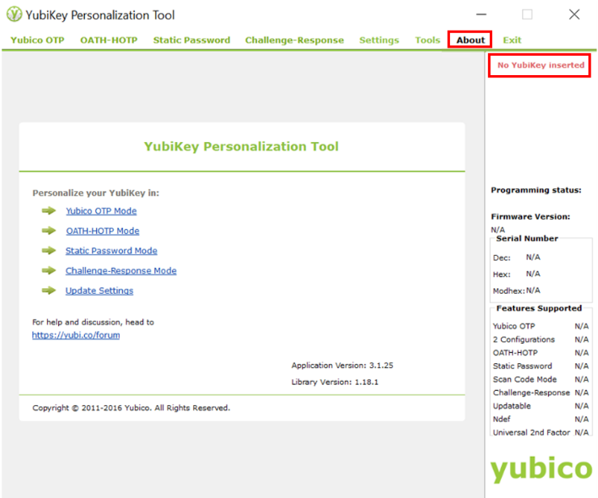
Figure 57: YubiKey Personalization Tool Startup Window
- Click the About tab. The device status message indicates “No YubiKey inserted”.
- Insert the YubiKey MFA device into a USB port. The device status message changes to “YubiKey is inserted”. An image of the device, the Firmware Version, Serial Number and Features Supported information appears when the device is recognized.
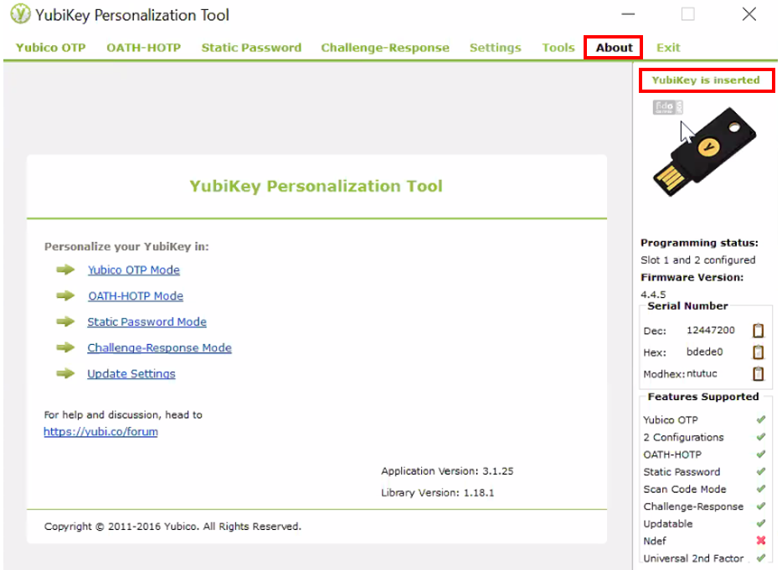
Figure 58: YubiKey Personalization Tool - Device Present
- Click the Settings tab. The Settings window appears.
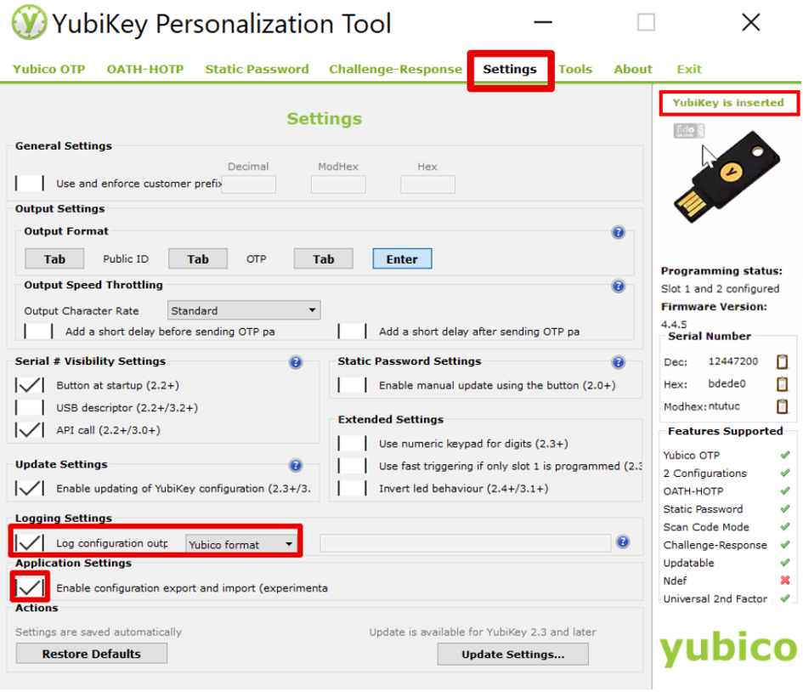
Figure 59: YubiKey Personalization Tool - Settings Tab
- Locate the Logging Settings category then check the Log configuration output box and select Yubico format.
- Locate the Application Settings category and check the Enable configuration export and import box.
- Click the Yubico OTP tab. The Program in Yubico OTP mode window appears.
- Click the Advanced button. The Program in Yubico OTP mode - Advanced window appears.
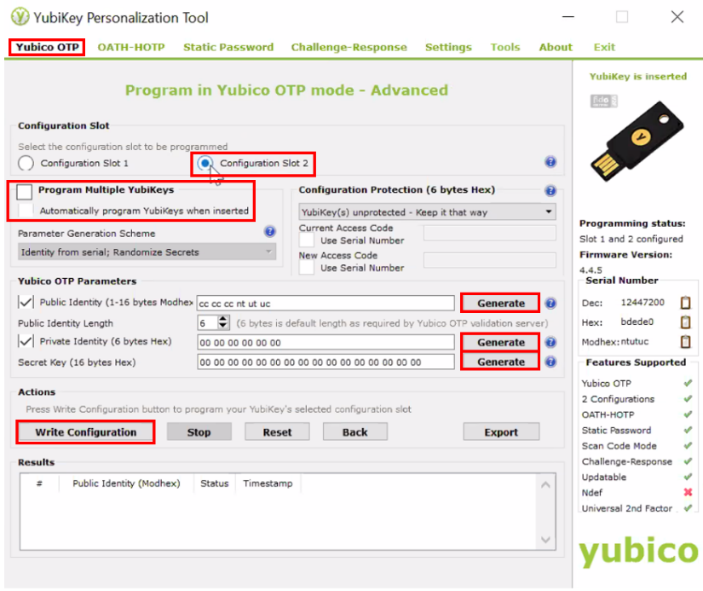
Figure 60: YubiKey Personalization Tool - Yubico OTP Tab
- Locate the Configuration Slot category and select a Configuration Slot.
- Locate the Yubico OTP Parameters category and click each of the three Generate buttons in the Yubico OTP Parameters section.
- (Optional) If multiple YubiKey MFA devices need to be configured, check the Program Multiple YubiKeys box and the Automatically program YubiKeys when inserted box. Doing this will enable personnel to configure the first YubiKey, remove it, then insert the next key until all keys are configured.
- Click the Write Configuration button. The configuration data is written to the YubiKey MFA device and a file output window appears. This file is the Seed File.
- Save the Seed file. The seed file is saved as a comma separated value (CSV).
- Attach the Seed File to the IDM SR. The IDM SR Team will review the SR and forward the SR and Seed File to the IDM Okta Team.

How to Manage YubiKey MFA Devices in Okta
The IDM Okta Team receives the YubiKey Seed File and uploads it to Okta using the procedure in this section. Use the following procedure to create the initial Seed File as well as updated Seed Files.
- Log in to the Okta Admin Portal.
- Click the Security menu option.
- Click the Multifactor menu option, then select YubiKey. The YubiKey administration window appears.
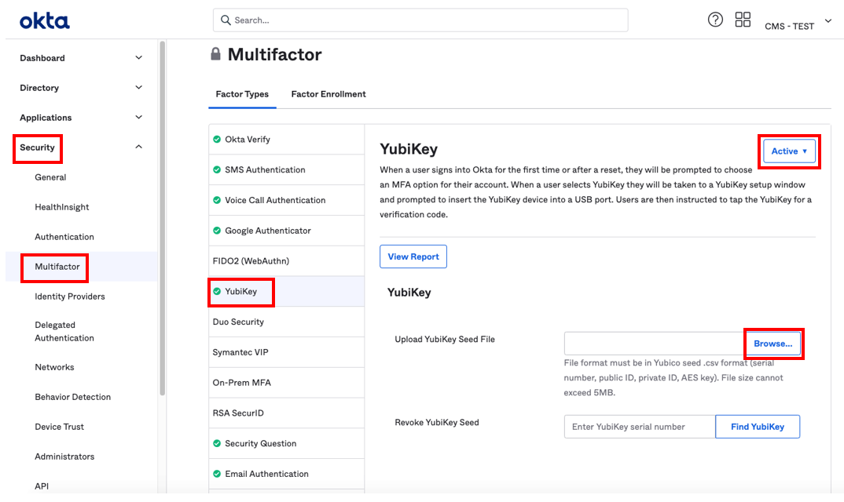
Figure 61: Okta YubiKey Administration Window
- (Optional) Select Active if the YubiKey status is in any other state. A YubiKey MFA device will have one of the following device statuses in Okta as summarized by Table 3: YubiKey Device Status List.
- Click the Browse button. Navigate to the location of the YubiKey Seed file and upload it to Okta.
- Inform the Application Team/Owner that the YubiKeys are now ready for activation by Application Users.

Table 3: YubiKey Device Status List
Device Status | Meaning
Unassigned | The Seed file has been sent to Okta and added to an Okta group, but the YubiKey has not been associated to the user's account.
Active | The YubiKey has been associated to the user's account and is functional.
Revoked | The YubiKey has been removed from the user's account.
Blocked | The YubiKey has been removed by an Okta Admin.

How to Revoke a YubiKey MFA Device in Okta
Once a YubiKey MFA device has been activated by a user and associated to their account, it must be revoked then deleted from Okta before it can be reactivated by the original user or reassigned to a new user. Use the following procedure to revoke a YubiKey so that it may be reactivated or reassigned.
- Log in to the Okta Admin Portal.
- Click the Security menu option.
- Click the Multifactor menu option, then select YubiKey. The YubiKey administration window appears as illustrated by Figure 61: Okta YubiKey Administration Window.
- (Optional) Click the View Report button and obtain the serial number of they YubiKey that will be revoked.
- Enter the YubiKey serial number into the Revoke YubiKey Seed field then click the Find YubiKey button.
- Confirm the decision to revoke (permanently delete) the YubiKey when the Delete YubiKey modal appears. A confirmation message appears.
- Click the Done button.

Appendix A: Password Policy

Passwords that are used to access the IDM system must conform to the following CMS guidelines:
- Passwords must be at least 8 characters in length.
- Passwords must include an uppercase letter.
- Passwords must include a lowercase letter
- Passwords must include a number (0 - 9).
- Passwords must include one of one special character.
- Passwords must not contain a space.
- Passwords must not be one of the user’s last 24 passwords.
- Passwords must not contain parts of the user’s First Name, Last Name, or User ID.
- 24 hours must have elapsed since the last password change.

Appendix B: IDM Report Categories

My Reports provides approved users with the ability to view one or more types of IDM reports that assist those users with the task of effectively managing other users who are under their authority.
Table 4: Summary of Current IDM Reports provides a summary of the reports that are available to users with Business Owner, Business Owner Representative, or Tier 1 Application Help Desk roles who have been also been approved for the IDM Reports role as of the date this user guide was released.

Table 4: Summary of Current IDM Reports
Report Name | Report Description
User Profile Audit Report | This report provides the history of user audit information for a specific application.
User Details Report | This report provides detailed user and role specific information about application users.
User Role Approver Audit | This report provides information about user role requests for an application, with the corresponding details of the approvers who took an action on these requests by either approving the request or rejecting the request.
Application Summary | This report provides a summary of the number of users registered to an application that is integrated with the IDM System. The report also includes the number of IDM account holders that do not have a role in any application.
Annual Role Certification Summary Report | This report displays the total count(s) of all the user roles that are certified, revoked and/or due for Annual Role Certification (ARC) by a single or multiple application.
Pending Annual Role Certification Report | This report displays data about all user roles that are pending or due for annual role certification.

Appendix C: Requesting Configurable Help Desk Privileges
This Appendix outlines the steps that application Business Owners and Representatives must take to request configurable Help Desk privileges in the IDM system.
- Define the following details for each Help Desk privilege that will be requested based on information provided in Table 5: Help Desk Privileges.
- Application
- Role(s) to Update
- Help Desk Privilege
- Justification for the privilege

- Submit an IDM Service Request (SR) that includes the details outlined in Step 1.
Table 5: Help Desk Privileges
 | Application Search |  |  | Enterprise Search
 | Application Help Desk | Application Approver | IDM Help Desk | Application Help Desk | Application Approver | IDM Help Desk
Remove Multiple Roles/Attributes | O | O | --- | -- | -- | X
Export Results | X | X | -- | -- | -- | --
View User Details | X | X | -- | X | -- | X
Update LOA | O | -- | -- | O | -- | X
Lock Account | -- | -- | -- | -- | -- | X
Unlock Account | -- | -- | -- | X | -- | X
Enable User | -- | -- | -- | -- | -- | X
Disable User | -- | -- | -- | -- | -- | X
Reset Password (Email) | -- | -- | -- | X | -- | X
Reset Password (Manual) | -- | -- | -- | O | -- | X
Manage MFA Device | -- | -- | -- | X | -- | X
Remove Roles/Attributes | -- | O | -- | -- | -- | X
Promote User | -- | -- | -- | -- | -- | --
Legend: X = Default O = Optional (Configurable) -- = Not Available

Appendix D: User Audit Report Type Summary

Table 6: IDM Help Desk User Audit Report Type summarizes the information that is contained within each User Audit report type
Table 6: IDM Help Desk User Audit Report Type
Report Type | Event Description | Old Value | New Value
User Authentication | Last login (successful login) | Null | Last Login Date
User Profile | User account creation | Null | User ID
User Profile | Password change | Null | Null
User Profile | Password reset | Null | Null
User Profile | Account status | Locked/Unlocked | Locked/Unlocked
User Profile | User status | Active/Disabled/Deleted | Active/Disabled/Deleted
User Profile | Update LOA | Old LOA | New LOA
User Profile | Update user profile. (Includes changes made to My Information, Personal Contact Information, and Business Contact Information.) | Old profile information values. | New profile information values.
User Profile | Update security questions and answers. | Null | Null
User Access | Add | Null | New application, role, and attribute information.
User Access | Modify | Old application, role, and attribute information. | New application, role, and attribute information.
User Access | Remove | Old application, role, and attribute information. | Null
User Access | Annual certification status. | Null | Application, role, attribute information, and status (certified/revoked)

Appendix E: Acronyms

Table 7: Acronyms
Acronym | Literal Translation
BCRS | Benefits Coordination and Recovery System
C-HIT | Chags Health Information Technology
CHIP | Children’s Health Insurance Program
CMS | Centers for Medicare & Medicaid Services
CSV | Comma Separated Value
ECRS | Electronic Correspondence Referral System
EIDM | Enterprise Identity Management
EUA | Enterprise User Administration
HD | Help Desk
ID | Identity
IDM | Identity Management
IE | Internet Explorer
IMPL | Implementation Environment
IVR | Interactive Voice Response
LOA | Level of Assurance
MAC | Medicare Administrative Contractor
MFA | Multi-factor Authentication
PIV | Personal Identity Verification
PROD | Production Environment
QA | Quality Assurance
QR | Quick Response
RIDP | Remote Identity Proofing
SMS | Short Message Service
SSN | Social Security Number
SR | Service Request
TEST | Test Environment
UI | User Interface
US | United States
USB | Universal Serial Bus

Appendix F: Approvals

The undersigned acknowledge that they have reviewed this document and agree with the information presented within this document. Changes to this document will be coordinated with, and approved by, the undersigned, or their designated representatives.

Table 8: Approvals
Document Approved By | Date Approved
Carla Layne, EIDM Contracting Officer Representative, CMS | Date
Verne Webster, EIDM Government Task Leader, CMS | Date
Charles Lall, EIDM Project Manager, C-HIT | Date
Micalina Mendoza, EIDM QA Manager, C-HIT | Date

Internet Explorer 11 (IE11) is no longer supported by IDM because Microsoft is ending support for the IE11 browser. Consequently, IE11 will no longer receive updates needed to adequately support some of the functions that are required by modern browser-based applications like IDM. Users should access IDM using a supported web browser to insure the best user experience.
Passwords must conform the guidance provided in Appendix A: Password Policy.
The Set Up Multifactor Authentication window appears for users who are required to use MFA but have not yet configured it. It allows users to activate one or more MFA devices.
Users who have multiple MFA devices registered to their profile can choose which one they wish to use. The method used to deliver the verification code may vary based on the user’s chosen MFA device.
Users who have multiple MFA devices should follow the directions for the MFA device they have chosen to use. If the MFA device uses push notifications, a verification code is not required.
The Select an Application menu will not display an application for which a user already has a role. To add a role to an existing application use the Manage My Roles button.
The phone number must be registered to the user who is currently navigating the RIDP workflow.
An email is sent to the user’s email address on record which indicates that the request was submitted successfully. Follow up emails will be sent when the request is approved, rejected, or it expires because no action was taken by an approver.
The IDM System evaluates the user’s current role and determines if that user is eligible to add additional roles for the same application. The system will display a message if they are not eligible.
An email is sent to the user’s email address on record which indicates that the request was submitted successfully. Follow up emails will be sent when the request is approved, rejected, or it expires because no action was taken by an approver.
Role modification requests may be auto-approved or approved after review by an approver.
The user can also view their role requests by clicking the My Requests indicator located at the top right corner of the Self Service Dashboard.
(Optional) The user may click the column headings of the list to change the sorting order of the displayed information.
An email is sent to the user’s email address of record which indicates that the request was accepted.
An email is sent to the user’s email address of record which indicates that the request was accepted.
The Edit Role Details window contains fields that are similar to those used during the initial role request, but it only permits the user to modify role attributes.
An email is sent to the user’s email address of record which indicates that the request was accepted.
Users are encouraged to add additional factors using the procedures described in Section 10 How to Manage MFA and Recovery Devices.
.The system sends an email to the user’s address on record which indicates that the user’s password was changed. It also indicates where the user can obtain assistance if they have questions.
The Reset Password hyperlink expires after four hours have elapsed. The user will be required to repeat this entire procedure if the link expires.
A zip code is not required for foreign addresses. The Zip Code dialog box will not be displayed if the user indicates that they have a foreign address.
The Unlock Account hyperlink expires after four hours have elapsed. The user will be required to repeat this entire procedure if the link expires.
Email, Text, and IVR MFA devices also function as Recovery devices that can be used to recover a forgotten password or unlock an account if the user has registered those devices to their account.
Users who have email as the default MFA and Recovery device will not be given the option to remove it.
Refer to Table 2: MFA and Recovery Device Summary.
Users who access the IDM System with CMS issued mobile phones must download the Google Authenticator app through the CMS app store and may require the assistance / permission of their IT department. Users who access the IDM System with personally owned mobile phones must use their respective app stores.
Users who are unable to scan the QR code may click the Can’t Scan link.  This link displays a manual Setup Key and instructions that explain how to use the key to activate the device.
Users who access the IDM System with CMS issued mobile phones must download the Okta Verify app through the CMS app store and may require the assistance / permission of their IT department. Users who access the IDM System with personally owned mobile phones must use their respective app stores.
Users who are unable to scan the QR code may click the Can’t Scan link. This link displays a manual Setup Key and instructions that explain how to use the key to activate the device.
Users who are required to use email as the default MFA device will not have the option to remove the Email MFA device.
The security question answer must be at least four characters long. Additionally, it must not contain parts of the user’s first name, last name, password, or security question.
The user can also view their pending approvals by clicking the My Approvals indicator  located at the top right corner of the Self Service Dashboard.
Not every application has Group, Organization, or other Role Attribute information. These attributes are specific to each role for a given application and will not always be present in a role request.
The Pending Approval Details window also provides the capability to approve or reject a single request that is pending approval. Refer Section 12.5 How to Approve/Reject a Single Request.
The specific record will be removed from the Pending Approvals to Process list and will remain in pending status. The Approver will receive periodic email reminders about the pending requests until they are acted on, or they expire.
The specific record will be removed from the Pending Approvals to Process list and will remain in pending status. The Approver will receive periodic email reminders about the pending requests until they are acted on, or they expire.
The Remove Now and Add to Remove Cart controls are displayed for the respective role if the Help Desk user has been granted access to that capability.
The system sends an email to the affected user’s email address on record which indicates that a role has been removed from their account. It also indicates where the user can obtain assistance if they have questions.
(Optional) Click the Add to Cart button at the bottom left corner of the window to add all roles displayed on the current page to the remove queue.
(Optional) Click the Remove All Now button  located at the bottom left of the window to remove all roles displayed on the current page.
The system sends an email to the affected user’s email address on record which indicates that a role has been removed from their account. It also indicates where the user can obtain assistance if they have questions.
The system sends an email to the affected user’s email address on record which indicates that a role has been removed from their account. It also indicates where the user can obtain assistance if they have questions.
The user is required to complete the Reset Password operation by clicking the Password Reset hyperlink in the email and following the on-screen prompts.
The Reset Password hyperlink expires after four hours have elapsed. The user will be required to repeat this entire procedure if the link expires.
Help Desk Users bear the responsibility to properly authenticate the end user before giving them the temporary password.
The user is required to complete the Reset Password operation by signing into the IDM System with the temporary password while following any on-screen prompts that appear.
The user is required to change their password when they sign into the system.
When a suspended user attempts to sign in, the Sign In window displays a message that informs the user that they are unable to sign in.
When a suspended user attempts to unlock their account, the Sign In window displays a message that informs the user that they do not have the permission to perform the requested action.
Help Desk Users who require but do not possess the Update LOA function must follow the process that is outlined in Appendix C: Requesting Configurable Help Desk Privileges.
The SSN may or may not be required based on the level that the LOA is being raised to and the application(s) the user requires access to. An SSN is required when updating to LOA 3.
A user’s LOA can only be raised; it cannot be lowered.
If the Application is not already an IDM integrated application, the Application Team/Owner also opens an IDM Jira ticket.
The IDM SR process is described on the IDM Confluence page: https://confluenceent.cms.gov/pages/viewpage.action?spaceKey=IDM&title=Service+Request+Process+for+IDM
The Application Team/Owner must create another Seed File whenever a user removes a YubiKey MFA device from their account and later has a need to add that YubiKey MFA device back to their account.
The YubiKey Personalization Tool is available for download from the Yubico website: https://www.yubico.com/support/download/yubikey-personalization-tools/
Approved users who are granted access to My Reports will not automatically receive access to every report. A user is granted access to reports based on that user’s specific role or roles.
The IDM SR process is described on the IDM Confluence page: https://confluenceent.cms.gov/pages/viewpage.action?spaceKey=IDM&title=Service+Request+Process+for+IDM

