
Identity Management (IDM)

My Reports Quick Reference Guide
Version 1.01
06/01/2022
Document Number: IDM My Reports Quick Reference Guide v1.01
Contract Number: HHSM-500-2017-00015I TO HHSM-500-T0001

Table of Contents
1. Introduction 1
2. How to Obtain Access to My Reports 2
3. How to Use My Reports 5
3.1 Helpful Tips to Remember When Using My Reports 5
3.2 How to View a Report 7
3.3 How to Filter, Sort, Paginate, and Print a Report 8
3.4 How to Print a Report 10
3.4.1 How to Download a Report as a PDF 12
3.5 How to Export a Report as an Excel Spreadsheet 13
Appendix A: Acronyms 15
Appendix B: Approvals 16

List of Figures
Figure 1: IDM Sign In Window 2
Figure 2: IDM Self Service User Interface 3
Figure 3: IDM Role Request Window 3
Figure 4: IDM Role Request Window 4
Figure 5: IDM Self Service User Interface 7
Figure 6: My Reports Selection Window 7
Figure 7: Sample Summary Report (Graphical Format) 8
Figure 8: Sample Report (Tabular Format) 8
Figure 9: IDM My Reports Window 9
Figure 10: IDM My Reports - Print Button 10
Figure 11: Prepare for Printing Window 11
Figure 12: Print Preview Window 11
Figure 13: IDM My Reports - Print Button 12
Figure 14: PDF Download Button 12
Figure 15: Save As Window 12
Figure 16: My Reports Window - Export Options 13
Figure 17: My Reports Download Status Window 13
Figure 18: Save As Window 14

List of Tables
Table 1: Summary of Reports Available to Application BO, BOR, and HD Users 1
Table 2: Helpful Tips for Using My Reports 5
Table 3: Summary of Filter, Sort, and Pagination Controls 9
Table 4: Acronyms 15
Table 5: Approvals 16

Introduction
My Reports provides approved users of the Identity Management (IDM) System with the ability to view one or more types of reports. The purpose of these reports is to assist users with the task of effectively managing other users under their authority.
Table 1 provides a summary of the IDM reports that are available to Application Business Owners (BO), Application Business Owner Representatives (BOR), and Application (Tier 1) Helpdesk (HD) users as of the date this user guide was published.

Note: Approved users who are granted access to My Reports will not automatically receive access to every report. A user is granted access to reports based on that user’s specific role or roles.

Table 1: Summary of Reports Available to Application BO, BOR, and HD Users
Report Name | Report Description
User Details Report | This report provides detailed user and role-specific information for IDM Integrated application users.
User Role Approver Report | This report provides information about user role requests for an application, with corresponding details of the approvers who took an action on these requests by either approving or rejecting the request.
Application Summary Report | This report provides a summary of the number of users registered to an application that is integrated with the IDM System. The report also includes the number of IDM account holders that do not have a role in any application.
Annual Role Certification Summary Report | This report displays the total count(s) of all the user roles that are certified, revoked and/or due for Annual Role Certification (ARC) by a single or multiple application.
Pending Annual Role Certification Report | This report displays data about all user roles that are pending or due for annual role certification.

How to Obtain Access to My Reports
Users who require access to My Reports must submit a role request using the following procedure. If you require assistance with the IDM role request process, please refer to IDM User Guide - How to Request a Role for a New Application.

Note: Application BO, BOR, and Tier 1 HD users will receive access to a predetermined number of reports based on the specific role that they request. Refer to Table 1 for a list of those reports.

Procedure | Example
- Navigate to https://home.idm.cms.gov and sign in to the IDM System. | 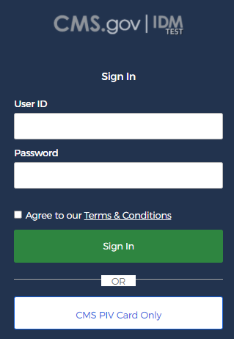  Figure 1: IDM Sign In Window
The IDM Self Service user interface appears.  - Click the Role Request button. | 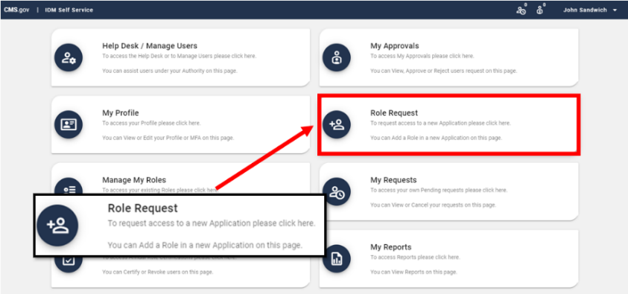  Figure 2: IDM Self Service User Interface
The Role Request window appears.  - Select IDM Reports using the Select an Application menu.  - Complete Remote Identity Proofing (RIDP) if not already completed.  - Select a Group.  - Select a Role.  - Select one or more Applications.  - Click the Review Request button. | 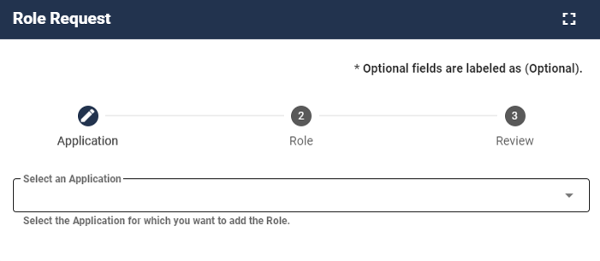  Figure 3: IDM Role Request Window
- Enter a justification.  - Click the Submit Role Request button.  The Role Request window displays a Request ID and a message which states that the request was successfully submitted to an approver for action. | 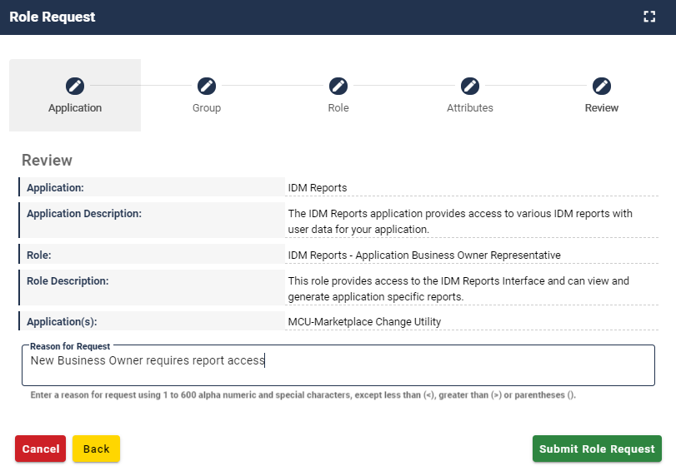  Figure 4: IDM Role Request Window

How to Use My Reports

Helpful Tips to Remember When Using My Reports
IDM My Reports uses the Amazon Web Services (AWS) QuickSight tool to provide a single dashboard for viewing data. QuickSight filter, search, and export functions may sometimes produce different results than expected. Table 2: Helpful Tips for Using My Reports summarizes those features along with solutions for producing the desired views of your data.
Table 2: Helpful Tips for Using My Reports
Function | QuickSight Feature |  | Solution
Filter Data | The QuickSight report viewer currently imposes a limit of 1000 unique values on the multi-select filter such that the report viewer displays a Search dropdown filter when a column contains greater than 1000 unique values in the report results. | 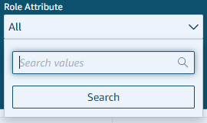 | Export the data in .CSV or .XLXS format and view it in Microsoft Excel.
Search Data | The QuickSight report viewer search feature is case sensitive. This requires search terms to be submitted using the same upper case/lower case characters as the term that is searched for. | 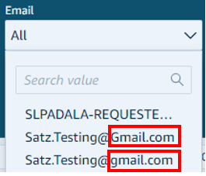 | Export the data in .CSV or .XLXS format and perform searches in Microsoft Excel.
Search Data | The QuickSight report viewer treats all comma delimited values in a row as a single value. This prevents the user from searching on the individual values. | 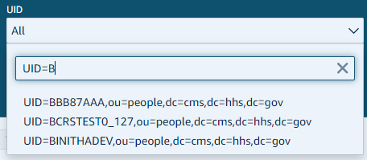 | Export the data in .CSV or .XLXS format and perform searches in Microsoft Excel using the “Contains” search filter.
Print Data | When printing data from the QuickSight report viewer, QuickSight only includes the data currently displayed on the screen. It will not include all of the data | 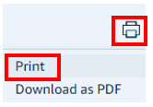 | Export the data in .CSV or .XLXS format and print it using the Microsoft Excel print function.
Download as PDF | When downloading data from QuickSight report viewer to a .PDF file, QuickSight only includes the data currently displayed on the screen. It will not include all of the data. | 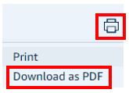 | Export the data in .CSV or .XLXS format and use the Microsoft Excel Save As .PDF function.
Export to Excel | The Export menu will not appear until you click a row of data in the report body. Users must be careful to click the report body. If the user clicks the area with the count results, only the count results will be exported. | 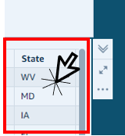 | Refer to Section 3.5 How to Export a Report as an Excel Spreadsheet

How to View a Report
Users who are approved for access to My Reports can view the reports that are available for their role using the following procedure.

Procedure | Example
Access the IDM Self Service user interface.  - Click the My Reports button. | 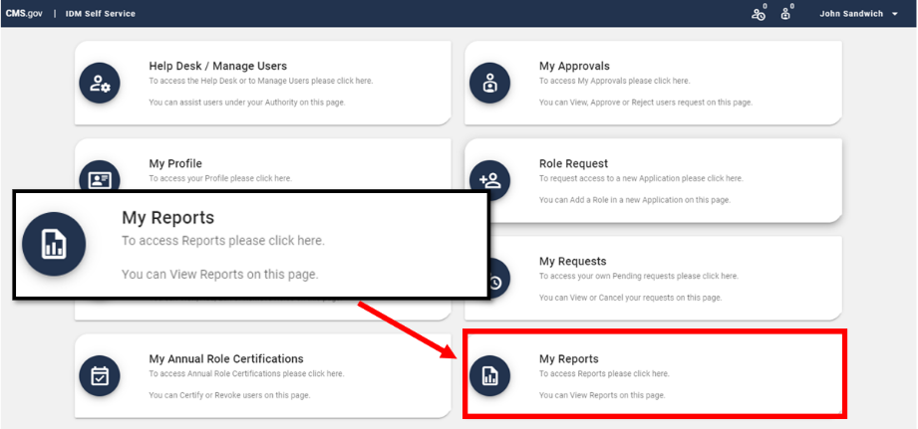  Figure 5: IDM Self Service User Interface
The My Reports window appears.  - Select a report from the dropdown. | 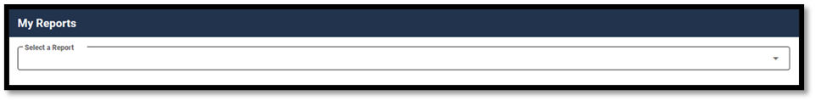  Figure 6: My Reports Selection Window
The screen refreshes and the selected report appears.  Note: Some reports display a graphical summary report on the first tab using charts.  Note: Tabular reports display the total number of records at the top of the report as Total Count. | 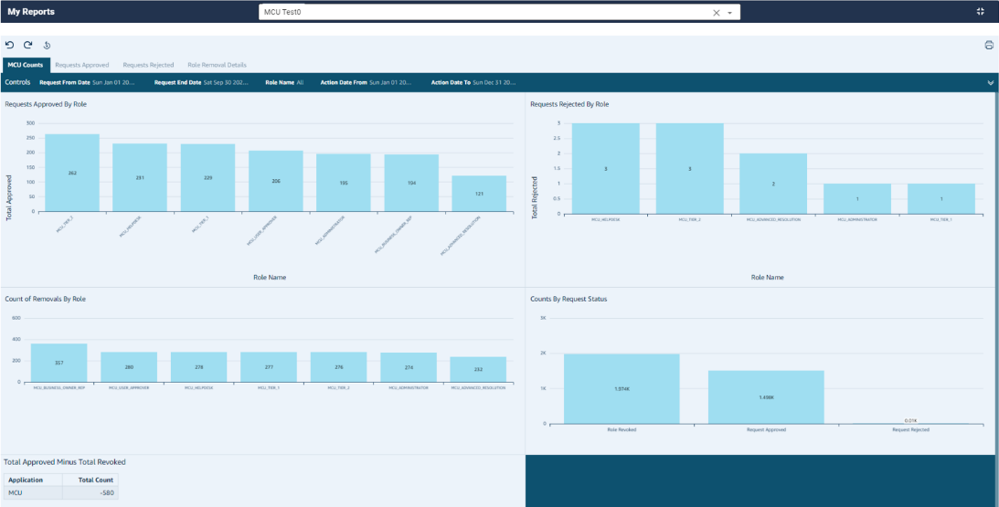  Figure 7: Sample Summary Report (Graphical Format)  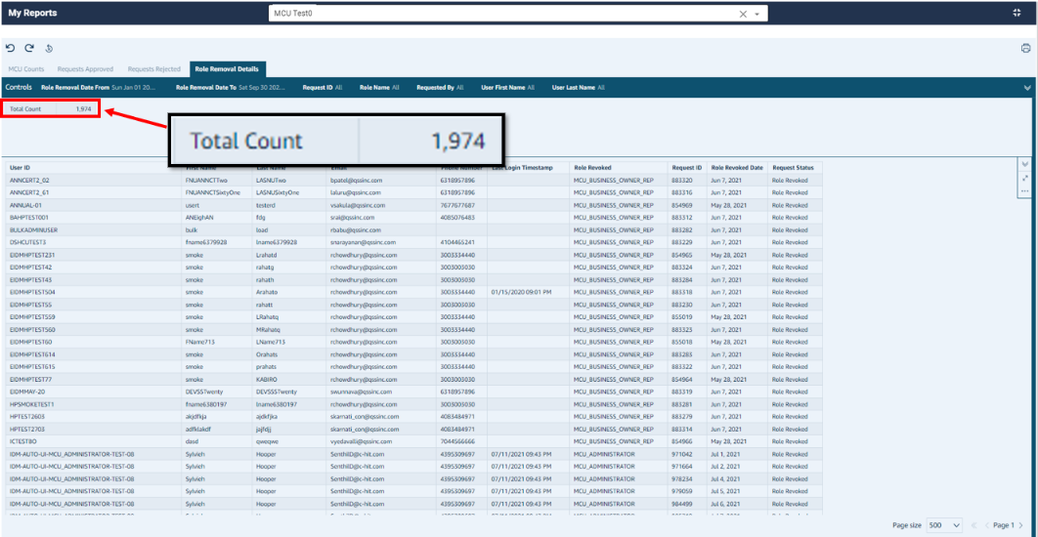  Figure 8: Sample Report (Tabular Format)

How to Filter, Sort, Paginate, and Print a Report
Table 3 provides a description of each of the controls used to filter, sort, and/or paginate the report.
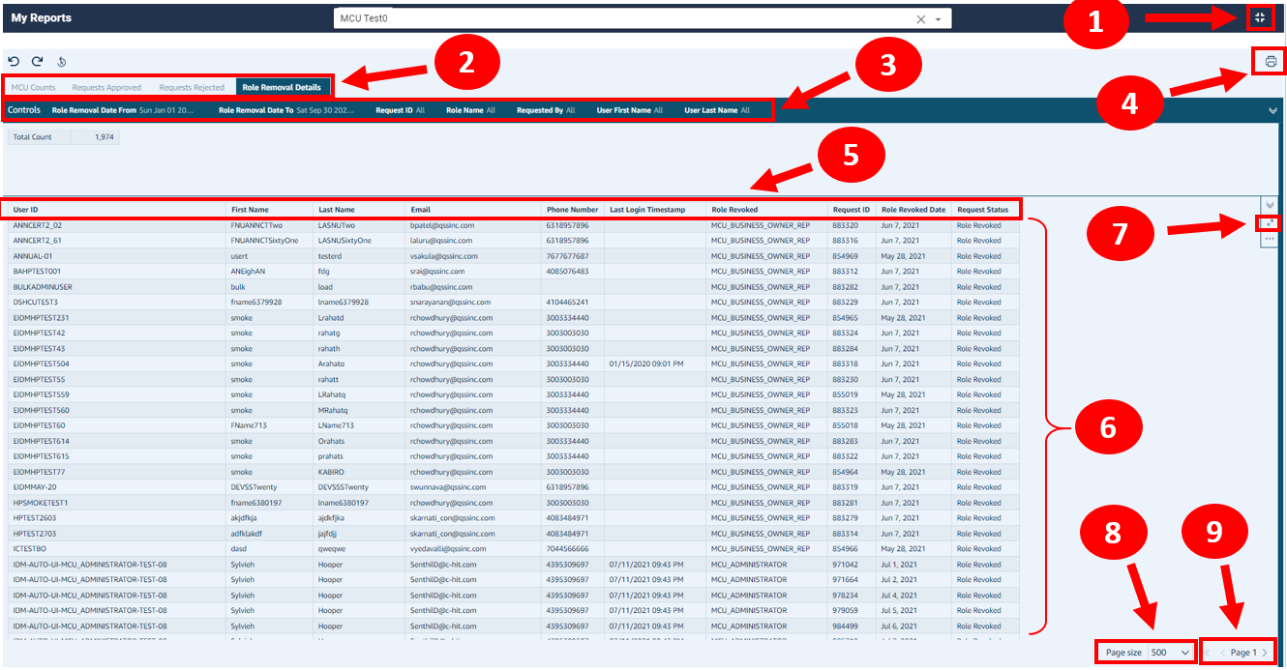
Figure 9: IDM My Reports Window
Table 3: Summary of Filter, Sort, and Pagination Controls
Task | Reference | Action
View Full Screen | 1 | Click the Full Screen button to switch the My Reports window between full screen and normal view.
Select a Report Section | 2 | Click the Report Section button that corresponds to the desired report section if multiple sections are available.  For example, an application may have a report that contains sections with information for Requests Approved and Requests Rejected.
Filter Report by Columns | 3 | Click a Report Column Filter controls to filter the report using information in one or more columns limit the number of records that are displayed on the page.  Note: A report may have multiple rows of filters which will only become visible when the user clicks the Report Column Filter controls.
Print | 4 | Click the Printer icon to print the current page of report information on a printer or create a Portable Document Format (PDF) file.  Note: Both the Print and PDF download options only output the information that is currently visible on the screen. Use the Export function described in Section 3.5 How to Export a Report as an Excel Spreadsheet to export and view all of the report data.
Sort Report Columns | 5 | Click a Column Header to change the sort order of the report data based on the order of the selected column.  Note: To change the width of a column - Position the mouse between two column headers until a double arrow appears, then hold down the left mouse button and drag the column border to the desired width.
Report Body | 6 | Click the Report Body to display or hide the Minimize/Maximize buttons and the Report Export Options menu.
Minimize/Maximize | 7 | Click the Minimize/Maximize buttons to switch the report body viewing area between minimized and maximized.  Note: The page navigation controls are always visible when the Maximize setting is selected.
Change Page Size | 8 | Select Page Size to change the number of records that are displayed on a page.
Page Navigation | 9 | Click the single Right Arrow to move to the next page.  Click the single Left Arrow to move to the previous page.  Click the double Left Arrow to return to the first page of the report.

How to Print a Report

Note: The Print option only prints the information that is currently visible on the screen. Use the Export function described in Section 3.5 How to Export a Report as an Excel Spreadsheet to export and view all of the report data.

Procedure | Example
- View the desired IDM Report.  - (Optional) Apply filters and sort report columns if desired.  - Click the Printer icon and choose the Print option. | 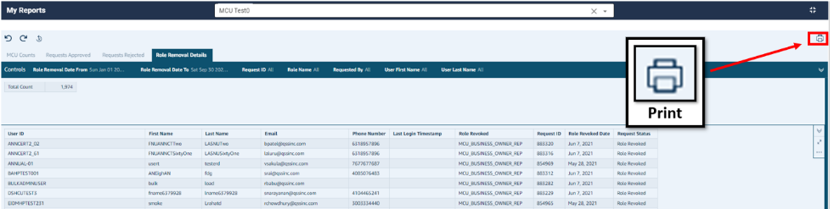  Figure 10: IDM My Reports - Print Button
The Prepare for Printing window appears.  - (Optional) Change the Paper size and/or the Paper orientation.  - (Optional) Select the Print background color option.  - Click the Go to preview button. | 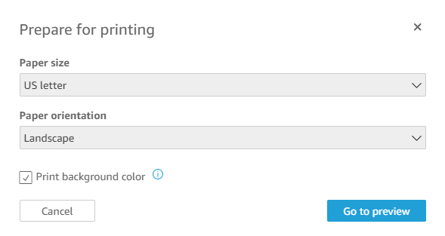  Figure 11: Prepare for Printing Window
The Print Preview window appears.  - (Optional) Select the Destination printer.  - (Optional) Adjust the page range, layout, and color settings.  - (Optional) Click the More Settings button to adjust the Paper size, Pages per sheet, Margins, and Scale settings.  - Click the Print button. | 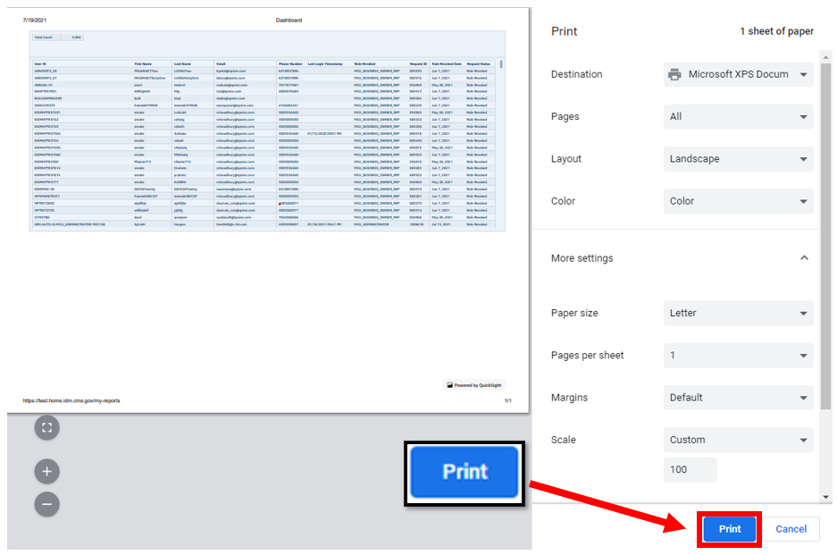  Figure 12: Print Preview Window

How to Download a Report as a PDF
Procedure | Example
- View the desired IDM Report.  - (Optional) Apply filters and sort report columns if desired.  - Click the Printer Icon and choose the Download as PDF option. | Figure 13: IDM My Reports - Print Button
The system displays a message that indicates it is working on the PDF. The Download Now button appears when the PDF is ready.  - Click the Download now button. |   Figure 14: PDF Download Button
The Save As window appears.  - Navigate to the location where you would like to save the file.  - Click the Save button. | 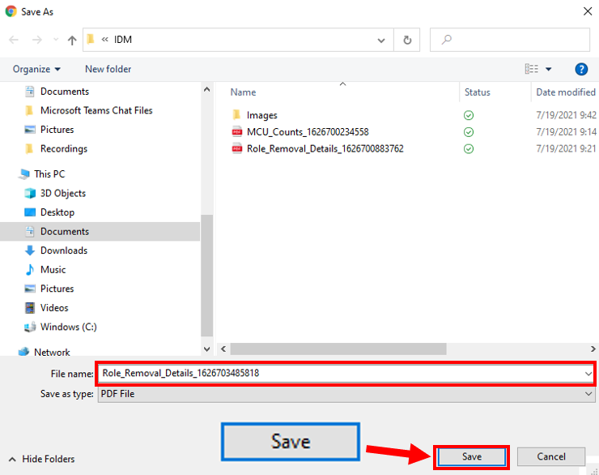  Figure 15: Save As Window

How to Export a Report as an Excel Spreadsheet
Procedure | Example
- View the desired IDM Annual Role Certification Report.  - (Optional) Apply filters and sort report columns if desired.  Note: The report data will be exported exactly as it is filtered and sorted. Remove all filters if the entire report is needed.  - If the Export Options menu is not already visible, click any row of the Report Body.  - Click the Export Options button and select the export format.  Note: Reports that contain more than 50,000 records cannot be exported as an Excel file. Reports with more than 50,000 records must be exported as a .csv file. | 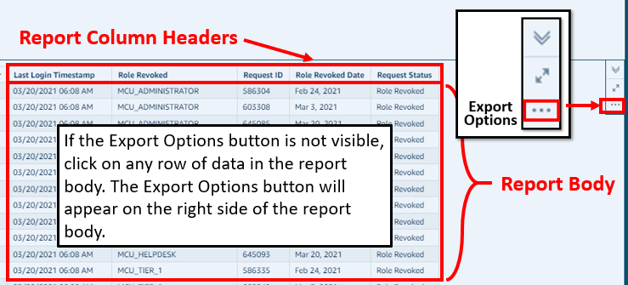  Figure 16: My Reports Window - Export Options
The Download Status window appears and displays the progress of the export operation. | 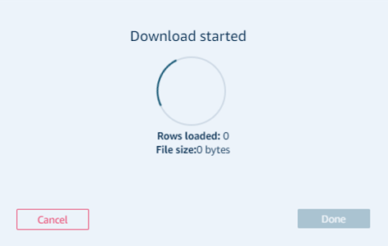  Figure 17: My Reports Download Status Window
The Save As window appears after the download is complete.  - Navigate to the location where you would like to save the file.  - Click the Save button.  - Click the Done button on the Download Status window. | 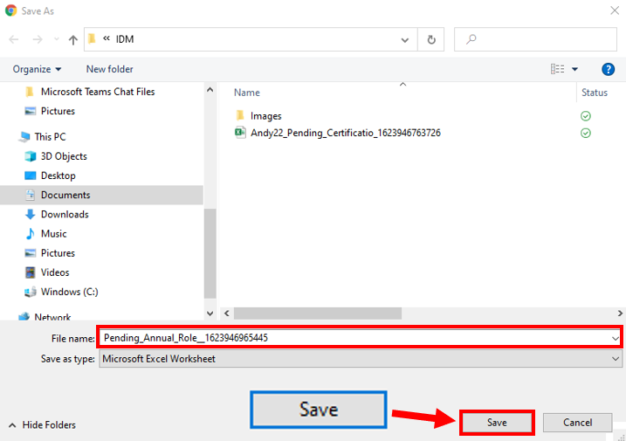  Figure 18: Save As Window

Appendix A: Acronyms

Table 4: Acronyms
Acronym | Literal Translation
ARC | Annual Role Certification
API | Application Programming Interface
AWS | Amazon Web Services
BO | Business Owner
BOR | Business Owner Representative
C-HIT | Chags Health Information Technology
CMS | Centers for Medicare & Medicaid Services
CSV | Comma Separated Value
EIDM | Enterprise Identity Management
HD | Helpdesk
IDM | Identity Management
LOA | Level of Assurance
PDF | Portable Document Format
QA | Quality Assurance
RIDP | Remote Identity Proofing
UI | User Interface

Appendix B: Approvals

The undersigned acknowledge that they have reviewed this document and agree with the information presented within this document. Changes to this document will be coordinated with, and approved by, the undersigned, or their designated representatives.

Table 5: Approvals
Document Approved By | Date Approved
Carla Layne, EIDM Contracting Officer Representative, CMS | Date
Verne Webster, EIDM Government Task Leader, CMS | Date
Veera Netla IDM Project Manager, C-HIT | Date
Micalina Mendoza, IDM QA Manager, C-HIT | Date

