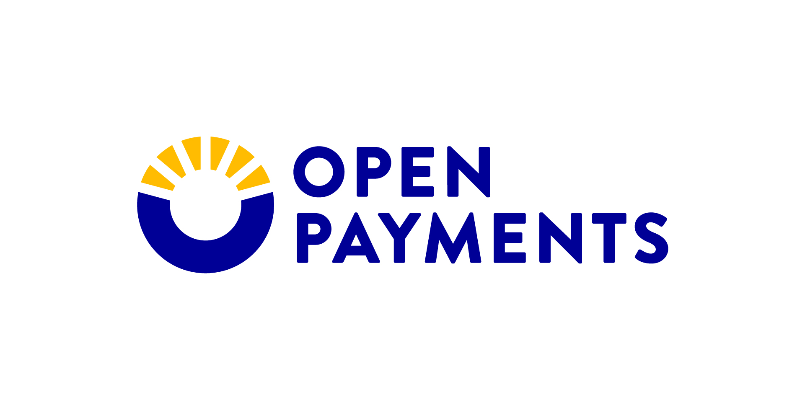  Open Payments Data Refresh Package  January 2026 | Summary  The Open Payments data will be refreshed in January 2026. The refresh contains changes and updates to the data that occurred between the initial data publication in June 2025 and December 2025. The update will be communicated via the Open Payments listserv.  Transparency & Data Group

Contents
Open Payments Data Refresh – Rollout Materials 2
Rollout Description 2
Reactive Statement 2
Rollout Materials Summary 2
Listserv Announcement 3
Night Note 5

Open Payments Data Refresh – Rollout Materials

Rollout Description
- This is the annual Open Payments data refresh sent with a listserv announcement.
On January 23, 2026, the CMS Open Payments team will refresh the Program Year 2018-2024 Open Payments data. The refreshed data includes updates made by applicable manufacturers and group purchasing organizations (GPOs) since the data publication on June 30, 2025. CMS is required to update/ refresh the data at least once annually (42 CFR 403.908(h)(2)).

Reactive Statement
- We anticipate the reaction to the Open Payments Data Refresh to be neutral to positive.
The data refresh is a standard practice that all stakeholders are familiar with and should not raise any concerns.

Rollout Materials Summary
- Listserv Announcement
  - The Listserv announcement will be provided to the CMS Office of Communications (OC) to serve as a press release, if needed.
  - The Open Payments team will send the listserv to the Open Payments listserv subscribers when the data refresh publication is live.
  - The listserv will also be provided as the required “Report to States” (SSA Sec. 1128G(d)(2)).
- Additionally, the CMS Open Payments team is providing a Night Note.

Listserv Announcement

- CMS Updates Open Payments Data
- Questions - Contact the Open Payments Help Desk
CMS Updates Open Payments Data
The Open Payments data is updated to reflect changes that took place since the June 2025 publication. The updated dataset is available at https://openpaymentsdata.cms.gov/.
The Open Payments data is refreshed once annually to include updates from disputes and other data corrections made since the initial data publication.
The refreshed Open Payments data reflects the following:
- Record Updates:
  - Changes to non-disputed records made on or before November 15, 2025, are published.
- Disputed Records:
  - Dispute resolutions completed on or before December 31, 2025, are displayed with the updated information.
  - Records with active disputes that were not resolved by December 31, 2025, are displayed as disputed.
- Record Deletions: Records deleted before December 31, 2025, are removed from the Open Payments published dataset. Records deleted after December 31, 2025, remained in the published dataset, but will be removed during the next data publication in June 2026.
The following is not included in the data refresh:
- Any records attested to after March 31, 2025.
- Any disputed records in which the resolution resulted in a change to the covered recipient.
- Changes made to non-disputed records after November 15, 2025.
- Changes made to disputed records after December 31, 2025.

Applicable manufacturers and group purchasing organizations (GPOs) submitted the Open Payments data; CMS publishes the data as received and does not alter the data in any way.
For more information about Open Payments data publication, visit www.cms.gov/openpayments.
(Back to top)
Questions - Contact the Open Payments Help Desk
Submit questions to the Help Desk via email at openpayments@cms.hhs.gov or by calling 1-855-326-8366 (TTY Line: 1-844-649-2766), Monday through Friday, from 9:00 a.m. to 5:00 p.m. (ET), excluding Federal holidays.
The Help Desk refers media inquiries to CMS’ Press Office for response.
(Back to top)
Creating Public Transparency of Industry-Provider Financial Relationships.
Centers for Medicare & Medicaid Services (CMS) has sent this update.
To contact CMS go to our Contact Us page.

Night Note
- On January 23, 2026, the Open Payments datasets will be updated to reflect changes to the data that took place since the June 2025 data publication.
- CMS is required to update/ refresh the Open Payments data at least once after the initial data publication. The January data refresh fulfills this requirement.
- This refresh includes updates to records made by applicable manufacturers and group purchasing organizations (GPOs) since June 2025.
  - These updates affect Program Years 2018 through 2024.
  - Program Year 2025 data will be reported by March 31, 2026, and published by June 30, 2026.
- The refreshed Open Payments Data Set includes:
  - Record Updates: Changes to non-disputed records made on or before November 15, 2025.
  - Disputed Records: Dispute resolutions completed on or before December 31, 2025, display with the updated information. Records with unresolved disputes as of December 31, 2025, are displayed as disputed.
  - Record Deletion: Records deleted before December 31, 2025, are removed from the Open Payments published dataset. Records deleted after December 31, 2025, remain in the published dataset, but will be removed during the June 2026 data publication.
- As happens every year, we expect that there will be a slight change in the data values; however, this is a standard fluctuation and the changes in value typically do not affect the data in any significant way.
  - The refreshed data points will be finalized on January 15, 2026.

