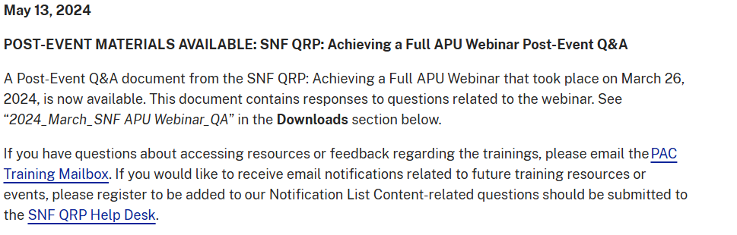
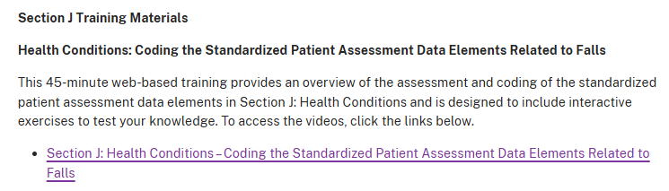
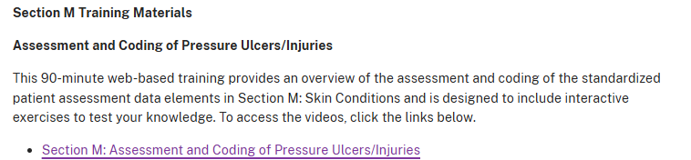
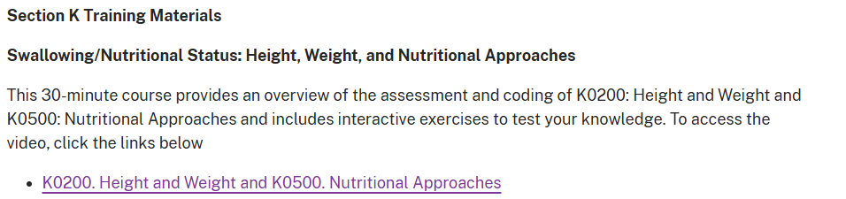
- Pocket Guide #2: Definitions for Coding Section J Fall Items (PDF).
- 2024_March_SNF_QRP_Achieving_A_Full_APU_Webinar_Update (PDF)
- 2024_June_SNF APU Webinar QA (PDF)

