
Identity Management (IDM) System

Quick Start Remote Identity Proofing (RIDP) User Guide
Version 0.10
09/13/2024

Document Number: Quick Start Remote Identity Proofing (RIDP) User Guide
Contract Number: HHSM-500-2017-00015I TO HHSM-500-T0001
Last Reviewed: 07/03/2024

Table of Contents
1. Introduction 1
1.1 Identity Management (IDM) System Overview 1
1.2 Purpose of the Quick Start Remote Identity Proofing (RIDP) User Guide 1
2. Remote Identity Proofing 2
2.1 Overview of Remote Identity Proofing 2
2.2 Description of the RIDP Process 2
3. RIDP Calling Options and User Authentication Procedure 3
3.1 Options for Calling RIDP 3
3.2 The RIDP User Authentication Procedure 3
4. Procedure to Complete the RIDP Process 8
4.1 Review and Accept the RIDP Terms and Conditions 8
4.2 Verify Personally Identifiable Information (PII) 9
4.3 Failed RIDP Recovery Procedure 14
Appendix A: Record of Changes 16
Appendix B: Acronyms 17

List of Figures
Figure 1: IDM Login Screen (Username, Password, and Terms Agreement) 8
Figure 2: MFA OTP Request Window 9
Figure 3: MFA OTP Email and MFA Verification Window 10
Figure 4: IAL Check Response Message for Requested IAL Equal to Existing IAL 11
Figure 5: RIDP Overview Page with Link to Terms and Conditions 12
Figure 6: RIDP PII Verification Form 14
Figure 7: Data Validation Error Message for Name and Email 15
Figure 8: Same Social Security Number Exists in System 15
Figure 9: Previously Submitted Information 15
Figure 10: Tier 1 Helpdesk PII Verification Error Message and Attempts Remaining 16
Figure 11: Tier 1 Helpdesk PII Max Retries Error Message 17
Figure 12: Experian PII Verification Error Message and Attempts Remaining 17
Figure 13: Tier 1 Helpdesk PII Max Retries Error Message 18
Figure 14: RIDP Success Message 18
Figure 15: Experian Identity Verification Confirmation 20
Figure 16: RIDP Phone Verification Failure, Contact Experian Support Services 21
Figure 17: RIDP Phone Verification Failure, Contact Application Helpdesk 22

List of Tables
Table 1: RIDP Standalone Mode URLs 3
Table 2: Standalone URL Parameters 3
Table 3 Record of Changes 16
Table 4: Acronyms 17

Introduction
The Centers for Medicare & Medicaid Services (CMS) is a federal agency that ensures health care coverage for more than 100 million Americans. CMS administers Medicare and Medicaid and provides funds and guidance for all of the 50 states in the nation, for their Medicaid programs, and Children’s Health Insurance Program (CHIP). CMS works together with the CMS community and organizations in delivering improved and better coordinated care.

Identity Management (IDM) System Overview
CMS created the IDM system to provide Business Partners with a means to request and obtain a single User ID which they can use to access one or more CMS applications. The IDM system uses a cloud-based distributed architecture that supports the needs of both legacy and new applications while providing an improved user experience on desktop and laptop computers as well as tablet and smartphone mobile devices.

Purpose of the Quick Start Remote Identity Proofing (RIDP) User Guide
This quick start user guide provides the user with basic step-by-step instructions on how to use the following core functions of the IDM user interface:
- RIDP: An automated web-enabled process that verifies a user’s identity quickly and securely.

Remote Identity Proofing

Overview of Remote Identity Proofing
RIDP is an important component of the CMS IDM system. It provides application owners with a basis to establish a high Identity Assurance Level (IAL) that a user is, in fact, who they claim to be.
RIDP makes use of a web service and data provided by Experian, a consumer credit reporting company. Experian uses information from a user’s credit history to remotely confirm the user’s identity.

Description of the RIDP Process
Remote Identity Proofing is a process that permits a user to verify their identity quickly and reliably by providing evidence to support their claim using a highly reliable computer-based automated service.
Remote identity proofing is a simple process that consists of the following stages:
- Review and accept the RIDP Terms and Conditions.
- Verify personally identifiable information (PII).
- Recover from a failed RIDP session (only necessary if a previous attempt failed).

RIDP Calling Options and User Authentication Procedure
This section provides information and procedures for calling RIDP and the RIDP authentication process.

Options for Calling RIDP
The RIDP process can be called by clicking or entering the following URLs for the respective environments as listed in Table 1: RIDP Standalone Mode URLs.

Table 1: RIDP Standalone Mode URLs
Environment | URL
Test | https://test.home.idm.cms.gov/ridp/?ial=IAL2?success-url=<url>&failed-url=<url>
Impl | https://impl.home.idm.cms.gov/ridp/?ial=IAL2?success-url=<url>&failed-url=<url>
Prod | https://home.idm.cms.gov/ridp/?ial=IAL2?success-url=<url>&failed-url=<url>

Each URL contains parameters that will vary based on the calling application Table 2: Standalone URL Parameters summarizes those parameters.

Table 2: Standalone URL Parameters
Parameter | Value(s) | Meaning
ial | IAL2 | The requested Identity Assurance Level
success-url | <url> | The URL to which the user should be redirected after completing the RIDP process successfully.
failed-url | <url> | The URL to which the user should be redirected in case of any failure.

The RIDP User Authentication Procedure
This section provides the procedure for how to authenticate to the CMS IDM system. The IDM system authenticates the user and permits the user to access the RIDP application with the proper IAL.

Note(s):
- If the user has previously authenticated to the IDM system AND their session HAS NOT expired, the user will be taken directly to the RIDP user interface.
- If the user has previously authenticated to the IDM system BUT their session HAS expired, the user will be taken to the IDM login screen.

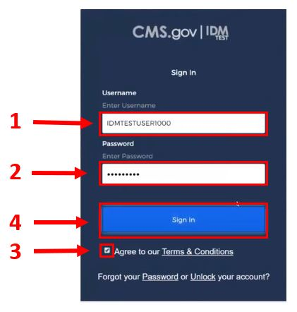
Figure 1: IDM Login Screen (Username, Password, and Terms Agreement)

Step 1: Type the Username into the Username dialog box.

Step 2: Type the Password into the Password dialog box.

Step 3: Click the checkbox to acknowledge agreement with the Terms & Conditions.

Step 4: Click the green Sign In button.

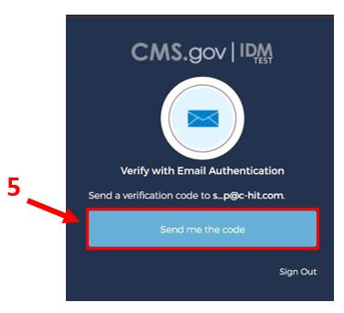
Figure 2: MFA OTP Request Window

Step 5: When the Multi-factor Authentication (MFA) One-time Password (OTP) Request window appears, Click the Send me the code button to request an OTP.
- The OTP delivery method can be an email, a voice message, a text message, or a push notification based on the user’s MFA device choice.

Note(s):
- The IDM system uses Email MFA by default, but it allows the user to use other MFA devices. If an alternate MFA device is used, then Step 5, Step 6, and Step 7 will vary slightly in the way a user requests and receives the OTP. In addition to Email MFA, IDM currently supports the following MFA devices:
  - Interactive Voice Response (IVR)
  - Google Authenticator
  - Okta Verify
  - Short Message Service (SMS) Text Message
  - YubiKey
- In some cases, users may not be required to use MFA verification. If MFA is not required, Step 5, Step 6, and Step 7 will be skipped, and the system will proceed to the LOA check phase.

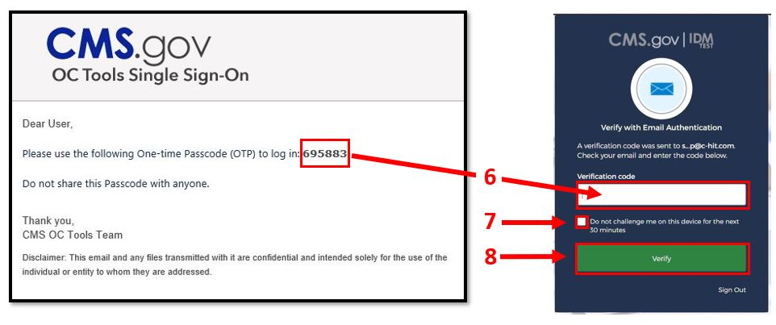
Figure 3: MFA OTP Email and MFA Verification Window

Step 6: The MFA device will return a six-digit OTP. Type the OTP into the Verification Code dialog box. If the MFA device uses push notifications, a code will not be required.

Step 7: (Optional) Click the checkbox to select the option “Do not challenge me on this device for the next 30 minutes”.
- If this step is performed, users will bypass the MFA verification phase of the authentication process if they logoff and log back onto the system again within 30 minutes of completing this MFA verification event.

Step 8: Click the Verify button.

Identity Assurance Level (IAL) Checks
A user’s identity assurance level is used to indicate the level of confidence that a given user is who they say they are based on the information they provide to the system during the initial account creation process and during subsequent logins and system use.
There are two IALs: IAL 1 and IAL 2; where IAL 1 represents the lowest Identity Assurance Level and IAL 2 represents the highest Identity Assurance Level. The following general guidelines pertain to a user’s IAL:
- A user is IAL 1 by default as soon as they register.
- Once IAL 2 is reached, no changes can be made to the IAL.

Once the user authenticates to the system, the requested IAL will be checked against the user’s existing IAL if one exists. The RIDP process will not initiate if the following condition exists:
- The requested IAL is equal to the existing IAL.

Requested IAL is Equal to Existing IAL: The RIDP process will not initiate if the user possesses an IAL that is equal to the requested IAL. The following will occur instead:
- The system will display a message that states, “This user has already been identity proofed at the required proofing level.”
- Click the red Cancel button.

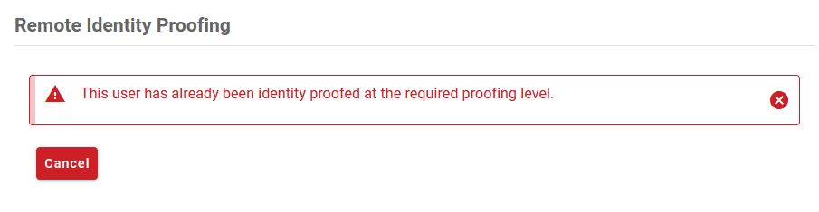
Figure 4: IAL Check Response Message for Requested IAL Equal to Existing IAL

Procedure to Complete the RIDP Process
This section provides the procedure for how to use the RIDP application.

Review and Accept the RIDP Terms and Conditions
The initial page provides an overview of the RIDP process and provides users with an opportunity to review the RIDP terms and conditions. The procedure in this section provides the steps to review and accept the RIDP terms and conditions.

Note(s):
- The Next button will not turn green nor will it become selectable until agreement with the terms and conditions have been acknowledged.

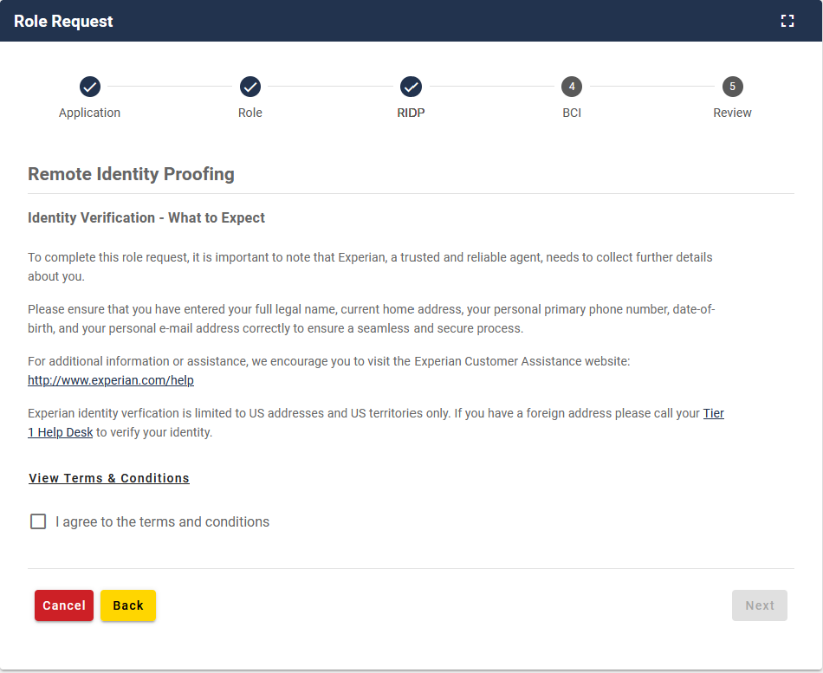
4
3
2
1
Figure 5: RIDP Overview Page with Link to Terms and Conditions

Step 1: Review the IDENTITY VERIFICATION description statement.

Step 2: Click the “View Terms & Conditions” link to review the RIDP terms and conditions.

Step 3: Click the “I agree to the terms and conditions” checkbox.

Step 4: Click the green Next button.

Verify Personally Identifiable Information (PII)
This stage of the RIDP process verifies the user’s identity based on the personally identifiable information (PII) that they provide using this form. The procedure in this section provides the steps users must follow to fill out the PII verification form.

The PII entered into this form will directly impact the decision to grant a higher IAL if the role being requested requires a higher IAL than what the user currently has for a given application.

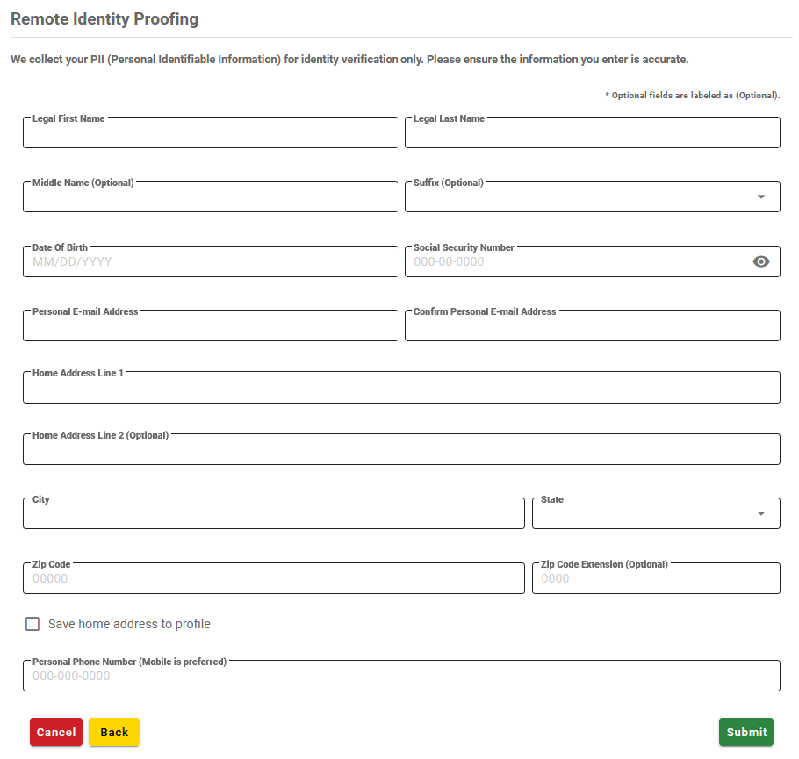
2
1
Figure 6: RIDP PII Verification Form

Step 1: Type the legal name, date of birth, social security number, personal email address, home address information, and personal mobile phone number into the respective fields.
Step 2: Click the green Submit button.

PII Data Validation
When a user submits PII data, that data is subject to local PII validation checks. The purpose of these checks is to maintain the integrity of the user information that is used by the IDM system for user authentication. The following three validation checks are performed:
- The combination of the user’s first name, last name, and email address must be unique in IDM.
- The SSN must be unique in IDM.
- The same PII must not be submitted again after a failed RIDP attempt.

The combination of last name, first name, and email address is not unique in IDM: This condition will cause a message to be displayed which states, “A record with the same last name, first name, and email combination exists in the system.” as shown in Figure 7: .
- If this message appears, review the information that was entered into the form. If it was entered correctly, contact the Application Helpdesk.

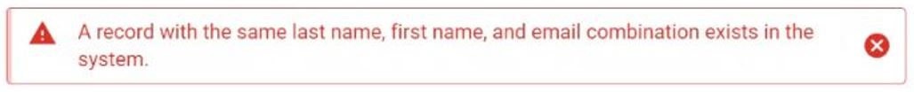
Figure 7: Data Validation Error Message for Name and Email
The social security number is not unique in IDM: This condition will cause a message to be displayed which states, “A record with the same social security number exists in the system.” as shown in Figure 8.
- If this message appears, review the information that was entered into the form. If it was entered correctly, contact the Application Helpdesk.
Figure 8: Same Social Security Number Exists in System
The same PII is submitted after a failed RIDP attempt: This condition will cause a message to be displayed which states, “It seems like you’ve already submitted this information. Please make sure to change the information in the form before submitting.” as shown in Figure 9.
- If this message appears, review the information that was entered into the form and update any information that may be inaccurate or entered incorrectly before resubmitting.
Figure 9: Previously Submitted Information

Experian PII Data Validation
If Experian is unable to verify the PII information that was submitted using the PII data validation form, the error message illustrated in Figure 10 or Figure 12 will be displayed with the number of attempts remaining down to 0 attempts. If the user has attempted the form more than 3 times without successful verification of the information, Figure 11 or Figure 13 will be displayed.
- Write down the error message and the Reference Number that is displayed, then contact the resource provided in the error page. This will either be Experian Support Services to complete a one-time verification process over the phone, or your Application Helpdesk.
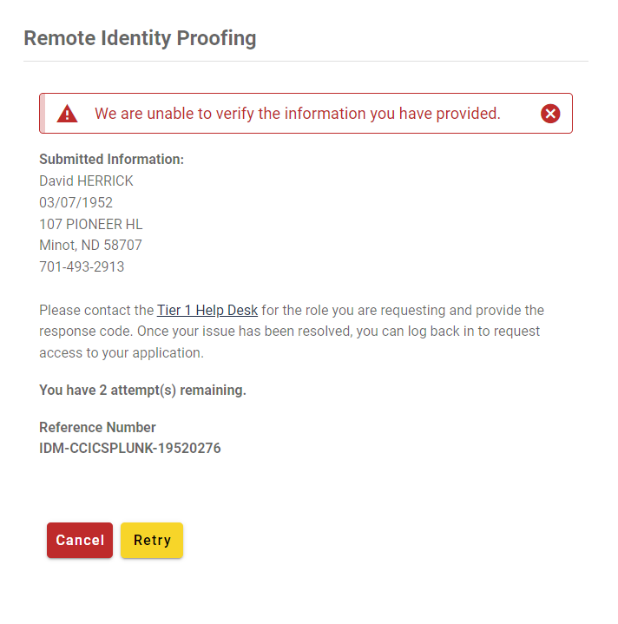
Figure 10: Tier 1 Helpdesk PII Verification Error Message and Attempts Remaining

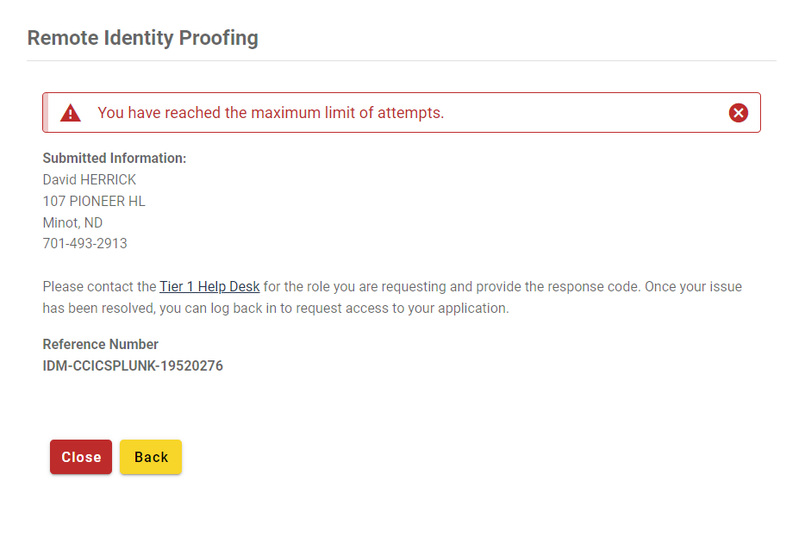
Figure 11: Tier 1 Helpdesk PII Max Retries Error Message
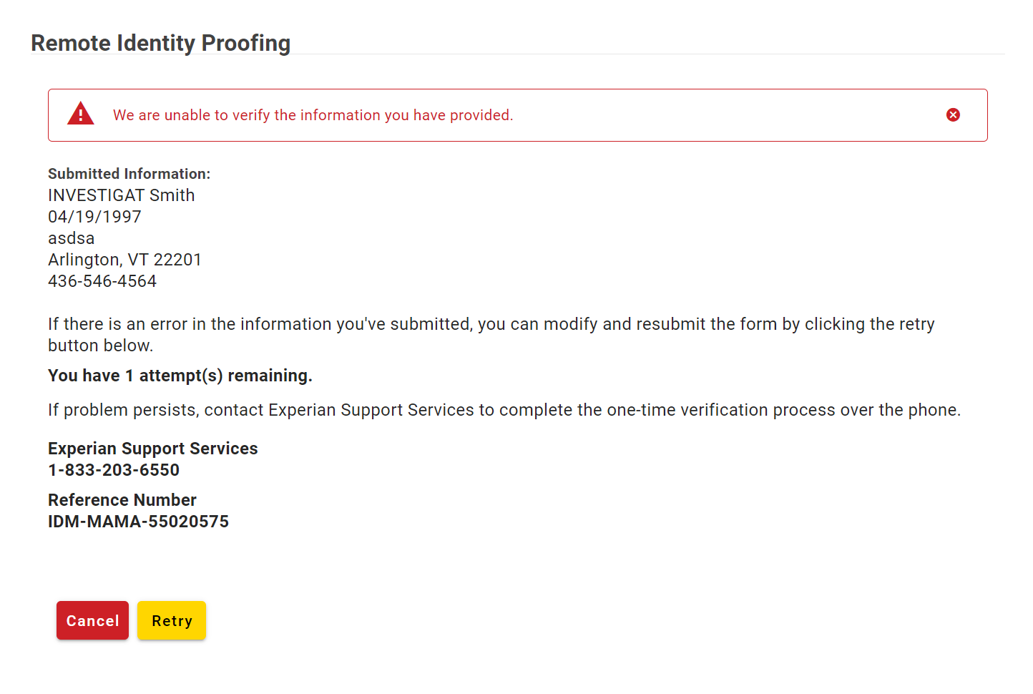
Figure 12: Experian PII Verification Error Message and Attempts Remaining

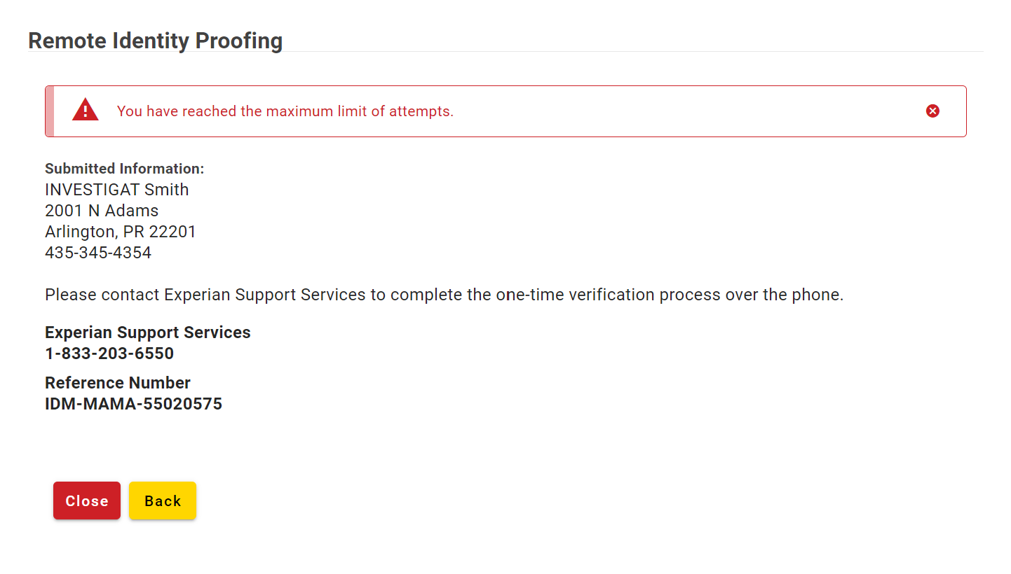
Figure 13: Tier 1 Helpdesk PII Max Retries Error Message

Step 3: Users that reside at a foreign address will not be able to complete the identity verification process online using this form. Users with a foreign address must:
- Contact the respective Application Helpdesk.
- Contact Experian as directed by a warning message that will appear.

Step 4: If a successful response is returned from Experian, a window will display a message indicating that “Remote Identity Proofing has been completed successfully”.

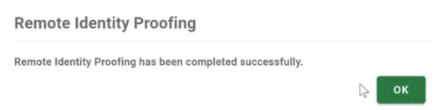
Figure 14: RIDP Success Message

Step 5: Click the green OK button.
- After the OK button is clicked, the user will be returned to the original process or application that triggered the RIDP procedure. This path will be identified by the success-url parameter that was provided by the application that called the RIDP process.

Failed RIDP Recovery Procedure
This section provides instructions that must be followed if Experian is unable to verify the PII. The procedure in this section provides the steps that must be followed to recover from a failed attempt to remotely verify the user’s identity.

Note(s):
- The user must logout of the IDM system and contact the Application Helpdesk before trying to recover from a failed RIDP attempt. The Application Helpdesk will provide instructions based on the “Reference Number” that was displayed in the web browser.
- If the Application Helpdesk advises the user to contact Experian, they must do so. If they attempt to proceed without contacting Experian, all attempts to use the RIDP procedure will fail. Click the red Cancel button if Experian has not been contacted.

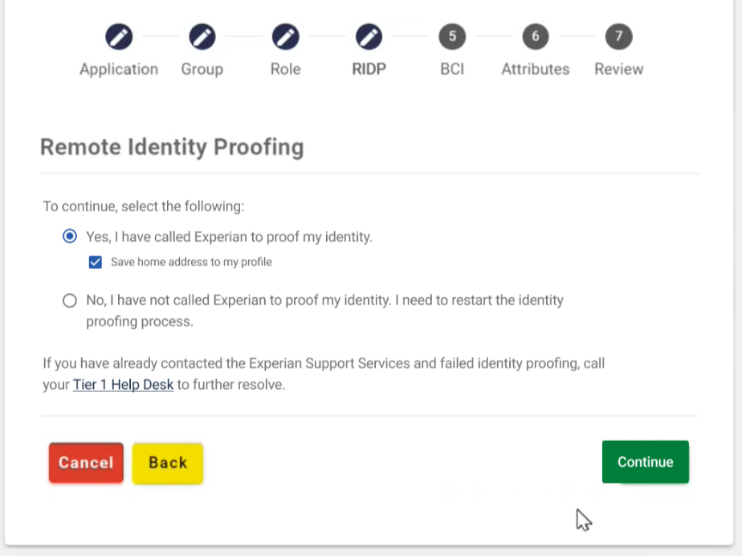
Figure 15: Experian Identity Verification Confirmation

Step 1: Login to the CMS IDM system. The RIDP application will be aware of the previous failed attempt and will display a window with a message which asks if Experian has been contacted.

Step 2: Click the “Yes, I have called Experian to proof my identity” radio button if Experian has been contacted. Then, click the “Save home address to my profile” radio button to overwrite the existing home address in your profile with the address used to identity proof.

Step 3: Click the green Continue button.

RIDP Phone Verification Failures
If IDM is unable to find a record of successful phone proofing, a window will display the error message illustrated in Figure 16.
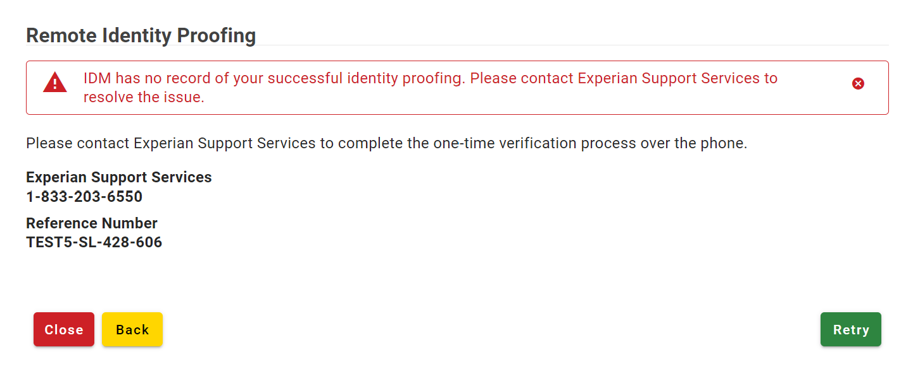
Figure 16: RIDP Phone Verification Failure, Contact Experian Support Services

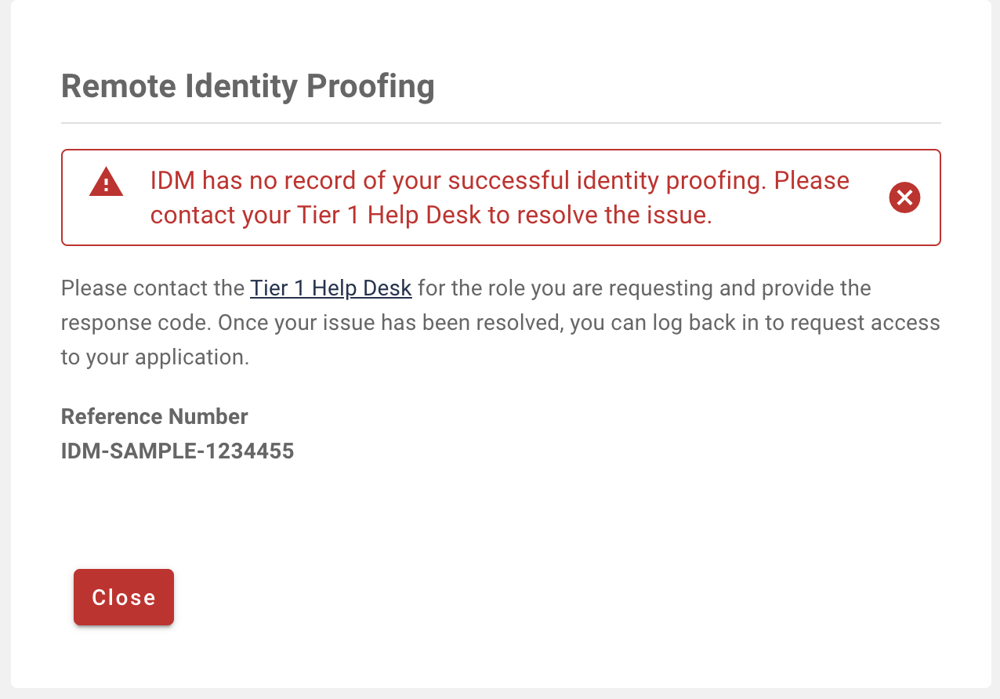
Figure 17: RIDP Phone Verification Failure, Contact Application Helpdesk
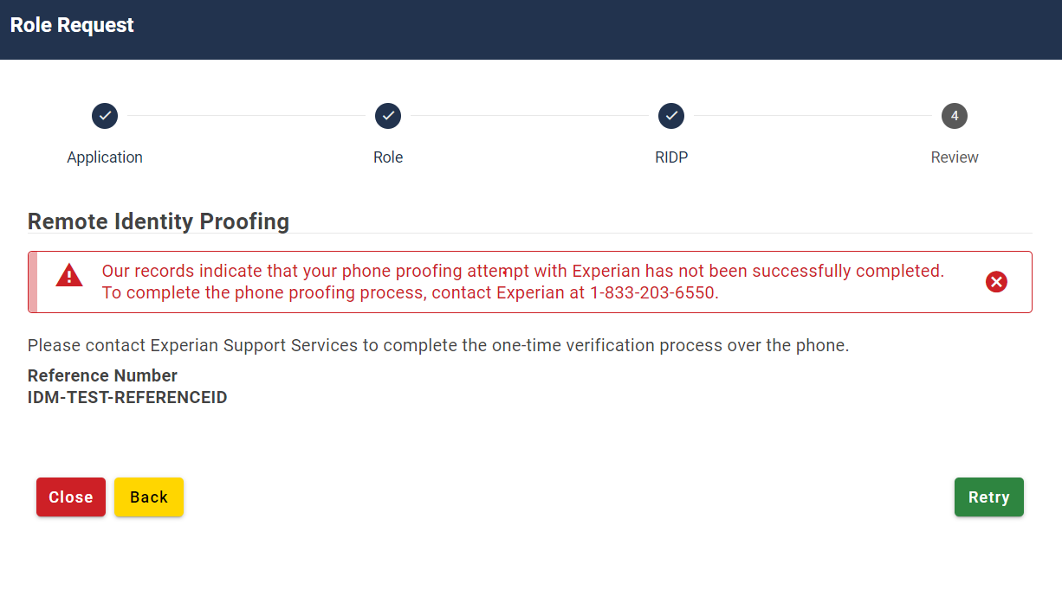
Figure 18: RIDP Phone Disconnect, Call Back Experian Support

Step 4:
- Contact the respective Application Helpdesk, if you get the error displayed in Figure 16.
- Call Experian Support Services if you get the error displayed in Figure 17. Once you have successfully completed the one-time verification process over the phone click Retry.
  - If person gets disconnected from the call, you get an error displayed in Figure 18. You must call back to Experian Support Services to continue phone proofing.
Appendix A: Record of Changes

Table 3 Record of Changes
Version Number | Date | Author/Owner | Description of Change | Approval(s)
0.01 | 07/13/2020 | C-HIT | Initial draft:  - Assign document title: Quick Start RIDP User Guide.
0.02 | 07/20/2020 | C-HIT | - Revised document style to reflect 3rd person point view.  - Updated Figure 1 and Figure 12.
0.03 | 06/13/2023 | Omni/Bana | Removed references to KBA and added references to RBA
0.04 | 08/15/2023 | Omni/Bana | - Updated Figure 11 and Figure 14  - Updated sections 4.2 and 4.3 to remove references to proofing questions.
0.05 | 10/02/2023 | Omni/Bana | - At the top of section 4.3, “Response Code” has been changed to “Reference Number” in the notes to be consistent with email notifications
0.06 | 11/14/2023 | Omni/Bana | - Replaced Figures 10 and 11 in section 4.2 in accordance with new UI updates (max retries/number of attempts remaining features). Updated description directly above these two figures.
0.07 | 11/28/2023 | Omni/Bana | - Replaced Figures 10 and 11 in section 4.2 in accordance with new UI updates (max retries/number of attempts remaining features). Updated description directly above these two figures. Same areas updated as last update with improvements.
0.08 | 11/30/2023 | Omni/Bana | - Updated Screenshots to include both error scenarios for PII verification failures and phone proofing failures.
0.09 | 07/03/2024 | Omni/Bana | - Updated screenshots with new Experian Phone Number on Figures 12,13, and 16
0.10 | 9/13/2024 | Omni/Bana | - Updated text and new screenshots for Figure 18
Appendix B: Acronyms

Table 4: Acronyms
Acronym | Literal Translation
C-HIT | Chags Health Information Technology
CMS | Centers for Medicare & Medicaid Services
EIDM | Enterprise Identity Management
IDM | Identity Management
IVR | Interactive Voice Response
LOA | Level of Assurance
MFA | Multi-factor Authentication
OTP | One-time Password
PII | Personally Identifiable Information
RIDP | Remote Identity Proofing
SMS | Short Message Service
SSN | Social Security Number

