Short Name: | SNFRM
Description: | This outcome measure assesses the risk-standardized rate of all-cause, unplanned inpatient hospital readmissions for Medicare fee-for-service (FFS) SNF  patients within 30 days of discharge from a prior proximal hospitalization. A prior proximal hospitalization is defined as an admission to an inpatient prospective payment system (IPPS) hospital, critical access hospital (CAH), or psychiatric hospital.  The measure is based on 12 months of data and uses a modified version of the CMS Planned Readmissions Algorithm.
Risk Window: | 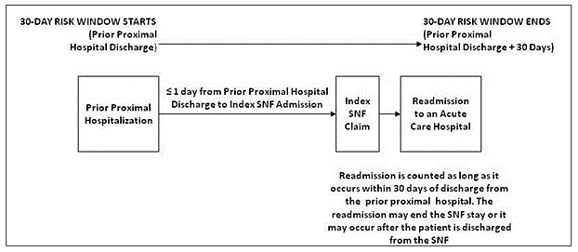
Numerator: | The measure does not have a simple form for the numerator—that is, the risk adjustment method used does not make the observed number of readmissions the numerator. The numerator is specifically defined as the risk-adjusted estimate of the number of unplanned readmissions (to an IPPS or CAH) that occurred within 30 days from discharge from the prior proximal acute hospitalization. The numerator, as defined, includes risk adjustment for patient characteristics and a statistical estimate of the facility effect beyond patient mix.
Denominator: | The measure does not have a simple form for the denominator—that is, the risk adjustment method used does not make the predicted number of readmissions the denominator. The denominator, in effect, is the number of SNF admissions within 1 day of a prior proximal hospital discharge during a target year, taking denominator exclusions into account. The denominator is computed with the same model used for the numerator, which is developed using all non-excluded SNF stays in the national data. For a particular facility the model is applied to the patient population, but the facility effect term is 0.
Denominator Exclusions: | The following* are excluded from the denominator:  - SNF stays where the patient had one or more intervening post-acute care (PAC) admissions (inpatient rehabilitation facility [IRF] or long-term care hospital [LTCH]), which occurred either between the prior proximal hospital discharge and SNF admission or after the SNF discharge, within the 30-day risk window.  - SNF admissions where the patient had multiple SNF admissions after the prior proximal hospitalization, within the 30-day risk window.  Rationale: For patients who have IRF or LTCH admissions prior to their first SNF admission, these patients are starting their SNF admission later in the 30-day risk window and receiving other additional types of services as compared to patients admitted directly to the SNF. They are clinically different and their risk for readmission is different than the rest of SNF admissions. Additionally, when patients have multiple PAC admissions, evaluating quality of care coordination is confounded and even controversial in terms of attributing responsibility for a readmission among multiple PAC providers. Similarly, assigning responsibility for a readmission for patients who have multiple SNF admissions subsequent to their prior proximal hospitalization is also controversial.  - SNF stays with a gap of greater than 1 day between discharge from the prior proximal hospitalization and the SNF admission.  Rationale: These patients are starting their SNF admissions later in the 30-day risk window than patients admitted directly to the SNF from the prior proximal hospitalization. They are clinically different and their risk for readmission is different than the rest of SNF admissions.  - SNF stays where the patient did not have at least 12 months of FFS Medicare enrollment prior to the proximal hospital discharge (measured as enrollment during the month of proximal hospital discharge and the for 11 months prior to that discharge).  Rationale: FFS Medicare claims are used to identify comorbidities during the 12-month period prior to the proximal hospital discharge for risk adjustment.  - SNF stays in which the patient did not have FFS Medicare enrollment for the entire risk period (measured as enrollment during the month of proximal hospital discharge and the month following the month of discharge).  Rationale: Readmissions occurring within the 30-day risk window when the patient does not have FFS Medicare coverage cannot be detected using claims.  - SNF stays in which the principal diagnosis for the prior proximal hospitalization was for the medical treatment of cancer. Patients with cancer whose principal diagnosis from the prior proximal hospitalization was for other diagnoses or for surgical treatment of their cancer remain in the measure.  Rationale: These admissions have a very different mortality and readmission risk than the rest of the Medicare population, and outcomes for these admissions do not correlate well with outcomes for other admissions.  - SNF stays where the patient was discharged from the SNF against medical advice.  Rationale: The SNF was not able to complete care as needed.  - SNF stays in which the principal primary diagnosis for the prior proximal hospitalization was for rehabilitation care; fitting of prostheses and for the adjustment of devices.  Rationale: Hospital admissions for these conditions are not for acute care.  *List does not include all denominator exclusions.
Data Source: | Administrative claims
Resources: | SNFRM Draft Technical Report  SNFRM August 2012 Expert Panel Report  SNFRM Public Comment Summary Report

