Activities include:

Start of Contract - September 2015

Information Gathering and SPADE Development - September 2015 to September 2017

TEP 1: April 21016

Alpha 1 Nurse and Facility Training: July to August 2016

Blueprint Public Comment Period 1: August to September 2016

Alpha 1 Data Collection: August to October 2016

Start of Year 2: September 2016 

TEP 2: January 2017

Alpha 2 Nurse and Facility Training: March to April 2017

Blueprint Public Comment Period 2: April to June 2017

Alpha 2 Data Collection: May to July 2017

Start of Year 3: September 2017 

FY 2018 Rule Activities: October 2016 to October 2017 

National Beta Nurse and Facility Training: October 2017 to February 2018

National Beta Data Collection: Novermber 2017 to August 2018

Stakeholder Outreach: January 2018 to November 2018

Start of Year 4: September 2018 

TEP 3: September 2018 

FY 2020 Rule Activities: March to September 2019

Final Reports: September 2018 to September 2019


Map of United States with Beta test cities listed by region. 
West Region: Los Angeles, CA; San Diego, CA; Phoenix, AZ; Dallas, TX; Houston, TX
Central Region: Kansas City, MO; St. Louis, MO; Nashville, TN; Chicago, IL
East Region: Boston, MA; Philadelphia, PA; Harrisburg, PA; Durham, NC; Ft. Lauderdale, FL

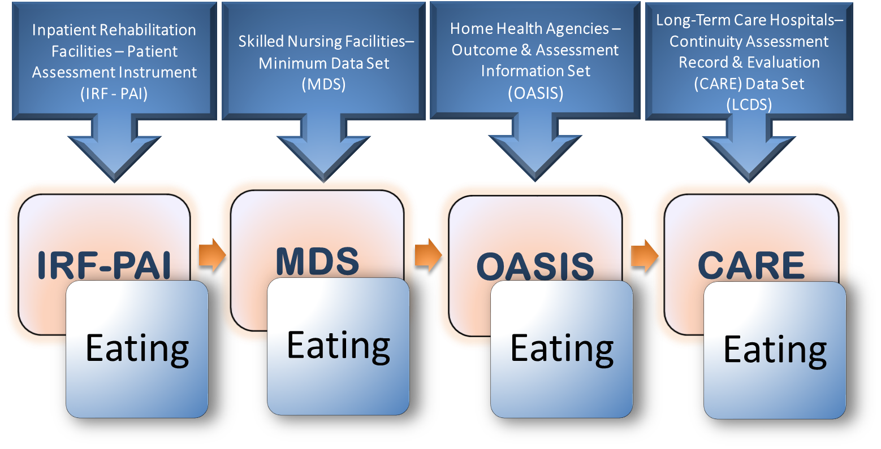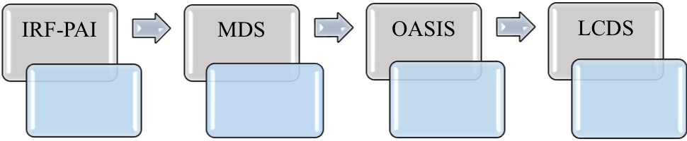

**Pain Frequency**

**Pain Frequency**

**Pain Frequency**

**Pain Frequency**