
Centers for Medicare & Medicaid Services

CMS Enterprise Portal Quick Reference Guide (QRG)
EIDM QRG - Completing Annual Certification
February 5, 2017
Version 1.2 Final

Table of Contents
1. Introduction 1
2. Annual Certification 1
3. User Initiated Annual Certification 2
4. Approvers Certifying Manually Approved Roles 8
5. Validated Roles 19
APPENDIX A: Annual Certification Link 21
APPENDIX B: Accessing Pending Certification Using the My Actions Link 22
APPENDIX C: Important Terminology 23

Introduction
This guide provides an overview of CMS Annual Certification process within Enterprise Identity Management (EIDM). This document includes step-by-step instructions for Approvers to use to certify the users under their approval authority.

Annual Certification
Beginning January 2016, the Centers for Medicare and Medicaid Services (CMS) enforced the Annual Certification requirement for all applications supported by EIDM.
Annual Certification is the annual recurrence of the role approval process. Role approval is the process used by the Business Owners, their representatives, Authorizers, Help Desks, or other Approvers to grant an application role to a user who is requesting the role.
CMS provides a means to record the Annual Certification actions taken for two types of roles:
- Manually Approved Roles – The original role request requires manual approval by the user who has the appropriate authorizing role.
- Validated Roles – The original role request requires that EIDM compare and validate user provided data to data maintained in a trusted resource (validation check). For e.g DBidS Authorized Official and Connexion Authorized Official
When a role fails certification, it is removed from the user’s profile.
- Manually approved roles can fail certification either because the Approver selected ‘Revoke’ for the user’s role, or because the Approver took no action prior to the Annual Certification due date.
- Validated roles can fail because the user provided data does not match the data in the trusted resource on the Annual Certification due date.
The Annual Certification due date is the date that a role is due to be certified. Annual Certification is not a certification of a User Identifier (UID) or a User’s Account.
- The Annual Certification due date for manually approved roles is one year after the create date for the first certification, and one year after the certification date each year thereafter.
- The Annual Certification due date for validated roles is June 1 every year.
The Annual Certification process for any given role is the sole responsibility of the application and their Approvers. This guide explains the Approvers’ responsibility with regards to Annual Certification for both the manually and validated roles.

User Initiated Annual Certification
The Annual Certification process for any given role is the sole responsibility of the Application and their Approvers. To help the approvers review and take action on these pending annual certifications, End Users have the ability to submit their roles for Annual Certification.
This section lists the step-by step instructions that an End User can take to submit their role(s) for Annual Certification.
The process starts with an E-mail notification that is sent out to the users on the 1st and 15th of every month if their roles are due for certification within the next 45 days and are not submitted for annual certification.

User Initiated Annual Certification
An End User with a manually approved role will receive and E-mail 45 days prior to the certification due date.

Please follow Steps 1 to 13 to submit a role for Annual Certification.
Steps | Screenshots
Review the E-mail notification that that is sent out on the 1st and 15th of every month if your roles are due for certification within the next 45 days and are not submitted for annual certification.  Follow the instructions in the E-mail to access the ‘My Annual Certifications’ page. | 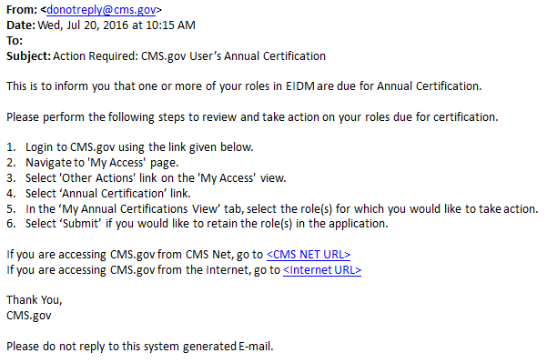
- Go to https://portal.cms.gov/ and select Login to CMS Secure Portal on the CMS Enterprise Portal.  Note: The CMS Enterprise Portal supports the following browsers: Internet Explorer 11, Firefox, Chrome, and Safari. | 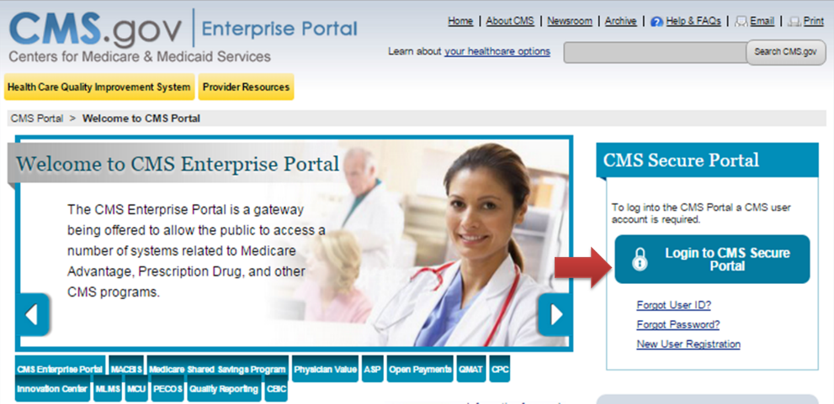
- Read the ‘Terms and Conditions’ page and select I Accept to continue. | 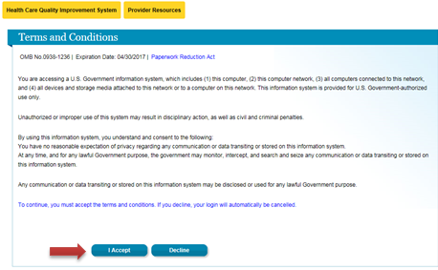
- Enter your User ID and select Next. | 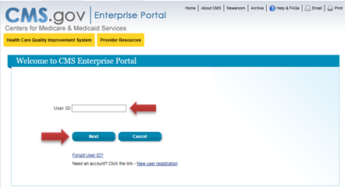
- Enter your Password, select an MFA Device Type from the drop-down, enter the Security Code, and select Log In.  Note: If you have a role not requiring MFA, you will only be prompted to enter your Password.  The ‘Security Code’ for the ‘E-mail’ and ‘One-Time Security Code’ options expires in 30 minutes. The ‘Security Code’ for the other MFA device types expires in 10 minutes. If you are unable to enter the code within the period, you will need to request a new one.  If you do not have access to your registered MFA device, please refer to the ‘User Login’ QRG for step-by-step instructions on how to register an MFA Device | 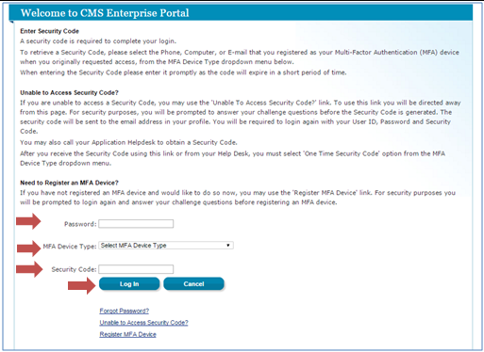
- Select My Access from the drop down menu at the top right corner of the Welcome screen. | 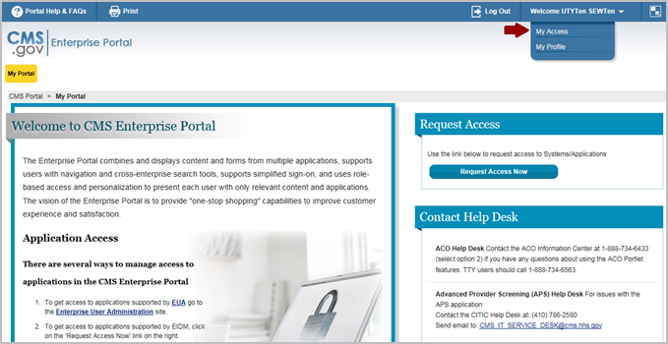
- Select Other Actions in the ‘My Access’ section. | 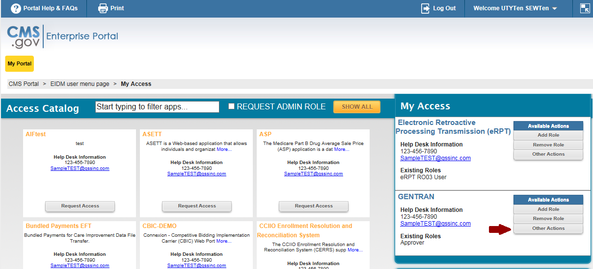
- You are navigated to the ‘My Access’ page. Select the link for Annual Certification on the left pane. | 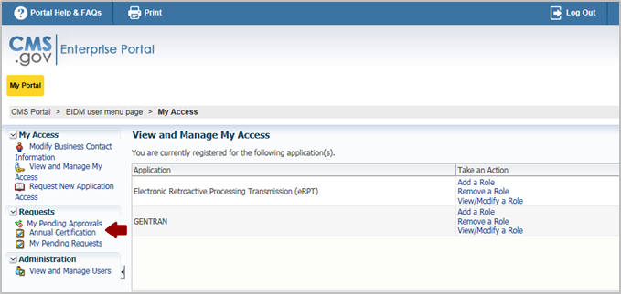
- Your roles are displayed on the My Annual Certifications View. Select one or multiple roles from the list using the checkboxes.  Use the Sort By fields to organize your pending certifications by Next Review Date, Application, Role Name, Attribute, Status or Last Review Date in ascending or descending order.  Select Submit.  Note: The default sorting is by the Next Review Date in ascending order. | 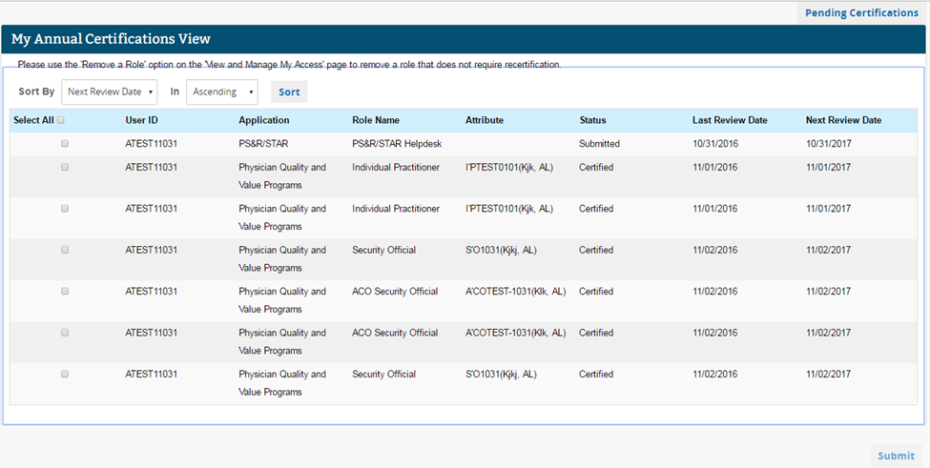
- The Review Details appear. All the roles selected on the My Annual Certifications View are displayed.  Select OK to proceed.  Note: Select Cancel to return to the My Annual Certifications View. | 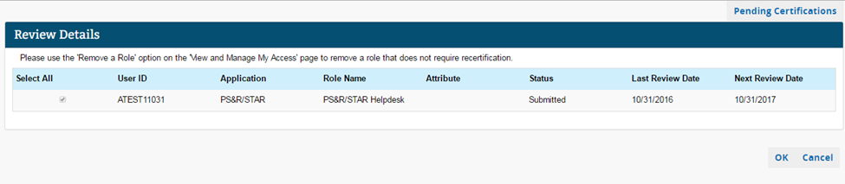
- The Annual Certification Acknowledgement page appears, displaying each role that you successfully submitted for annual certification.  Select OK to return to the My Annual Certifications View.  Note: The approver can now see that you have submitted a request to certify the selected role(s) for Annual Certification. | 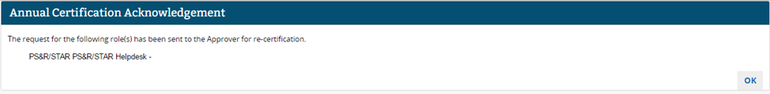
- You will receive an E-mail notification when the role that was submitted for Annual Certification is certified. | 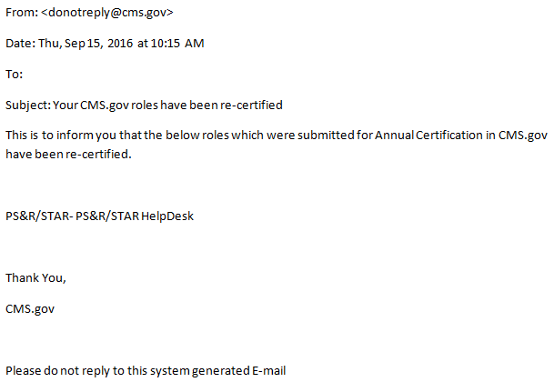
- You will also receive an E-mail when the Approver revokes the role access, or when no action is taken by the Annual Certification due date and the system removes your role. These E-mails are sent out even if you have not requested the roles to be re-certified.  Note: Instructions for regaining access to the application are provided in the E-mail. | 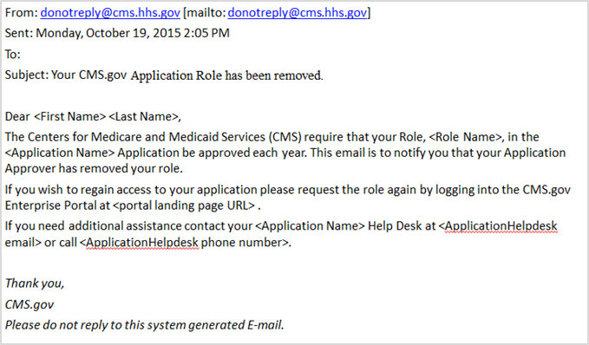

Approvers Certifying Manually Approved Roles
Approvers for manually approved roles have the ability to search for, certify, or revoke the roles assigned to the users under their authority any time they choose via the ‘Annual Certification’ page. However, if they do not take an action by the certification due date, then their users’ role(s) will be revoked.
This section lists the step-by-step instructions that an Approver must take to certify or revoke their users’ access as part of Annual Certification.
The certification process is initiated with an E-mail notification that is sent to the Approver. The notification E-mail will provide instructions for completing the certification for users under their authority.
Certifying Manually Approved Roles
An Approver for manually approved roles will receive an E-mail notifying them that users under their authority are pending Annual Certification. The initial E-mail is sent 30 days prior to the certification due date for users requiring manual approval. Reminder E-mails continue to be sent to the Approver fifteen, seven, and one day prior to the certification due date.

Please follow Steps 1 to 22 to certify pending users’ roles for Annual Certification.
Steps |  | Screenshots
- Review the E-mail notification that lists the number of roles pending certification. Follow the instructions in the E-mail to access the ‘Pending Certifications’ page to certify users’ access.  Note: The roles pending certification requests listed in the E-mail provides the number of pending certifications that require your action in the specified number of days. |  | 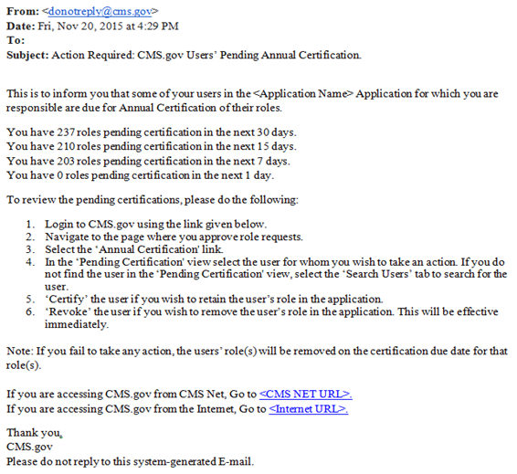
- Go to https://portal.cms.gov/ and select Login to CMS Secure Portal.  Note: The CMS Enterprise Portal supports the following browsers: Internet Explorer 11, Firefox, Chrome, and Safari.  Enable JavaScript and adjust any zoom features to ensure you are not missing part of the screen because the view is too wide. |  | 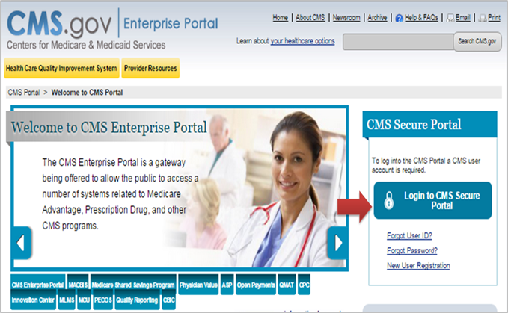
- Read ‘Terms and Conditions’ and select I Accept to continue. |  | 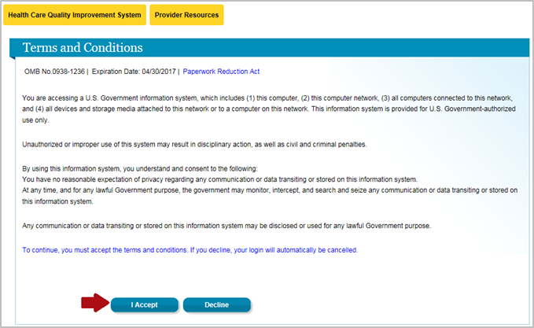
- Enter your User ID and select Next. |  | 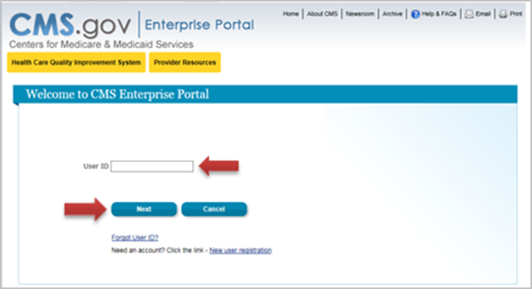
- Enter your Password, select an MFA Device Type from the drop-down, enter the Security Code, and select Log In.  Note: If you have a role not requiring MFA, you will only be prompted to enter your Password.  The ‘Security Code’ for the ‘E-mail’ and ‘One-Time Security Code’ options expires in 30 minutes. The ‘Security Code’ for the other MFA device types expires in 10 minutes. If you are unable to enter the code within the period, you will need to request a new one.  If you do not have access to your registered MFA device, please refer to the ‘User Login’ QRG for step-by-step instructions on how to register an MFA Device. |  | 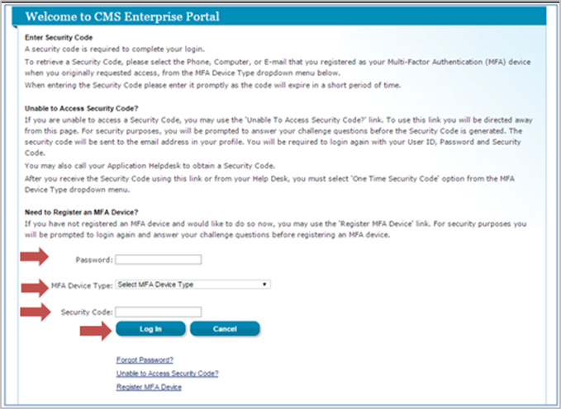
Approvers can access the Annual Certification User Interface (UI) in the same location where they go to approve or reject role requests. Depending on which applications and roles an approver belongs to, you can access this interface via either ‘My Actions’ or ‘My Access’.

This section includes steps to access the Annual Certification UI via the ‘My Access’ page. Refer to the steps listed in Appendix B for accessing this interface via the ‘My Actions’ page. To find out which path you should take to access the Annual Certification UI, refer to the table in Appendix A, which lists the Applications and the appropriate method to access this interface.
- Select My Access in the drop down menu at the top right corner of the Welcome screen.

Note: Please refer to Appendix B for instructions on accessing the ‘Pending Approvals’ UI via My Actions.
- Select Other Actions in the ‘My Access’ section.

Note: The following screenshots show an approver with a GENTRAN Approver role certifying users under their authority.
 | - You are navigated to the ‘My Access’ page. Select the link for Annual Certification on the left pane.  Note: If you are accessing the ‘Pending Approval’ UI via My Actions select the link for Annual Certification under the ‘My Actions’ page. Please refer to Appendix B. |  |  | 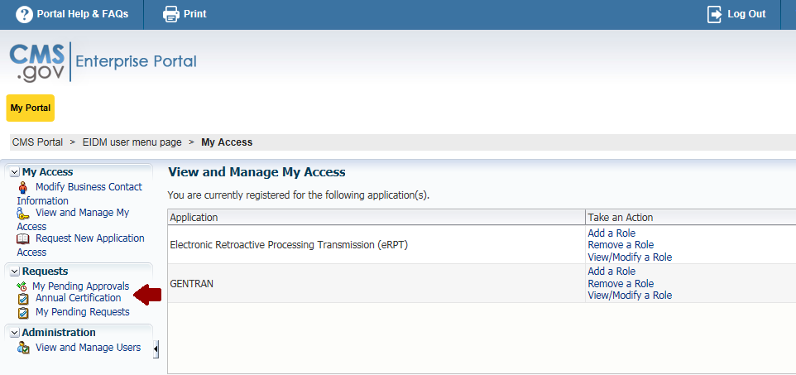
 | - Select users one by one or in bulk (by selecting the Select All checkbox) to Certify or Revoke users’ roles. Only users whose roles are due for certification within the next 30 days will be shown initially.  You may use the Search Users tab to search for users outside the 30 day window or to search for a specific pending certification by UID, User name, etc.  Follow Steps 11 and 12 if you require additional user role information to certify/revoke the role.  Follow Steps 15 to 24 to search and certify users using the Search Users tab.  Note: By default, the My Users’ Certifications View displays up to 500 results sorted in ascending order by the Next Review Date. You can also sort by User ID, First Name, Last Name, Role Name, Attribute, User Requested, User Requested Date and Last Review Date. You can also use the Filter option to customize the results.  The system uses pagination when displaying results. The ability to toggle through pages can be utilized by selecting the Up Arrow, Down Arrow, First, Previous, Next, and Last buttons or by entering the desired page number in the Page field.  Use Results Per Page to display up to 100 results per page. By default, it is set to 20. |  |  | 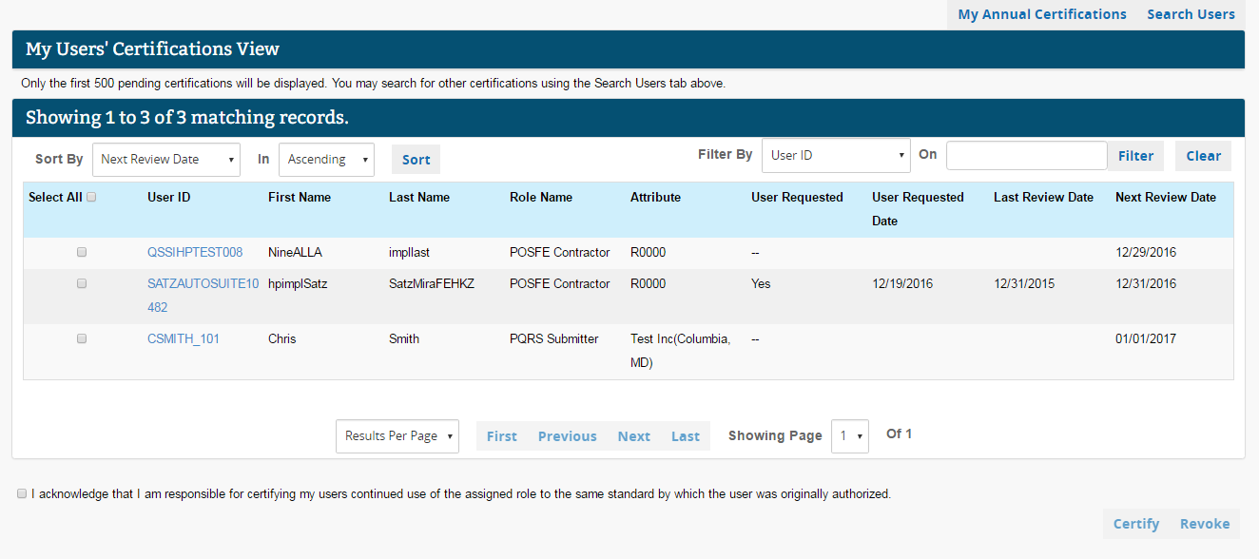
 | - Agree to the acknowledgement statement by selecting the checkbox in the lower left corner of the page. Select Certify or Revoke to complete the pending role certification.  Continue to Step 13.  Note: The Certify button approves the user’s continued use of a role in your application. Upon successful certification, an E-mail is sent to the user who requested their roles to be certified.  The Revoke button removes the user’s role for the application. The user is notified via E-mail when their role is revoked. |  | 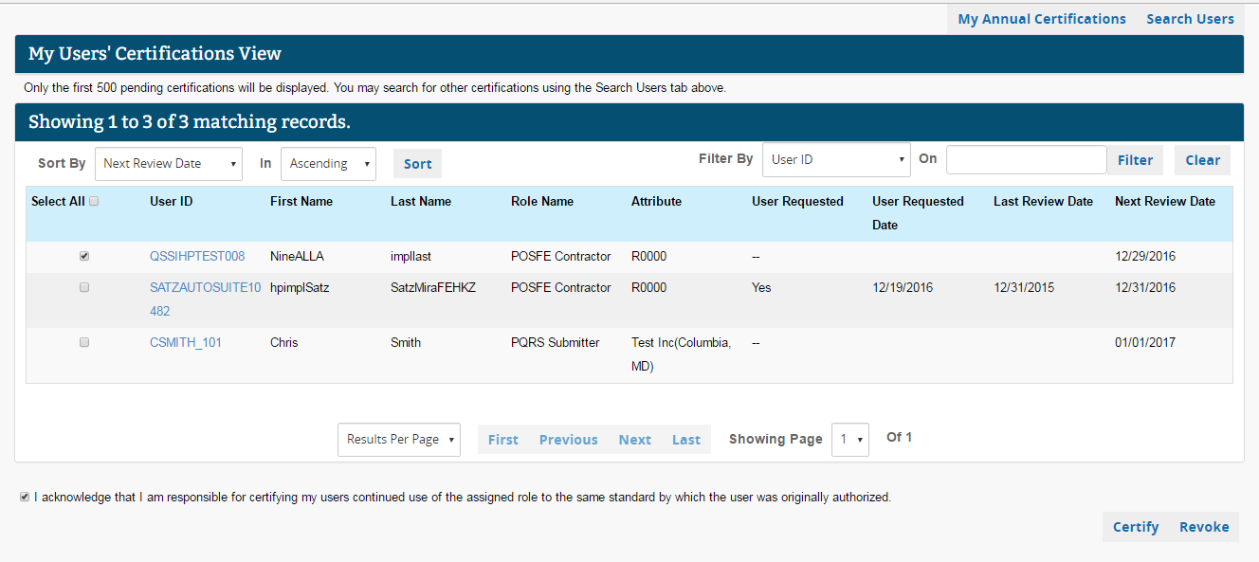
 | - Select the User ID hyperlink to view all role attributes for the selected role and Business Contact Information for the user. |  | 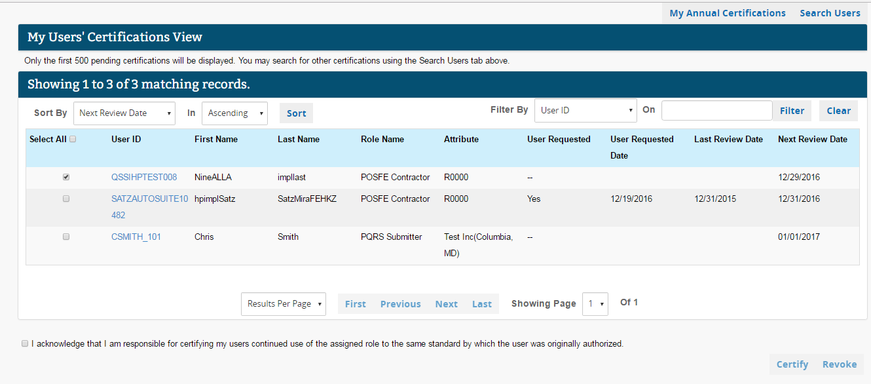
 | - Review the role information on the User Details tab. Agree to the acknowledgement statement by selecting the checkbox in the lower left corner. Select Certify or Revoke to complete the pending user’s role certification.  Note: Selecting Cancel will return you to the My Users’ Certifications View. |  | 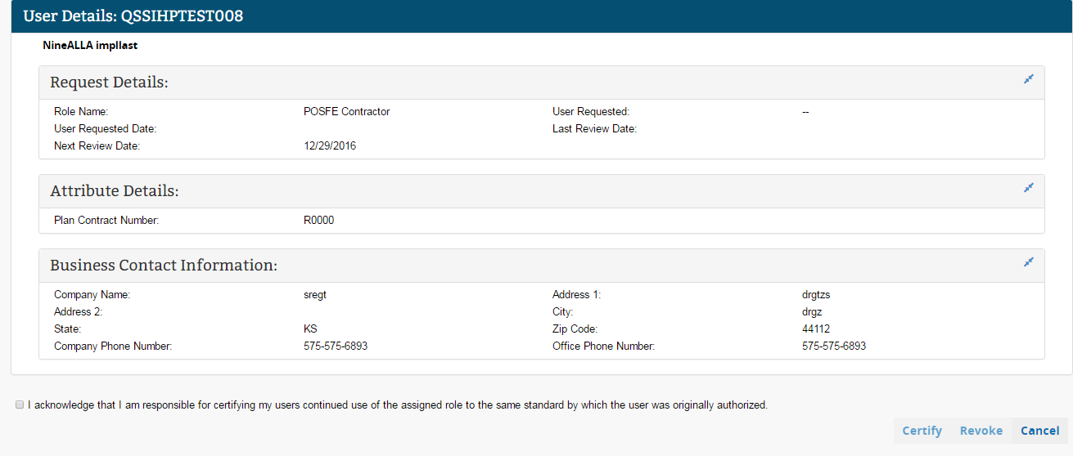
 | - The Review Details page displays the confirmation message and the list of users included for that action. Review the UID, role, and Approver-based information of the pending certifications that are going to certified or revoked.  Confirm your action by selecting the OK button. Select the Cancel button to cancel the action and return to the ‘Search Users View’ page.  Note: Sample screenshots are shown for both Certify and Revoke actions.  A summary table of the role information will not be shown when taking action from the User Details tab. |  | 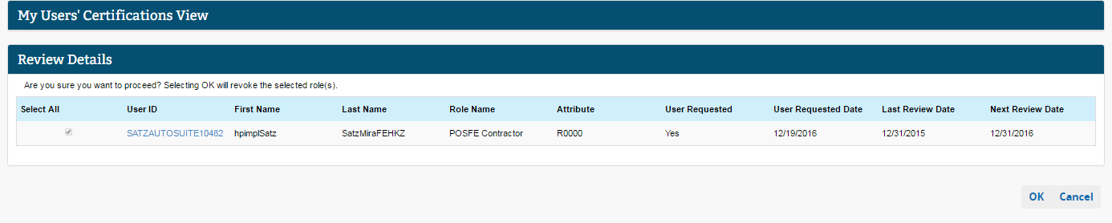  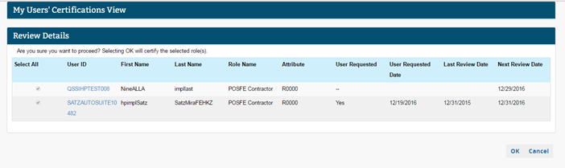
 | - You are navigated to the My Users’ Certifications View after certifying or revoking roles for users under your authority. An informational message is displayed stating that the roles have been Certified or Revoked. If there are additional users’ roles to be certified, follow Steps 1 to 10 to take action.  Note: The users’ roles which were certified or revoked will no longer be included in the My Users’ Certifications list. |  | 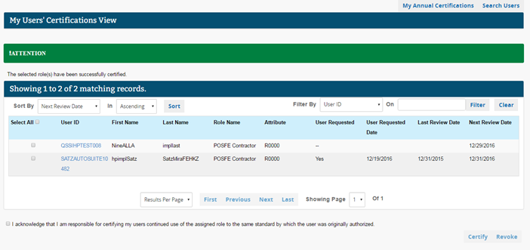
 | Approvers can select the Search Users tab to search pending certifications for users’ roles under their approval authority. Users whose roles are due for certification matching the search criteria are populated in the search results. The following screenshots provide step-by-step instructions for searching pending certifications and taking action on the search results.
 | - Approvers can search for pending role certifications of users under their approval authority by providing search criteria on the Search Users page.  Note: The following characters are not allowed in any of the search fields: Asterisk (*), Percentage (%), Double quotation mark (“), Ampersand (&), Cap (^), Less-than sign (<), and Greater-than sign (>).  UID, First Name, and Last Name: Enter a minimum of 2 characters in the search field.  Application: This is a mandatory field if you are an approver for more than one application. Please select the application. If you are an approver for only one application, the application name will be pre-selected by default and will be grayed out.  Role: This is an optional field and displays the roles within the application which are under your approval authority. If you are an approver for only one role in the application, the role will be pre-selected by default and will be grayed out.  Certification Date From and To: Enter dates in mm/dd/yyyy format, or select dates using the calendar icon to search pending certifications.  User Requested: This field allows you to search for or hide certifications that were requested by an end user.  User Requested Date From and To: Enter dates in mm/dd/yyyy format, or select dates using the calendar icon to search for certifications requested by the end user within a specific period. |  | 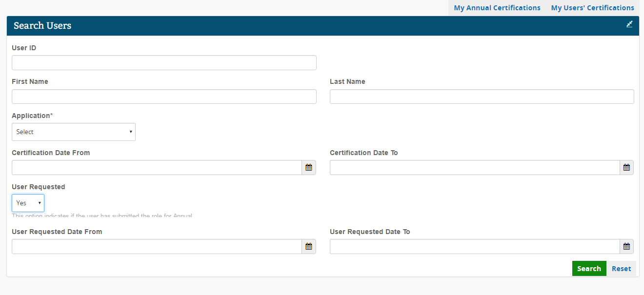
 | - Select Search to retrieve a list of users matching the search criteria. To clear the search criteria, select the Reset button.
 | - Review the pending certifications that match your search criteria. Select users one by one or in bulk by selecting Select All to certify or revoke roles.  Follow Steps 20 and 21 if you require additional user role information to certify/revoke the role.  Note: By default, the results are sorted by the Next Review Date column. You can sort the search results in ascending or descending order using the ‘Sort By’ option. By default, up to 500 results are populated. You can see all pending certifications that are due up to the next 365 days.  The system uses pagination when displaying results. The ability to toggle through pages can be utilized by selecting the Up Arrow, Down Arrow, First, Previous, Next, and Last buttons or by entering the desired page number in the Page field.  Use the Results Per Page to display up to 100 results per page. By default, it is set to 20. The following are the different fields that are displayed in the search results:  UID, First Name, Last Name: User information of the user who matches the search criteria  Role Name: User role for the user who matches the search criteria  Attribute: The role attribute that is provided by the user at the time of role request and is used to identify the Approver and route the request to that Approver.  User Requested: Indicates whether the annual certification request has been initiated by the end user.  User Requested Date: The date an end user submitted the Annual Certification request.  Last Review Date: The last date Annual Certification was completed.  Next Review Date: The next Annual Certification due date.  External Validation Error: Only shown for application roles where the original role request required that EIDM compare and validate user-provided data to data maintained in a trusted resource. It will be displayed only when the trusted resource validation fails.  Select the double arrow in the top right corner to expand the table view to see all populated columns. |  | 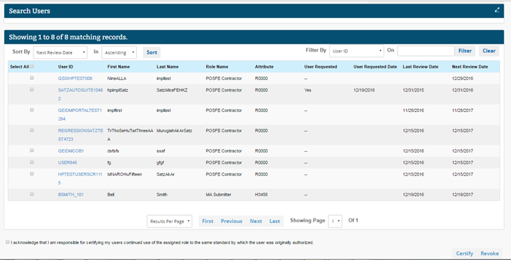
 | - Agree to the acknowledgement statement by selecting the checkbox in the lower left corner of the page. Select Certify or Revoke to complete the pending user’s role certification.  Continue to Step 22.  Note: The Certify button approves the user’s continued use of a role in your application.  The Revoke button removes the user’s role for the application. The user is notified via E-mail when a role is revoked.  The Cancel button clears the search and navigates you back to the My Users’ Certifications View. |  | 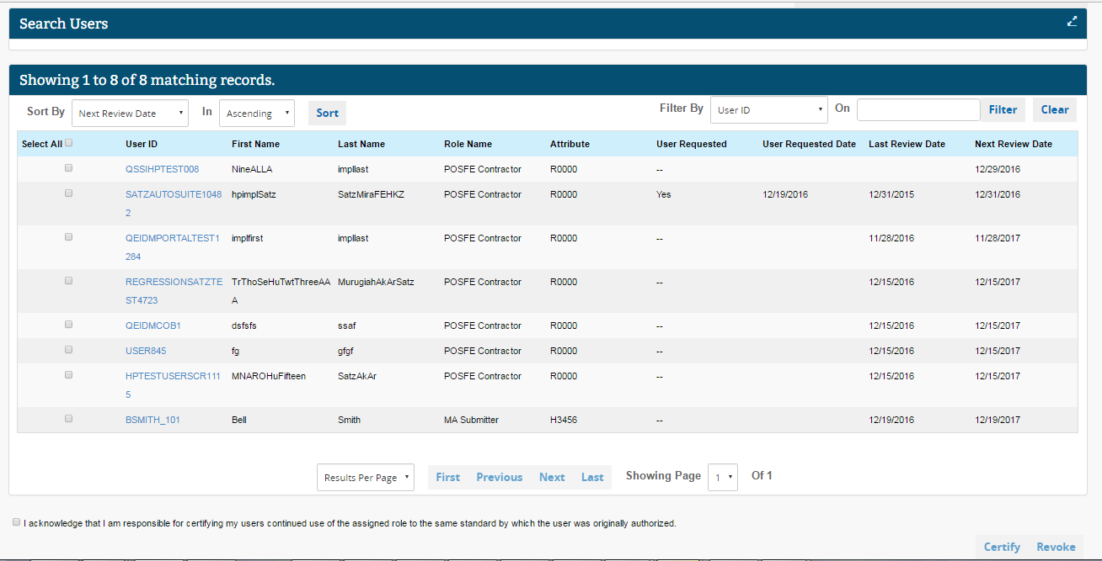
 | - Select the User ID link to view all role attributes for the selected role. |  | 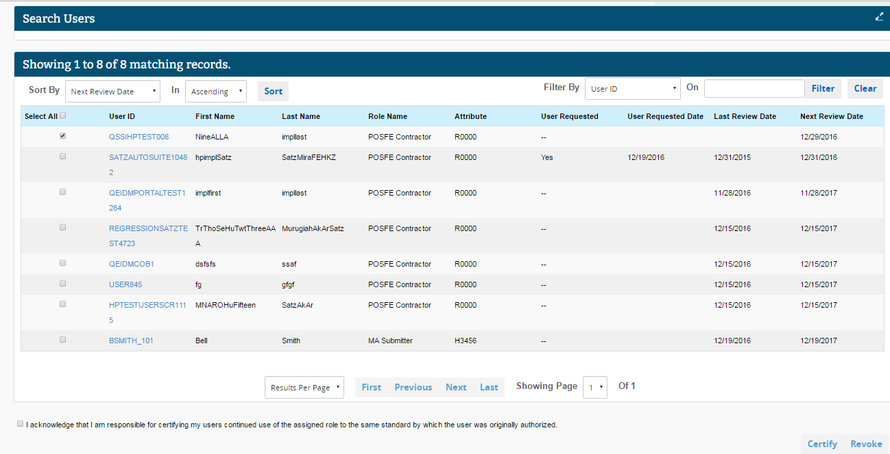
 | - Review the role information on the Role Details tab. Agree to the acknowledgement statement by selecting the checkbox in the lower left corner of the page. Select Certify or Revoke to complete the pending user’s role certification. |  | 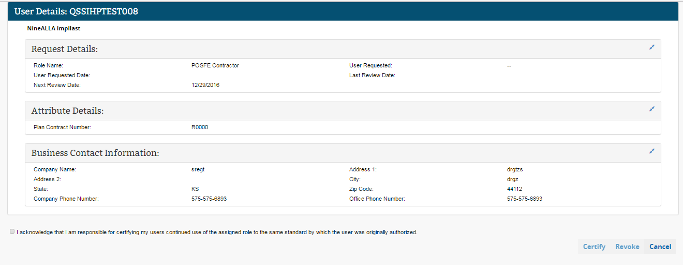
 | - The Review Details page appears providing the list of users included for that action. Review the UIDs, role, and approver-based information of the pending certifications that are going to be certified or revoked. Confirm the action by selecting the OK button. Select the Cancel button to cancel the action and to return to the ‘Search Users View’ page.  Note: Sample screen shots with the Review Details are shown for both Certify and Revoke actions. |  | 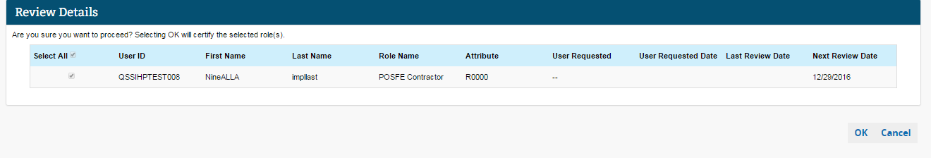  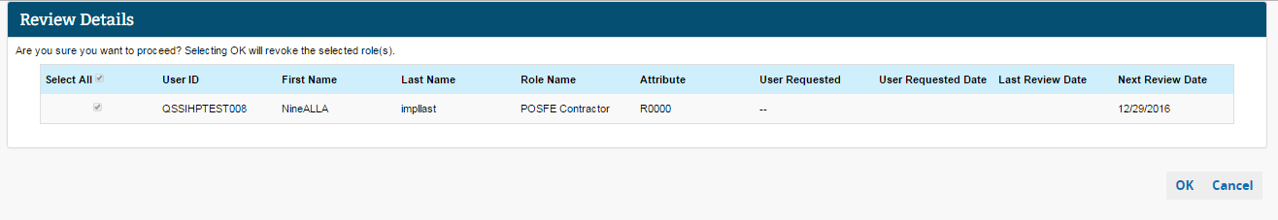
 | - You are navigated to the Search Users View after certifying or revoking the roles for users under your authority. An informational message is displayed stating that the roles have been certified or revoked. If there are additional users’ roles to be certified, or to start a new search, follow Steps 16 to 22.  Note: If you certify/revoke a user role from the Role Details tab, you will return to the My Users’ Certifications View. |  | 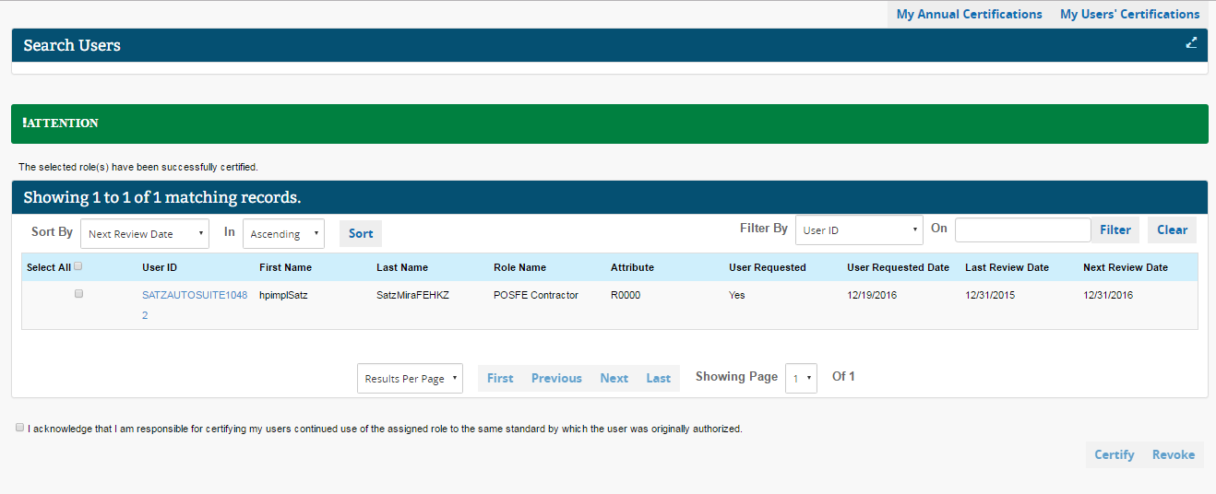  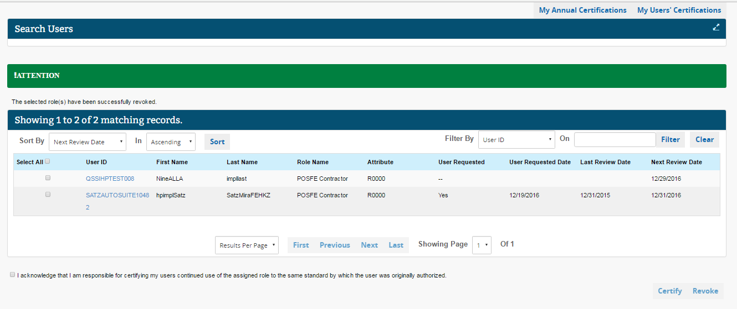

Validated Roles
This section provides sample E-mail notifications received by the Approver, Business Owner, and End User when validated roles do not pass account validation as part of Annual Certification. Please note that validated roles are certified by the system, and approvers need not take any action in certifying or revoking the roles. The next level Approvers and Business Owner of an application are notified about the users who failed the validation check. Please refer to the Introduction section of this document for an explanation and additional details on this type of certification.
Validated Roles require that EIDM compare and validate user provided data (data provided at the time of role request) against the data maintained in a trusted resource (validation check). When validation check fails because of the user data not matching data in the trusted resource, an Approver or Business owner will receive an E-mail notification.

Please see Steps 1 to 3, to view E-mail notifications for Validated Roles pending Annual Certification.
Function | Sample E-mail
- Approvers responsible for users with validated roles receive an initial E-mail 90 days prior to the Annual Certification due date. This E-mail includes the users and roles which failed the validation check. Reminder E-mails will continue to be sent if the user(s) do not pass the validation check 60 days, 30 days, seven days, and one day prior to the Annual Certification due date.  Note: If the user’s account fails the validation check by the certification due date, their role will be removed and the user will be notified by E-mail.  If the user’s account passes the validation check, then the role has passed Annual Certification until the next certification due date. No E-mails are sent to either users or Approvers in this case. Approvers are responsible for taking action to correct data in the trusted resource by the certification due date. | 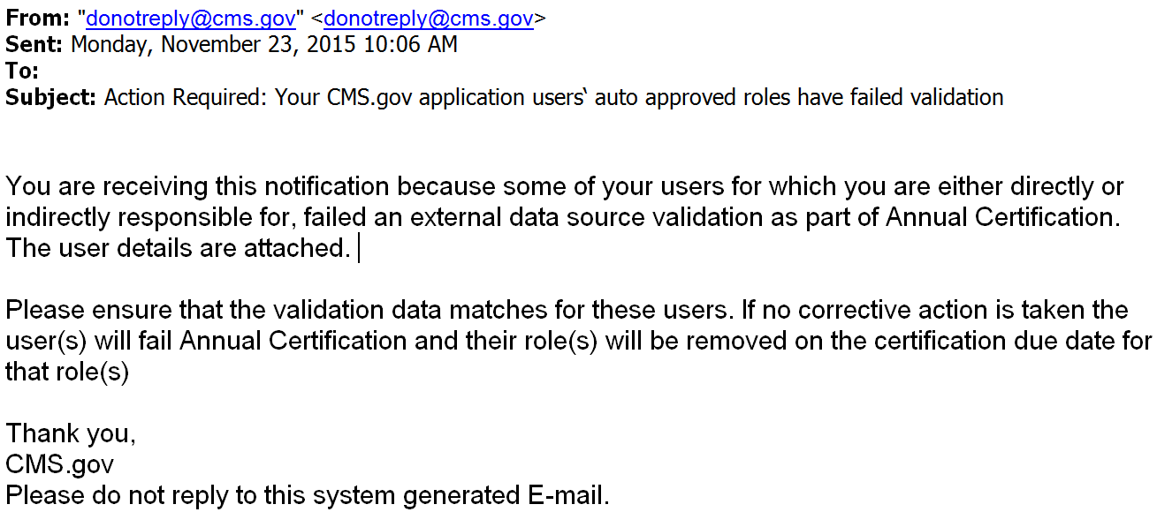

- Approvers responsible for users who have validated role(s) will receive an E-mail informing them of their users’ role removal, when a validated role fails Annual Certification due to failing the validation check.  Note: Instructions for regaining access to the application are provided in the E-mail. | 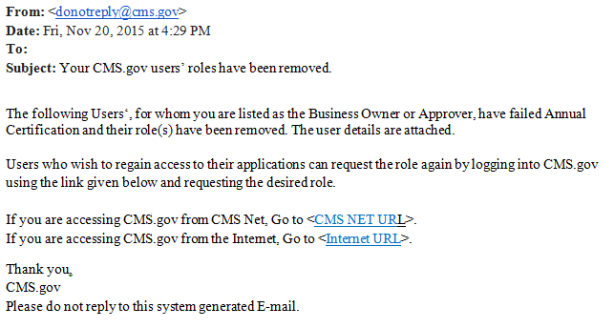
- Users with validated roles who fail Annual Certification will receive an E-mail notifying them that their role has been removed.  Note: Instructions for regaining access to the application are provided in the E-mail. | 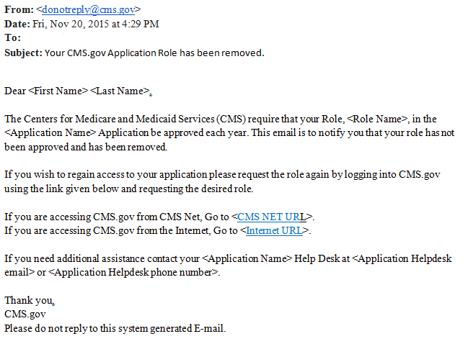

APPENDIX A: Annual Certification Link
Approvers can access the Annual Certification UI in the same location where they go to approve or reject role requests. Depending on which applications and roles an approver belongs to, the Approver can access this interface via either ‘My Actions’ or ‘My Access’. The figure below shows the path an Approver should take to access the interface, depending on the Application(s) in which he/she has approval roles.
Applications via the ‘My Access’ Page |  | Applications via the ‘My Actions’ or ‘My Access’ Page
- BCRS  - BUNDLED PAYMENTS EFT  - CERRS  - Cisco WebEx SaaS  - COB  - CONNEXION  - CPMS  - CSR  - DBidS  - ECRS  - ELMO  - eRPT  - GENTRAN  - HDT | - INTERNET SERVER (ISV)  - MAMA  - MDR  - MED  - MYCGS  - NOVITASPHERE  - PMDA  - PS&R/STAR  - PV-PQRS  - QARM  - SERTS  - SERVIS  - SPOT (FCSO)  - UCM  - VMS CLIENT LETTER | - ASETT  - FFSDCS  - EPPE  - ESD  - FFM/Training – Agents/Brokers/Assisters  - HIOS  - IC | - IDHD  - MACPro  - MCU  - MLMS  - OPEN PAYMENTS  - SHIM (SHOP)  - T-MSIS  - zONE

APPENDIX B: Accessing Pending Certification Using the My Actions Link
This appendix explains the steps that Approvers can take to access the My Users’ Certifications UI from the ‘My Actions’ link.
Steps | Screenshots
- Corresponding with Step 6 in Section 4 above: Select My Actions from the drop down menu at the top right corner of the Welcome screen. | My Actions  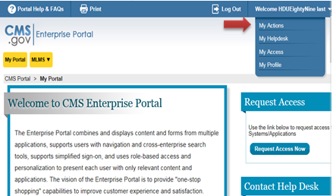
- Select the Annual Certification link on the ‘My Actions’ page. | 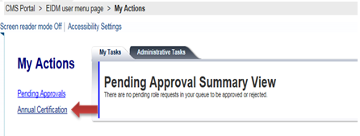

APPENDIX C: Important Terminology
Below are some important terms related to Annual Certification and account reviews:
- Inactive – The user has not logged into either their Application or EIDM for 60 days or more.
- Locked – The user is prevented from logging in to any application. They may log into EIDM.
  - The user’s account will be locked following 60 days of inactivity.
  - To unlock an account, the user must log into EIDM, answer their challenge questions, and reset their password.
- Deleted – The user’s account may no longer be used for any purpose. The user must register again.
  - Account deletion occurs upon failure of account review when both statements below are true:
    - The user’s account does not have a role in any application; and
    - The user’s account has been inactive for more than 360 days.

