
Centers for Medicare & Medicaid Services

CMS.gov Enterprise Portal Quick Reference Guide for Existing Users Adding Multi-Factor Authentication (MFA) to Application Role
March 23, 2016
Version 0.1 Final

Table of Contents
1. Introduction 2
2. Step-by-Step Instructions to Register for Multi-Factor Authentication (MFA) in CMS.gov Enterprise Portal 3
3. Remove a Registered Multi-Factor Authentication (MFA) Device 14
4. Login Using MFA 19

Introduction
This guide provides step-by-step instructions on how users who already have an active CMS.gov Enterprise Portal account and a role in <Your Application Name> can register for Multi-Factor Authentication (MFA), remove a registered MFA device, and log in with MFA.
Note: Do not use this guide if you do not have a role in <Your Application Name>. If you want to request a role in <Your Application Name>, please refer to the ‘EIDM Quick Reference Guide for New Users Completing RIDP and MFA’. If you do not have an EIDM account and want to register for one, visit https://portal.cms.gov.

Step-by-Step Instructions to Register for Multi-Factor Authentication (MFA) in CMS.gov Enterprise Portal

MFA

MFA is a security mechanism that is implemented to verify the legitimacy of a person or transaction.

MFA requires you to provide more than one form of verification in order to prove your identity. MFA registration is required only once when you are requesting a role, but will be verified every time you log into the CMS Enterprise Portal.

During the MFA registration process, the CMS.gov Enterprise Portal requires registration of a phone, computer, or email to add an additional level of security to a user’s account.

You may select from the following options to complete the registration process:
- Smart Phone: Download Verification and Identity Protection (VIP) access software on your smart phone/tablet. You must enter the alphanumeric credential ID that is generated by the VIP access client. You will then enter the Security Code generated by the VIP client.
- Computer: Download VIP access software on your computer. You must enter the alphanumeric credential ID generated by the VIP access client. You will enter the Security Code generated by the VIP client.
- E-mail: Select the e-mail option to receive an e-mail containing a Security Code required at login. You must provide a valid, accessible e-mail address.
- Short Message Service (SMS): Use the SMS option to have your Security Code texted to your phone. You must enter a valid phone number. The phone must be capable of receiving text messages. Carrier charges may apply.
- Interactive Voice Response (IVR): Select the IVR option to receive a voice message containing your Security Code. You must provide a valid phone number and (optional) phone extension.

Steps | Screenshots
1. Go to https://portal.cms.gov/ and select Login to CMS Secure Portal on the CMS Enterprise Portal.  Note: The CMS Enterprise Portal supports the following internet browsers:  - Internet Explorer 8, 9, 10, and 11  - Mozilla-Firefox  - Chrome  - Safari | 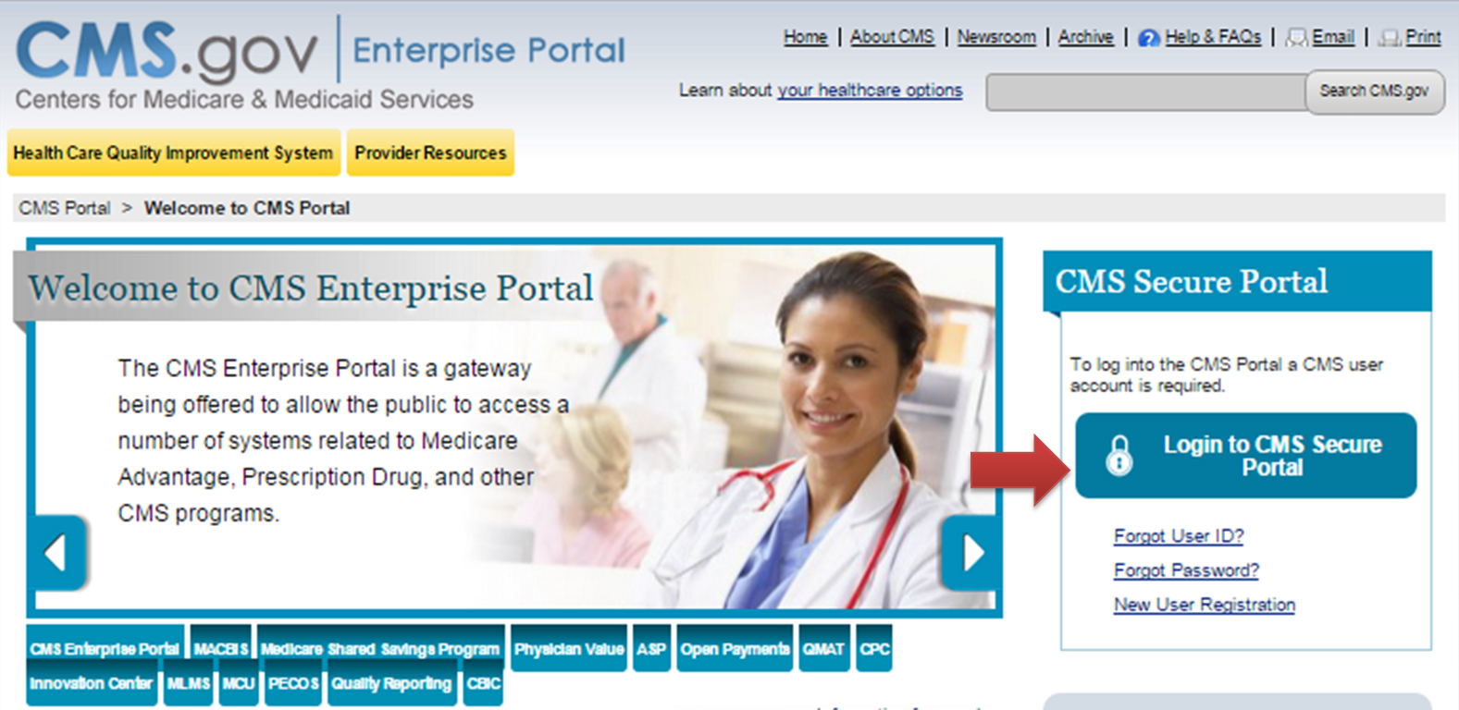
2. Read the Terms and Conditions and select I Accept to continue. | 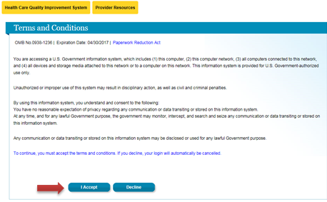
3. Enter your User ID and select Next. | 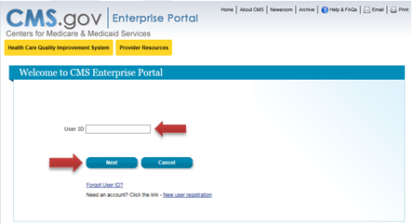
4. Select the Register MFA Device link. | 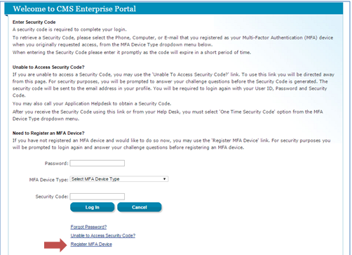
5. Select OK to navigate away from the login page.  Note: Selecting Cancel will end the process to register an MFA Device. | 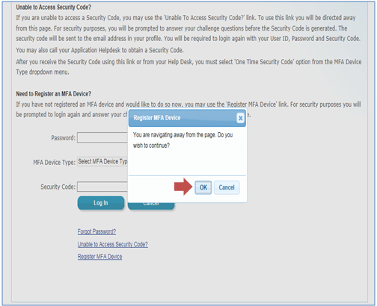
6. Read the Terms and Conditions and select I Accept.
7. Enter your User ID and Password, and select Log In. | 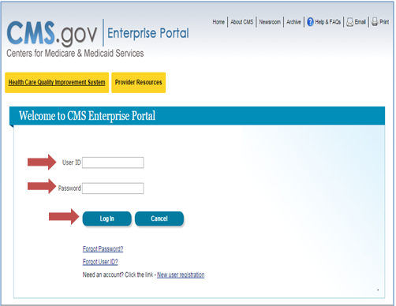
8. Answer the challenge questions and select Next. | 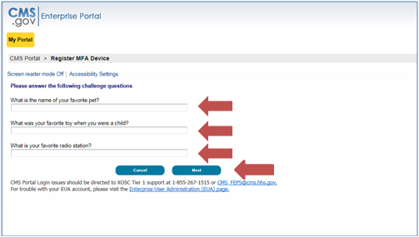
9. Select an MFA device from the MFA Device Type dropdown.  Note: You can select the arrows on the left of each MFA Device Type for additional information. | 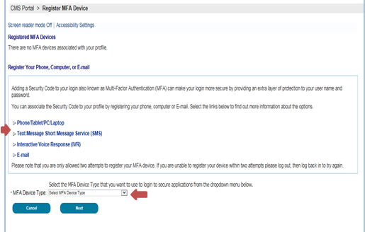
9(a). If selecting Phone/Tablet/PC/Laptop as the MFA Device Type, enter the alphanumeric code that displays under the field labeled Credential ID (on the VIP Access software) in the Credential ID field. Enter a brief description (e.g., Laptop) in the field labeled MFA Device Description. Then select Next. | MFA Option (a) Screenshots  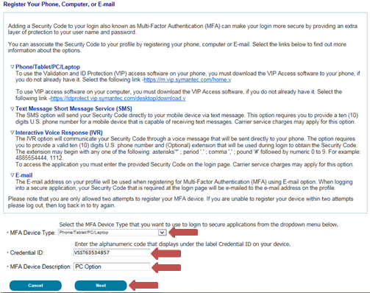  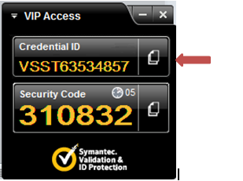
OR  9(b). If selecting Text Message – Short Message Service (SMS) as the MFA Device Type, enter the Phone Number that will be used to obtain the Security Code. Enter a brief description (e.g., Text) in the field labeled MFA Device Description and select Next. | OR  MFA Option (b) Screenshot  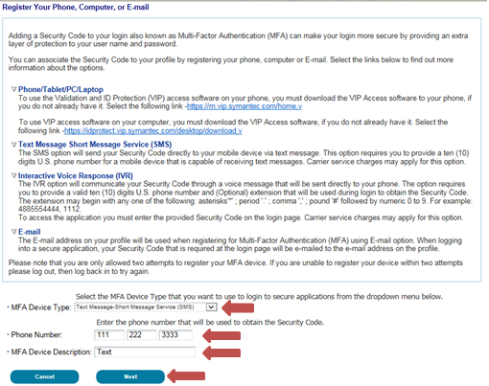
OR  9(c). If selecting Voice Message – Interactive Voice Response (IVR) as the MFA Device Type, enter the Phone Number and corresponding Extension that will be used to obtain the Security Code. Enter a brief description (e.g., IVR) in the field labeled MFA Device Description and select Next.  Note: Extension is an optional field. You may choose to provide a 10-digit phone number or a phone number with an extension. | OR  MFA Option (c) Screenshot  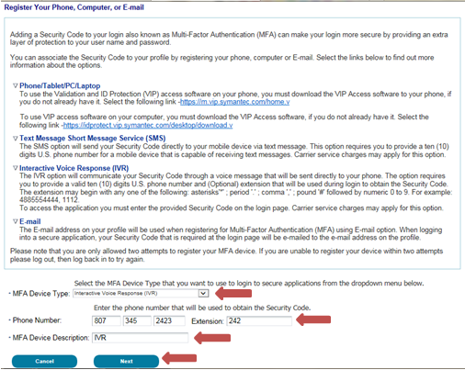
OR  9(d). If selecting E-mail as the MFA Device Type, the E-mail address on your profile will be automatically used to obtain the Security Code. Enter a brief description (e.g., E-mail) in the field labeled MFA Device Description and select Next.  Note: The E-mail address cannot be changed at the time of MFA device registration. It can only be changed using the 'Change E-Mail Address' option from the 'Change My Profile' menu. | OR  MFA Option (d) Screenshot  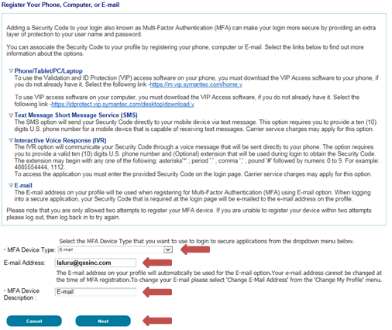
10. Your registration for the Multi-Factor Authentication is now complete. Select OK to continue to log in with MFA.  Note: You will receive an E-mail notification for successfully registering the MFA Device Type. | 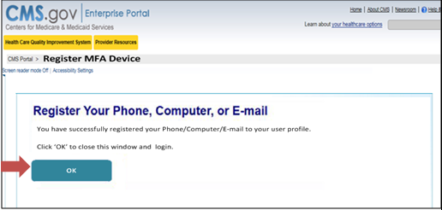
11. Enter your User ID and select Next to continue to log in.

Remove a Registered Multi-Factor Authentication (MFA) Device
To remove a registered Phone or Computer, please follow each step listed below unless otherwise noted.
Steps | Screenshots
1. Go to https://portal.cms.gov/ and select Login to CMS Secure Portal on the CMS Enterprise Portal.

Note: The CMS Enterprise Portal supports the following internet browsers:
- Internet Explorer 8, 9, 10, and 11
- Mozilla-Firefox
- Chrome
- Safari

2. Read the Terms and Conditions and select I Accept to continue.
3. Enter your User ID and select Next to continue.
4. Enter your Password, select an MFA device from the MFA Device Type dropdown, and select Log In.  Note: You should select the MFA Device Type that you previously registered. | 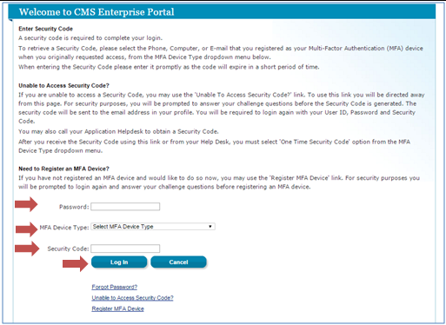
5. Select your username and then select My Profile from the dropdown menu to go to your profile. | 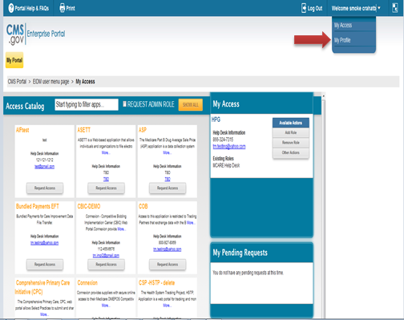
6. Select the Remove Your Phone, Computer, or E-mail link to remove a registered MFA device from your profile.  Select the radio button next to the device you wish to remove, enter the Security Code sent to your device, and select Next to continue. | 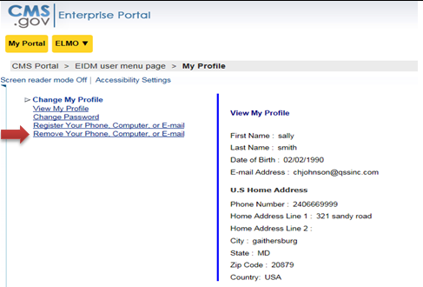
7. Select the registered device you want to remove, select Send Security Code, enter the security code received on the selected MFA Device Type, and select Next to proceed.  Note: Selecting Cancel will end the device removal process. | 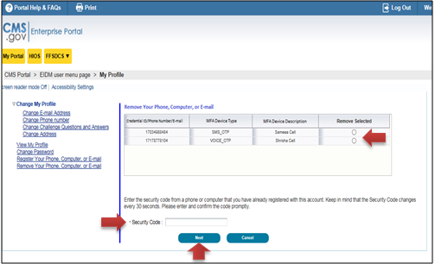
8. Removal of your registered MFA device is now complete. Select OK to proceed.  Note: You will receive an E-mail notification for successfully removing the MFA device. | 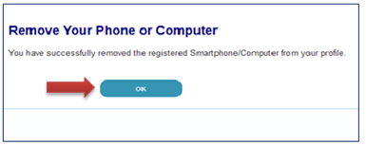
9. You will need at least one MFA device registered to your profile to continue to access your application using MFA.  To remove the last registered device from your profile, you will need to register a new device to your profile. | 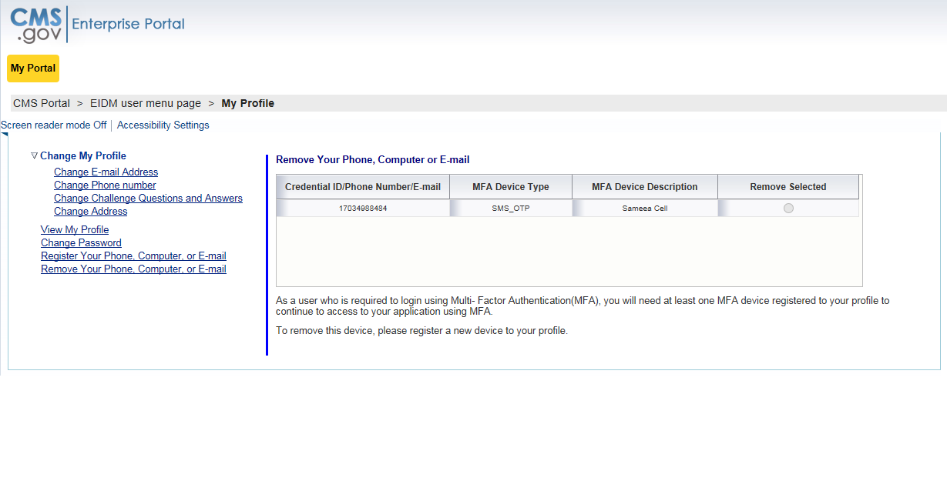

Login Using MFA

Steps | Screenshots
1. Go to https://portal.cms.gov/ and select Login to CMS Secure Portal on the CMS Enterprise Portal.

Note: The CMS Enterprise Portal supports the following internet browsers:
- Internet Explorer 8, 9, 10, and 11
- Mozilla-Firefox
- Chrome
- Safari

2. Read the Terms and Conditions and select I Accept to continue.
3. Enter your User ID and select Next.

4. Enter your Password, select an MFA device from the MFA Device Type dropdown, and select Log In.  Note: The Security Code for E-mail and One-Time Security Code will expire in 30 minutes. The Security Code for the other MFA device types will expire in 10 minutes. If you are unable to enter the code within the period, you will need to request a new Security Code.  If you do not have access to your registered MFA device, please refer to the EIDM Quick reference Guide ‘EIDM QRG – User Login’, for step-by-step instructions on how to register an MFA device. | 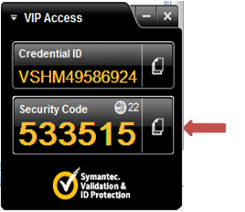
4(a). If you select Phone/Tablet/PC/Laptop as the MFA Device Type, enter the Security Code that displays under the field labeled Security Code (on the VIP Access software) in the Security Code field. Select Log In. | 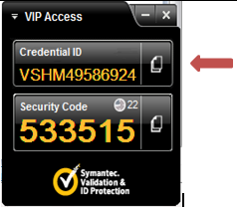  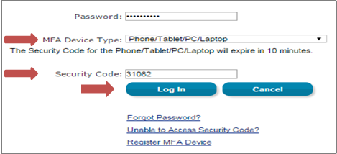
4(b). If you select Text Message – Short Message Service (SMS) or Interactive Voice Response (IVR) or E-mail as the MFA Device Type, select Send to receive the Security Code on the selected MFA device type. Enter the Security Code in the Security Code field and select Log In. | 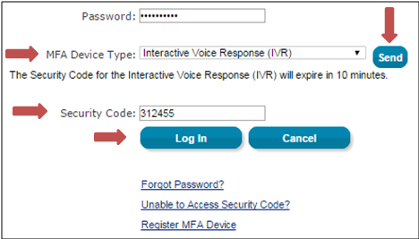
4(c). If you select One-Time Security Code as the MFA Device Type, enter the Security Code that was sent to your registered E-mail address via the ‘Unable to Access Security Code?’ link or provided by the Helpdesk, in the Security Code field. Select Log In. | 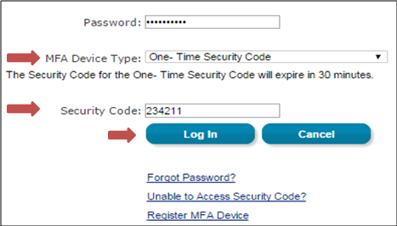
5. If you are not able to access your Security Code, select the ‘Unable to Access Security Code?’ link. On selecting this link, the ‘Unable to Access Security Code’ popup message will be displayed.  Select OK to continue | 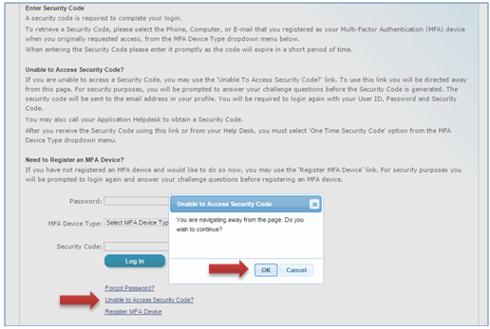
6. Enter your User ID and select Next. | 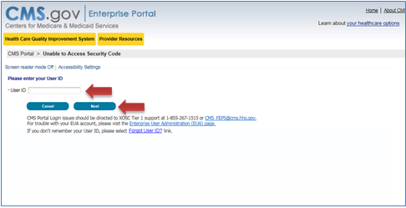
7. Answer the challenge questions and select Next. | 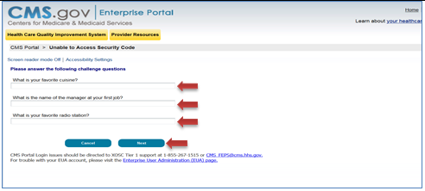
8. Select OK to return to the login page.  Note: This security code will expire in 30 minutes or after it is used successfully for the first time. | 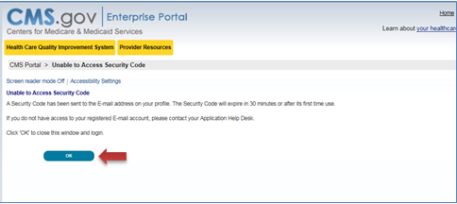
9. An E-mail with the Security Code will be sent to the E-mail address on your profile. | 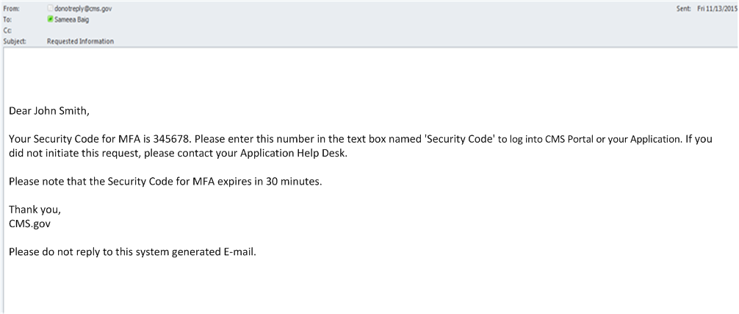
10. Read the Terms and Conditions and select I Accept to continue.
11. Enter your User ID and select Next.
12. Enter your Password, select One-Time Security Code as the MFA Device Type, and enter the Security Code that was sent to the E-mail address on your profile. Then select Log In. | 